Lab 05 Report
Christopher Bero
EE 316

Basic Filters and Frequency Response

Simulation

In this lab we will be modeling both low pass and high pass filters. The filter design (RC) is excellent for analyzing the connection between formulas and implementation, as there are no ICs involved. Low pass filters make sense, as the capacitor will easily oscillate to absorb high frequencies when placed in parallel with the input. High pass filters put the capacitor in series with the source, where low frequencies are killed by the saturation of the capacitor. The generic filter circuits are listed below, along with simulation results.

Simulation - Low Pass

Model

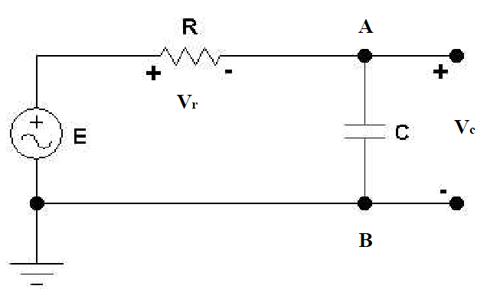

Circuit

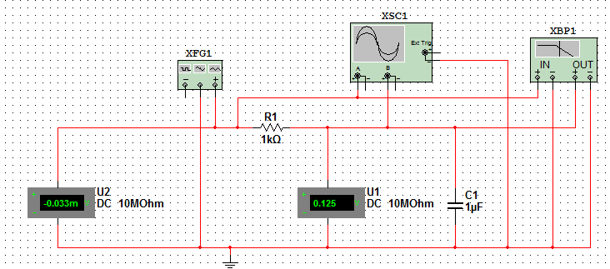

Bode

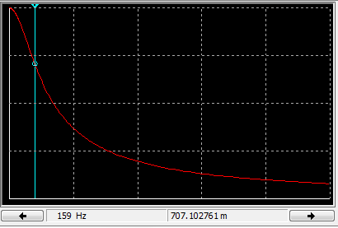
Results

Data

Frequency (Hz) | Gain Magnitude | Phase Angle (degree)
25 | 986.923 | -8.918
50 | 953.159 | -17.424
75 | 903.847 | -25.209
100 | 846.126 | -32.116
150 | 727.351 | -43.274
200 | 622.443 | -51.459
250 | 536.893 | -57.491
300 | 468.573 | -62.028
400 | 369.669 | -68.282
500 | 303.298 | -72.326
600 | 256.391 | -75.129
800 | 195.132 | -78.736
1000 | 157.173 | -80.948

Oscilloscope

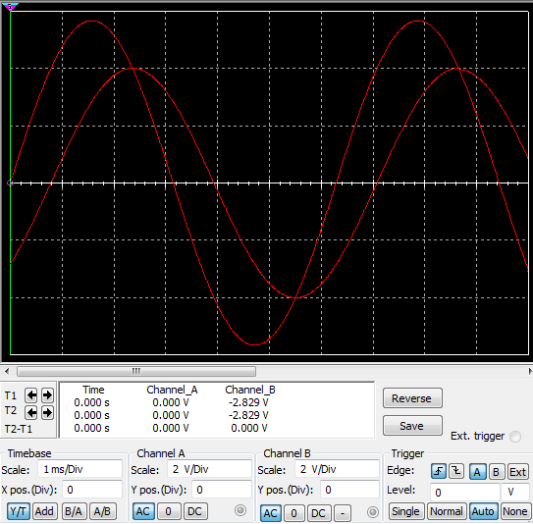

Simulation – High Pass

Model

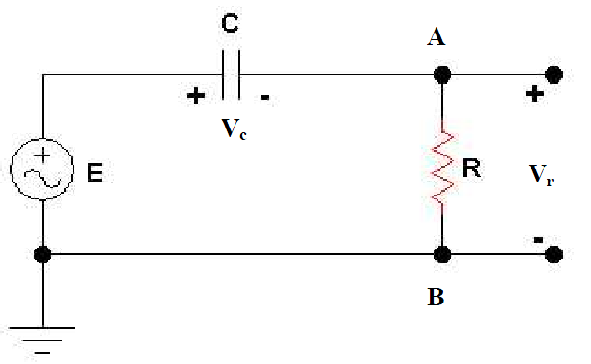

Circuit

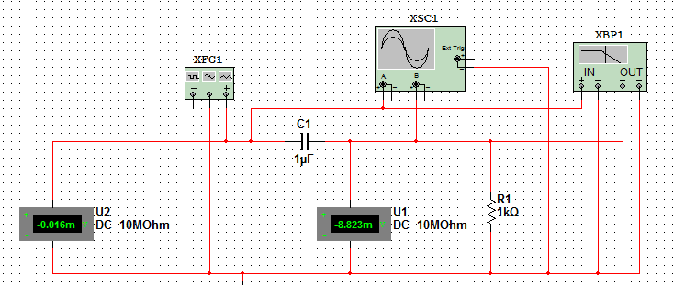

Bode

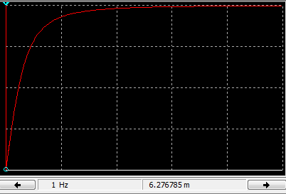
Results

Data

Frequency (Hz) | Gain Magnitude | Phase Angle (degree)
25 | 155.025 | 81.082
50 | 299.442 | 72.576
75 | 425.918 | 64.791
100 | 531.637 | 57.884
150 | 685.471 | 46.726
200 | 782.162 | 38.541
250 | 843.298 | 32.541
300 | 883.165 | 27.972
400 | 929.010 | 21.718
500 | 952.797 | 17.674
600 | 966.502 | 14.871
800 | 980.736 | 11.264
1000 | 987.546 | 9.052

Oscilloscope

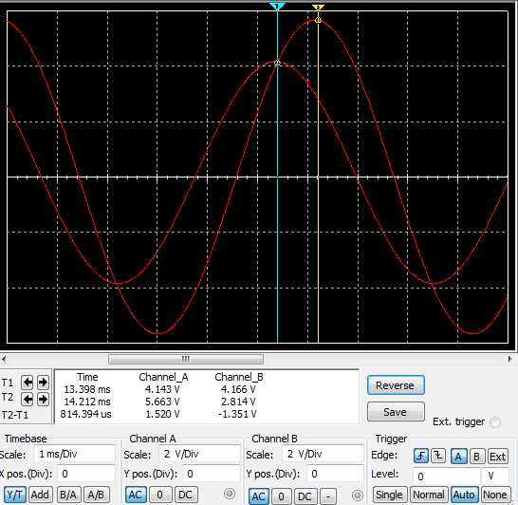

Hardware – Low Pass

Results

Data

Frequency (Hz) | Gain (V_{pk-pk}) | Phase Angle (degree)
25 | -0.1 | -7
55 | -0.7 | -18
99 | -1.6 | -30
150 | -2.6 | -43
201 | -3.9 | -48
253 | -4.5 | -54
304 | -5.1 | -58
400 | -5.98 | -64
501 | -6.55 | -67
601 | -6.95 | -69
699 | -7.27 | -71
800 | -7.51 | -72
900 | -7.67 | -73
1000 | -7.83 | -73

Conclusion

In this lab we saw how RC filters could be implemented to modify input signals based on their frequency. In both the simulation and hardware portion of the lab, the placement of the capacitor was an ostensible task which aided in visualizing how the system works. Based on the mathematical structure behind the circuit, provided in the manual, we know that modifying the constants associated with the capacitor and resistor allow us to tune the filter for specific use cases, though the general model has limitations which lead it to be replaced for more demanding tasks.

