Lab 06 Report
Christopher Bero
EE 316

AC Signals, Transformers and The Bridge Rectifier

Simulation

In this lab we took several circuits which deal with converting AC voltages and analyzed their behavior. By using a transformer we could retrieve in-phase, out-of-phase, and damped signals for our given 60Hz input. We then used a transformer and bridge rectifier in tandem to exchange the AC input signal for a DC output.

Circuit 1

This circuit used a virtual 10:1 transformer to dampen the input AC voltage. We first viewed the signal as an output in regard to the input, then changed the oscilloscope connections to see both terminals of the transformer as outputs.

Model-1
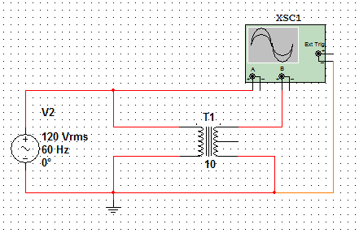

Oscilloscope-1
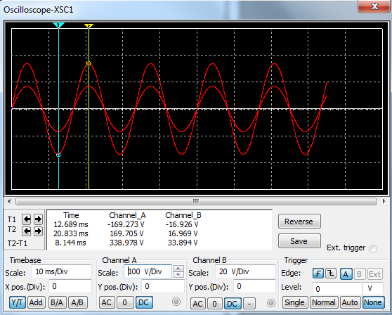
From the oscilloscope output we can see that both the input and output are very close to 60Hz and the output is indeed ten times less than the input and in-phase with it.

Model-2
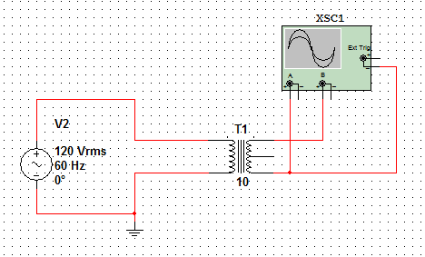
Oscilloscope-2
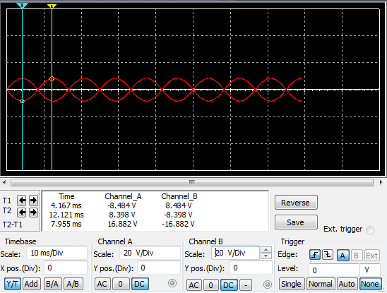
We can see from the second circuit arrangement that the output of the transformer's terminals are out-of-phase with each other.

Circuit 2

In the next circuit arrangement, we connected the transformer's center tap to ground.

Model
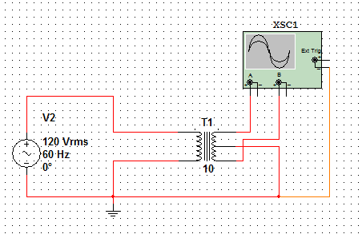
Oscilloscope
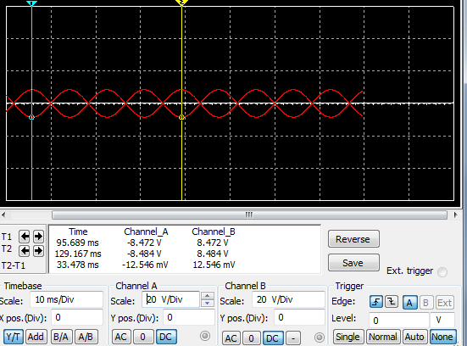
We can see from the oscilloscope output that connecting the center tap to ground does not affect the transformer output with respect to the two opposed terminals.
Circuit 3

The last circuit implements a bridge rectifier with four diodes to make sure that the same positive or negative current is kept aligned on the output to create a DC signal.

Model
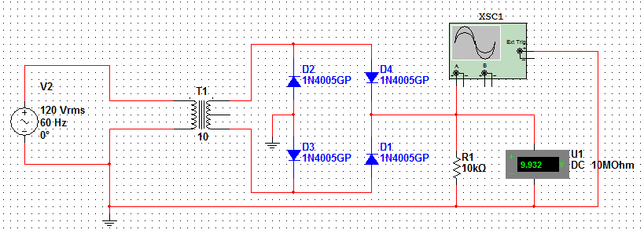
Oscilloscope
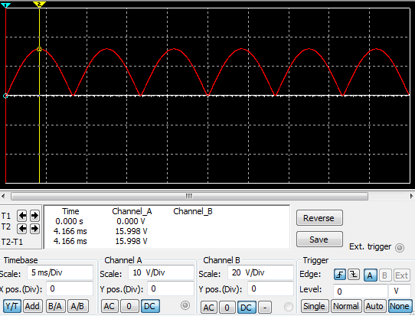
From the oscilloscope output we can see that there are no negative voltages being produced. A level DC signal can be generated by introducing a filter, or capacitor, on the output signal.
The third simulation circuit is then created in lab. We used a provided 10:1 transformer and diodes on a breadboard.

Hardware Transformer

Peak-Peak Voltage: 41V
RMS Voltage: 13.9V
Phase Relationship between input-output: -148 Degrees
AC Voltage reading at node C: 4.45V

Hardware Rectifier

V Peak-Peak: 20.5V
V DC: 13.05V
Frequency: 120Hz

