Lab 07 Report
Christopher Bero
EE 316

Characteristics of a Bipolar Junction Transistor

Lab

In this lab we explored Bipolar Junction Transistors via both Multisim and hardware circuits. Understanding the operation of BJTs is important to working with them and similar devices such as MOSFETs with small signal analysis in class. For our simulation and circuit exercise we place a set of resistors between the base and its voltage source and measure their impact on the circuit's current and voltage passthrough. From the theoretical analysis with this lab we expect to see a nonlinear relationship between the base resistor and the device's voltage difference.

The circuit to be modeled
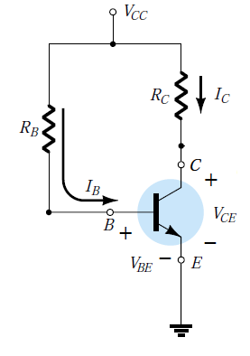

Simulation Results

Circuit
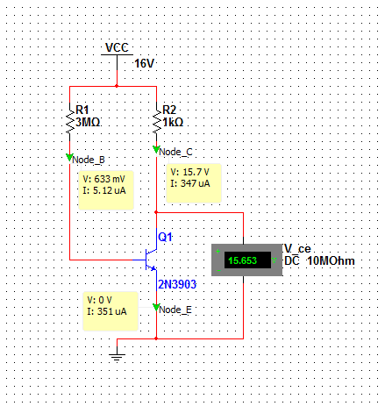

Measurements
R_{B} (K) | I_{B} (uA) | I_{C} (mA) | I_{E} (mA) | V_{CE} (V)
10 | 1,520 | 15.9 | 17.4 | 0.097
50 | 305 | 15.8 | 16.1 | 0.159
100 | 153 | 12.5 | 12.7 | 3.456
300 | 51 | 4.46 | 4.51 | 11.542
500 | 30.6 | 2.60 | 2.63 | 13.399
1000 | 15.3 | 1.21 | 1.23 | 14.788
2000 | 7.68 | 0.552 | 0.558 | 15.488
3000 | 5.12 | 0.347 | 0.351 | 15.653

Hardware

The hardware circuit was designed similar to the Multisim model. To collect results, we cycled through the base's resistor values for each node and collected the currents and voltage one at a time.

Measurements
R_{B} (Ohm) | I_{B} (uA) | I_{C} (mA) | I_{E} (mA) | V_{CE} (V)
10K | 1.527 | 16.05 | 17.57 | 0.026
50K | 0.307 | 16.01 | 16.31 | 0.065
100K | 0.152 | 15.97 | 16.12 | 0.102
300K | 0.051 | 8.77 | 8.84 | 7.25
500K | 0.030 | 5.21 | 5.27 | 10.86
1M | 0.015 | 2.49 | 2.52 | 13.59
2M | 0.007 | 1.17 | 1.18 | 14.92
3M | 0.005 | 0.74 | 0.75 | 15.35

Saturation is likely ~15mA as the graphs level off in that region.
VCC is 16V.
Q Point should be near the 8.77V mark.

We can see from these plots that the simulation and circuit model the same behavior that we expect for a BJT. Q Points can be chosen for each application, but is generally fitted to be the best area where an AC signal can be superimposed on the DC carrier. As such, we've picked a middle biased Q Point which should make the best use of an amplifier, given that the AC signal is within bounds and does not clip high or low on the amplifier.

