Lab 08 Report
Christopher Bero
EE 316

Amplification of a Signal at Low/High Frequencies using BJTs

In this lab we look at the effect of frequency on an amplifier circuit built around a BJT. We know from the theoretical analysis at the beginning of the lab that our circuit has a filtering aspect to it which should dampen low frequencies and allow higher frequencies to be amplified. We believe this is cause by the capacitors in place in our circuit, which saturate at lower frequencies and halt the circuit's current flow. At higher frequencies the capacitors spend more time unsaturated and act more as shorts rather than open circuits.

Simulation

The simulated circuit has an input voltage of 0.1V, and is modeled after the following:

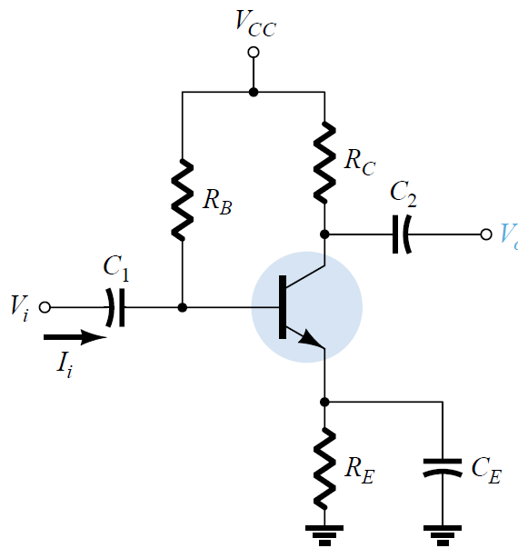

Simulation Results

Frequency | Vout (V) | Voltage Gain
10 | 0.000 | 0
30 | 0.019 | 0.19
60 | 0.026 | 0.26
100 | 0.030 | 0.3
200 | 0.033 | 0.33
500 | 0.203 | 2.03
1 KHz | 0.773 | 7.73
2 kHz | 1.915 | 19.15
5 KHz | 3.641 | 36.41
10 KHz | 3.956 | 39.56
15 KHz | 4.004 | 40.04
20 KHz | 4.030 | 40.3
50 KHz | 4.053 | 40.53
75 KHz | 4.058 | 40.58
100 KHz | 4.065 | 40.65
150 KHz | 4.077 | 40.77
200 KHz | 4.083 | 40.83
500 KHz | 4.160 | 41.6
750 KHz | 4.132 | 41.32
1 MHz | 4.113 | 41.13
1.5 MHz | 3.792 | 37.92
2.0 MHz | 2.646 | 26.46

Hardware Results

Hardware circuit was analyzed with a 1V input.

Frequency | Vout (V) | Voltage Gain
10 | 0.000 | 0
30 | 0.164 | 1.64
60 | 0.458 | 4.58
100 | 0.879 | 8.79
200 | 2.046 | 20.46
500 | 3.982 | 39.82
1 KHz | 4.360 | 43.6
2 kHz | 4.231 | 42.31
5 KHz | 4.229 | 42.29
10 KHz | 6.029 | 60.29
15 KHz | 5.599 | 55.99
20 KHz | 5.890 | 58.9
50 KHz | 6.042 | 60.42
75 KHz | 7.252 | 72.52
100 KHz | 6.040 | 60.4
150 KHz | 5.734 | 57.34
200 KHz | 5.452 | 54.52
500 KHz | 5.281 | 52.81
750 KHz | 4.849 | 48.49
1 MHz | 4.853 | 48.53
1.5 MHz | 4.937 | 49.37
2.0 MHz | 5.091 | 50.91

As we can see from the gathered data, the BJT circuits do match our hypothesis of amplification. After some fairly low frequencies are damped, all others are amplified by the circuit, and a graph of their gain holds some similarities to Op-Amp outputs. We can suppose from this information that a lower capacitance value would lead to more low end frequencies being damped, and a higher capacitance would allow more amplification in lower frequencies.

