Lab 12 Report
Christopher Bero
EE 316

Gain and Bandwidth Characteristics of MOSFETs

Hardware

The hardware circuit was constructed from the following model and tested against a range of frequencies.

Circuit Model
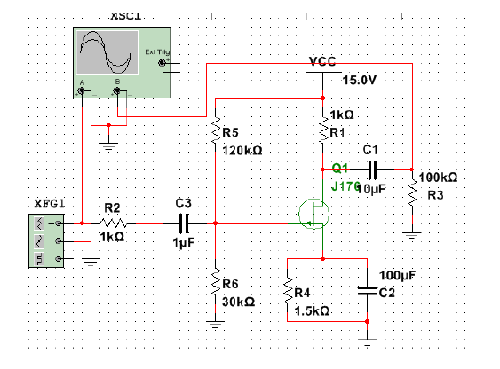

Hardware Results

Frequency (Hz) | Vout (Vpk-pk) | Voltage Gain
0.5 | 0.032 | 0.15
1 | 0.040 | 0.19
10 | 0.257 | 1.23
100 | 0.386 | 1.85
500 | 0.394 | 1.89
1,000 | 0.394 | 1.89
10,000 | 0.398 | 1.9
50,000 | 0.446 | 2.13
100,000 | 0.442 | 2.11
500,000 | 0.406 | 1.94
1,000,000 | 0.374 | 1.79
1,500,000 | 0.334 | 1.6
2,000,000 | 0.310 | 1.48
2,500,000 | 0.277 | 1.33
3,000,000 | 0.293 | 1.4

Conclusion

In this lab we saw a modest amplification of the input frequency across a wide portion of the tested bandwidth. The circuit output's low variation lends itself to applications with less constraints on the input frequency and requirement for some slight amplification in the 1-2 V/V range.

