Lab 02
Christopher Bero
EE384

1.1
function [ y, n ] = unit_impulse( n1, n2, n_p )
%unit_impulse: Returns a vector of the unit impulse
n=n1:n2;
y=((n-n_p)==0);
end

1.2
function [ y, n ] = unit_step( n1, n2, n_p )
%Unit Step: Returns a vector of the unit step.
n=n1:n2;
y=((n-n_p)>=0);
end

2.1
function [ m, y ] = time_shifting( x, n, n_d )
%Time Shifting, Move a signal by n_d samples
y=x;
m=n+n_d;
end

2.2
n=-10:10;
x=(2*n+3);
% P2.2a
figure;
subplot(3,1,1);
stem(n,x);
title('Problem 2.2a, Unmodified');
xlabel('Domain');
ylabel('Range');
% P2.2b
n_d=3;
[m,y]=time_shifting(x, n, n_d);
subplot(3,1,2);
stem(m,y);
title('Problem 2.2b, Time Shifting');
xlabel('Domain');
ylabel('Range');
% P2.2c
[y,m]=time_reversal(x, n);
subplot(3,1,3);
stem(m,y);
title('Problem 2.2c, Time Reversal');
xlabel('Domain');
ylabel('Range');

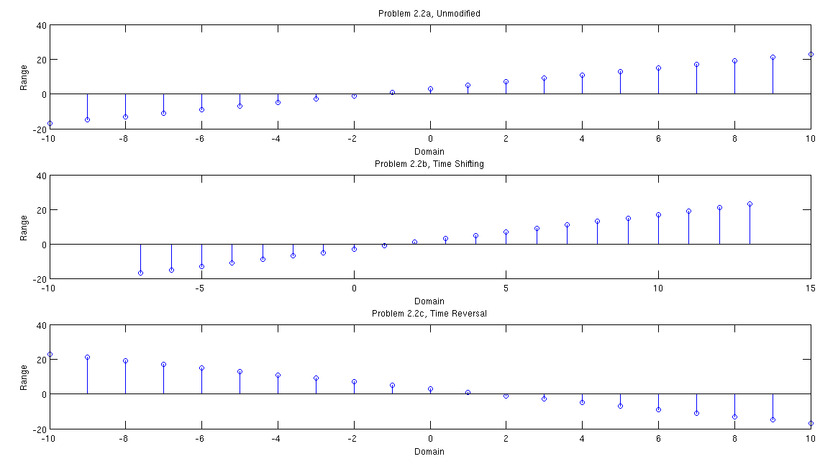
2.3
n=-10:10;
[y1,m1]=unit_impulse(-10, 10, -4);
[y2,m2]=(unit_impulse(-10, 10, 2));
y1=y1*5;
y2=y2*2;
y=y1-y2;
figure;
stem(n, y);
title('Problem 2.3');
xlabel('Domain');
ylabel('Range');

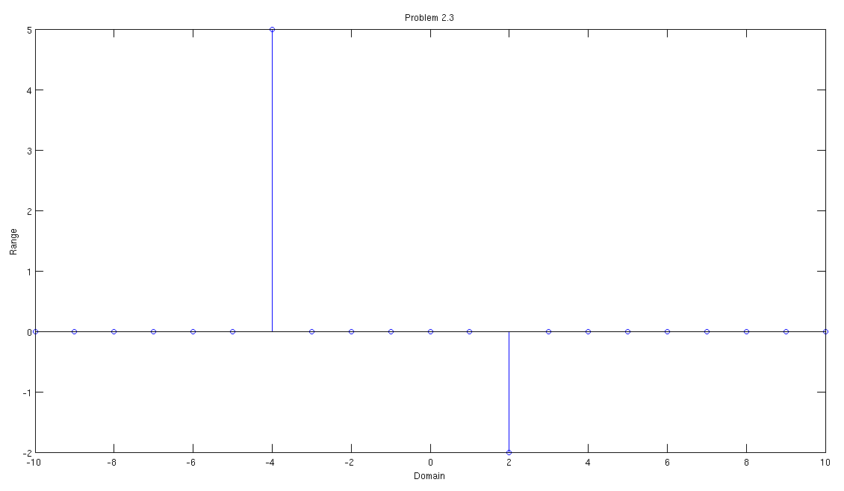
2.4
n=-10:10;
[y1,m1]=unit_step(-10, 10, 0);
[y2,m2]=unit_step(-10, 10, 4);
y=y1-y2;
figure;
stem(n, y);
title('Problem 2.4');
xlabel('Domain');
ylabel('Range');

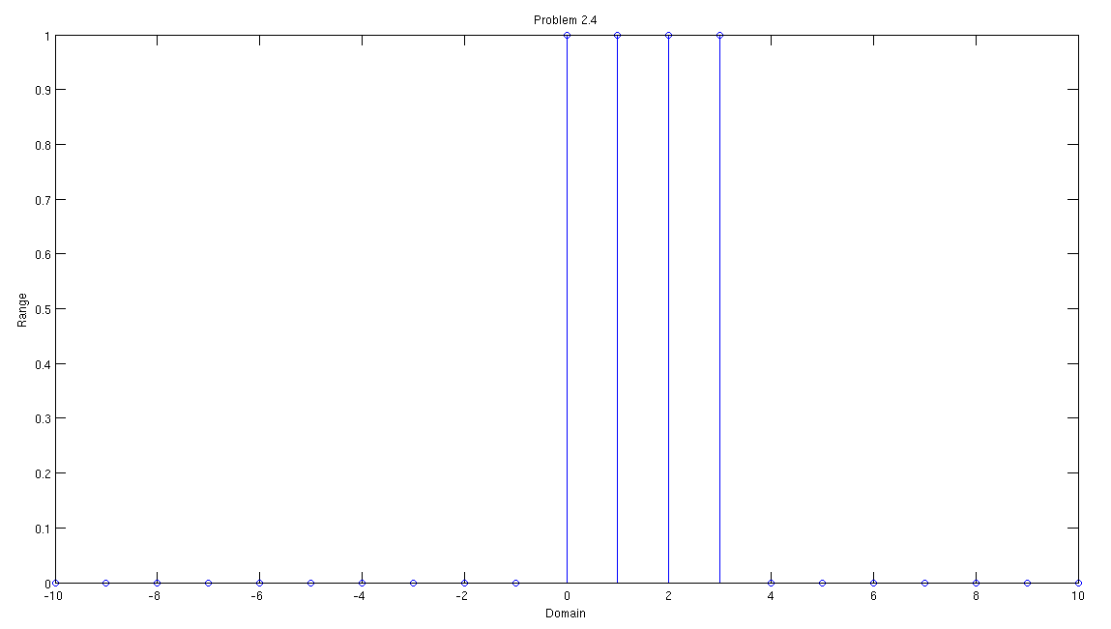
3.1, 3.2, 3.3
% 3.1
% Load and plot ECG data
% Change this to match your path
load('/home/berocs/Documents/uah/ee384/lab02/SAMPLE_ECG.mat');
n=1:2000;
figure;
subplot(2,1,1);
plot(n,ECG_Data);
axis([0 2000 100 220]);
title('Problem 3.1, RAW ECG');
xlabel('Time');
ylabel('Amplitude');

% 3.2 & 3.3
y=zeros(2000,1);
for index = n
if index+2 > 2000
break
end
y(index)=(ECG_Data(index)+ECG_Data(index+1)+ECG_Data(index+2))/3;
end
subplot(2,1,2);
plot(n,y);
axis([0 2000 100 220]);
title('Problem 3.2&3.3, FILTERED ECG');
xlabel('Time');
ylabel('Amplitude');

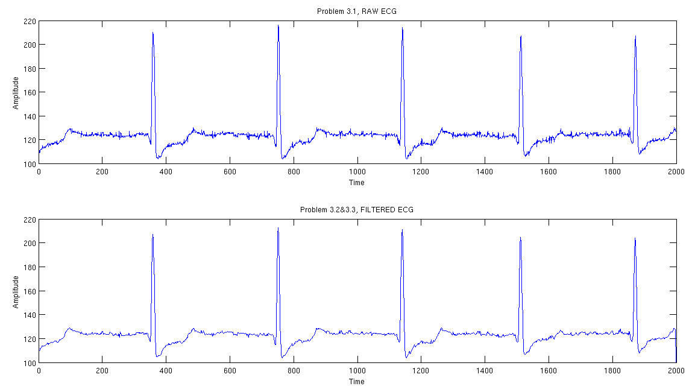
3.4
Yes! The ECG plot is definitely lacking some of the “jittery” peaks.

