Christopher Bero
CPE412
Exam 2

1a.
The critical directive instructs OpenMP to provide mutual exclusion synchronization in sections of code. It serves to ensure that when multiple threads of execution are following a structured block they do not descend on a singular change simultaneously and lose information.

Use:
#pragma omp critical
global_result += local_result;

Further information in the textbook: page 218.

1b.
The for loop present in the given code is in the canonical form, which indicated that using OpenMP to parallelize it should be acceptable. Inside of the loop, sum is copied to each thread and made a local variable; after the loop's conclusion OpenMP automatically reduces it with the given operator into the original variable. If the reduction clause is not used, then sum would continue to be a shared variable, and the loop would have an unaddressed critical section.

Output:
The sum is 10

Further information in the textbook: page 225.

1c.
I wasn't able to uncover any details on MPMD MPI configurations in the textbook, websites that I referenced for this problem are cited below.

MPI naively supports running a batch of processes created from a collection of executables. By using appfiles we can direct mpirun to create a set number of processes from each executable; these processes can then share a common MPI_COMM_WORLD in order to operate common message passing commands [1]. On the DMC I would create an appfile that lists my boss process first (to set rank 0) and then worker processes from a separate executable next. Then the script files we use in class could be updated with the --app flag to receive the appfile.

Example appfile:
# Boss process
-np 1 p1c_main
# Worker process
-np 8 p1c_worker

Example invocation:
$ mpirun –app appfile

[1] N.A. (August, 2015). FAQ: Running MPI Jobs. [Online]. Available: https://www.open-mpi.org/faq/?category=running#mpmd-run

1d.
Possible values to num at output are 1, 2, 6, 3, 4, 123, 124, 372, 369, 370. These are possible because after spawning the threads no action is taken to control the order in which they operate on the global variable or at what point in execution each thread is when the variable is printed to output.

Further information in the textbook: page 198.

1e.
Global synchronization affects all threads or processes and stalls execution until each one has reached a given point. Local synchronization only affects processes with coinciding execution, as stated by the abstract for Analysis of Delays Caused by Local Synchronization, processes synchronize with those from which there is an incoming edge of a representative graph [2]. Barriers are an example of global synchronization. Local synchronization is preferred because it is generally more performance oriented, even though it can make following the threads of execution more difficult.

Further information in the textbook: page 176, 218.

[2] J. Lipman, Q. Stout. (2010). Analysis of Delays Caused by Local Synchronization. [Online]. Available: http://web.eecs.umich.edu/~qstout/abs/SICOMPLocalSynch.html

1f.
Statically allocating data blocks to processes for a Mandelbrot program tends to be a bad idea because the density of computation required for regions of the output vary heavily. This would lead to some processes having much more workload than others. Instead, a dynamic allocation approach would have processes work through a pool of allotments one at a time, keeping the workload more evenly distributed.

1g.
Monte Carlo problems use random sampling to obtain information. In our class example we calculate pi/4 by overlaying a unit circle on a square of dimension 2. We then determine the ratio of sample that land inside and outside of the circle, and given enough data it should approach pi/4.
Although we can solve many 2-dimension integration problems by scanning across a region with trapezoidal approximation, in higher dimensions this become impractical and Monte Carlo systems are preferred. In our example we look at a section of curve, and randomly select points and compare them to our function. The ratio of points inside of the curve versus the region size should provide an approximation of the integral's solution.
Because Monte Carlo approaches rely on random sampling, they can be made very parallel with each process generating a collection of random samples and then reducing them in conclusion. For parallelization to be appropriately useful, a good random number generator must be employed. If the random numbers fail to adequately cover the region being investigated, then the result may have a large error.

Problem 2

Makefile:
all: tsp_serial tsp_omp

tsp_serial:
g++ src/tsp_serial.cpp -o bin/tsp_serial -O3 -lm -Wall

tsp_omp:
#export OMPI_CXX=g++
g++ src/tsp_omp.cpp -o bin/tsp_omp -lm -O3 -Wall -fopenmp

clean:
rm bin/*
rm src/*.o

2a.
Run on DMC, class queue, 8 cores, defaults.

Queue Script:
#!/bin/bash

./bin/tsp_serial 3 > tsp_serial.out
./bin/tsp_serial 4 >> tsp_serial.out
./bin/tsp_serial 5 >> tsp_serial.out
./bin/tsp_serial 6 >> tsp_serial.out
./bin/tsp_serial 7 >> tsp_serial.out
./bin/tsp_serial 8 >> tsp_serial.out
./bin/tsp_serial 9 >> tsp_serial.out
./bin/tsp_serial 10 >> tsp_serial.out
./bin/tsp_serial 11 >> tsp_serial.out
./bin/tsp_serial 12 >> tsp_serial.out
./bin/tsp_serial 13 >> tsp_serial.out
./bin/tsp_serial 14 >> tsp_serial.out

Cleaned Queue Output:
# p2_tsp serial timings
#count time
3 0
4 0.000001
5 0.000006
6 0.000028
7 0.000186
8 0.001519
9 0.010518
10 0.095712
11 1.132270
12 15.1781
13 206.954
14 3003.18

Time Complexity:
From the output graph, we can see that the algorithm is likely exponential time.

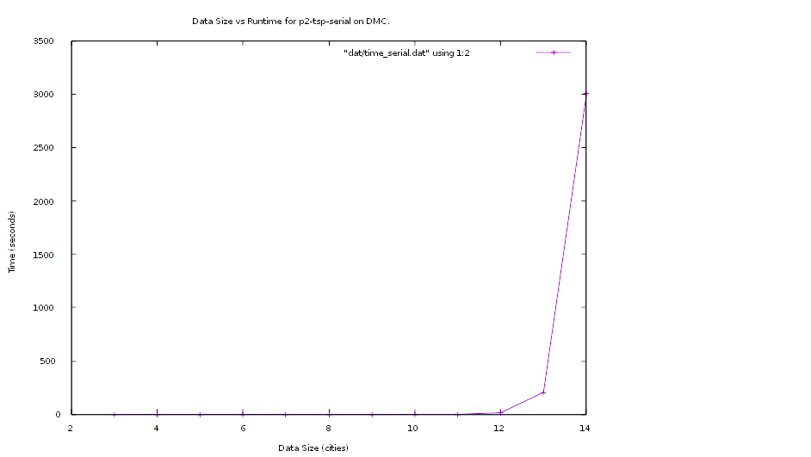

Execution Time Estimate:
By plugging in our data (sans the erroneous 3,0) to a graphing calculator and solving for exponential fit:
y = (6.59252546327E-11)*exp(2.17927659514*(x))

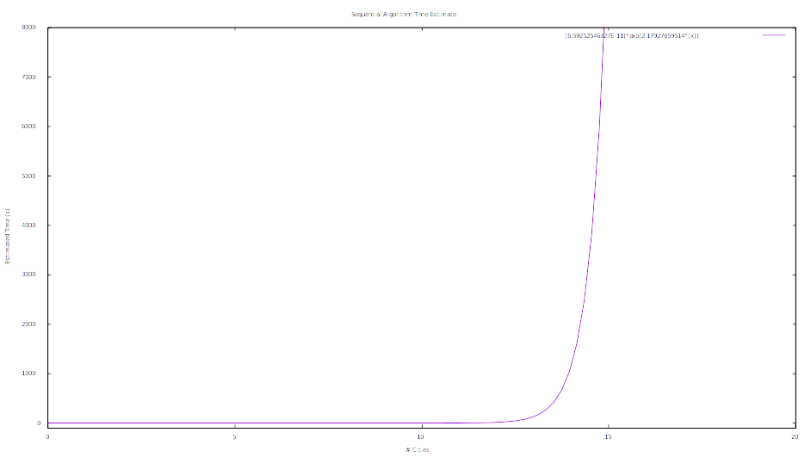
Estimations are likely used in place of exhaustive enumeration approaches because of the hard line increase in time. To make software faster, approaches that consume the level of resources as this would likely be replaced with tables or less exact methods.

2b.
Modified with OpenMP. Run on DMC, class queue, 8 cores, defaults.

Queue Script:
#!/bin/bash

./bin/tsp_omp 2 8 > tsp_omp_2.out
./bin/tsp_omp 2 9 >> tsp_omp_2.out
[...]
./bin/tsp_omp 2 13 >> tsp_omp_2.out
./bin/tsp_omp 2 14 >> tsp_omp_2.out

./bin/tsp_omp 4 8 > tsp_omp_4.out
./bin/tsp_omp 4 9 >> tsp_omp_4.out
[...]
./bin/tsp_omp 4 13 >> tsp_omp_4.out
./bin/tsp_omp 4 14 >> tsp_omp_4.out

./bin/tsp_omp 8 8 > tsp_omp_8.out
./bin/tsp_omp 8 9 >> tsp_omp_8.out
[...]
./bin/tsp_omp 8 13 >> tsp_omp_8.out
./bin/tsp_omp 8 14 >> tsp_omp_8.out

./bin/tsp_omp 12 8 > tsp_omp_12.out
./bin/tsp_omp 12 9 >> tsp_omp_12.out
[...]
./bin/tsp_omp 12 13 >> tsp_omp_12.out
./bin/tsp_omp 12 14 >> tsp_omp_12.out

Cleaned OMP Output:
# OMP time data
#
#Citites Times
#Threads -> 1 2 4 8 12
8 0.001519 0.000937 0.000612 0.000432 0.000596
9 0.010518 0.007415 0.00368 0.001771 0.002372
10 0.095712 0.049137 0.026193 0.013275 0.01897
11 1.13227 0.568546 0.28036 0.14794 0.179683
12 15.1781 7.54595 3.79051 2.00875 2.31003
13 206.954 101.505 51.0793 26.9759 29.5517
14 3003.18 1477.3 740.998 390.597 435.675

Runtime Script:
set title "Data Size vs Runtime for p2-tsp-omp on DMC."
set xlabel "Data Size (cities)"
set ylabel "Time (seconds)"
set autoscale
plot "dat/time_omp.dat" using 1:2 with linespoints, \
"dat/time_omp.dat" using 1:3 with linespoints, \
"dat/time_omp.dat" using 1:4 with linespoints, \
"dat/time_omp.dat" using 1:5 with linespoints, \
"dat/time_omp.dat" using 1:6 with linespoints

Speedup Script:
set title "Speedup for p2-tsp-omp on DMC."
set xlabel "Data Size (cities)"
set ylabel "Speedup (time_1 / time_core)"
set autoscale
plot "dat/time_omp.dat" using 1:($2/$2) with linespoints, \
"dat/time_omp.dat" using 1:($2/$3) with linespoints, \
"dat/time_omp.dat" using 1:($2/$4) with linespoints, \
"dat/time_omp.dat" using 1:($2/$5) with linespoints, \
"dat/time_omp.dat" using 1:($2/$6) with linespoints

Efficiency Script:
set title "Efficiency for p2-tsp-omp on DMC."
set xlabel "Data Size (cities)"
set ylabel "Efficiency (serial / (core * speed))"
set yrange [0:2]
plot "dat/time_omp.dat" using 1:($2/(1*$2)) with linespoints, \
"dat/time_omp.dat" using 1:($2/(2*$3)) with linespoints, \
"dat/time_omp.dat" using 1:($2/(4*$4)) with linespoints, \
"dat/time_omp.dat" using 1:($2/(8*$5)) with linespoints, \
"dat/time_omp.dat" using 1:($2/(12*$6)) with linespoints

Graphs:
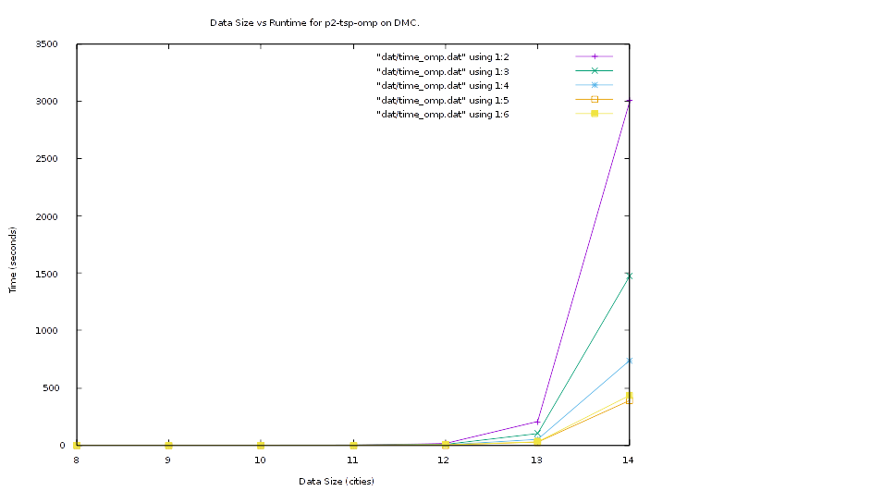
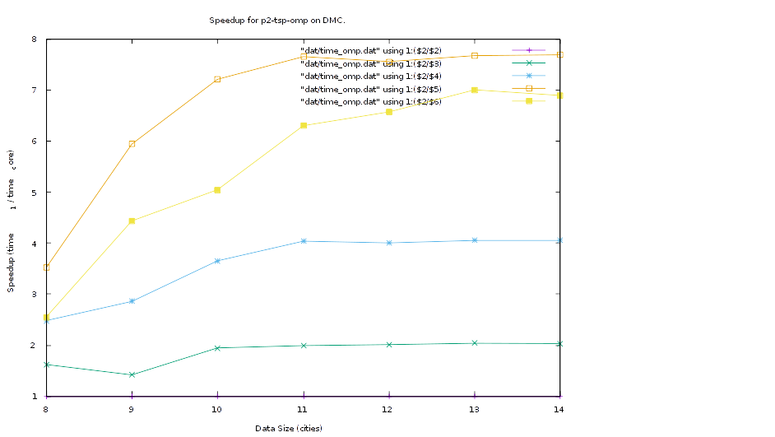

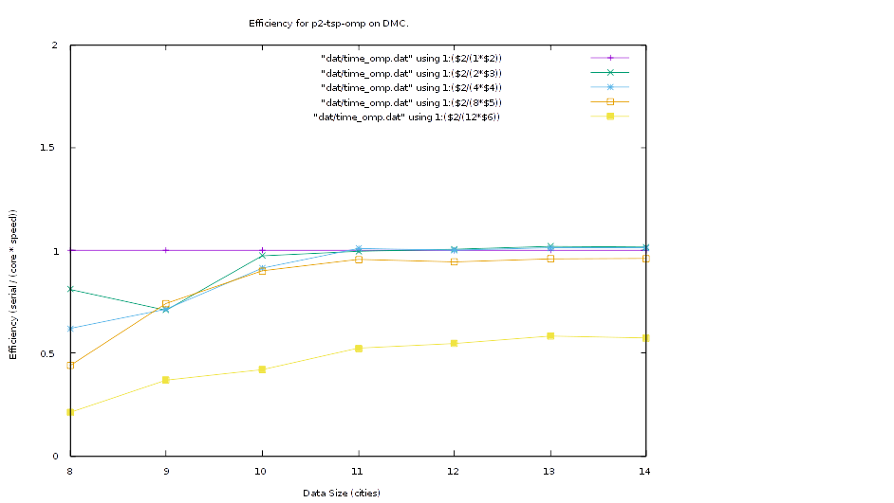

Problem 3

Makefile:
all: mm_mult_hybrid mm_mult_serial_gnu

mm_mult_serial_gnu:
g++ src/mm_mult_serial.cpp -o bin/mm_mult_serial_gnu -O3

mm_mult_omp:
g++ src/mm_mult_omp.cpp -o bin/mm_mult_omp -O3 -fopenmp -Wall

mm_mult_hybrid:
export OMPI_CXX=g++
mpic++ src/mm_mult_hybrid.cpp -o bin/mm_mult_hybrid -O3 -fopenmp -Wall

clean:
rm bin/*
rm src/*.o

3.a
Serial output:
$ ./bin/mm_mult_serial_gnu 9 10 11

C matrix =
21618.7 22321.2 21545.9 17372.3 20727.8 18327.1 30508.6 21923.4 23088.1 24634.6 24465.5
28828.4 32799.9 33316 26060.6 25942.6 23885.2 42572.4 28279.7 26424.2 32469.4 30314.7
23504 23862 27058.2 18609.2 19706.9 23431.1 38936.7 32590.7 29764.7 32524.6 32348.1
18204.2 22829 23964.7 15910.3 22348.8 21103.3 29826.8 27404.5 26796.1 20818 20367.4
34886.2 36150.8 36297.2 29850.2 33196.1 31883.3 50988.5 34803.8 36177.1 38917.7 38527.2
27428.9 28656 26231.5 20413.7 27521.6 27800 39080.7 33508.1 34796.6 26637.4 32037.6
23459.2 24927.9 18748.2 19857.6 21415.7 18287.7 31086 20485.5 23447.5 24119.4 21553.8
28129.5 33462.4 23782 23641.1 26517.3 24262.7 36669.8 28761 28438.4 25429.3 24817
20841 23039.3 27470.4 17533.7 20821.5 19890.7 33471.7 26292.9 25006.2 28000.7 24355

Two process, four threads:
$ mpirun -np 2 ./bin/mm_mult_hybrid 4 9 10 11

C matrix =
21618.7 22321.2 21545.9 17372.3 20727.8 18327.1 30508.6 21923.4 23088.1 24634.6 24465.5
28828.4 32799.9 33316 26060.6 25942.6 23885.2 42572.4 28279.7 26424.2 32469.4 30314.7
23504 23862 27058.2 18609.2 19706.9 23431.1 38936.7 32590.7 29764.7 32524.6 32348.1
18204.2 22829 23964.7 15910.3 22348.8 21103.3 29826.8 27404.5 26796.1 20818 20367.4
34886.2 36150.8 36297.2 29850.2 33196.1 31883.3 50988.5 34803.8 36177.1 38917.7 38527.2
27428.9 28656 26231.5 20413.7 27521.6 27800 39080.7 33508.1 34796.6 26637.4 32037.6
23459.2 24927.9 18748.2 19857.6 21415.7 18287.7 31086 20485.5 23447.5 24119.4 21553.8
28129.5 33462.4 23782 23641.1 26517.3 24262.7 36669.8 28761 28438.4 25429.3 24817
20841 23039.3 27470.4 17533.7 20821.5 19890.7 33471.7 26292.9 25006.2 28000.7 24355

Four process, two threads
$ mpirun -np 4 ./bin/mm_mult_hybrid 2 9 10 11

C matrix =
21618.7 22321.2 21545.9 17372.3 20727.8 18327.1 30508.6 21923.4 23088.1 24634.6 24465.5
28828.4 32799.9 33316 26060.6 25942.6 23885.2 42572.4 28279.7 26424.2 32469.4 30314.7
23504 23862 27058.2 18609.2 19706.9 23431.1 38936.7 32590.7 29764.7 32524.6 32348.1
18204.2 22829 23964.7 15910.3 22348.8 21103.3 29826.8 27404.5 26796.1 20818 20367.4
34886.2 36150.8 36297.2 29850.2 33196.1 31883.3 50988.5 34803.8 36177.1 38917.7 38527.2
27428.9 28656 26231.5 20413.7 27521.6 27800 39080.7 33508.1 34796.6 26637.4 32037.6
23459.2 24927.9 18748.2 19857.6 21415.7 18287.7 31086 20485.5 23447.5 24119.4 21553.8
28129.5 33462.4 23782 23641.1 26517.3 24262.7 36669.8 28761 28438.4 25429.3 24817
20841 23039.3 27470.4 17533.7 20821.5 19890.7 33471.7 26292.9 25006.2 28000.7 24355

Eight process, one thread:
$ mpirun -np 8 ./bin/mm_mult_hybrid 1 9 10 11

C matrix =
21618.7 22321.2 21545.9 17372.3 20727.8 18327.1 30508.6 21923.4 23088.1 24634.6 24465.5
28828.4 32799.9 33316 26060.6 25942.6 23885.2 42572.4 28279.7 26424.2 32469.4 30314.7
23504 23862 27058.2 18609.2 19706.9 23431.1 38936.7 32590.7 29764.7 32524.6 32348.1
18204.2 22829 23964.7 15910.3 22348.8 21103.3 29826.8 27404.5 26796.1 20818 20367.4
34886.2 36150.8 36297.2 29850.2 33196.1 31883.3 50988.5 34803.8 36177.1 38917.7 38527.2
27428.9 28656 26231.5 20413.7 27521.6 27800 39080.7 33508.1 34796.6 26637.4 32037.6
23459.2 24927.9 18748.2 19857.6 21415.7 18287.7 31086 20485.5 23447.5 24119.4 21553.8
28129.5 33462.4 23782 23641.1 26517.3 24262.7 36669.8 28761 28438.4 25429.3 24817
20841 23039.3 27470.4 17533.7 20821.5 19890.7 33471.7 26292.9 25006.2 28000.7 24355

3.b
Run on Jetson.

Queue Scripts:
#!/bin/bash
# Serial script
./bin/mm_mult_serial_gnu 3000 3000 3000 > mm_mult_serial.txt
./bin/mm_mult_serial_gnu 3000 3000 3000 >> mm_mult_serial.txt
./bin/mm_mult_serial_gnu 3000 3000 3000 >> mm_mult_serial.txt
./bin/mm_mult_serial_gnu 3000 3000 3000 >> mm_mult_serial.txt
./bin/mm_mult_serial_gnu 3000 3000 3000 >> mm_mult_serial.txt

#!/bin/bash
# 2 processes, 4 threads each
mpirun -np 2 ./bin/mm_mult_hybrid 4 3000 3000 3000 > mm_mult_hybrid_2.txt
mpirun -np 2 ./bin/mm_mult_hybrid 4 3000 3000 3000 >> mm_mult_hybrid_2.txt
mpirun -np 2 ./bin/mm_mult_hybrid 4 3000 3000 3000 >> mm_mult_hybrid_2.txt
mpirun -np 2 ./bin/mm_mult_hybrid 4 3000 3000 3000 >> mm_mult_hybrid_2.txt
mpirun -np 2 ./bin/mm_mult_hybrid 4 3000 3000 3000 >> mm_mult_hybrid_2.txt

#!/bin/bash
# 4 processes, 2 threads each
mpirun -np 4 ./bin/mm_mult_hybrid 2 3000 3000 3000 > mm_mult_hybrid_4.txt
mpirun -np 4 ./bin/mm_mult_hybrid 2 3000 3000 3000 >> mm_mult_hybrid_4.txt
mpirun -np 4 ./bin/mm_mult_hybrid 2 3000 3000 3000 >> mm_mult_hybrid_4.txt
mpirun -np 4 ./bin/mm_mult_hybrid 2 3000 3000 3000 >> mm_mult_hybrid_4.txt
mpirun -np 4 ./bin/mm_mult_hybrid 2 3000 3000 3000 >> mm_mult_hybrid_4.txt

#!/bin/bash
# 8 processes, 1 thread each
mpirun -np 8 ./bin/mm_mult_hybrid 1 3000 3000 3000 > mm_mult_hybrid_8.txt
mpirun -np 8 ./bin/mm_mult_hybrid 1 3000 3000 3000 >> mm_mult_hybrid_8.txt
mpirun -np 8 ./bin/mm_mult_hybrid 1 3000 3000 3000 >> mm_mult_hybrid_8.txt
mpirun -np 8 ./bin/mm_mult_hybrid 1 3000 3000 3000 >> mm_mult_hybrid_8.txt
mpirun -np 8 ./bin/mm_mult_hybrid 1 3000 3000 3000 >> mm_mult_hybrid_8.txt

Output:

Serial:
time: 880.58116 seconds
speedup: 1
efficiency: 1

Hybrid_MPI2:
time: 120.90869 seconds
speedup: 7.28
efficiency: 0.91

Hybrid_MPI4:
time: 114.25176 seconds
speedup: 7.70
efficiency: 0.96

Hybrid_MPI8:
time: 113.36545 seconds
speedup: 7.76
efficiency: 0.97

Preferring more processes via MPI provides slightly better performance. I suspect that this may be due to the way threads of execution share resources; since multiple threads must access the same matrix a, b, and c variables, there may be several stalls while OpenMP handles writing critical sections and also while threads wait for access to read. With more MPI processes, there are more instances of each variable, cutting down on the number of read and write collisions.

Problem 4

Makefile:
all: main

main:
g++ main.c -o bin/p4_omp -O3 -lm -Wall -fopenmp

clean:
rm bin/*
rm *.o

Execution:
$ ./bin/p4_omp 0.01 1.0 4 100000
Start: 0.010000, End: 1.000000, Threads: 4, Bins: 100000
Thread: 3, interval: 0.000010, bins: 25000, start: 0.752500, end: 1.000000, result: 0.441662
Thread: 2, interval: 0.000010, bins: 25000, start: 0.505000, end: 0.752500, result: 0.398658
Thread: 1, interval: 0.000010, bins: 25000, start: 0.257500, end: 0.505000, result: 0.184188
Thread: 0, interval: 0.000010, bins: 25000, start: 0.010000, end: 0.257500, result: -0.020576
Result: 1.003932

Problem 5

*Pass go, collect $200*

