Christopher Bero
CPE 412
Optional Final Portion

Rather than include somewhat lengthy source files in this document, they can be reviewed and downloaded from https://github.com/ctag/uah/tree/master/cpe412/optional_final_take_home/src

Problem 1

1.1

Compiling

pgc++ laplace2d_omp.cpp -fast -mp -o ../bin/laplace2d_omp

Queue settings

Run on class queue, dmc, 8 cores.

Execution times

1: 52.622280 s
2: 52.339716 s
4: 52.464614 s
8: 52.315337 s

Discussion

The lack of speedup on this program gave me fits, I tried compiling with gcc and explicitly stating the num_threads criteria, nothing got me away from a 52 second runtime. I'm including these results with an expectation that something has gone horribly wrong.

1.2

Compiling

pgcc on the DMC is broken and appears to not work from a makefile (there's also very little troubleshooting information online). Compiled manually from src/ directory.
pgc++ -fast laplace2d_acc.cpp -o ../bin/laplace2d_acc -acc -ta=nvidia -Minfo=accel

Build Output

main:
77, Generating copyout(Anew[1:4094][1:4094])
Generating copyin(A[:][:])
Generating copyout(A[1:4094][1:4094])
78, Loop is parallelizable
79, Loop is parallelizable
Accelerator kernel generated
Generating Tesla code
78, #pragma acc loop gang /* blockIdx.y */
79, #pragma acc loop gang, vector(128) /* blockIdx.x threadIdx.x */
82, Max reduction generated for error
86, Loop is parallelizable
87, Loop is parallelizable
Accelerator kernel generated
Generating Tesla code
86, #pragma acc loop gang /* blockIdx.y */
87, #pragma acc loop gang, vector(128) /* blockIdx.x threadIdx.x */

Changed Code

76 #pragma acc kernels
77 {
78 for( int j = 1; j < n-1; j++) {
79 for( int i = 1; i < m-1; i++ ) {
80 Anew[j][i] = 0.25 * ( A[j][i+1] + A[j][i-1]
81 + A[j-1][i] + A[j+1][i]);
82 error = fmax( error, fabs(Anew[j][i] - A[j][i]));
83 }
84 }
85
86 for( int j = 1; j < n-1; j++) {
87 for( int i = 1; i < m-1; i++ ) {
88 A[j][i] = Anew[j][i];
89 }
90 }
91 }
92 if (iter % 100 == 0) cout << iter << " " << setprecision(6)
93 << fixed << error << endl;
94 iter++;
95 }
96 double runtime = GetTimer();
97 cout << " total: " << runtime/1000 << " s" << endl;
98 }

Queue settings

Run on class queue, kepler.

Execution time: 153.107151 s

Discussion

And I thought that part 1.1's runtime was bad.. This queue run had a speedup of 0.34 over the OMP serial. I expect this is due to some memory thrashing between the cpu and gpu caches, we discussed how in the process of applying ACC to a program we could experience pretty bad results until locality was set up.

1.3

Compiling

pgc++ -fast laplace2d_acc_a13.cpp -o ../bin/laplace2d_acc_a13 -acc -ta=nvidia -Minfo=accel

Build Output

main:
74, Generating copy(A[:][:])
Generating create(Anew[:][:])
79, Loop is parallelizable
80, Loop is parallelizable
Accelerator kernel generated
Generating Tesla code
79, #pragma acc loop gang /* blockIdx.y */
80, #pragma acc loop gang, vector(128) /* blockIdx.x threadIdx.x */
83, Max reduction generated for error
87, Loop is parallelizable
88, Loop is parallelizable
Accelerator kernel generated
Generating Tesla code
87, #pragma acc loop gang /* blockIdx.y */
88, #pragma acc loop gang, vector(128) /* blockIdx.x threadIdx.x */

Changed code

73 #pragma acc data copy(A) create (Anew)
74 while ( error > tol && iter < iter_max ) {
75 error = 0.0;
76
77 #pragma acc kernels
78 {
79 for( int j = 1; j < n-1; j++) {
80 for( int i = 1; i < m-1; i++ ) {
81 Anew[j][i] = 0.25 * ( A[j][i+1] + A[j][i-1]
82 + A[j-1][i] + A[j+1][i]);
83 error = fmax( error, fabs(Anew[j][i] - A[j][i]));
84 }
85 }

Queue settings

Run on class queue, kepler.

Execution time: 5.504448 s

Discussion

With a speedup of 9.45 over the OMP serial execution, this iteration of the ACC program appears to have broken past the runtime wall of the previous. It looks like the memory transfer was just the issue with part 1.2, since we've instructed the gpu to hang onto A and Anew this time.

1.4

Compiling

pgc++ -fast laplace2d_acc_a14.cpp -o ../bin/laplace2d_acc_a14 -acc -ta=nvidia,time -Minfo=accel

Build Output (last)

main:
74, Generating copy(A[:][:])
Generating create(Anew[:][:])
80, Loop is parallelizable
82, Loop is parallelizable
Accelerator kernel generated
Generating Tesla code
80, #pragma acc loop gang, vector(4) /* blockIdx.y threadIdx.y */
82, #pragma acc loop gang(32), vector(32) /* blockIdx.x threadIdx.x */
85, Max reduction generated for error
90, Loop is parallelizable
92, Loop is parallelizable
Accelerator kernel generated
Generating Tesla code
90, #pragma acc loop gang, vector(4) /* blockIdx.y threadIdx.y */
92, #pragma acc loop gang(32), vector(32) /* blockIdx.x threadIdx.x */

Changed code

79 #pragma acc loop
80 for( int j = 1; j < n-1; j++) {
81 #pragma acc loop gang(32), vector(32)
82 for( int i = 1; i < m-1; i++ ) {
83 Anew[j][i] = 0.25 * ( A[j][i+1] + A[j][i-1]
84 + A[j-1][i] + A[j+1][i]);
85 error = fmax( error, fabs(Anew[j][i] - A[j][i]));
86 }
87 }
88
89 #pragma acc loop
90 for( int j = 1; j < n-1; j++) {
91 #pragma acc loop gang(32), vector(32)
92 for( int i = 1; i < m-1; i++ ) {
93 A[j][i] = Anew[j][i];
94 }
95 }
96 }

Timing data (last)

GPU number 3 is assigned to this job
libcupti.so not found

Accelerator Kernel Timing data
/mnt/homeapps/home/uahcls16/uah/cpe412/optional_final_take_home/src/laplace2d_acc_a14.cpp
main NVIDIA devicenum=0
time(us): 61,618
74: data region reached 1 time
74: data copyin transfers: 8
device time(us): total=22,323 max=2,795 min=2,785 avg=2,790
78: compute region reached 1000 times
78: data copyin transfers: 1000
device time(us): total=5,025 max=309 min=3 avg=5
82: kernel launched 1000 times
grid: [32x1024] block: [32x4]
elapsed time(us): total=2,603,325 max=3,007 min=2,595 avg=2,603
82: reduction kernel launched 1000 times
grid: [1] block: [256]
elapsed time(us): total=97,014 max=127 min=89 avg=97
82: data copyout transfers: 1000
device time(us): total=14,131 max=41 min=10 avg=14
92: kernel launched 1000 times
grid: [32x1024] block: [32x4]
elapsed time(us): total=2,010,076 max=2,033 min=1,993 avg=2,010
100: data region reached 1 time
100: data copyout transfers: 9
device time(us): total=20,139 max=2,536 min=16 avg=2,237

Queue settings

Run on class queue, kepler.

Execution time: 5.179581 s

Discussion

Ran 40 queues against a variety of gang and vector combinations. Eventually eeked out a 0.3s savings in time over the other implementation. I had a lot of trouble interpreting the ACC options to work with data shaping. The way ACC switches between notion specific to itself and CUDA naming schemes is pretty hard to follow.

2.1 ACC Program

Compiling

pgc++ -fast matrix_mult_serial2.cpp -o ../bin/matrix_mult_serial2 -acc -ta=nvidia -Minfo=accel

Build Output (last)

main:
227, Generating copyin(a[:dim_l*dim_n+1],b[:dim_m*dim_n+1])
Generating copyout(c[:dim_l*dim_n+1])
229, Loop is parallelizable
231, Loop is parallelizable
Accelerator kernel generated
Generating Tesla code
229, #pragma acc loop gang(8000) /* blockIdx.y */
231, #pragma acc loop gang /* blockIdx.x */
234, #pragma acc loop vector(128) /* threadIdx.x */
235, Sum reduction generated for dot_prod
234, Loop is parallelizable

Changed Code

225 #pragma acc data copyin(a[0:dim_l*dim_n+1], b[0:dim_m*dim_n+1]), create(c[0:dim_l*dim_n+1]), copyout(c[0:dim_l*dim_n+1])
226 #pragma acc kernels
227 {
228 #pragma acc loop independent, gang(8000)
229 for (i=0;i<dim_l;i++) {
230 #pragma acc loop
231 for (j=0;j<dim_n;j++) {
232 dot_prod = 0.0;
233 #pragma acc loop
234 for (k=0;k<dim_m;k++) {
235 dot_prod += A(i,k)*B(k,j);
236 }
237 C(i,j) = dot_prod;
238 }
239 }
240 }

Timing data (last)

GPU number 0 is assigned to this job
libcupti.so not found

Accelerator Kernel Timing data
/mnt/homeapps/home/uahcls16/uah/cpe412/optional_final_take_home/src/matrix_mult_acc.cpp
main NVIDIA devicenum=0
time(us): 121,810
227: compute region reached 1 time
231: kernel launched 1 time
grid: [8000x8000] block: [128]
elapsed time(us): total=17,300,620 max=17,300,620 min=17,300,620 avg=17,300,620
227: data region reached 1 time
227: data copyin transfers: 32
device time(us): total=83,351 max=2,751 min=710 avg=2,604
240: data region reached 1 time
240: data copyout transfers: 16
device time(us): total=38,459 max=2,534 min=675 avg=2,403

Queue: class, kepler.
Execution Time: 17.99979 seconds

2.2 Serial Program

Compiling

pgc++ -fast matrix_mult_serial2.cpp -o ../bin/matrix_mult_serial2 -acc -ta=nvidia -Minfo=accel

Queue settings

Run on class queue, dmc, 1 core.

Execution Time: 282.57433 seconds

ACC speedup: 15.70

Discussion

Compared with the serial version of this program the ACC statements are very beneficial. I still feel like there's even more improvements to be made here and at a faster rate than just iterating gang and vector numbers and running a bunch of queue jobs to test them.

Problem 2

Staging

I let someone borrow my textbook, so I gathered the linear point to point communication model from a PDF [http://cseweb.ucsd.edu/~carter/260/yelickMPI.pdf]. I'm going to modify a copy of the matrix-matrix multiplication MPI program from previous homeworks to send the specified data size 1000 times each from rank0 to rank1-6 which should give me five node timings to average and then graph. I assume that Jetson automatically load balances the MPI processes as evenly as possible, but just in case I may try to use the '--map-by node' argument to provoke that behavior.

Communication Performance

Data transfer time = latency + (message size / bandwidth)

Compiling

export OMPI_CXX=g++
mpic++ speedTest_mpi.cpp -o ../bin/speedTest_mpi -lm -O3 -Wall

Jetson Queue

Turns out that –map-by isn't supported in the version of MPI available, so I instead ran with:
mpirun -np 6 -pernode ../bin/speedTest_mpi [data] > ../output/speedTest_mpi_1.txt
See queue/queue_speedTest_mpi.sh for details.

Computing average

grep "Time" speedTest_mpi_1.txt | gawk -F' ' '{s+=$3} END { print "Average: ", s/NR }'

Averaged Results

16,384 – 0.000179315 s
32,768 - 0.000299356 s
65,536 - 0.00109336 s
131,072 - 0.00138076 s
262,144 - 0.00271055 s
524,288 - 0.00480462 s
1,048,576 - 0.00930467 s
2,097,152 - 0.0181635 s
4,194,304 - 0.0360705 s

Graph
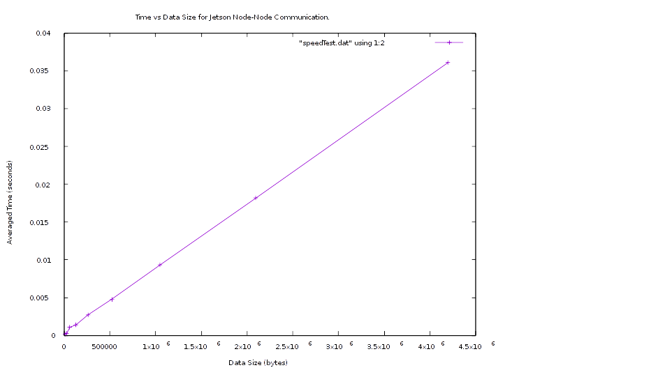
We can see from the graph that there is a very nice, linear correlation between data size and communication time. Now we process this into our startup and data timings.

Solving for Tdata/Tstartup

I've misplaced my HP50g, so we'll be solving the linear regression with gnuplot rather than the calculator's statistics tool:
gnuplot> f(x) = m * x + b
gnuplot> fit f(x) 'speedTest.dat' via m,b
iter chisq delta/lim lambda m b
0 6.0082755672e+00 0.00e+00 8.11e-01 -3.482901e-07 9.999950e-01
1 2.4368647474e-01 -2.37e+06 8.11e-02 -1.073562e-07 1.688629e-01
2 3.7641223323e-06 -6.47e+09 8.11e-03 8.073747e-09 8.352404e-04
3 2.3583708951e-07 -1.50e+06 8.11e-04 8.539047e-09 2.795394e-04
4 2.3583708413e-07 -2.28e-03 8.11e-05 8.539065e-09 2.795183e-04
iter chisq delta/lim lambda m b

After 4 iterations the fit converged.
final sum of squares of residuals : 2.35837e-07
rel. change during last iteration : -2.28345e-08

degrees of freedom (FIT_NDF) : 7
rms of residuals (FIT_STDFIT) = sqrt(WSSR/ndf) : 0.000183551
variance of residuals (reduced chisquare) = WSSR/ndf : 3.3691e-08

Final set of parameters Asymptotic Standard Error
======================= ==========================
m = 8.53907e-09 +/- 4.637e-11 (0.5431%)
b = 0.000279518 +/- 7.486e-05 (26.78%)

correlation matrix of the fit parameters:
m b
m 1.000
b -0.576 1.000
gnuplot> plot 'speedTest.dat' using 1:2 with points, f(x) title 'Linear Fit'

Result:
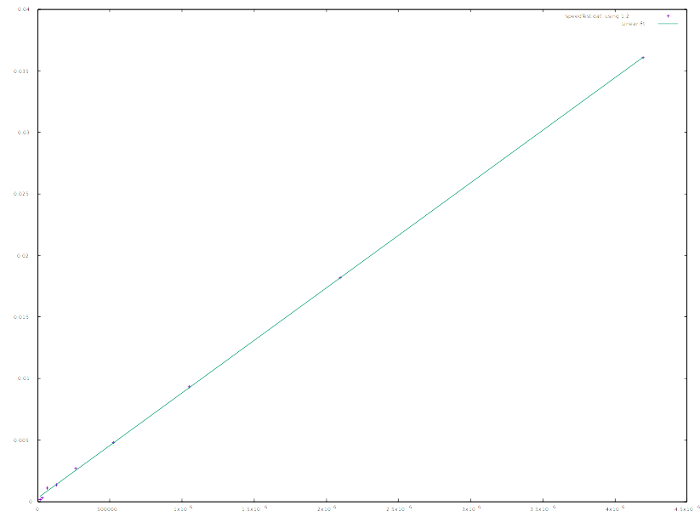
Awesome, now we just have to look at our y-intercept for the Time-transfer value. Should be 0.000279518 seconds. The slope, m, then corresponds to the increase in time per byte, 8.53907e-09 seconds.

To restate:
Tstartup = 0.000279518 seconds
Tdata = 8.53907e-09 seconds

