Christopher Bero
CPE 412
Parallel Project

Parallel Seam Carving Qt Implementation

Original Project Proposal
This project's initial proposal involved parallel dictionary attacks against low-entropy openPGP passphrases. However the C libraries that were implemented either were beyond my ability to implement them or non thread safe.

This Project Proposal
Content aware resizing – Seam Carving – is a tool to change an image's aspect ratio while preserving the appearance of important or high energy regions. It entails a list of steps to generate image brightness and energy maps which then are used to determine which seam of pixels in an image are least visually costly to remove. This project is an attempt at a parallel implementation along with a general investigation into using the parallel programming tools we learned in class with Qt datatypes.

Parallelization Approach
The first step to this Qt based seam carving application is a quick go/no-go check that OpenMP and pThreads do work with Qt applications using Qt datatypes, something I was generally unsure of. In the case that one or both did not work, I intended to switch to a console application approach which would accept an image path as input and write back a modified image file rather than displaying it.

Once the validity of Qt was determined, the parallelization approach to seam carving needed to be considered. I viewed seam carving as a similar item to the first matrix-matrix class homework: several 2D arrays which needed to be processed to produce a final 2D output. I decided to work with OpenMP and pThreads, as MPI seemed ill suited to an application running on a single machine. At this stage I was unaware that we would be implementing the matrix homework in OpenMP and pThreads during the semester, and believed that using these two parallelization techniques would also be breaking new ground for myself as a student.

To generate a parallel algorithm to seam carving with the two chosen methods, I (naively) intended to apply our method from the first homework; first write a serial implementation, and then parallelize by determining where data computation performance would benefit from multiple threads.

Qualitative Tests - Serial
The first image is entitled Armour-clad and is copyright 2015 BogdanBoev.

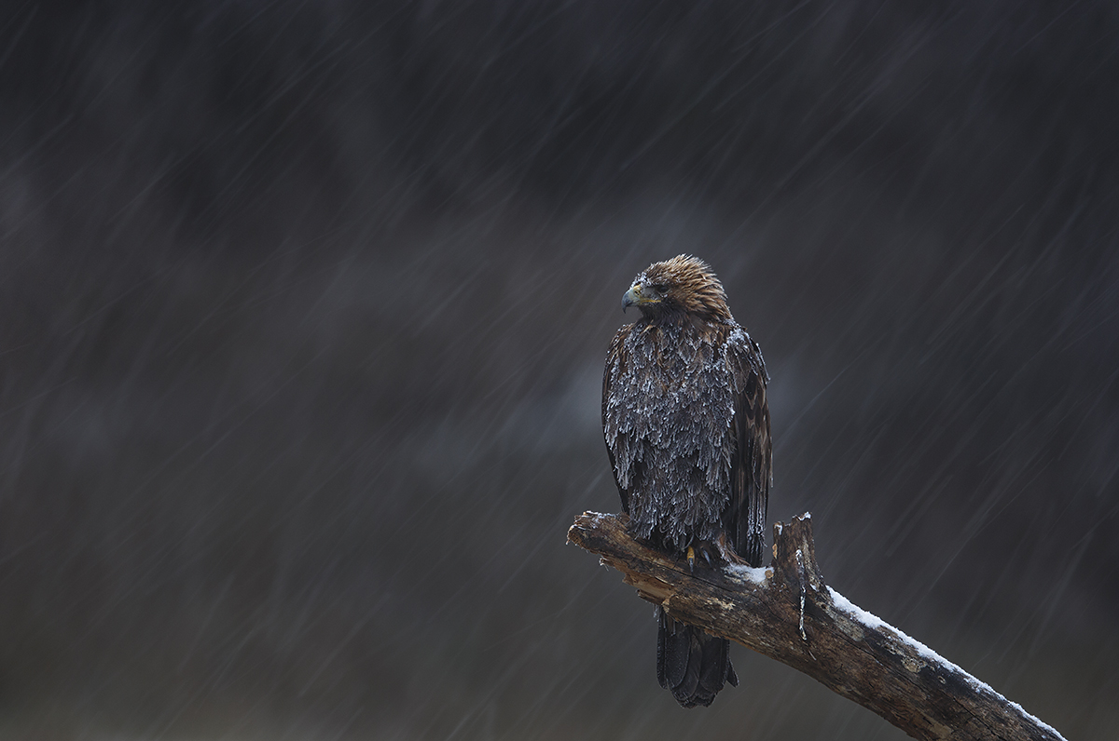Illustration 1: Original Image [1200 x 796]
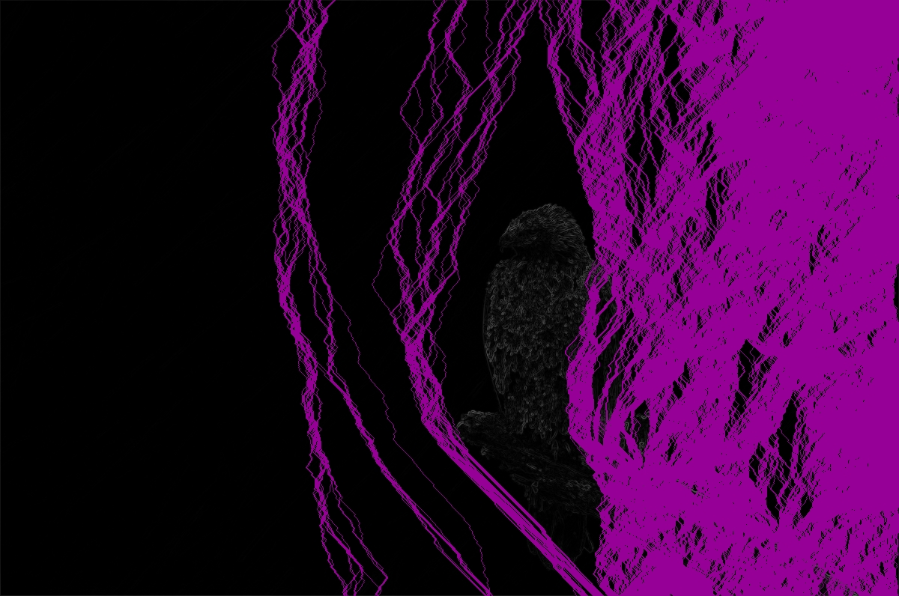Illustration 2: Pixel Energy and Seams [1200 x 796]

It is important to keep in mind that this serial implementation is broken in order to make conversion to parallel tasks possible; the seam carving algorithms developed by Shai Avidan and Ariel Shamir included protections against previously removed seams opening up vulnerabilities in higher-energy paths.
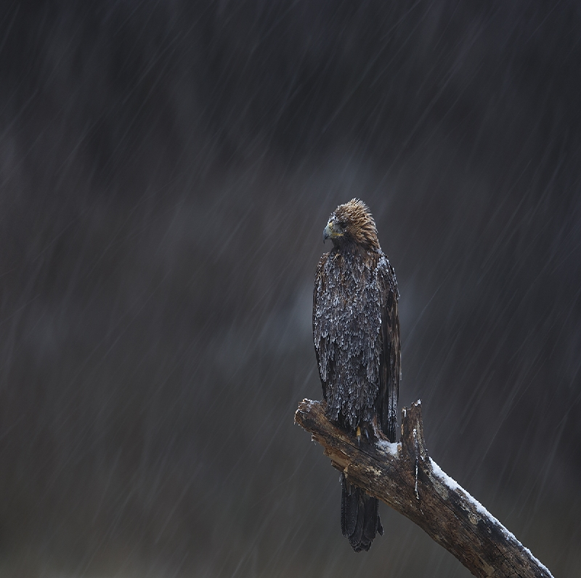Illustration 3: Native Resize [800 x 796]
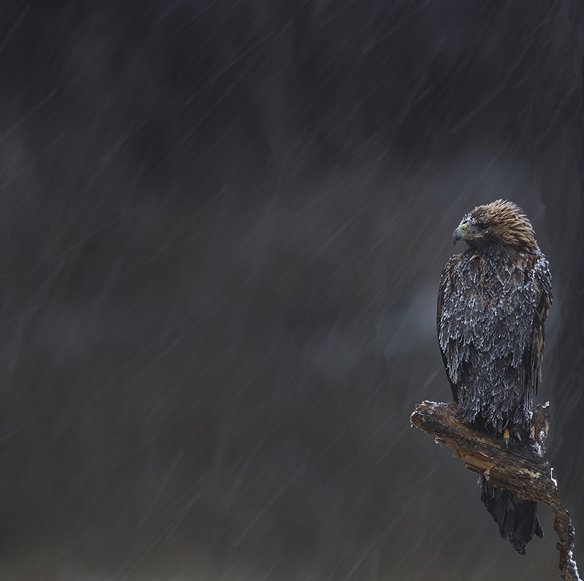Illustration 4: Serial Seam Carve [800 x 796]
Here our high-energy subject is fairly well preserved in the carved image despite some lost mass to the righthand side.

Qualitative Tests - Serial
The second image is entitled Victory of The Fates and is copyright 2015 WayneBenedet.

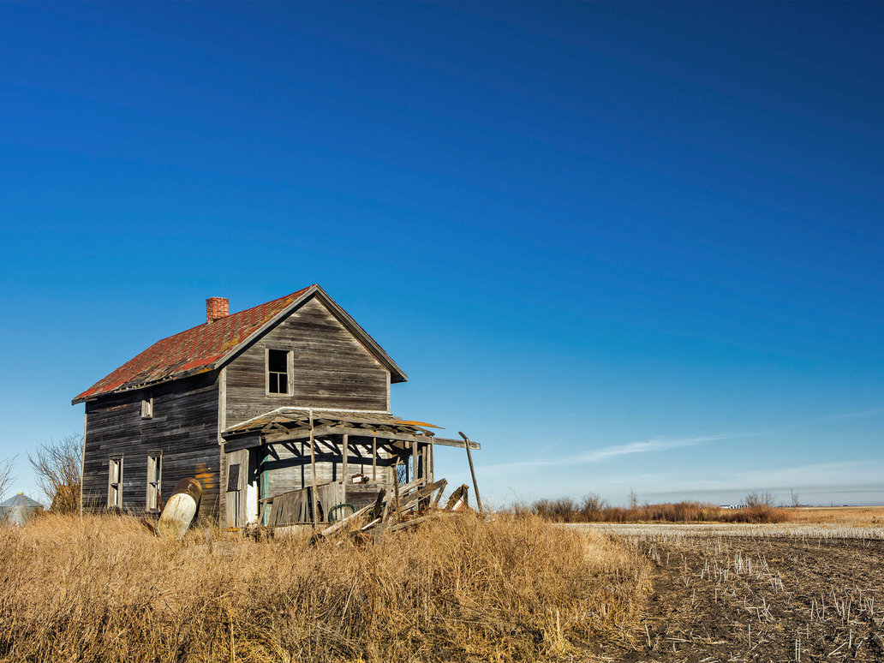Illustration 5: Original Image [1032 x 774]
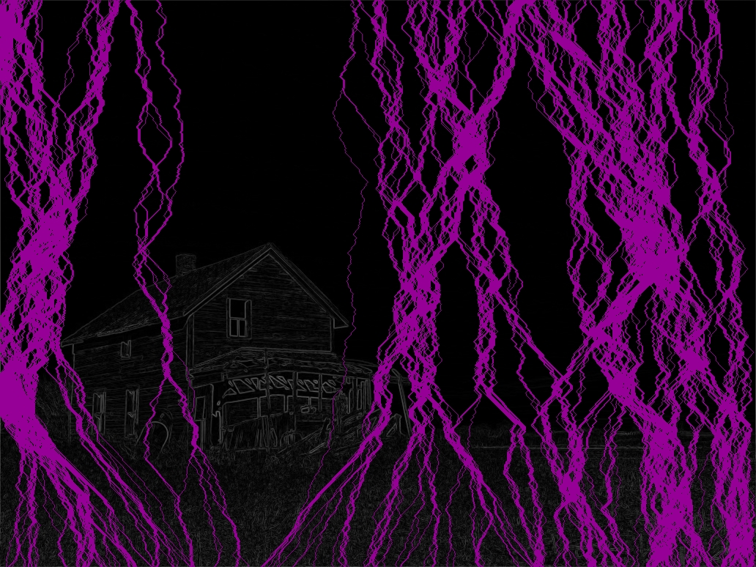Illustration 6: Pixel Energy and Seams [1032 x 774]

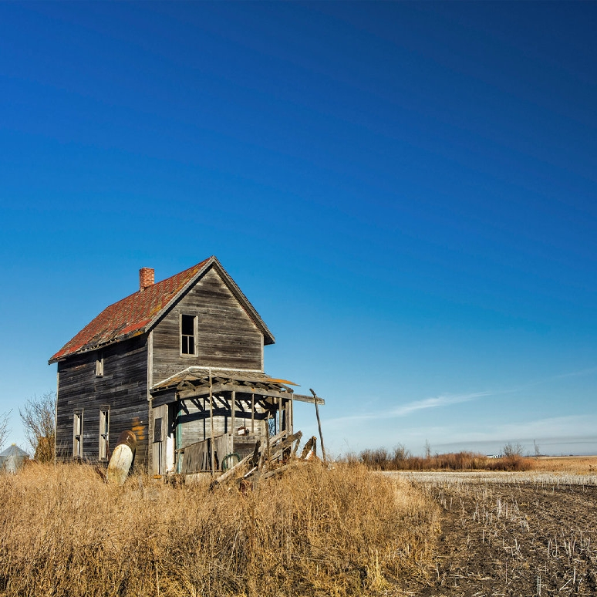Illustration 7: Native Resize [774 x 774]
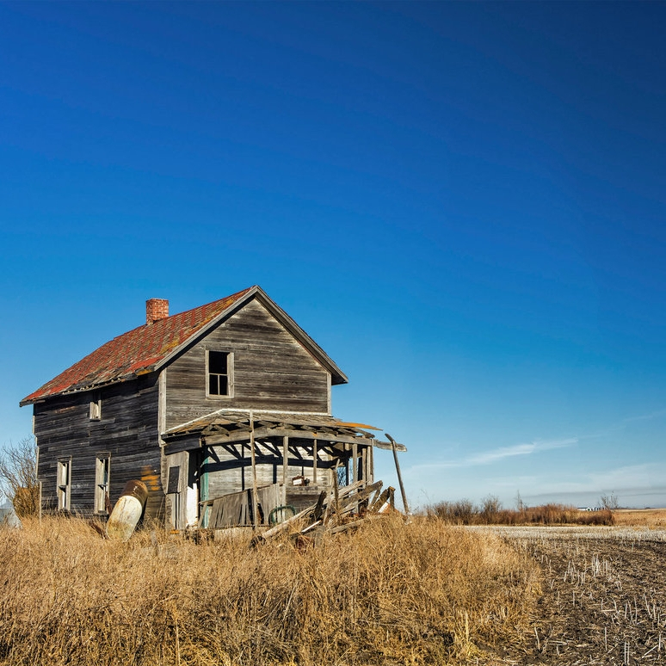Illustration 8: Serial Seam Carve [774 x 774]
Here our image processing provides less ground against the simple resizing. The subject is fighting very high energy grass textures to the right, and at some points loses mass.

Qualitative Tests - OpenMP
The first image is entitled Armour-clad and is copyright 2015 BogdanBoev.

Illustration 9: Original Image [1200 x 796]
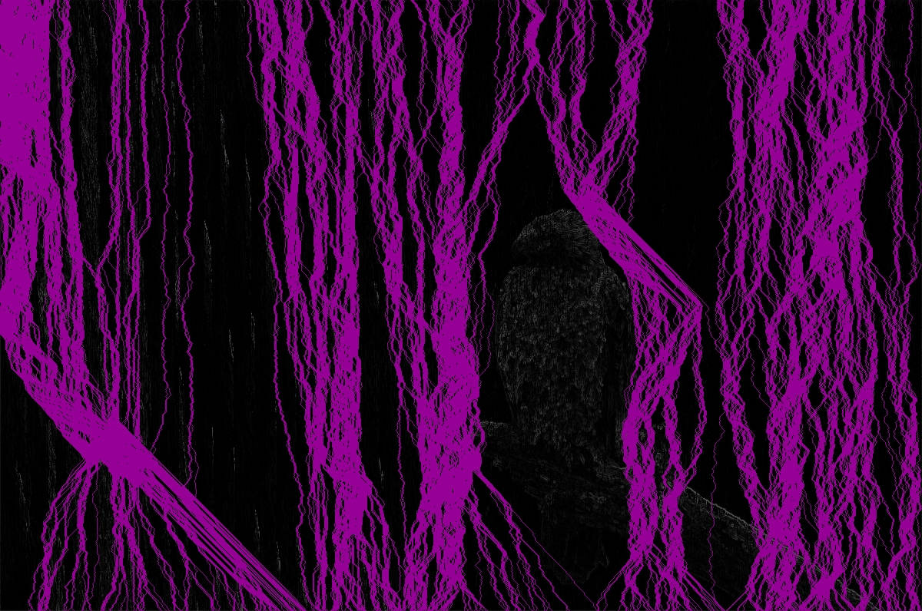Illustration 10: Pixel Energy and Seams [1200 x 796]

Illustration 11: Native Resize [800 x 796]
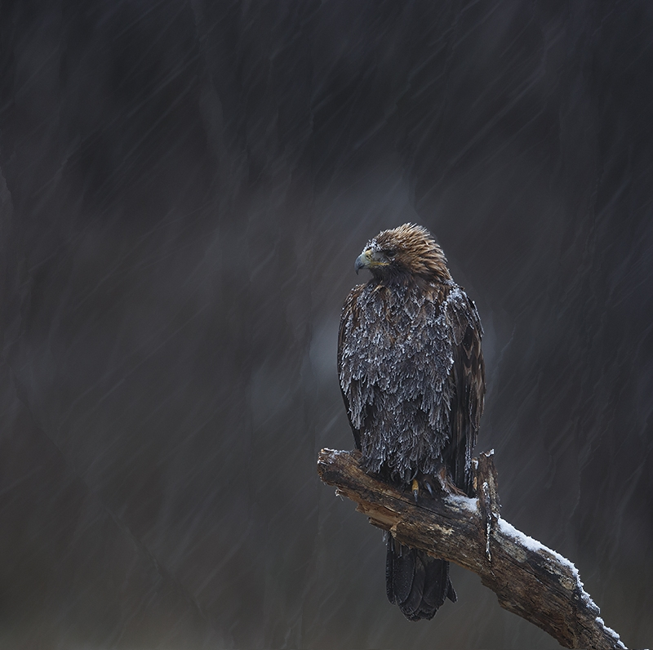Illustration 12: OMP Seam Carve [800 x 796]
Here our subject is surprisingly well preserved. By forcing the system to alternate sections in which seams are started, fewer clusters are generated from stale path data after a seam is removed.

Qualitative Tests - OpenMP
The second image is entitled Victory of The Fates and is copyright 2015 WayneBenedet.

Illustration 13: Original Image [1032 x 774]
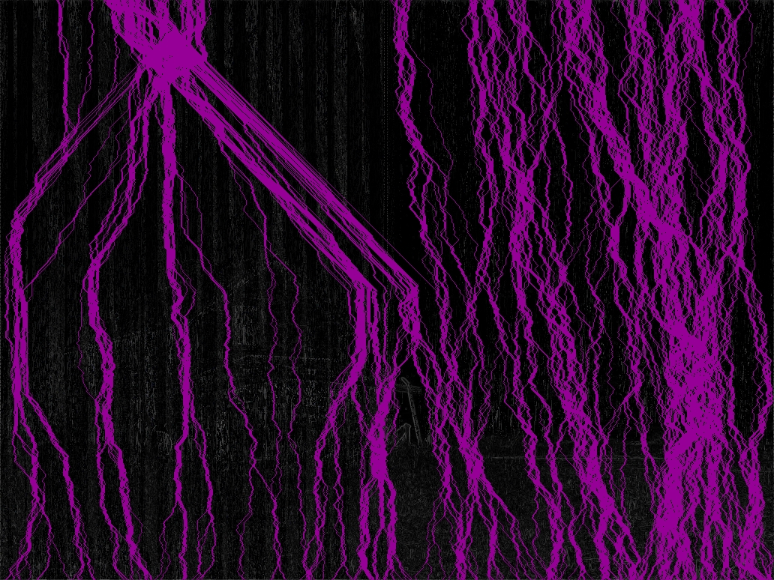Illustration 14: Pixel Energy and Seams [1032 x 774]

Illustration 15: Native Resize [774 x 774]
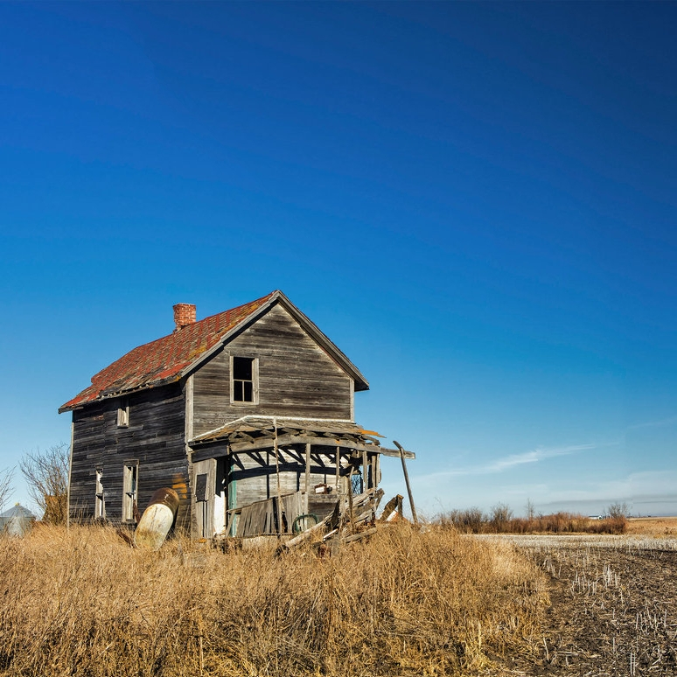Illustration 16: OMP Seam Carve [774 x 774]
Again, the OpenMP implementation very evenly partitions the image, although we still lose mass from the image subject. Even so, the result compares nicely against simple resizing.
Qualitative Tests - pThreads
The first image is entitled Armour-clad and is copyright 2015 BogdanBoev.

Illustration 17: Original Image [1200 x 796]
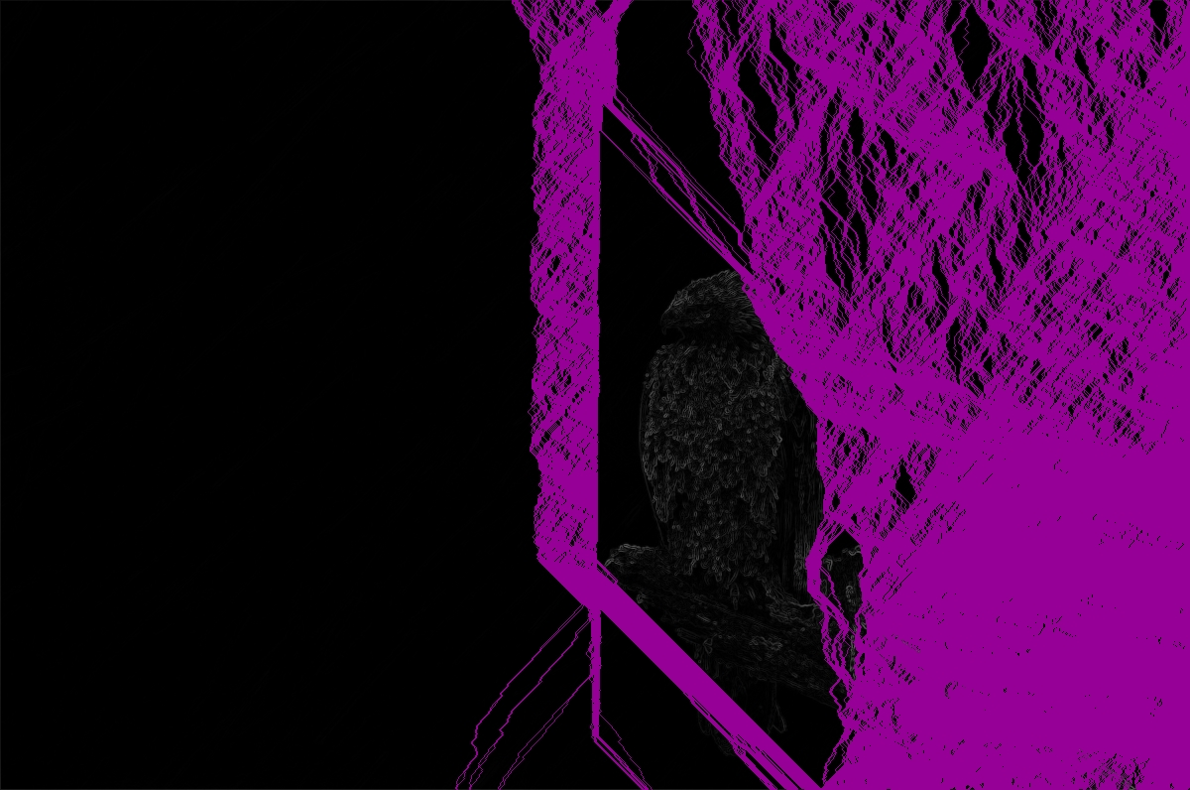Illustration 18: Pixel Energy & Seams [1200x796]

Illustration 19: Native Resize [800 x 796]
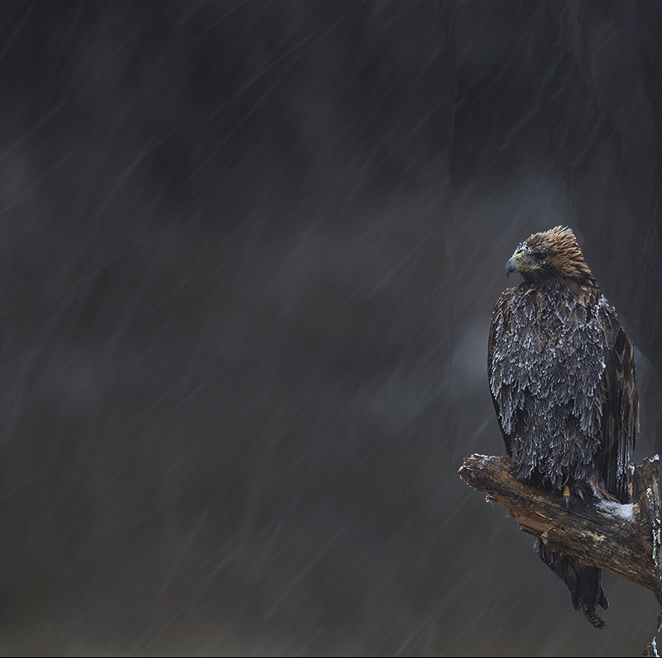Illustration 20: pThreads Seam Carve [800x796]
Here the subject once again loses mass during carving, and our energy image conveyed similar seam paths as the serial implementation.
Qualitative Tests - pThreads
The second image is entitled Victory of The Fates and is copyright 2015 WayneBenedet.

Illustration 21: Original Image [1032 x 774]
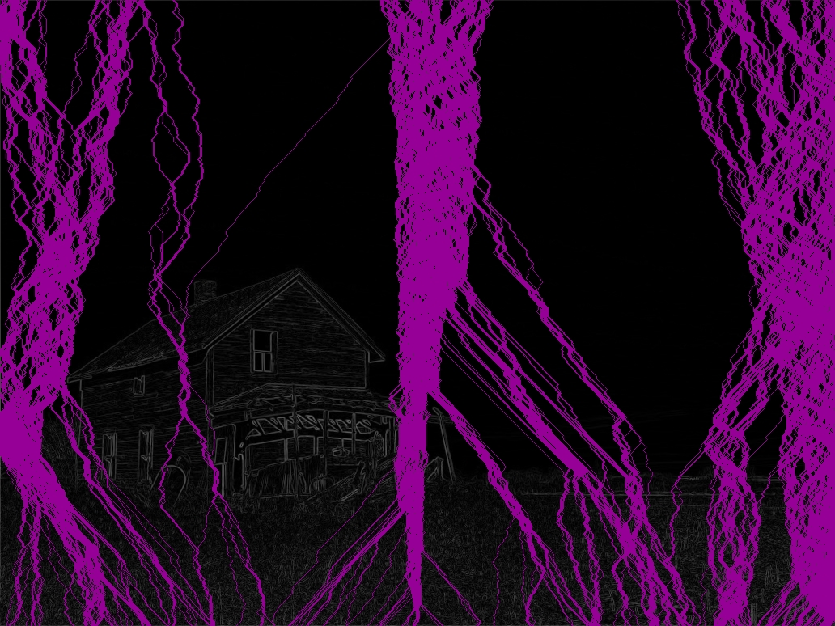Illustration 22: Pixel Energy and Seams [1032 x 774]

Illustration 23: Native Resize [774 x 774]
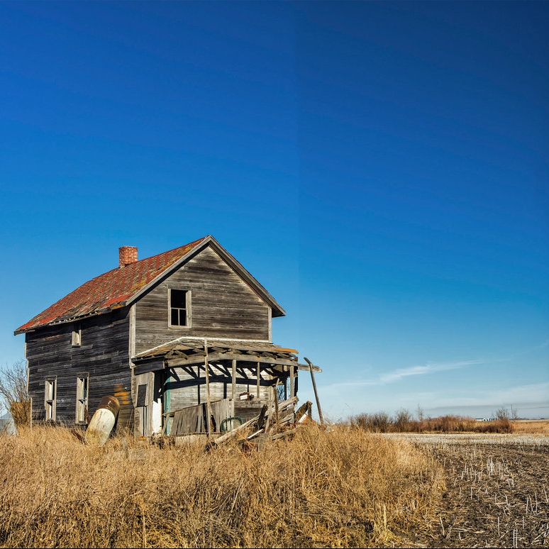Illustration 24: Serial Seam Carve [774 x 774]
Here our image appears more broken than either the serial or OMP results, as the sky has been sliced by a clump of seams.
Performance Results
This program was tested on a Lenovo Thinkpad laptop with an Intel Core2 CPU @2.40GHz, which may not reflect the majority of its manufacturing line performance-wise as it runs Libreboot firmware and does not have microcode updates.

Execution Time
Execution time is measured against each of the two sample images twice, averaged, and then averaged between the two images.

Image1 – 200 seams
Serial: 1406 ms
Serial: 1399 ms
[2t]OpenMP: 871 ms
[2t]OpenMP: 868 ms
[2t]pThreads: 1115 ms
[2t]pThreads: 1147 ms

Image1 – 400 seams
Serial: 1535 ms
Serial: 1511 ms
[2t]OpenMP: 1023 ms
[2t]OpenMP: 945 ms
[2t]pThreads: 1090 ms
[2t]pThreads: 1124 ms

Image2 – 200 seams
Serial: 1178 ms
Serial: 1179 ms
[2t]OpenMP: 747 ms
[2t]OpenMP: 755 ms
[2t]pThreads: 897 ms
[2t]pThreads: 862 ms

Image2 – 400 seams
Serial: 1279 ms
Serial: 1279 ms
[2t]OpenMP: 797 ms
[2t]OpenMP: 802 ms
[2t]pThreads: 955 ms
[2t]pThreads: 916 ms

Average – 200 seams
Serial: 1290.5 ms
OpenMP: 810.2 ms
pThreads: 1005.2 ms

Average – 400 seams
Serial: 1401 ms
OpenMP: 891.7 ms
pThreads: 1021.2 ms

Speedup

Averaged – 200 seams
Serial: 1.0
OpenMP: 1.59
pThreads: 1.28

Averaged – 400 seams
Serial: 1.0
OpenMP: 1.57
pThreads: 1.37

Averaged – total
Serial: 1.0
OpenMP: 1.58
pThreads: 1.32

Cost and efficiency are not factored metrics here because we are working with direct image manipulation on single-user, single-processor (multi-core) systems. Here I assume any user would prefer fast execution using all available resources.

Conclusion
At the end of this semester, there is very little I would do the same were I to repeat this project. Content aware resizing does not lend itself to parallelization as I had supposed, and it is in fact very difficult to both parallelize and then do so with speedup.

Working with OpenMP and pThreads in a Qt project was pleasantly surprising, and I would rather have spent more time on analyzing locality in parallel tasks with Qt datatypes. With the general ease of implementation of these two parallel methods, I am confident that they will find their way into future Qt projects of mine.

I am not clued into the research world, but I believe there is territory here for better seam carving parallel implementations, both in energy functions and path generation. This project code was written to be pedantic and easy to follow so that I could return to it as the class progressed. This is ill suited for parallel performance, and an initial improvement would be to condense and write for performance and locality. Next in line would be to review methods of regenerating energy values in some form of continuously updated matrix such that as each thread operates to generate paths, they don't choose stale energy values as starting points (the cause of many of the clumps of seams).

Despite my poor choice in application, this project was a great aide in understanding OpenMP and pThreads during their discussions in class, and I am excited to see concepts from previous courses (CPE353 - Qt) and current ones come together.

Appendix

Source code is provided here, but the entire project is available online in a more readily compiled format.
https://github.com/ctag/uah/tree/master/cpe412/project/seamCarver

mainwindow.h
#ifndef MAINWINDOW_H
#define MAINWINDOW_H
#include <math.h>
#include <stdlib.h>
#include <omp.h>
#include <pthread.h>
#include <QMainWindow>
#include <QImage>
#include <QtDebug>
#include <QGraphicsView>
#include <QGraphicsScene>
#include <QPixmap>
#include <QGraphicsPixmapItem>
#include <QColor>
#include <QVector>
#include <QElapsedTimer>
#include <QFileDialog>
#include <QApplication>
namespace Ui {
class MainWindow;
}
class MainWindow : public QMainWindow
{
Q_OBJECT
public:
explicit MainWindow(QWidget *parent = 0);
~MainWindow();
int getBrightness(int x, int y);
void setBrightness(int x, int y, int value);
int getEnergy(int x, int y);
void setEnergy(int x, int y, int value);
int getPath(int x, int y);
int getLowestPathIndex(int startX, int endX);
int getNearestLateral(int x, int y);
void setMask(int x, int y, bool value);
bool getMask(int x, int y);
void setPath(int x, int y, int value);
void serialGenEnergy();
void serialGenBrightness();
void serialGenPath();
void serialGenMask();
void serialGenMod();
void ompGenEnergy();
void ompGenBrightness();
void ompGenPath();
void ompGenMask();
void ompGenMod();
static void * pthreadBootstrap(void * arg);
void *pthreadManager();
void pthreadGenEnergy(int rank);
void pthreadGenBrightness(int rank);
void pthreadGenPath(int rank);
void pthreadGenMask(int rank);
void pthreadGenMod(int rank);
void setParallel(const QString method);
public slots:
void doLoadImage();
void doProcResize();
void doHandleRadioSerial();
void doHandleRadioOmp();
void doHandleRadioPthreads();
private:
Ui::MainWindow *ui;
QElapsedTimer timer;
QString imagePath;
int origWidth;
int origHeigth;
int modWidth;
int threadCount;
int threadRankAssign;
long thread;
pthread_t * thread_handles;
pthread_mutex_t mutex;
pthread_barrier_t barrier;
QImage * origImage;
QPixmap * origPix;
QGraphicsScene * origScene;
QImage * resizeImage;
QPixmap * resizePix;
QGraphicsScene * resizeScene;
QImage * energyImage;
QPixmap * energyPix;
QGraphicsScene * energyScene;
QImage * modImage;
QPixmap * modPix;
QGraphicsScene * modScene;
QVector<int> brightnessGrid;
QVector<int> energyGrid;
QVector<int> pathGrid;
QVector<bool> maskGrid;
};
#endif // MAINWINDOW_H
mainwindow.cpp
#include "mainwindow.h"
#include "ui_mainwindow.h"
MainWindow::MainWindow(QWidget *parent) :
QMainWindow(parent),
ui(new Ui::MainWindow)
{
ui->setupUi(this);
// Allocate images and scenes
// QImage is used to manipulate image data
// QPixmap is used to load that image data into a scene
// QGraphicsScene is used to display the image on the UI
origImage = new QImage();
origPix = new QPixmap();
origScene = new QGraphicsScene(this);
resizeImage = new QImage();
resizePix = new QPixmap();
resizeScene = new QGraphicsScene(this);
energyImage = new QImage();
energyPix = new QPixmap();
energyScene = new QGraphicsScene(this);
modImage = new QImage();
modPix = new QPixmap();
modScene = new QGraphicsScene(this);
// Connect the QGraphicsScene variables to the UI
ui->graphicsView_orig->setScene(origScene);
ui->graphicsView_resize->setScene(resizeScene);
ui->graphicsView_energy->setScene(energyScene);
ui->graphicsView_mod->setScene(modScene);
// Set up UI signals->slots
connect(ui->pushButton_imageSelect, SIGNAL(clicked()), this, SLOT(doLoadImage()));
connect(ui->pushButton_doResize, SIGNAL(clicked()), this, SLOT(doProcResize()));
connect(ui->radioButton_algSerial, SIGNAL(clicked()), this, SLOT(doHandleRadioSerial()));
connect(ui->radioButton_algOmp, SIGNAL(clicked()), this, SLOT(doHandleRadioOmp()));
connect(ui->radioButton_algPthreads, SIGNAL(clicked()), this, SLOT(doHandleRadioPthreads()));
// Set initial UI state
ui->radioButton_algSerial->setChecked(1);
ui->radioButton_algOmp->setChecked(0);
ui->radioButton_algPthreads->setChecked(0);
ui->pushButton_doResize->setEnabled(0);
}
MainWindow::~MainWindow()
{
delete ui;
}
// Slot which captures the load image pushbutton
void MainWindow::doLoadImage()
{
// Display file selection window
imagePath = QFileDialog::getOpenFileName(this, tr("Open File"), "", tr("JPEG (*.jpg *.jpeg);; PNG (*.png)"));
// Load image into QImage variable and extract dimensions
origImage->load(imagePath);
origWidth = origImage->width();
origHeigth = origImage->height();
// Update UI
ui->label_imagePath->clear();
ui->label_imagePath->setText(imagePath + " [" + QString::number(origWidth) + "x" + QString::number(origHeigth) + "]");
ui->spinBox_x->setMaximum(origWidth);
ui->spinBox_x->setValue(origWidth);
ui->spinBox_y->setValue(origHeigth);
// Load new image in UI panel
*origPix = QPixmap::fromImage(*origImage);
origScene->clear();
origScene->addPixmap(*origPix);
origScene->setSceneRect(origPix->rect());
ui->graphicsView_orig->show();
// Enable the resize button
ui->pushButton_doResize->setEnabled(1);
}
// Slot which captures the resize pushbutton
void MainWindow::doProcResize()
{
// Indicate processing start
ui->pushButton_doResize->setEnabled(0);
ui->pushButton_doResize->setText("Processing...");
qApp->processEvents(); // Force ui update
modWidth = ui->spinBox_x->value();
// Resize image without seam carving
//free(resizeImage);
*resizeImage = origImage->scaled(modWidth, origHeigth, Qt::IgnoreAspectRatio);
*resizePix = QPixmap::fromImage(*resizeImage);
resizeScene->clear();
resizeScene->addPixmap(*resizePix);
resizeScene->setSceneRect(resizePix->rect());
ui->graphicsView_resize->show();
if (ui->radioButton_algSerial->isChecked()) // Serial processing
{
// Start timer
ui->textBrowser_console->append("\n--\nStarting serial processing.");
timer.start();
// Run the hurdles
serialGenBrightness();
serialGenEnergy();
serialGenPath();
serialGenMask();
serialGenMod();
// Output total time spent (plus preemption apparently)
ui->textBrowser_console->append("Finished processing at: " +
QString::number(timer.nsecsElapsed()) + "ns." +
" (" + QString::number(timer.nsecsElapsed()/1000000) + " ms)");
//qDebug() << "Took: " << timer.nsecsElapsed() << " nsecs.";
}
else if (ui->radioButton_algOmp->isChecked()) // OMP processing
{
// Get number of threads
threadCount = ui->spinBox_threads->value();
// Start timer
ui->textBrowser_console->append("\n--\nStarting OMP processing.");
timer.start();
// Run the hurdles
ompGenBrightness();
ompGenEnergy();
ompGenPath();
ompGenMask();
ompGenMod();
// Output total time spent (plus preemption apparently)
ui->textBrowser_console->append("Finished processing at: " +
QString::number(timer.nsecsElapsed()) + "ns. (" +
QString::number(timer.nsecsElapsed()/1000000) + " ms)");
}
else if (ui->radioButton_algPthreads->isChecked()) // pThreads processing
{
// Get number of threads
threadCount = ui->spinBox_threads->value();
// Start timer
ui->textBrowser_console->append("\n--\nStarting [" + QString::number(threadCount) + "] pThread processing.");
timer.start();
// Set up for threads
thread_handles = (pthread_t*)malloc(threadCount * sizeof(pthread_t));
threadRankAssign = 0;
if (pthread_mutex_init(&mutex, NULL))
{
qDebug() << "Error in pthread mutex init.";
}
if (pthread_barrier_init(&barrier, NULL, threadCount))
{
qDebug() << "Error in pthread barrier creation.";
}
// Run the hurdles
for (thread = 0; thread < threadCount; thread++)
{
if (pthread_create(&thread_handles[thread], NULL, &MainWindow::pthreadBootstrap, this))
{
qDebug() << "Error creating pthreads.";
}
}
for (thread = 0; thread < threadCount; thread++)
{
if (pthread_join(thread_handles[thread], NULL))
{
qDebug() << "Error joining pthreads.";
}
}
// Clean up for threads
free(thread_handles);
// Output total time spent (plus preemption apparently)
ui->textBrowser_console->append("Finished processing at: " +
QString::number(timer.nsecsElapsed()) + "ns. (" +
QString::number(timer.nsecsElapsed()/1000000) + " ms)");
}
*energyPix = QPixmap::fromImage(*energyImage);
energyScene->clear();
energyScene->addPixmap(*energyPix);
energyScene->setSceneRect(energyPix->rect());
ui->graphicsView_energy->show();
*modPix = QPixmap::fromImage(*modImage);
modScene->clear();
modScene->addPixmap(*modPix);
modScene->setSceneRect(modPix->rect());
ui->graphicsView_mod->show();
// Save modified files to disk
resizeImage->save((imagePath+"-resize.jpg"), 0, 100);
energyImage->save((imagePath+"-energy.jpg"), 0, 100);
modImage->save((imagePath+"-mod.jpg"), 0, 100);
// Indicate processing end
ui->pushButton_doResize->setEnabled(1);
ui->pushButton_doResize->setText("Process Resize");
}
void MainWindow::doHandleRadioSerial()
{
if (ui->radioButton_algSerial->isChecked())
{
ui->radioButton_algOmp->setChecked(0);
ui->radioButton_algPthreads->setChecked(0);
}
}
void MainWindow::doHandleRadioOmp()
{
if (ui->radioButton_algOmp->isChecked())
{
ui->radioButton_algSerial->setChecked(0);
ui->radioButton_algPthreads->setChecked(0);
}
}
void MainWindow::doHandleRadioPthreads()
{
if (ui->radioButton_algPthreads->isChecked())
{
ui->radioButton_algOmp->setChecked(0);
ui->radioButton_algSerial->setChecked(0);
}
}
int MainWindow::getBrightness(int x, int y)
{
// Variables
int index;
// Check for out-of-bounds
if (x < 0 || x >= origWidth || y < 0 || y >= origHeigth)
{
return 0;
}
// Calculate the index
index = (x*origHeigth)+y;
// Check for erroneous index
if (index >= brightnessGrid.count())
{
qDebug() << "get: index out of range for brightness!";
qDebug() << "Last indecies: " << x << ", " << y << ". Index: " << index;
qDebug() << "Size of brightness: " << brightnessGrid.count();
exit(-1);
}
// Return brightness from actual pixel
return (brightnessGrid[index]);
}
void MainWindow::setBrightness(int x, int y, int value)
{
// Variables
int index;
// Check for out-of-bounds
if (x < 0 || x > origWidth || y < 0 || y > origHeigth)
{
qDebug() << "Tried to set bad x/y value for brightness!";
exit(-1);
}
// Calculate the index
index = (x*origHeigth)+y;
// Check for erroneous index
if (index >= brightnessGrid.count())
{
qDebug() << "set: index out of range for brightness!";
exit(-1);
}
// Return brightness from actual pixel
brightnessGrid[index] = value;
}
int MainWindow::getEnergy(int x, int y)
{
// Variables
int index;
// Check for out-of-bounds
if (x < 0 || x >= origWidth || y < 0 || y >= origHeigth)
{
return 0;
}
// Calculate the index
index = (x*origHeigth)+y;
// Check for erroneous index
if (index >= energyGrid.count())
{
qDebug() << "get: index out of range for energyGrid!";
qDebug() << "Last indecies: " << x << ", " << y << ". Index: " << index;
qDebug() << "Size of brightness: " << energyGrid.count();
exit(-1);
}
// Return brightness from actual pixel
return (energyGrid[index]);
}
void MainWindow::setEnergy(int x, int y, int value)
{
// Variables
int index;
// Check for out-of-bounds
if (x < 0 || x > origWidth || y < 0 || y > origHeigth)
{
qDebug() << "Tried to set bad x/y value for energyGrid!";
exit(-1);
}
// Calculate the index
index = (x*origHeigth)+y;
// Check for erroneous index
if (index >= energyGrid.count())
{
qDebug() << "set: index out of range for energyGrid!";
exit(-1);
}
// Return brightness from actual pixel
energyGrid[index] = value;
}
int MainWindow::getPath(int x, int y)
{
// Variables
int index;
// Check for out-of-bounds
if (x < 0 || x >= origWidth || y < 0 || y >= origHeigth)
{
return 0;
}
// Calculate the index
index = (x*origHeigth)+y;
// Check for erroneous index
if (index >= pathGrid.count())
{
qDebug() << "get: index out of range for pathGrid!";
qDebug() << "Last indecies: " << x << ", " << y << ". Index: " << index;
qDebug() << "Size of brightness: " << pathGrid.count();
exit(-1);
}
// Return brightness from actual pixel
return (pathGrid[index]);
}
void MainWindow::setPath(int x, int y, int value)
{
// Variables
int index;
// Check for out-of-bounds
if (x < 0 || x > origWidth || y < 0 || y > origHeigth)
{
qDebug() << "Tried to set bad x/y value for pathGrid!";
exit(-1);
}
// Calculate the index
index = (x*origHeigth)+y;
// Check for erroneous index
if (index >= pathGrid.count())
{
qDebug() << "set: index out of range for pathGrid!";
qDebug() << "Pathgrid size: " << pathGrid.count();
exit(-1);
}
// Return brightness from actual pixel
pathGrid[index] = value;
}
bool MainWindow::getMask(int x, int y)
{
// Variables
int index;
// Check for out-of-bounds
if (x < 0 || x >= origWidth || y < 0 || y >= origHeigth)
{
return 1;
}
// Calculate the index
index = (x*origHeigth)+y;
// Check for erroneous index
if (index >= maskGrid.count())
{
qDebug() << "get: index out of range for maskGrid!";
qDebug() << "Last indecies: " << x << ", " << y << ". Index: " << index;
qDebug() << "Size of brightness: " << maskGrid.count();
exit(-1);
}
// Return brightness from actual pixel
return (maskGrid[index]);
}
void MainWindow::setMask(int x, int y, bool value)
{
// Variables
int index;
// Check for out-of-bounds
if (x < 0 || x > origWidth || y < 0 || y > origHeigth)
{
qDebug() << "Tried to set bad x/y value for maskGrid!";
exit(-1);
}
// Calculate the index
index = (x*origHeigth)+y;
// Check for erroneous index
if (index >= maskGrid.count())
{
qDebug() << "set: index out of range for maskGrid!";
exit(-1);
}
// Return brightness from actual pixel
maskGrid[index] = value;
}
int MainWindow::getLowestPathIndex(int startX, int endX)
{
int x, y, low, lowIndex;
y = origHeigth-1;
low = getEnergy(startX, y);
while (getMask(startX, y))
{
startX++;
}
lowIndex = startX;
for (x = startX+1; x <= endX; x++)
{
if (low > getEnergy(x, y) && !getMask(x, y))
{
low = getEnergy(x, y);
lowIndex = x;
}
}
return(lowIndex);
}
int MainWindow::getNearestLateral(int x, int y)
{
int dist = 0;
while (1)
{
// Check left
if (!getMask(x-dist, y))
return x-dist;
// Check right
if (!getMask(x+dist, y))
return x+dist;
dist++;
}
}
void MainWindow::serialGenBrightness()
{
// Variables
int r, g, b, total;
brightnessGrid.clear();
// Instantiation
brightnessGrid.resize(origWidth * origHeigth);
// Process
for (int x = 0; x < origWidth; x++)
{
for (int y = 0; y < origHeigth; y++)
{
QColor::fromRgb(origImage->pixel(x, y)).toRgb().getRgb(&r, &g, &b);
total = (r + g + b) / 3;
setBrightness(x, y, total);
}
}
//qDebug() << "Image size: " << image->width() << " x " << image->height() << ". Count: " << (image->width() * image->height());
//qDebug() << "brightness size: " << brightness->size();
}
void MainWindow::serialGenEnergy()
{
// Variables
int energy, energyx, energyy, a, b, c, d, f, g, h, i, energyPixel;
// Instantiation
energyGrid.clear();
energyGrid.resize(origWidth * origHeigth);
if (energyImage != NULL)
{
delete energyImage;
energyImage = new QImage(origWidth, origHeigth, QImage::Format_RGB32);
}
for (int x = 0; x < origWidth; x++)
{
for (int y = 0; y < origHeigth; y++)
{
a = getBrightness(x-1, y-1);
b = getBrightness(x, y-1);
c = getBrightness(x+1, y-1);
d = getBrightness(x-1, y);
f = getBrightness(x+1, y);
g = getBrightness(x-1, y+1);
h = getBrightness(x, y+1);
i = getBrightness(x+1, y+1);
energyx = a + (2*d) + g - c - (2*f) - i;
energyy = a + (2*b) + c - g - (2*h) - i;
energy = sqrt((energyx * energyx) + (energyy * energyy));
energyPixel = abs(energy);
if (energyPixel > 255)
energyPixel = 255;
setEnergy(x, y, energy);
energyImage->setPixel(x, y, QColor::fromRgb(energyPixel, energyPixel, energyPixel).rgb());
}
}
}
void MainWindow::serialGenPath()
{
int left, middle, right, energy;
int x, y;
// Instantiation
pathGrid.clear();
pathGrid.resize(origWidth * origHeigth);
for (y = 0; y < origHeigth; y++)
{
// Handle case where left is off-image
x = 0;
middle = getPath(x, y-1);
right = getPath(x+1, y-1);
energy = getEnergy(x, y);
if (right < left && right < middle)
{
setPath(x, y, (right + energy));
}
else
{
setPath(x, y, (middle + energy));
}
// Handle common case
for (x = 1; x < origWidth-1; x++)
{
left = getPath(x-1, y-1);
middle = getPath(x, y-1);
right = getPath(x+1, y-1);
energy = getEnergy(x, y);
if (left < middle && left < right)
{
setPath(x, y, (left + energy));
}
else if (right < left && right < middle)
{
setPath(x, y, (right + energy));
}
else
{
setPath(x, y, (middle + energy));
}
}
// Handle case where x is on right side
x = origImage->width()-1;
left = getPath(x-1, y-1);
middle = getPath(x, y-1);
energy = getEnergy(x, y);
if (left < middle && left < right)
{
setPath(x, y, (left + energy));
}
else
{
setPath(x, y, (middle + energy));
}
}
// QByteArray text;
// for (int y = 0; y < 50 /*origImage->height()*/; y++)
// {
// text.clear();
// for (int x = 0; x < 5 /*origImage->width()*/; x++)
// {
// text += QByteArray::number(getPath(x,y));
// text += ',';
// text += ' ';
// }
// text += " : ";
// for (int x = 0; x < 5 /*origImage->width()*/; x++)
// {
// text += QByteArray::number(getEnergy(x,y));
// text += ',';
// text += ' ';
// }
// text += '\n';
// ui->textBrowser_console->append(text);
// }
}
void MainWindow::serialGenMask()
{
// Variables
int seamCount, y, pathX;
int left, middle, right;
// Instantiation
maskGrid.clear();
maskGrid.resize(origWidth * origHeigth);
// for (x = 0; x < origImage->width(); x++)
// {
// for (y = 0; y < origImage->height(); y++)
// {
// //
// }
// }
for (seamCount = 0; seamCount < (origWidth - modWidth); seamCount++)
{
pathX = getLowestPathIndex(0, origWidth-1);
for (y = origHeigth-1; y >0; y--)
{
setMask(pathX, y, 1);
middle = getPath(pathX, y-1);
if (pathX == 0)
{
// edge case left
right = getPath(pathX+1, y-1);
if (right < middle)
{
pathX = getNearestLateral(pathX+1, y-1);
}
else
{
pathX = getNearestLateral(pathX, y-1);
}
}
else if (pathX == origImage->width()-1)
{
// edge case right
left = getPath(pathX-1, y-1);
if (left < middle)
{
pathX = getNearestLateral(pathX-1, y-1);
}
else
{
pathX = getNearestLateral(pathX, y-1);
}
}
else
{
// common case
left = getPath(pathX-1, y-1);
right = getPath(pathX+1, y-1);
if (left < middle && left < right)
{
pathX = getNearestLateral(pathX-1, y-1);
}
else if (right < middle && right < left)
{
pathX = getNearestLateral(pathX+1, y-1);
}
else
{
pathX = getNearestLateral(pathX, y-1);
}
}
}
setMask(pathX, y, 1);
}
for (int x = 0; x < origWidth; x++)
{
for (int y = 0; y < origHeigth; y++)
{
if (getMask(x, y))
energyImage->setPixel(x, y, QColor::fromRgb(150, 0, 150).rgb());
}
}
}
void MainWindow::serialGenMod()
{
int x, modX, y;
if (modImage != NULL)
{
free(modImage);
modImage = new QImage(modWidth, origHeigth, QImage::Format_RGB32);
}
for (y = 0; y < origHeigth; y++)
{
modX = 0;
for (x = 0; x < origWidth; x++)
{
if (getMask(x, y))
{
continue;
}
if (modX >= modWidth)
qDebug() << "problem";
modImage->setPixel(modX, y, origImage->pixel(x, y));
modX++;
}
}
}
////////////////////////////////////////////////////////////////////////////////////////////////////////////
/// OMP
///////////////////////////////////////////////////////////////////////////////////////////////////////////////
void MainWindow::ompGenBrightness()
{
// Variables
int r, g, b, total;
brightnessGrid.clear();
// Instantiation
brightnessGrid.resize(origWidth * origHeigth);
// Process
#pragma omp parallel for num_threads(threadCount)
for (int x = 0; x < origWidth; x++)
{
for (int y = 0; y < origHeigth; y++)
{
QColor::fromRgb(origImage->pixel(x, y)).toRgb().getRgb(&r, &g, &b);
total = (r + g + b) / 3;
setBrightness(x, y, total);
}
}
//qDebug() << "Image size: " << image->width() << " x " << image->height() << ". Count: " << (image->width() * image->height());
//qDebug() << "brightness size: " << brightness->size();
}
void MainWindow::ompGenEnergy()
{
// Instantiation
energyGrid.clear();
energyGrid.resize(origWidth * origHeigth);
if (energyImage != NULL)
{
delete energyImage;
energyImage = new QImage(origWidth, origHeigth, QImage::Format_RGB32);
}
#pragma omp parallel for num_threads(threadCount)
for (int x = 0; x < origWidth; x++)
{
// I'm glad we went over this in class, I spent way too long wondering why values weren't right,
// when it was because each thread was sharing them.
int energy, energyx, energyy, a, b, c, d, f, g, h, i, pixelEnergy;
for (int y = 0; y < origHeigth; y++)
{
a = getBrightness(x-1, y-1);
b = getBrightness(x, y-1);
c = getBrightness(x+1, y-1);
d = getBrightness(x-1, y);
f = getBrightness(x+1, y);
g = getBrightness(x-1, y+1);
h = getBrightness(x, y+1);
i = getBrightness(x+1, y+1);
energyx = a + (2*d) + g - c - (2*f) - i;
energyy = a + (2*b) + c - g - (2*h) - i;
energy = sqrt((energyx * energyx) + (energyy * energyy));
setEnergy(x, y, energy);
pixelEnergy = abs(energy);
if (pixelEnergy > 255)
pixelEnergy = 255;
energyImage->setPixel(x, y, QColor::fromRgb(pixelEnergy, pixelEnergy, pixelEnergy).rgb());
//#pragma omp critical
//ui->textBrowser_console->append(", " + QString::number(energy));
}
}
}
void MainWindow::ompGenPath()
{
// Instantiation
pathGrid.clear();
pathGrid.resize(origWidth * origHeigth);
#pragma omp parallel for num_threads(threadCount)
for (int y = 0; y < origHeigth; y++)
{
int left, middle, right, energy;
int x;
// Handle case where left is off-image
x = 0;
middle = getPath(x, y-1);
right = getPath(x+1, y-1);
energy = getEnergy(x, y);
if (right < left && right < middle)
{
#pragma omp critical
setPath(x, y, (right + energy));
}
else
{
#pragma omp critical
setPath(x, y, (middle + energy));
}
// Handle common case
for (x = 1; x < origWidth-1; x++)
{
left = getPath(x-1, y-1);
middle = getPath(x, y-1);
right = getPath(x+1, y-1);
energy = getEnergy(x, y);
if (left < middle && left < right)
{
#pragma omp critical
setPath(x, y, (left + energy));
}
else if (right < left && right < middle)
{
#pragma omp critical
setPath(x, y, (right + energy));
}
else
{
#pragma omp critical
setPath(x, y, (middle + energy));
}
}
// Handle case where x is on right side
//x = origWidth-1;
left = getPath(x-1, y-1);
middle = getPath(x, y-1);
energy = getEnergy(x, y);
if (left < middle && left < right)
{
#pragma omp critical
setPath(x, y, (left + energy));
}
else
{
#pragma omp critical
setPath(x, y, (middle + energy));
}
}
// QByteArray text;
// for (int y = 0; y < 50 /*origImage->height()*/; y++)
// {
// text.clear();
// for (int x = 0; x < 5 /*origImage->width()*/; x++)
// {
// text += QByteArray::number(getPath(x,y));
// text += ',';
// text += ' ';
// }
// text += " : ";
// for (int x = 0; x < 5 /*origImage->width()*/; x++)
// {
// text += QByteArray::number(getEnergy(x,y));
// text += ',';
// text += ' ';
// }
// text += '\n';
// ui->textBrowser_console->append(text);
// }
}
void MainWindow::ompGenMask()
{
// Variables
// int seamCount, y, pathX;
// int left, middle, right;
// Instantiation
maskGrid.clear();
maskGrid.resize(origWidth * origHeigth);
// for (x = 0; x < origImage->width(); x++)
// {
// for (y = 0; y < origImage->height(); y++)
// {
// //
// }
// }
#pragma omp parallel for num_threads(threadCount)
for (int seamCount = 0; seamCount < (origWidth - modWidth); seamCount++)
{
int y, pathX;
int left, middle, right;
#pragma omp critical
{
pathX = getLowestPathIndex(0, origWidth-1);
setMask(pathX, (origHeigth-1), 1);
}
for (y = origHeigth-1; y > 0; y--)
{
#pragma omp critical
setMask(pathX, y, 1);
middle = getPath(pathX, y-1);
if (pathX == 0)
{
// edge case left
right = getPath(pathX+1, y-1);
if (right < middle)
{
#pragma omp critical
pathX = getNearestLateral(pathX+1, y-1);
}
else
{
#pragma omp critical
pathX = getNearestLateral(pathX, y-1);
}
}
else if (pathX == origWidth-1)
{
// edge case right
left = getPath(pathX-1, y-1);
if (left < middle)
{
#pragma omp critical
pathX = getNearestLateral(pathX-1, y-1);
}
else
{
#pragma omp critical
pathX = getNearestLateral(pathX, y-1);
}
}
else
{
// common case
left = getPath(pathX-1, y-1);
right = getPath(pathX+1, y-1);
if (left < middle && left < right)
{
#pragma omp critical
pathX = getNearestLateral(pathX-1, y-1);
}
else if (right < middle && right < left)
{
#pragma omp critical
pathX = getNearestLateral(pathX+1, y-1);
}
else
{
#pragma omp critical
pathX = getNearestLateral(pathX, y-1);
}
}
}
#pragma omp critical
setMask(pathX, y, 1);
}
#pragma omp parallel for num_threads(threadCount)
for (int x = 0; x < origWidth; x++)
{
for (int y = 0; y < origHeigth; y++)
{
if (getMask(x, y))
energyImage->setPixel(x, y, QColor::fromRgb(150, 0, 150, 150).rgb());
}
}
int counter = 0;
for (int x = 0; x < origImage->width(); x++)
{
if (getMask(x,795))
counter++;
}
ui->textBrowser_console->append("Data: "+QString::number(counter));
}
void MainWindow::ompGenMod()
{
if (modImage != NULL)
{
free(modImage);
modImage = new QImage(modWidth, origHeigth, QImage::Format_RGB32);
}
#pragma omp parallel for num_threads(threadCount)
for (int y = 0; y < origHeigth; y++)
{
int x, modX;
modX = 0;
for (x = 0; x < origWidth; x++)
{
if (getMask(x, y))
{
continue;
}
if (modX >= modWidth)
{
//qDebug() << "problem";
break;
}
modImage->setPixel(modX, y, origImage->pixel(x, y));
modX++;
}
}
}
//////////////////////////////////////////////////////////////////////////////////////////////////////////////
// PTHREAD
//////////////////////////////////////////////////////////////////////////////////////////////////////////////
void * MainWindow::pthreadBootstrap(void * arg)
{
return ((MainWindow *)arg)->pthreadManager();
}
void * MainWindow::pthreadManager()
{
// long * my_rank = (long*) rank;
int rank = 0;
int rc;
pthread_mutex_lock(&mutex);
rank = threadRankAssign;
//qDebug() << "Hello from rank " << rank;
threadRankAssign++;
pthread_mutex_unlock(&mutex);
if (rank == 0)
{
brightnessGrid.clear();
brightnessGrid.resize(origWidth * origHeigth);
energyGrid.clear();
energyGrid.resize(origWidth * origHeigth);
pathGrid.clear();
pathGrid.resize(origWidth * origHeigth);
maskGrid.clear();
maskGrid.resize(origWidth * origHeigth);
if (energyImage != NULL)
{
delete energyImage;
energyImage = new QImage(origWidth, origHeigth, QImage::Format_RGB32);
}
if (modImage != NULL)
{
free(modImage);
modImage = new QImage(modWidth, origHeigth, QImage::Format_RGB32);
}
}
rc = pthread_barrier_wait(&barrier);
if (rc != 0 && rc != PTHREAD_BARRIER_SERIAL_THREAD)
{
qDebug() << "Error: rank " << QString::number(rank) << " issue with barrier.";
}
pthreadGenBrightness(rank);
rc = pthread_barrier_wait(&barrier);
if (rc != 0 && rc != PTHREAD_BARRIER_SERIAL_THREAD)
{
qDebug() << "Error: rank " << QString::number(rank) << " issue with barrier.";
}
pthreadGenEnergy(rank);
rc = pthread_barrier_wait(&barrier);
if (rc != 0 && rc != PTHREAD_BARRIER_SERIAL_THREAD)
{
qDebug() << "Error: rank " << QString::number(rank) << " issue with barrier.";
}
pthreadGenPath(rank);
rc = pthread_barrier_wait(&barrier);
if (rc != 0 && rc != PTHREAD_BARRIER_SERIAL_THREAD)
{
qDebug() << "Error: rank " << QString::number(rank) << " issue with barrier.";
}
pthreadGenMask(rank);
rc = pthread_barrier_wait(&barrier);
if (rc != 0 && rc != PTHREAD_BARRIER_SERIAL_THREAD)
{
qDebug() << "Error: rank " << QString::number(rank) << " issue with barrier.";
}
pthreadGenMod(rank);
if (rank == 0)
{
// serialGenPath();
// serialGenMask();
// serialGenMod();
}
return(NULL);
}
void MainWindow::pthreadGenBrightness(int rank)
{
// Variables
int r, g, b, total;
int xStart, xSlice;
xSlice = (origWidth / threadCount);
xStart = (xSlice * (rank));
if (rank == (threadCount-1))
{
xSlice = origWidth-xStart;
}
// Process
for (int x = xStart; x < (xStart+xSlice); x++)
{
for (int y = 0; y < origHeigth; y++)
{
QColor::fromRgb(origImage->pixel(x, y)).toRgb().getRgb(&r, &g, &b);
total = (r + g + b) / 3;
pthread_mutex_lock(&mutex);
setBrightness(x, y, total);
pthread_mutex_unlock(&mutex);
}
}
}
void MainWindow::pthreadGenEnergy(int rank)
{
// Variables
int energy, energyx, energyy, a, b, c, d, f, g, h, i;
int xStart, xSlice;
int energyPixel;
xSlice = (origWidth / threadCount);
xStart = (xSlice * (rank));
if (rank == (threadCount-1))
{
xSlice = origWidth-xStart;
}
for (int x = xStart; x < (xStart+xSlice); x++)
{
for (int y = 0; y < origHeigth; y++)
{
a = getBrightness(x-1, y-1);
b = getBrightness(x, y-1);
c = getBrightness(x+1, y-1);
d = getBrightness(x-1, y);
f = getBrightness(x+1, y);
g = getBrightness(x-1, y+1);
h = getBrightness(x, y+1);
i = getBrightness(x+1, y+1);
energyx = a + (2*d) + g - c - (2*f) - i;
energyy = a + (2*b) + c - g - (2*h) - i;
energy = sqrt((energyx * energyx) + (energyy * energyy));
pthread_mutex_lock(&mutex);
setEnergy(x, y, energy);
energyPixel = abs(energy);
if (energyPixel > 255)
energyPixel = 255;
energyImage->setPixel(x, y, QColor::fromRgb(energyPixel, energyPixel, energyPixel).rgb());
pthread_mutex_unlock(&mutex);
}
}
}
void MainWindow::pthreadGenPath(int rank)
{
int left, middle, right, energy;
int x, y;
int xStart, xSlice;
xSlice = (origWidth / threadCount);
xStart = (xSlice * (rank));
if (rank == (threadCount-1))
{
xSlice = origWidth-xStart;
}
for (y = 0; y < origHeigth; y++)
{
for (x = xStart; x < (xStart+xSlice); x++)
{
if (x == 0) // Handle case where left is off-image
{
middle = getPath(x, y-1);
right = getPath(x+1, y-1);
energy = getEnergy(x, y);
if (right < left && right < middle)
{
setPath(x, y, (right + energy));
}
else
{
setPath(x, y, (middle + energy));
}
}
else if (x == origWidth) // Handle case where x is on right side
{
left = getPath(x-1, y-1);
middle = getPath(x, y-1);
energy = getEnergy(x, y);
if (left < middle && left < right)
{
setPath(x, y, (left + energy));
}
else
{
setPath(x, y, (middle + energy));
}
}
else
{
left = getPath(x-1, y-1);
middle = getPath(x, y-1);
right = getPath(x+1, y-1);
energy = getEnergy(x, y);
if (left < middle && left < right)
{
setPath(x, y, (left + energy));
}
else if (right < left && right < middle)
{
setPath(x, y, (right + energy));
}
else
{
setPath(x, y, (middle + energy));
}
}
}
}
// QByteArray text;
// for (int y = 0; y < 50 /*origImage->height()*/; y++)
// {
// text.clear();
// for (int x = 0; x < 5 /*origImage->width()*/; x++)
// {
// text += QByteArray::number(getPath(x,y));
// text += ',';
// text += ' ';
// }
// text += " : ";
// for (int x = 0; x < 5 /*origImage->width()*/; x++)
// {
// text += QByteArray::number(getEnergy(x,y));
// text += ',';
// text += ' ';
// }
// text += '\n';
// ui->textBrowser_console->append(text);
// }
}
void MainWindow::pthreadGenMask(int rank)
{
// Variables
int seamCount, y, pathX;
int left, middle, right;
int seamTarget;
seamTarget = (origWidth - modWidth) / threadCount;
if (rank == (threadCount-1))
{
seamTarget = (origWidth - modWidth) - (seamTarget * rank);
}
for (seamCount = 0; seamCount < seamTarget; seamCount++)
{
pthread_mutex_lock(&mutex);
pathX = getLowestPathIndex(0, origWidth-1);
setMask(pathX, y, 1);
pthread_mutex_unlock(&mutex);
for (y = origHeigth-1; y >0; y--)
{
setMask(pathX, y, 1);
middle = getPath(pathX, y-1);
if (pathX == 0)
{
// edge case left
right = getPath(pathX+1, y-1);
if (right < middle)
{
pathX = getNearestLateral(pathX+1, y-1);
}
else
{
pathX = getNearestLateral(pathX, y-1);
}
}
else if (pathX == origImage->width()-1)
{
// edge case right
left = getPath(pathX-1, y-1);
if (left < middle)
{
pathX = getNearestLateral(pathX-1, y-1);
}
else
{
pathX = getNearestLateral(pathX, y-1);
}
}
else
{
// common case
left = getPath(pathX-1, y-1);
right = getPath(pathX+1, y-1);
if (left < middle && left < right)
{
pathX = getNearestLateral(pathX-1, y-1);
}
else if (right < middle && right < left)
{
pathX = getNearestLateral(pathX+1, y-1);
}
else
{
pathX = getNearestLateral(pathX, y-1);
}
}
}
setMask(pathX, y, 1);
}
for (int x = 0; x < origWidth; x++)
{
for (int y = 0; y < origHeigth; y++)
{
if (getMask(x, y))
energyImage->setPixel(x, y, QColor::fromRgb(150, 0, 150).rgb());
}
}
}
void MainWindow::pthreadGenMod(int rank)
{
int x, modX, y;
int yStart, ySlice;
ySlice = (origHeigth / threadCount);
yStart = (ySlice * (rank));
if (rank == (threadCount-1))
{
ySlice = origHeigth-yStart-1;
}
for (y = yStart; y < (yStart+ySlice); y++)
{
modX = 0;
for (x = 0; x < origWidth; x++)
{
if (getMask(x, y))
{
continue;
}
if (modX >= modWidth)
qDebug() << "problem";
modImage->setPixel(modX, y, origImage->pixel(x, y));
modX++;
}
}
}

