Christopher Bero
CPE 434
IEEE Article

Memristor Implementation

A large topic of discussion for present day operating system and architecture courses is the state of direct nonparallel processor throughput. As computers reach a heat barrier in providing for transistor operating temperatures, so does the memory hierarchy reach similar saturation limits. Von Neumann architecture has been the basis for most computing since the concept of a personal computer was introduced, but either a new paradigm or material science breakthrough is necessary to continue forward progress in the field. New composites for transistor substrate doping and circuit materials may help further the use of current implementations, but ultimately bring about separate issues such as electron leakage via quantum tunneling and the like. Eventually new schemes in managing data storage and implementation will be required to increase throughput.

Though not explicitly stated in the EE courses I've taken, any extended period of work developing circuits or interacting with lower level electronics will bring an understanding of “fundamental components.” From the metrics used to analyze circuits: current, voltage, charge, and flux, we have discrete components which – within reason – accurately model the relationships. Resistors couple voltage and current, capacitors link voltage and charge, and inductors couple current to flux [3]. These components are so called fundamental due to their unique abilities, which means that none of them can be (straightforwardly) created by a combination of the others. In 1971 Professor Leon Chua postulated that a fourth fundamental device may yet to be discovered. This notion was based on the imbalance between forces and the existing fundamental components, a fourth component may bring balance to the set by providing a relationship between charge and flux. This is modeled by an I-V curve, a “pinched hysteresis loop.” And the hypothetical element does in fact lend itself to exhibiting hysteresis, if created the component should remember past affectors. From out reference [1], the differential form of this model should be: dϕ = Mdq. Following from this, the current-voltage relationship can be modeled by:

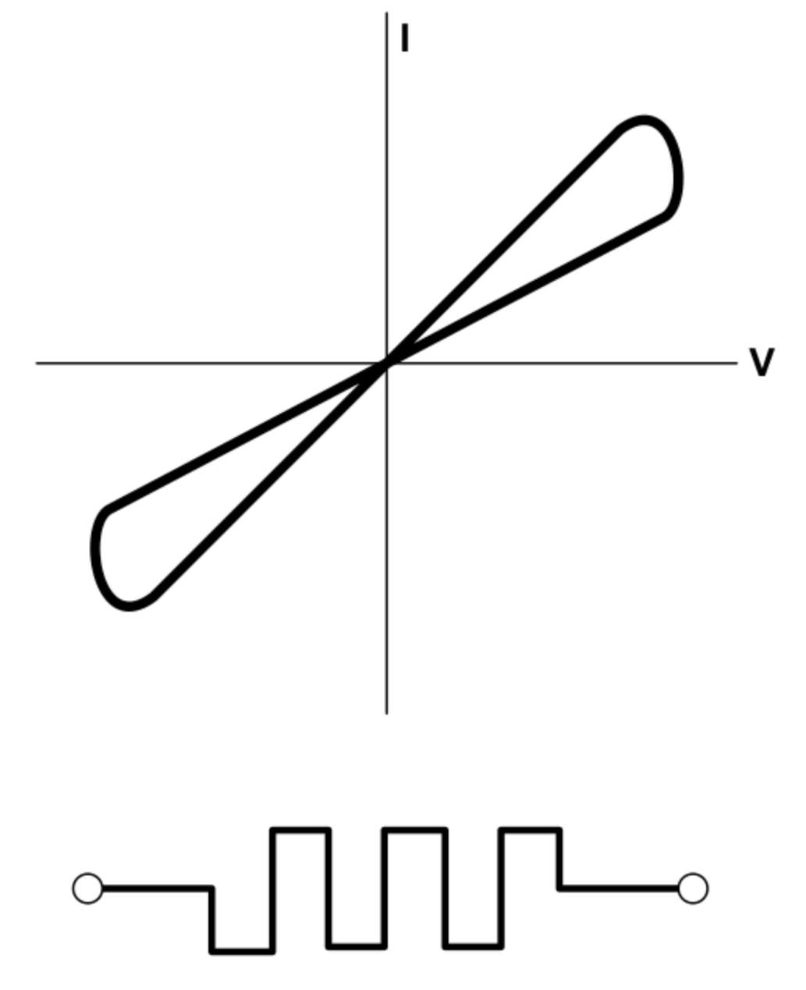Illustration 1: Memristor I/V Curve [1]

Note the “hysteresis loop,” clearly visible in the figure, as voltage is “washed” across the device (alternation of positive and negative potential) the corresponding dependent value of current allowed to pass – which matches resistance – will modulate. This phenomenon is reminiscent of core memory, a precursor to DRAM which was nonvolatile. A computer utilizing only main storage and core memory can lose power and then resume immediately when power is restored, which we will discuss further with HP's The Machine.

After the plausible component was released as a mathematical curiosity, the absence of a physical counterpart forced the concept to the background of computer sciences as the modern computer processing architectures – history as we know it – unfolded. That may have changed in 2008, when a team at HP discovered that Dr. Leon Chua's model matched odd behavior they had witnessed when pushing components limits of decreased size and power. This “real life” memristor was comprised of thin films of TiO2 – Titanium Dioxide – between Platinum electrodes, on a small enough scale voltage applied across the system would push Oxygen vacancies away, moving the boundary of doped and undoped material [1]. This has the affect of changing the operating resistance, resulting in a memristor. The team determined their memristance as:

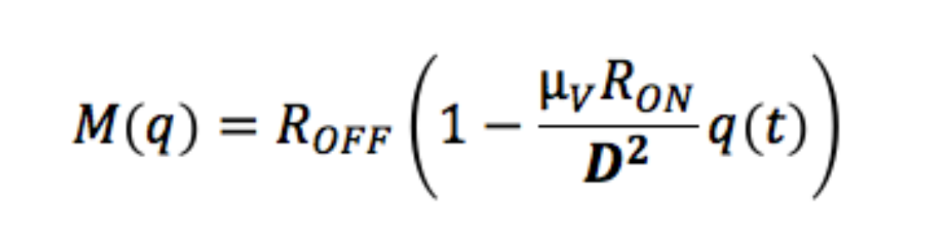
Where D equals the TiO2's film thickness. This formula provides a working overview of why memristors in this form haven't been discovered previously: as the oxide plate thickens, memristance as an affect is lost to resistance and the component ceases to operate in this manner [1]. Another utilitous feature of this memristor is that it can be arranged in an array, and each one may be individually addressed without a select transistor, which paves the way for denser and more efficient memory [1].

Several companies have since started efforts to track and implement the memristor in a variety of ways. HP is attempting to use memristors to turn over the monopoly held by Von Neumann architecture, and several research teams are investigating memristors for use in pipelining, threading, and specialized “RRAM”. Dubbed “The Machine,” HP's research efforts at high efficiency computing have launched anew since the memristor connection was discovered, and in June earlier this year the company planned to release a new Linux++ operating system which would showcase how programming might change with memristor based architecture [2]. The cardinal difference between a conventional server and The Machine involves hierarchical memory: while a conventional computer uses disks, DRAM, and CPU caches, The Machine's implementation of memristors will mean that only one form of storage will serve all purposes. This entirely eliminates the shuttling services which shepard data from slower storage to faster memory, and the performance benefit is estimated to be large with up to six times more computing power at as low as 1.25 percent the electrical draw used by current systems [2]. That's was the plan at least; in June of this year – rather than release the scheduled Linux++ – HP killed their memristor based The Machine project, and refocused efforts on other component improvements such as photonics and phase shift based memory [4]. The divergence appears to be caused by the struggle to produce memristors in any meaningful quantity at economically feasible costs. The server architecture will still be heavily directed to large scale data storage, but no longer with the aforementioned phenomenal processing and IO speeds.

Though they proved too elusive for use in HP's project, memristors still play a role in many future-prospective studies and research projects. An IEEE Computer Architecture letter entitled “Memristor-Based Multithreading” discusses the improvements upon existing pipeline and cache systems that memristor based components could bring. Switch on Event, traditional pipelining, is a well adopted method of improving performance of a single core and operates by jumping thread focus when a hiccup occurs – such as a cache miss. The IEEE article investigates a potential situation where memristors can be wielded to create Continuous Flow Multithreading, in which a set of multistate registers keep the state of many threads to remove the need for pipeline flushing in the datapath.

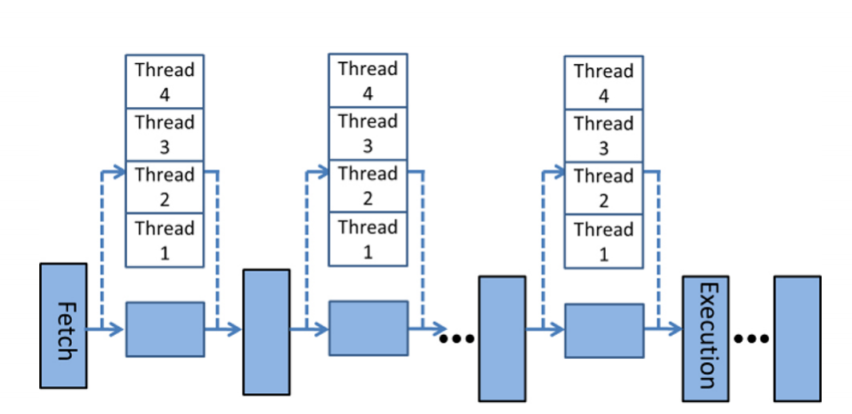Illustration 2: Memristor based Multipath Pipeline [5]
On the opposite side of the spectrum from multipath state registers for general use processing is the work on very specific cortical processors. A collaborative team from the University of Pittsburgh and Southwest University (Chongqing, China) discusses the future of machine learning for uses such as image recognition and language processing [6]. The effort takes inspiration from how well human brains operate at massively parallel tasks while closely packing memory and compute systems together. Current computers are not well adapted to this sort of system, and require immense memory and computing resources to simulate it; by merging traditional architecture with memristor based systems, these neuromorphic computations may be achieved at high scale and efficiency. As we follow their paper, the researchers begin with a crossbar array of memristors and then discuss the computational methods that it can represent.

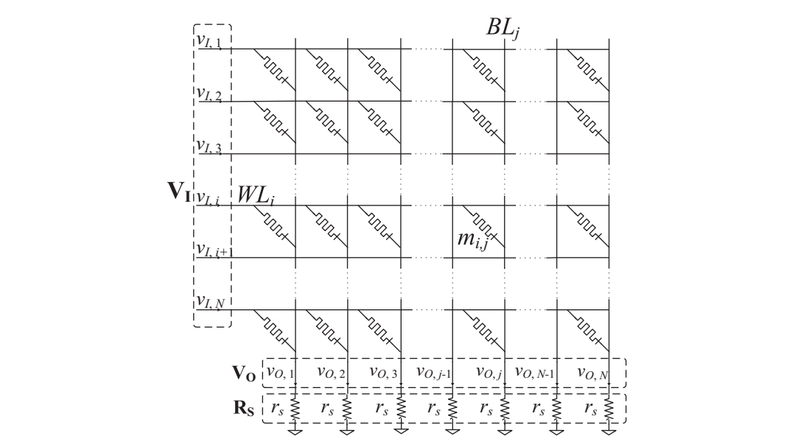Illustration 3: Memristor Crossbar Array [6]

This memristor crossbar array can be used to demonstrate matrix computation with input and output voltages in a function V_{O} = CV_{I}. This fast approximation method in which the crossbar array acts as a decayed matrix to provide our output follow the relationship C_{i,j} = c_{i,j} ·g_{max}/g_{s}. Next, a neuromorphic computing accelerator (NCA) is proposed. The NCA consists of several such crossbar arrays, with additional hardware for vector computations on the matrix output. A heterogeneous processing cluster is then investigated in which every processor is paired with an NCA. The NCA is tied into pipeline registers to detect when instructions require it, and since the memristor array's output is analog, an ADC/DAC set is used to interact with it from the processor's perspective. This configuration of combining existing and emerging architecture methods promises greater efficiency, as this model compared to x86 shows a factor of 86.8 improvement.

From this brief tour of a memristor laden future, we can see the promise and some of the struggle involved. It's truly fascinating to see memristor based mechanics emerge almost forty years after their mathematical structure was discovered. Even beyond the methods discussed here where memristance is used to bolster existing systems we can anticipate work to bring in the wildly difference approaches to computing where memristors with multiple states are the basis of – rather than the ancillary to – processor computing methods. A divergence from the binary paradigm may provide radically different capabilities in terms of both computer sciences and general personal computing.
Bibliography

[1] Bryon Moyer. (2012, January). A Memristor By Any Other Name?. Electronic Engineering Journal. Electronic.

[2] Tom Simonite. (2014, December). HP Will Release a “Revolutionary” New Operating System in 2015. MIT Technology Review. Electronic.

[3] Sally Adee. (2008, May). The Mysterious Memristor. IEEE Spectrum. Electronic.

[4] Jowl Hruska. (2015, June). HP Kills The Machine, Repurposes Design Around Conventional Technologies. ExtremeTech. Electronic.

[5] Shahar Kvatinsky, Yuval H. Nacson, Yoav Etsion, Eby G. Friedman, Avinoam Kolodny, Uri C. Weiser. (2014, January). Memristor-Based Multithreading. IEEE Computer Architecture Letters. Electronic. Volume 13 (1).

[6] Hai (Helen) Li, Miao Hu, Xiaoxiao Liu, Mengjie Mao, Chuandong Li, Shukai Duan, “Emerging Memristor Technology Enabled Next Generation Cortical Processor,” in System-On-Chip Conference, Las Vegas, NV, 2014.

