Christopher Bero
Homework 6
CPE 495

Teamwork Skills and Project Management Strategies

1. Explain the difference between cross-functional and multi-disciplinary teams.

Cross functional teams are composed of people from different organizational functions, such as engineering, marketing, and manufacturing. Multidisciplinary teams are composed of members from different disciplines.

2. Identify the characteristics of the forming, storming, norming and performing stages in team development.

Forming – Teams are generated
Storming – The team develops objectives and defines member roles.
Norming – The team agrees on common problem solving paths and procedures.
Performing – The team focuses on achieving objectives. Disagreements are resolved by procedures defined in the Norming section.

3. Describe the distinction between teams and teamwork.

A team is a small group of people with complementary skills, who are committed to a common performance. Teamwork is the set of associated actions which are found in a real team, but does not necessarily require a team to be formed.

4. According to the “Teams and Teamwork” chapter of the text, it is difficult to develop a consensus as the number of team members increases. Consider the situation where a team needs to agree on a proposal. Furthermore, assume that each team member's vote is random, with a 50% chance of agreeing with the proposal. Plot the probability of the team unanimously agreeing to the proposal versus the number of team members. Consider team sizes from 2 to 10. Overlay three additional plots for the situation where each team member has a 75%, 90% and 99% chance of agreeing to the proposal.

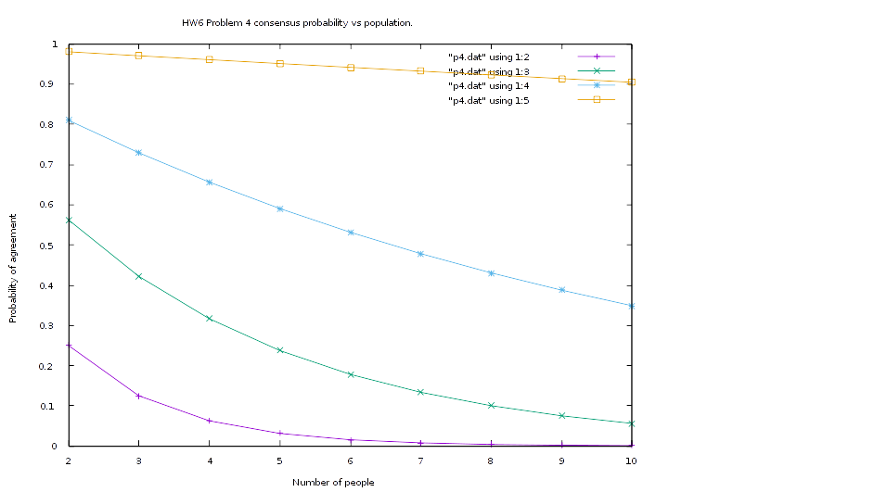

5. In your own words, describe what is meant by the term Work Breakdown Structure.

A WBS is the set of items, tasks, and milestones which are deemed necessary to complete a project.

6. Consider the set of activities, duration (in days), and predecessors for a project given below.
Activity | A | B | C | D | E | F | G | H | I
Duration | 3 | 9 | 6 | 6 | 6 | 3 | 2 | 6 | 7
Predecessors |  |  |  | A,B | D,B | C | F,E | G | F
a) Develop a network diagram representation for the project
b) Determine the critical path.
c) Determine the float time for all activities that are not on the critical path.

On scanned paper.

7. Explain why a network diagram cannot contain cycles (where a cycle is defined to be a sequence of activities where you can travel back to an activity already visited).

A cycle indicates that a set of tasks cannot be completed without the others, which will gridlock the project.

8. Describe the advantages and disadvantages of the network diagram and Gantt chart representation of a project. Identify the situations that would favor one over the other?

The Gantt Chart is more explicit in management details of a project's subtasks while the network diagram makes relationships and overall timeline more readily understood. The network diagram would serve as an excellent introduction to a project's expected timeline for new team members, while the Gantt Chart, with its breakdown of dates and durations, may be more useful once the subtasks are underway.

