Lab 05
Christopher Bero
EE384

Problem 1

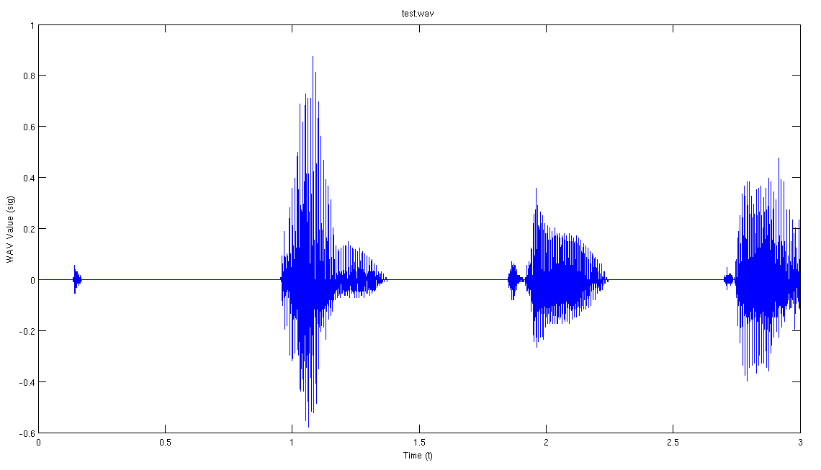

% P1.a
% Read and listen to test.wav
% What do you hear?
% What is the sampling frequency?
[sig,fs]=wavread('/home/berocs/Documents/uah/ee384/lab05/test.wav');
%sound(sig,fs);
% Audio: "One, two, three."
% Sampling Frequency: 8000Hz

% P1.b
% Plot the sound data vs time
seconds=(length(sig)/fs);
t=0:(1/fs):seconds-(1/fs);
plot(t,sig);
title('test.wav');
xlabel('Time (t)');
ylabel('WAV Value (sig)');

Problem 2

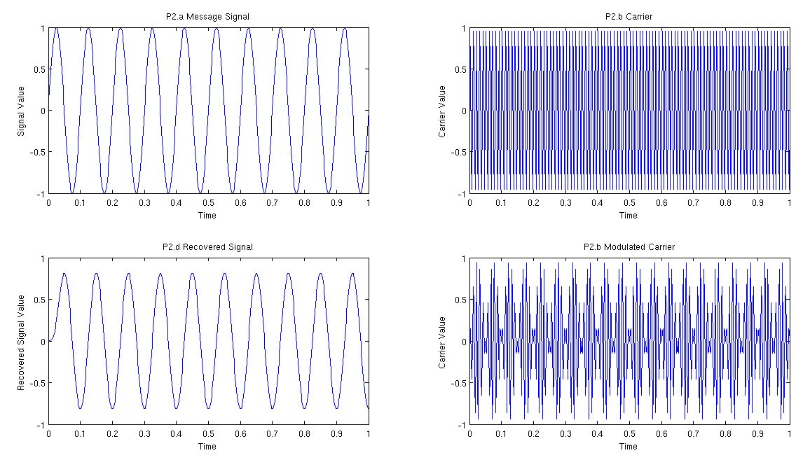
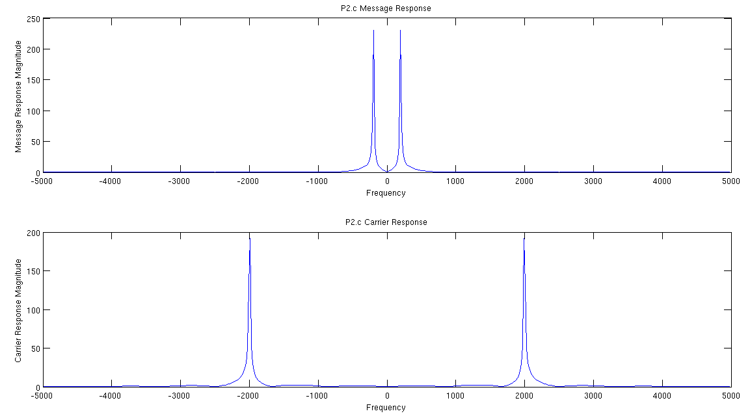

% P2.a
sfs=500;
fs=10;
t=0:(1/sfs):1;
sig=sin(2*pi*t*fs);
fig1=figure();
subplot(2,2,1);
plot(t,sig);
title('P2.a Message Signal');
xlabel('Time');
ylabel('Signal Value');

% P2.b
% No ammod available on R2012
% Procedure gathered from http://www.mathworks.com/matlabcentral/fileexchange/34590-amplitude-modulation-matlab-code
cfs=100;
carrier=sin(2*pi*t*cfs);
carrier_mod=sig.*carrier;
figure(fig1);
subplot(2,2,2);
plot(t,carrier);
title('P2.b Carrier');
xlabel('Time');
ylabel('Carrier Value');
subplot(2,2,4);
plot(t,carrier_mod);
title('P2.b Modulated Carrier');
xlabel('Time');
ylabel('Carrier Value');

% P2.c
% Plot the frequency spectrum of message and modulated signals
% What are the differences between the two plots?
samples=length(t);
fl=2^ceil(log2(samples));
bins=(-fl/2:fl/2-1)/(fl*1.e-4);

sig_resp=fftshift(fft(sig,fl));
carrier_resp=fftshift(fft(carrier,fl));

fig2=figure();
subplot(2,1,1);
plot(bins,abs(sig_resp));
title('P2.c Message Response');
xlabel('Frequency');
ylabel('Message Response Magnitude');

subplot(2,1,2);
plot(bins,abs(carrier_resp));
title('P2.c Carrier Response');
xlabel('Frequency');
ylabel('Carrier Response Magnitude');

% The message plot shows our signal at low frequencies,
% while the carrier shows the same signal shifted and mirrored at
% a higher frequency

% P2.d
% No amdemod available
% Demodulate the modified signal and plot
% Compare result to plot of message signal
figure(fig1);
dem=2*carrier_mod.*carrier;
a=fir1(25,100*1.e-4);
b=1;
rec=filter(a,b,dem);
subplot(2,2,3);
plot(t,rec);
title('P2.d Recovered Signal');
xlabel('Time');
ylabel('Recovered Signal Value');

