Christopher Bero
CPE384
Lab Report 01

Problem 1

1.1
a)
EDU>> a+b

ans =

5
18
16

b)
EDU>> a*b
Error using *
Inner matrix dimensions must agree.

c)
EDU>> a.*b

ans =

6
65
64

1.2
a)
EDU>> a+b
Error using +
Matrix dimensions must agree.

b)
EDU>> a*b

ans =

5
35
-6

c)
EDU>> a.*b
Error using .*
Matrix dimensions must agree.

Problem 2

% p2a
t=0:1:50;
y1=cos(t);
y2=sin(t);
figure
plot(t,y1,t,y2);
title('Step Size: 1');
xlabel('Samples (t)');
ylabel('Amplitude of y1/y2');

%p2b
t=0:0.1:50;
y1=cos(t);
y2=sin(t);
figure
plot(t,y1,t,y2);
title('Step Size: 0.1');
xlabel('Samples (t)');
ylabel('Amplitude of y1/y2');

a)
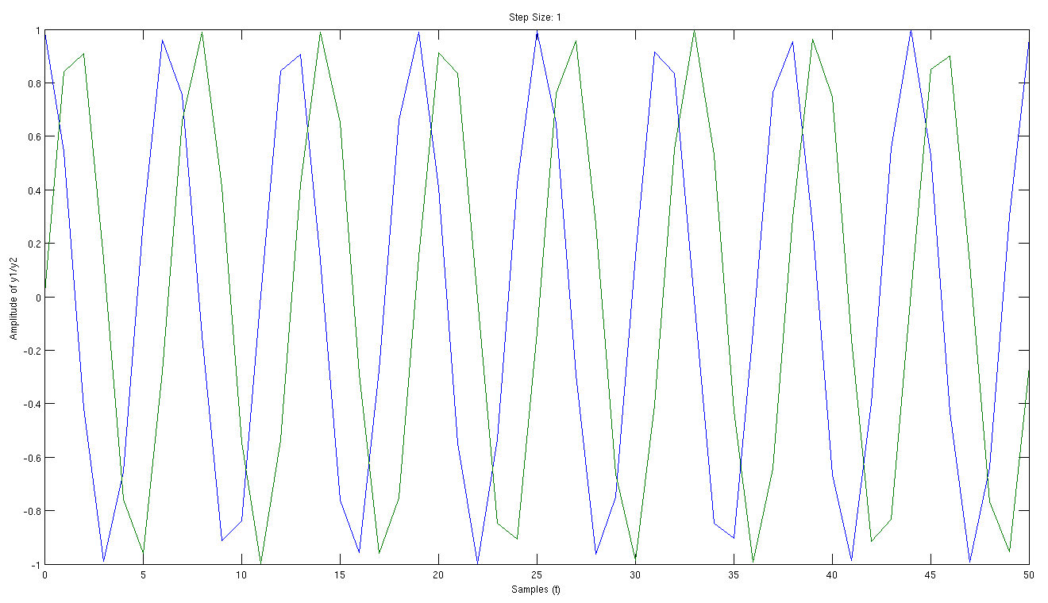

b)
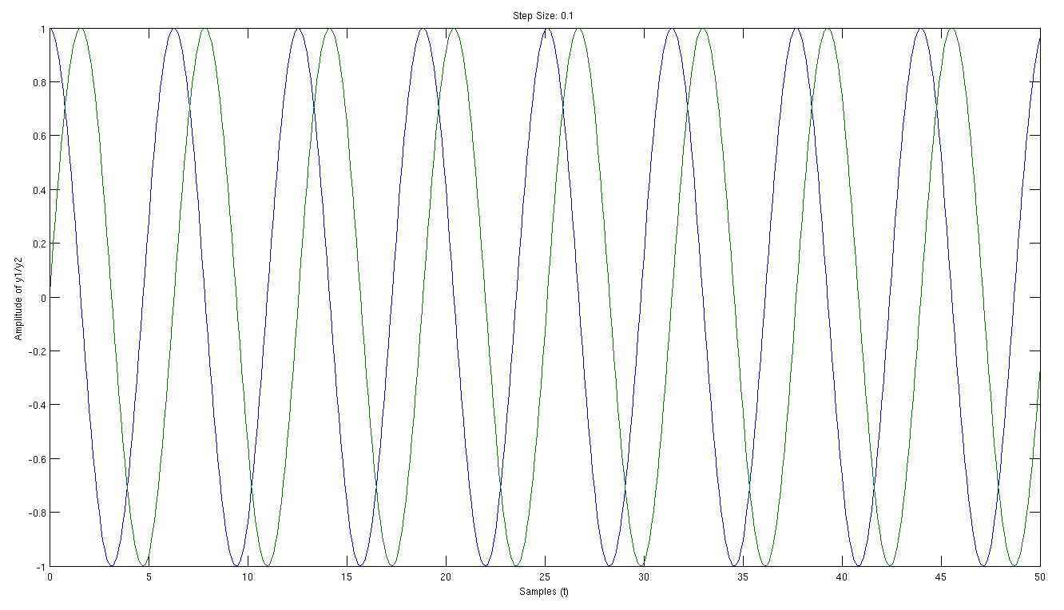

Problem 3

Script:
% p3
% Solve a small system of equations

a1=input('Enter the value of a1:');
b1=input('Enter the value of b1:');
c1=input('Enter the value of c1:');
d1=input('Enter the value of d1:');

a2=input('Enter the value of a2:');
b2=input('Enter the value of b2:');
c2=input('Enter the value of c2:');
d2=input('Enter the value of d2:');

a3=input('Enter the value of a3:');
b3=input('Enter the value of b3:');
c3=input('Enter the value of c3:');
d3=input('Enter the value of d3:');

A=[a1 b1 c1; a2 b2 c2; a3 b3 c3];
d=[d1; d2; d3];

sol=A\d

Usage:
EDU>> p3
Enter the value of a1:2
Enter the value of b1:3
Enter the value of c1:1
Enter the value of d1:3
Enter the value of a2:1
Enter the value of b2:3
Enter the value of c2:-1
Enter the value of d2:6
Enter the value of a3:2
Enter the value of b3:2
Enter the value of c3:0
Enter the value of d3:7

sol =

4.0000
-0.5000
-3.5000

Problem 4

Script:
% p4
% Prompt for and calculate an equation

x=input('Enter x:');
u=input('Enter mu:');

num=(log(1+(u*abs(x))));
den=(log(1+u));

y=((num/den).*sign(x));

figure;
p=plot(x,y);
set(p,'Color','black');
ylabel('output (y)');
xlabel('vector (x)');
title('Y according to X');

Result:
