Christopher Bero
CPE435
Lab 8

pThreads Integrator

Compiling:
gcc -Wall -g -c /home/berocs/Documents/uah/cpe434_435/lab08/lab8/main.c -o obj/Debug/main.o
g++ -L/lib64 -o bin/Debug/lab8 obj/Debug/main.o -pthread

Output file is bin/Debug/lab8 with size 15.64 KB
Process terminated with status 0 (0 minute(s), 0 second(s))
0 error(s), 0 warning(s) (0 minute(s), 0 second(s))

Execution:
$ ./bin/Debug/lab8

This is the parallel program.
Please enter the number of threads to execute >2

Please enter the number of intervals >10

Area estimation: 3.304518
Time elapsed: 0.000140s

Source Code:
Separate document.

Time Data:
Serial:
10 0.000005
20 0.000012
50 0.000013
100 0.000007
200 0.000010
300 0.000050
400 0.000021
500 0.000017
600 0.000028
700 0.000022
800 0.000024
900 0.000034
1000 0.000028
5000 0.000129
10000 0.000256
50000 0.003955
100000 0.006540

2T:
10 0.000141
20 0.000147
50 0.000129
100 0.000129
200 0.000115
300 0.000147
400 0.000127
500 0.000146
600 0.000151
700 0.000159
800 0.000154
900 0.000132
1000 0.000114
5000 0.000191
10000 0.000239
50000 0.000794
100000 0.001468

4T:
10 0.000217
20 0.000163
50 0.000195
100 0.000212
200 0.000271
300 0.000205
400 0.000172
500 0.000178
600 0.000232
700 0.000224
800 0.000226
900 0.000195
1000 0.000226
5000 0.000241
10000 0.000323
50000 0.000829
100000 0.001526

6T:
10 0.000274
20 0.000299
50 0.000281
100 0.000275
200 0.000282
300 0.000266
400 0.000282
500 0.000266
600 0.000274
700 0.000276
800 0.000251
900 0.000270
1000 0.000296
5000 0.000320
10000 0.000366
50000 0.000919
100000 0.001603

Time Graph:
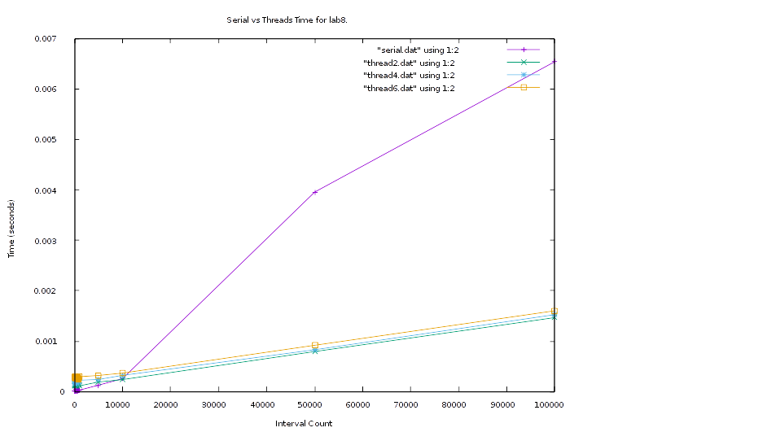
*My laptop has a 2-core processor, hence the lack of improvement after 2 threads*

