CPE 323 MSP430 INSTRUCTION SET ARCHITECTURE

Aleksandar Milenkovic

In the previous lecture we discussed various aspects of an instruction set architecture (ISA) in general terms. We have seen that ISA aspects include (a) class of ISA, (b) memory model, (c) addressing modes, (d) types and sizes of operands, (e) data processing and control flow operations supported by machine instructions, and (f) instruction encoding. In this document we will discuss the ISA aspects for the MSP430 family of devices.

Before we start discussing the MSP430 ISA, let us introduce MSP430. The MSP430 is a mixed-signal microcontroller family from Texas Instruments. It combines a 16-bit low-power processor with on-chip Flash and RAM memories, and a rich set of analog and digital input/output (I/O) peripherals, including, digital input/output ports, serial communication interfaces, timers, analog-to-digital (ADC) converters, digital-to-analog converters (DAC), comparators, and even operational amplifiers. The MSP430 targets low-cost and low-power battery-powered embedded applications. It is used in a range of consumer and industrial applications, such as metering, medical equipments, home appliances and others. The MSP430 family includes over 230 parts available that range from those that cost as low as 10 cents to those that cost over $10 in high volumes.

Class of ISA (Registers)

The MSP430 belongs to register-memory type of architectures which means that machine instructions find their operands can in either general-purpose registers or memory locations. The number of operands that can be specified by machine instructions is maximum two. In two-operand instructions, the first operand is usually referred to as source and the second operand is referred to as destination or source/destination depending on instruction type.

The MSP430 has a fairly large register file with 16 registers named R0 – R15 that are all visible to programmers. Some of these registers are reserved for special functions. For example, register R0 is reserved for the program counter (PC), register R1 serves as the stack pointer (SP), and register R2 serves as the status register (SR). Register R3 can be used for constant generation, while the remaining registers R4-R15 serve as general-purpose registers (i.e., they can be used by programmers freely for storing local variables and addresses).

A relatively large number of general-purpose registers compared to other microcontrollers, allows the majority of program computation to take place on operands in general-purpose registers, rather than operands in main memory. This helps improve performance and reduce code size. A block diagram of the processor core is shown in Figure 1.

Register-register operations are performed in a single clock cycle. For example, ADD R4, R5 instruction will read the contents of registers R4 and R5; the register R5 goes to the src input of the arithmetic-logic unit (ALU) and register R5 goes to the dst input of the ALU. The result shows on the ALU output and the memory data bus (MDB) and it is stored back in the register R5.

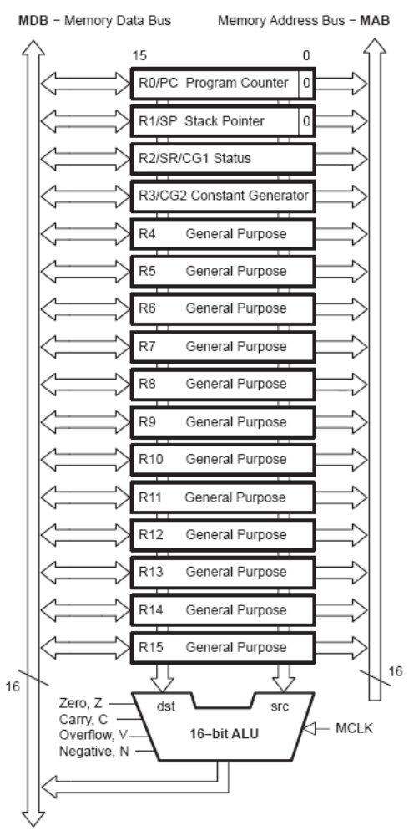
Figure 1. MSP430 CPU Block Diagram.

Program counter (PC/R0). PC always points to the next instruction to be executed. MS430 instructions can be encoded with 2 bytes, 4 bytes, or 6 bytes depending on addressing modes used for source (src) and source/destination (src/dest) operands. The MSP430 has byte-addressable architecture (the smallest unit in memory that can be addressed directly is a byte). Hence, the instructions have always an even number of bytes (they are word-aligned), so the least significant bit of the PC is always zero.

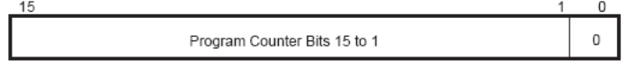
Figure 2. Program Counter.

The PC can be addressed by all instructions. Let us consider several examples:
MOV #LABEL,PC ; Branch to address LABEL
MOV LABEL,PC ; Branch to address contained in LABEL
MOV @R14,PC ; Branch indirect to address in R14

Stack pointer (SP/R1). The program stack is a dynamic LIFO (Last-In-First-Out) structure allocated in RAM memory. The stack is used to store the return addresses of subroutine calls and interrupts, as well as the storage for local data and passing parameters for subroutines. The MSP430 architecture assumes the following stack convention: the SP points to the last full location on the top of the stack and the stack grows toward lower addresses in memory. The stack is also word-aligned, so the LSB bit of the SP is always 0.
Two main stack operations are PUSH (the SP is first decremented by 2, and then the operand is stored in memory at the location addressed by the SP), and POP (the content from the top of the stack is retrieved; the SP is incremented by 2).

[[Illustrate PUSH and POP operations on the stack.]]

Status register (SR/R2). The status register keeps the content of arithmetic flags (C, V, N, Z), as well as some control bits such as SCG1, SCG0, OSCOFF, CPUOFF, and GIE. The exact format of the status register and the meaning of the individual bits is show in Figure 3.
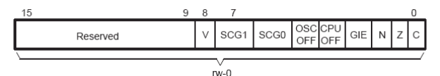
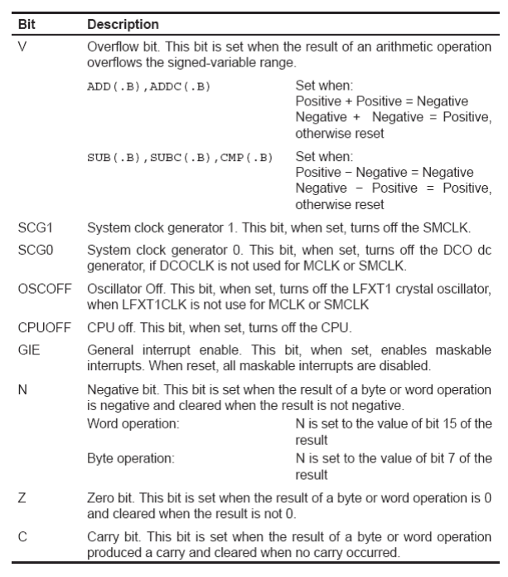
Figure 3. Status register format (top) and bits description (bottom).

Constant generator (R2-R3). Profiling common programs for constants shows that just a few constants, such as 0, +1, +2, +4, +8, -1, are responsible for majority of program constants. However, to encode such a constant we will need 16 bits in our instruction. In order to reduce the number of bits spent for encoding frequently used constants, a trick called constant generation is used. By specifying dedicated registers R2 and R3 in combination with certain addressing modes, we tell hardware to generate certain constants. This results in shorter instructions (we need less bits to encode such an instruction). Figure 4 describes values of constant generators.

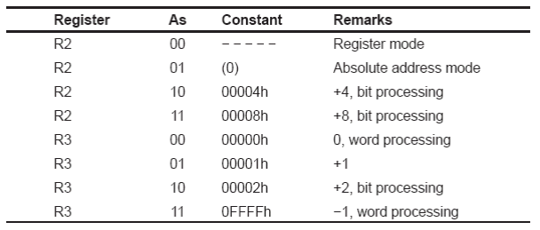
Figure 4. Constant generation.

An example: Let’s say you want to clear a word in memory at the address dst. To do this, a MOVE instruction could be used:

MOVE #0, dst

This instruction would have 3 words: the first contains the opcode and addressing mode specifiers for src and src/dst operands. The second word keeps the constant zero, and the third word contains the address of the memory location. Alternatively, the instruction

MOVE R3, dst

performs the same task, but we need only 2 words to encode it.

General-purpose registers (R4-R15). These registers can be used to store temporary data values, addresses of memory locations, or index values, and can be accessed with BYTE or WORD instructions.

Let us consider a register-byte operation using the following instruction:

ADD.B R5, 0(R6).

This instruction specifies that the src operand is the register R5, and the src/dest operand is in memory at the address (R6+0). The suffix .B indicates that the operation should be performed on byte-size operands. Thus, a lower byte from the register R5, 0x8F, is added to the byte from the memory location Mem(0x0203)=0x12, and the result is written back, so the new value of Mem(0x0203)=0xA1. The content of the register R5 is intact.

Let us now consider a byte-register operation using the following instruction:

ADD.B @R6, R5.

This instruction specifies a source operand in memory at the address contained in R6, and the destination operand is in the register R5. A suffix .B is used to indicate that the operation uses byte-sized operands. A suffix .W indicates that operations are performed on word-sized operands and is default (i.e., by omitting .W we imply word-sized operands). As shown below, a byte value Mem(0x0223)=0x5F is added to the lower byte of R5, 0x02. The result of 0x61 is zero extended to whole word, and the result is written back to register R6. So, the upper byte is always cleared in case of byte-register operations.
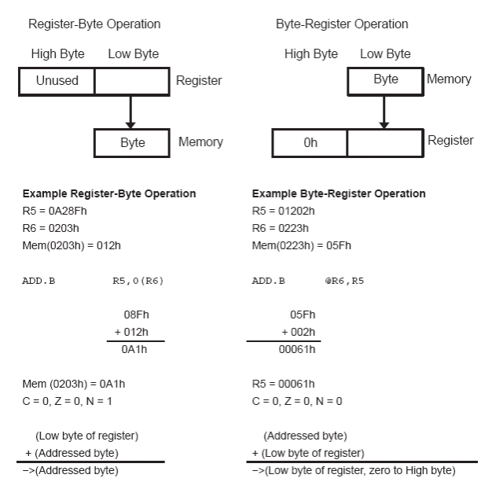
Figure 5. Register-byte (left) and byte-register (right) operations.

Addressing Modes

The MSP430 architecture supports a relatively rich set of addressing modes. Seven of addressing modes can be used to specify a source operand in any location in memory (Figure 6), and the first four of these can be used to specify the source/destination operand. Figure 6 also illustrates the syntax and gives a short description of the addressing modes. The addressing modes are encoded using As (2-bit long) and Ad (1-bit long) address specifiers in the instruction word, and the first column shows how they are encoded.

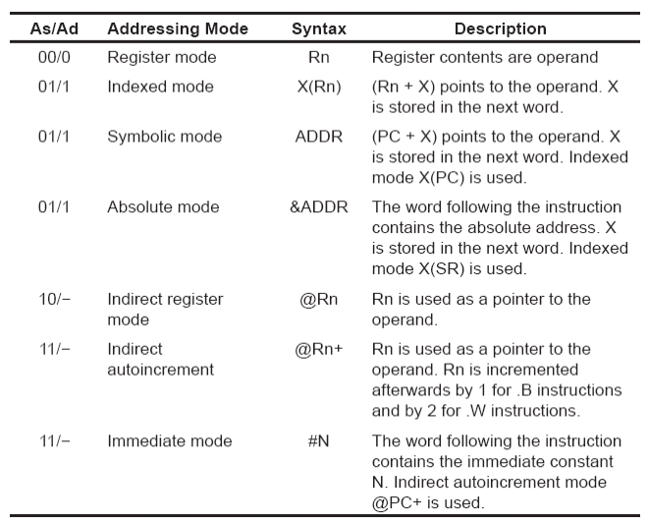
Figure 6. Addressing Modes.
Register mode. The fastest and shortest mode is used to specify operands in registers. The address field specifies the register number (4 bits).

Indexed mode. The operand is located in memory and its address is calculated as a sum of the specified address register and the displacement X, which is specified in the next instruction word. The effective address of the operand is ea, ea=Rn+X.

Symbolic mode. This addressing mode can be considered as a subset of the indexed mode. The only difference is that the address register is the PC, and thus ea=PC+X.

Absolute mode. The instruction specifies the absolute (or direct) address of the operand in memory. The instruction includes a word that specifies this address.

Indirect register mode. It can be used only for source operands, and the instruction specifies the address register Rn, and the ea=Rn.

Indirect autoincrement. The effective address is the content of the specified address register Rn, but the content of the register is incremented afterwards by +1 for byte-size operations and by +2 for word-size operations.

Immediate mode. The instruction specifies the immediate constant that is operand, and is encoded directly in the instruction.

One should notice a smart encoding of the addressing modes. Only a 2-bit address specifier As is sufficient to encode 7 addressing modes. How does it work? For example, please note that the absolute addressing mode is encoded in the same way as the indexed and the symbolic modes, As=01. With indexed mode we specify a general-purpose register that is used as the base address and an address displacement that is encoded in a following instruction word. However, to use the status register in calculating the effective memory address would be meaningless and it is never used for that. This fact can be used so that when register R2 is specified we actually interpret this as the absolute addressing mode. So, the instruction decoder would check not only the As filed to determine which source addressing mode is used, but also the source register field (src). Similarly, when using register (R0) as the address register we actually specify symbolic addressing mode. Strictly speaking, the symbolic mode is a special case of the indexed addressing mode. This way, we have one address specified (As=01) that covers 3 different addressing modes.

Next, the immediate mode uses the same As=11 as the autoincrement mode. It is distinguished from the autoincrement mode because the specified register is the R0 (PC), which is never used in the autoincrement mode (R0 is dedicated register). Similarly, we can explain how only a single bit Ad suffices in distinguishing 4 addressing modes for the destination operand (Ad=1 covers the same 3 addressing modes, symbolic, absolute, indexed using an additional src/dst register field).

[[Examples]]

Instruction Set and Instruction Encoding

The MSP430 instruction set consists of 27 core instructions and 24 emulated instructions. The core instructions are instructions that have unique op-codes decoded by the CPU. The emulated instructions are instructions that make code easier to write and read, but do not have op-codes themselves; instead, they are replaced automatically by the assembler with an equivalent core instruction. There is no code or performance penalty for using emulated instruction.
There are three core-instruction formats:
- Double-operand
- Single-operand
- Jump

All single-operand and double-operand instructions can be byte or word instructions (operate on byte-size or word-size operands) by using .B or .W extensions. Byte instructions are used to access byte data or byte peripherals. Word instructions are used to access word data or word peripherals. If no extension is used, the instruction is a word instruction.

The source and destination of an instruction are defined by the following fields:
- src - The source operand defined by As and S-reg
  - As - The addressing bits responsible for the addressing mode used for the source (src)
  - S-reg The working register used for the source (src)
- dst - The destination operand defined by Ad and D-reg
  - Ad - The addressing bits responsible for the addressing mode used for the destination (dst)
  - D-reg - The working register used for the destination (dst)
- B/W Byte or word operation:
  - 0: word operation
  - 1: byte operation

Figure 7 shows the double-operand instruction format and the list of all double-operand core instructions.
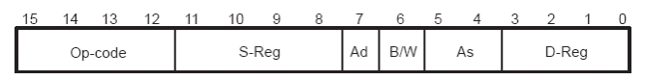

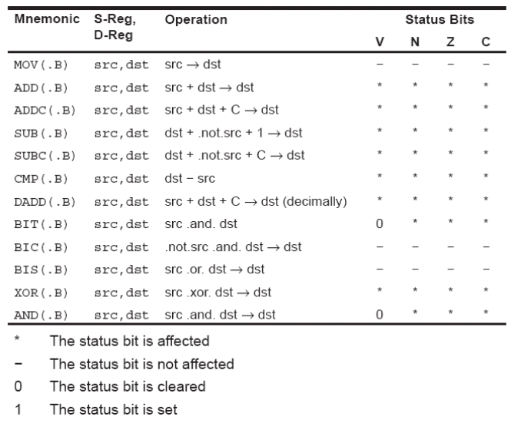
Figure 7. Double-operand instruction format (top) and instruction table (bottom).

Figure 8shows the single-operand instruction format and the list of all single-operand core instructions.

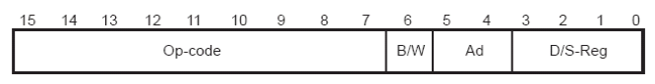
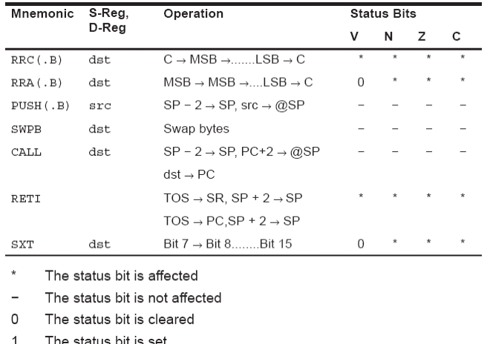
Figure 8. Single-operand instruction format (top) and instruction table (bottom).

Figure 8 shows the jump instruction format and the list of all jump core instructions. Conditional jumps support program branching relative to the PC and do not affect the status bits. The possible jump range is from −511 to +512 words relative to the PC value at the jump instruction. The 10-bit program-counter offset is treated as a signed 10-bit value that is doubled and added to the program counter:

PCnew = PCold + 2 + PCoffset × 2

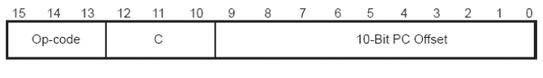
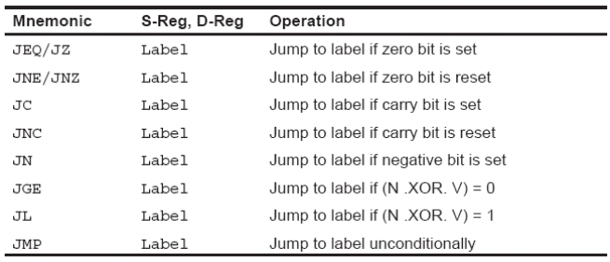
Figure 9. Jump instruction format (top) and instruction table (bottom).

Figure 10 shows a complete list of the MSP430 core and emulated instructions.
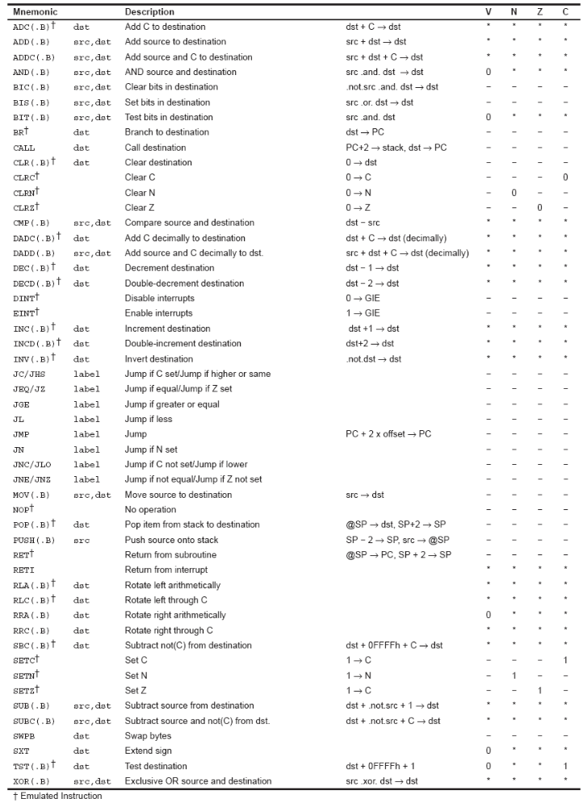
Figure 10. The complete MSP430 Instruction Set (core + emulated instructions).

Memory Architecture

The MSP430 family follows the Von-Neumann architecture – the program and data share a single address space. As we have seen before the operations can be performed on byte or word size operands and the smallest addressable unit is a byte. All addresses are 16-bit long, and the address space is thus 65,536 (2^16) bytes. The address space is divided into several sections: for special-purpose registers, 8-bit peripheral device registers, 16-bit peripheral device registers, RAM memory, and flash (non-volatile) memory. The processor communicates with memory and I/O peripheral modules through a 16-bit address bus, a 16-bit data bus, and a control bus. Memory is organized in such a way that in one bus operations an entire word from an even address can be read from or written to. All words are aligned in memory. Multi-byte objects are stored in memory using little-endian policy (lower byte of the object is stored at a memory location with lower address).

References
- MSP430 User Manual, http://www.ece.uah.edu/~milenka/npage/data/cpe323/Documents/slau056j-4xx-UG.pdf
- Textbook, Chapter 5

