Christopher Bero
EH-102 Research Paper
Due 2014-8-1
A Society Spelunking
For a moment I stare perplexed at my left arm. Ahead, Nathan calling that he has gotten free of the crawl is heard. Behind me Daniel chuckles in amazement at our friend's pace through the Blue Crawl. A section of cave widely regarded as the most difficult area in Tumbling Rock Caverns, this “Blue Crawl” makes a basis for any experienced caver's nightmare. I look down the horizontal tunnel and see no sign of Nathan's lights, which is unsurprising as the passage is over one hundred feet long and so small that my hardhat has to be removed and pushed sideways in front of me. To reach the crawl, we scaled a ledge which allows for no reversal; A one way ticket: being able to physically fit becomes mandatory. Ostensibly, I have just failed that bit. Only a few feet into the crawl my left elbow slid forward and dropped my torso several inches, totally wedging it between the sides of the tunnel. Frozen like a grotesque ballerina, I lie on my side with arms raised in front of my head and toes pointed backwards to keep my boots from becoming jammed. There is no room to move my hands backwards and push myself through, nothing to grab hold of in front of me and pull. As claustrophobia encroaches I squirm and arch to no avail. Eventually more sophisticated measures are called for, such as swearing while crying in desperation. A sense of hopelessness washes over me and burns hot behind my nose as I consider just how asinine the situation is. An eternity passes, and fifteen minutes later, I kick free with help from Daniel and begin slowly working the remaining ninety feet to the tunnel's end.
It is only hours later and back above ground that I step back to consider my thoughts while seized, and find that they are not entirely new to me. The notion occurs that most caving accidents must begin with a simple mis-movement, and that my experience was very similar to introductory sequences of tales from actual caving deaths. For instance, in a particularly haunting scenario, John Jones was visiting a popular cave. Some ways back his group arrived at a passage comparable to the Blue Crawl, entailing a claustrophobic squeeze around a corner. He became stuck upside down. Caving rescue worked for hours to free Jones, but ultimately was unable to extract him, and the following morning he was declared dead (S. Green). I'll never know how close I came to the finite point at which our stories end the same, and it terrifies me to consider that his first reaction would be to squirm, and then swear as I had done. Why, then, would I allow an entire population – especially one in which I take part – to catch itself on the rocks and writhe? Everywhere I look, I see stuck cavers. The feelings from my recent scare are the same as those from contemplating the outcome of a society so confident that it goes about brazenly altering itself and the only planet is has claim to. What if we are all entrapped cavers: testing the tunnel of technology as a whole, from which our culture may or may not emerge? Society has no control group, no recourse prepared in the event that modern niceties comfort us into decay while eschewing any view of reality. Items such as televisions, computers, and cellphones pose a grave threat to us all in the form of an undeveloped risk which has been entirely accepted and subsequently dismissed by my generation.
Television (TV) systems evolved rapidly after World War II, and cathode ray sets marched on living rooms under banners depicting a united and interconnected world of intellectuals. Then soap operas were invented. I kid, but as displayed by Figure 2, TVs have become so widespread today they are measured not in number of houses with television but rather the number of televisions per house. In fact, they even outnumber people, as there are now more TVs per household in America than inhabitants (Perry). A 2010 article entitled “Health Effects of Media on Children and Adolescents” lists a slew of situations and corresponding trends of important physiological and psychological shifts which indicate a slide in the wellbeing of children (Strasburger et al.). The studies correlate TV usage to attention-deficit disorder (ADD), speech development issues, poor academic performance, hypertension, sleep disorders, mood disorders, eating disorders, depression, and other psychological distress. Indeed, as we consider only the previous decade, the comparison of Figure 1 and Figure 2 shows a strong association between the average number of televisions in households and the percentage of children diagnosed with Attention Deficit Hyperactive Disorder (ADHD). The rise of this diagnosis from 6% to 9% is absolutely tremendous, indicating that nearly one in ten children now grow up in need of medication just to attend public schools. There is, however, a reason that televisions outnumber Americans: they hold large entertainment value, and the initial offer to create a unified and aware population is not untrue – although also not automatic or guaranteed. In fact, healthy TV viewing may be entirely possible, with clinical aspects a symptom of distorted use. According to the American Academy of Pediatrics two hours of quality programming is the maximum healthy viewing time per day, and televisions should be kept out of a child's bedroom (Strasburger et al.). As such, guidelines of moderation may protect the use of TV in everyday life. The key of success then becomes acceptance and integration; realizing that there are valuable reasons to moderate television and then implicating that moderation in daily life. Only the entire track, ending in an shift of our lifestyle, may diminish the undeveloped negative aspects of current use.
In the most straightforward and unconcealed form of technology integration, sitting in front of a computer is well recognized as detrimental to physical health. Neck pain, back pain, shoulder and arm pain, carpel tunnel syndrome, poor circulation, eye strain, and headaches are documented, and practices to reduce and prevent such injuries have made their way into the general policies of large companies and institutions such as the University of Pittsburgh (“Computer Operators'”). These injuries leave little room to be dismissed or unrecognized. Unlike a sprain received after stepping wrongly, the shoulder damage collected from constant contact with a computer is often much longer lived, even becoming chronic as the source of such pain is not removed in many cases (B. Green). In this way, an otherwise unmarred and capable body is entirely lowered in standard, presenting its associated character pain and limited ability. As cavers, we are very much stuck: computers show no sign of going away or becoming any less prevalent in daily life, yet they are also stagnated in crucial interface development, or even becoming worse as in the case of touch screen systems (Tessler). An article by the University of Nebraska-Lincoln summarily concludes the gravity of computer injury by identifying its category as “Cumulative Trauma Disorder,” which indicates the persistent and unnatural qualities associated with damage by computer use (Marxhausen). And those were just the obvious injuries, a 2007 study of preschoolers' media and computer interaction concluded that intervention in schools was required to lower the risk of childhood obesity (Mendosa et al.). At the same time, trendsetting school systems – such as Huntsville City Schools – are rampantly investing in a computer and media exclusive curriculum for attending students (Bonvillian). We now have ongoing, chronic oppression of a working class and dangerous precedents for younger generations. It's too late to promote a more casual and refined approach, as fanatic integration of computer usage is becoming institutionalized. Perhaps a rescue team will dig us out of the cave and show people how to properly interact with computers in a way which respects traditional experiences, like going outdoors or shaking hands with someone new.
Even if the teenagers of tomorrow are bothered to leave their school issued laptops and venture outside, they'll likely carry the future's version of a cellphone along too. Cellular phones have absolutely detonated, their adoption rate in just a few years blowing away that of televisions and computers. Regardless of the insane scale at which they are churned through and replaced, cellphones provide possibly the most concrete examples of technology killing us and our society even as we flock to buy newer, better models. At the forefront of the social stage is encumbered driving: the use of cellphones while behind the wheel was responsible for 16,000 traffic related deaths between 2001 and 2006 according to a study released on Reuters (Fox). That's an average of over 2,500 tragedies per year as a direct result of cellphone use. And that study was based on 8 year old information, other reports put the mark at over 3,300 deaths for more recent years (“Injury Prevention”). More troubling still is that these numbers are vastly lower than the reality they are supposed to reflect. The National Safety Council released a report which uncovered a trend: nearly double the reported cases of cellphone use involved in traffic deaths exists:
The report reviewed 180 fatal crashes from 2009 to 2011, where evidence indicated driver cell phone use. Of these fatal crashes, in 2011 only 52% were coded in the national data as involving cell phone use. (“Crashes Involving”)
Such associated uncertainty assigned to grave information should be cause for hesitation. Cellphones have been directly held responsible for between 3,000 and 6,000 deaths in the past year, if given statistics are extrapolated. That's a huge margin to consider, and a large basis to begin with. The idea of a frivolous toy, handy as it may be, claiming the lives of thousands is not something to hand wave at and disregard, instead it calls for deeper understanding of the lack in common educational foundations and training to keep drivers alive. This problem is particularly nasty, as it affects the entirety of people who travel. If a person is to “opt out” of cellular phones, he or she may still be killed by another distracted driver, thus removing options for a generalized control group of citizenry. If a majority of drivers own cellphones, then any effect they play out is done so on the entire society.
These are but a small subset of the considerations that should be held by any society in which such vast paradigms have taken hold. The advent and acceptance of electronics has lead us on a path towards type I civilization – which is interplanetary and based on multicultural acceptance. This is a good goal, but the transition has become a problematic phase in which we retain the stigmas and biases associated with divided societies and groups, yet also have means to
destroy the planet on which we reside. To move forward then, we must effectively utilize technology as a society without following the mindless consumerism model in effect today which promotes replacing cellphones every other year to drive profits. As cavers it becomes our job to thoughtfully plan a route; we must practice caution and determination when deciding whether any given technology will act as an appropriate passage to that aw-inspiring solar system sized society.

Figure 1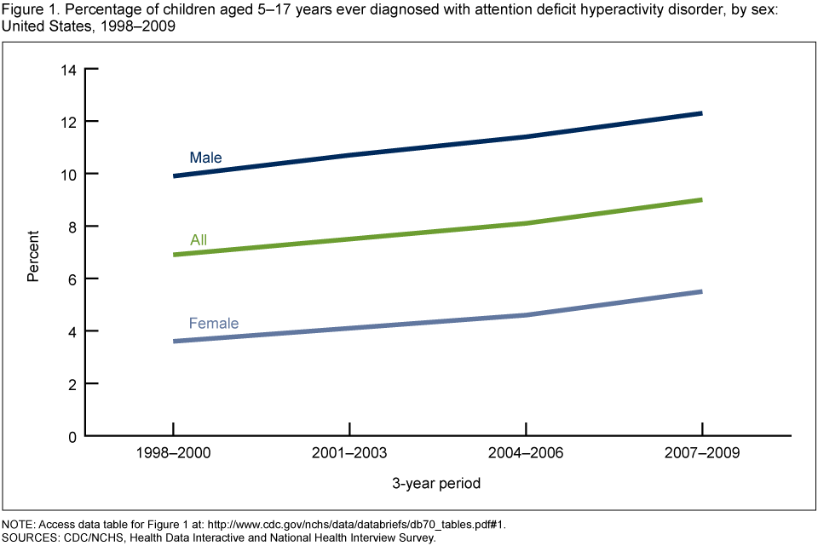
(Akinbami et al.)

Figure 2
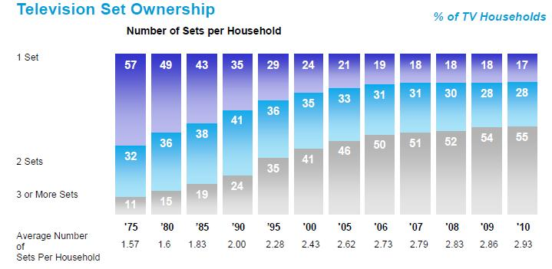
(Perry)
Works Cited

Akinbami, Lara J., et al. “Attention Deficit Hyperactivity Disorder Among Children Aged 5–17 Years in the United States, 1998–2009” CDC, Center for Disease Control.
Bonvillian, Crystal. “Huntsville District Preparing more than 22,000 Laptops, Ipads, for New School Year.” Blog.al.com. AL.com, 15th July 2012. Web. 30Th July 2014.
“Computer Operators' Risk Factors.” Workplace Health and Safety. University of Pittsburgh, Sept. 19th 2007. Web. 29th July 2014.
“Crashes Involving Cell Phones.” National Safety Council. National Safety Council, 5th July 2013. Web. 30Th July 2014.
Fox, Maggie. “Talking to Death: Texts, Phones kill 16,000: study.” Reuters.com. Reuters, 23rd Sept. 2010. Web. 30Th July 2014.
Green, Bart N. “A Literature Review of Neck Pain Associated with Computer Use: Public Health Implications.” J Can Chiropr Assoc. 52(3) (Aug 2008): 161-167. Web. 29Th July 2014.
Green, Stewart. “Utah Caver Dies After Becoming Stuck.” About. n.p., 28th Nov. 2009. Web. 29th July 2014.
“Injury Prevention and Control: Motor Vehicle Safety.” CDC.com. Center for Disease Control, 28th Jan. 2014. Web. 30Th July 2014.
Marxhausen, Paul. “Computer Related Repetitive Strain Injury.” unl. University of Nebraska-Lincoln, 2013. Web. 29Th July 2014.
Mendosa, Jason A., et al. “Television Viewing, Computer Use, Obesity, and Adiposity in US Preschool Children.” International Journal of Behavioral Nutrition and Physical Activity 2007, 4:44. Web. 30Th July 2014.
Perry, Mark J. “More TV Sets (2.93) Than People Per US Household (2.54); Average TV Sets Per Home Sets New Record” Carpe Deim. Blogspot, 2nd May 2010. Web. 30Th July 2014.
Strasburger, Victor C. et al. “Health Effects of Median on Children and Adolescents.” Pediatrics Vol. 125 (1 April 2010): 756-767. Web. 29Th July 2014.
Tessler, Franklin. “The Hidden Danger of Touchscreens.” Infoworld.com. Infoworld, 11th Jan. 2012. Web. 30Th July 2014.

