CPE322
SIM 04 HW
Christopher Bero

texter_control

module texter_control (clk, sw, dash_dit, dc_error, space, tm_reset, nxt_char, back_sp, nxt_bit, sp_load, out_char, out_space);

input clk, sw, dash_dit, dc_error, space;
output tm_reset, nxt_char, back_sp, nxt_bit, sp_load, out_char, out_space;

reg [2:0] state, nextstate;
reg tm_reset, nxt_char, nxt_bit, back_sp, sp_load, out_char, out_space;

initial
begin
state = 0;
nextstate = 0;
tm_reset = 0;
nxt_char = 0;
nxt_bit = 0;
back_sp = 0;
sp_load = 0;
out_char = 0;
out_space = 0;
end

always @(posedge clk)
begin
if (state == 0) begin
if (sw) begin
tm_reset = 1;
nxt_char = 1;
nextstate = 1;
end
else
nextstate = 0;
end

else if (state == 1) begin
if (sw) begin
nextstate = 1;
end
else if (space) begin
back_sp = 1;
nextstate = 1;
end
else begin
nxt_bit = 1;
if (dash_dit) begin
sp_load = 1;
end
nextstate = 2;
end
end

else if (state == 2) begin
tm_reset = 1;
nextstate = 3;
end

else if (state == 3) begin
if (sw) begin
sp_load = 1;
nextstate = 4;
end
else begin
if (dash_dit) begin
if (dc_error) begin
nextstate = 0;
end
else begin
out_char = 1;
nextstate = 5;
end
end
else begin
nextstate = 3;
end
end
end

else if (state == 4) begin
tm_reset = 1;
nextstate = 1;
end

else if (state == 5) begin
if (sw) begin
nxt_char = 1;
tm_reset = 1;
nextstate = 1;
end
else begin
if (space) begin
out_space = 1;
nextstate = 0;
end
else begin
nextstate = 5;
end
end
end
state = nextstate;
end

endmodule

Stimulus

#
# Stimulus
# [0] is LSB
# SUB_ADD: 0=add (A+B), 1=subtract (A-B)
# Library: cycloneive_ver
#

#add list Bin reset clk Bout

#add wave Bin reset clk Bout

force dc_error 0 0, 1 800, 0 1000

force dash_dit 1 0, 0 50 -repeat 100

force space 0 0, 1 400 -repeat 800

force sw 1 0, 0 200 -repeat 400

force clk 0 0, 1 20 -repeat 40

run 4000

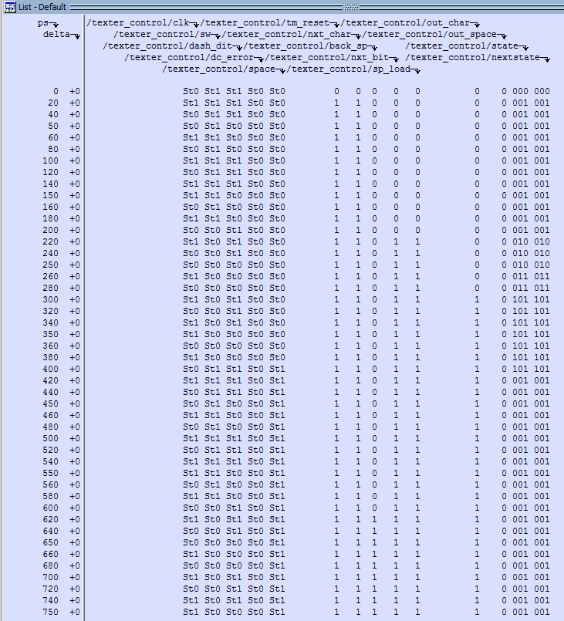
Output

