Christopher Bero
CPE 381
Spring 2015

Project Phase 1 Report

Task

Create a program which can overlay a sine wave on an existing signal saved in a .wav file and then construct a new file to hold the modified wave.

Proposed Solution

I intend to use C++ with gcc 4.9.2 to create a program which accomplishes the above task. The wave file will be opened as a “ios::binary” [1] file stream inside of a class capable of reading and storing header data as well as parsing samples. Two of these classes will be used to manage input and output .wav files. Sine wave generation will be taken care of by the sin() function in the <cmath> header file [2].

Procedure

My initial solution is ostensibly naive, and the C++ file has grown to some complexity just to open and read the header from the .wav file. I am now beginning the project over again to pursue the method discussed in class. This next project will be written as closely as possible to C99 standards, and will also use gcc 4.9.2 as a compiler. The first order of business is to open the input .wav file, read the header, and process its contents. In C, a file stream may be declared as 'binary' type to facilitate direct assignment to pointers [3][4]. Once the file is opened, I notice that character arrays in my struct aren't receiving the correct values. Instead of “RIFF” my first character array will have “RIFF$x”. At first I believe this is because of compiler optimizations in the struct, which compiles the structure for speed and incidentally changes the position of variables. To keep such changes from occurring, a data type can be given the __attribute__((__packed__)) macro [5]. Applying this workaround, however, did not fix the problem. Going back to look at the input file, we see that the malformed string is caused by the way character arrays operate. In a char[3] array, there are four elements, the last of which is '\0' to null terminate the string. When the header is chunked into a corresponding struct, the char[4] arrays suddenly have many more characters until '\0' next appears, and thus they lose shape. Rather than attempt modifying the variables, which inadvertently clobbers the header to be written to our output file, I stop printing the strings and ignore them.

Two separate methods are employed in generating the sine wave values. For the default 0.25 & 2.4KHz, values are pulled from a pre generated array. For all manually specified values ('-a' and '-f' flags), the signal is generated by sin(). The array is created in MATLAB with the following commands:

EDU>> t=[0:(1/44100):(1/2400)];
EDU>> y=sin(2*pi*t*2400)*(0.25)*(32767);
EDU>> f=int16(y);

The variable 'f' is then copied to the C program, and edited to instantiate an array. A plot of 'f' follows:
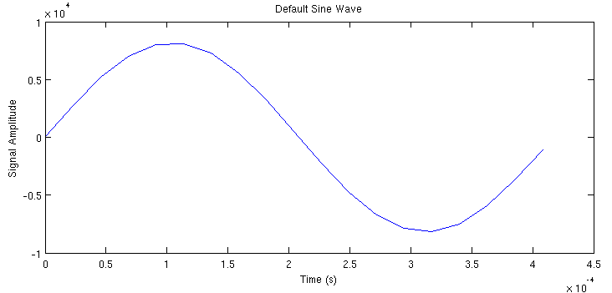
Another included feature is the ability to run a rough test on outgoing samples, and keep them from overflowing their container. If the '-c' flag is passed to the program, then samples which hold values outside their signed container's representation will be reassigned to either the container's maximum or minimum. Thus, the resulting signal will be deformed rather than filled with noise that is produced when a value “wraps around” the integer data type during an overflow.

Without Overflow Protection
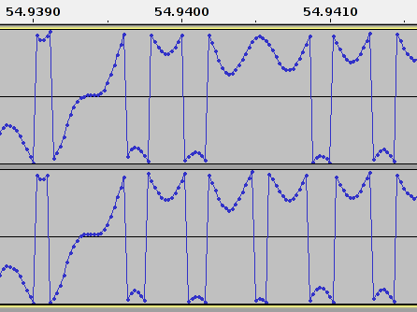
With Overflow Protection
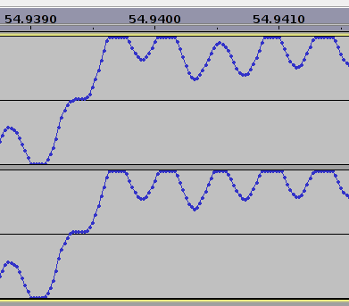

Default Usage

To run the program with default files and output:

./rtspc -s summary.txt -i orig.wav -o mod.wav

Compilation

This program should compile with the following gcc commands:

gcc -g -c main.c -o rtspc.o
g++ -o rtspc rtspc.o

RIFF Header

To read the fields of the header file, a list of byte associations was created from reference [12]. From the limited experience this project has brought with handling .wav files, this header description holds for audio exported from Audacity.

[1-4] - "RIFF" - Marks file as RIFF type.
[5-8] - File Size (integer) minus 8 bytes.
[9-12] - "WAVE" - File type header.
[13-16] - "fmt " - Format chunk marker.
[17-20] - Length of "format data" area. Typically 16 for PCM.
[21-22] - Type of format. "1" is PCM, which we work with.
[23-24] - Number of channels (integer).
[25-28] - Sample Rate = # of samples per second or Hz.
[29-32] - (Sample Rate * Bits Per Sample * Channels) / 8
- Bytes per Second.
[33-34] - (Bits Per Sample * Channels) / 8.
1: 8 bit mono. 2: 8 bit stereo. 3: 16 bit mono.
4: 16 bit stereo.
[35-36] - Bits Per Sample.
[37-40] - "data" - Data chunk header.
Included in "size of data" below.
[41-44] - Size of data section in bytes.

Real Time Processing

While the program itself is inherently not real time due to the nature of recording a file, the algorithm used to modify samples can hypothetically be used in real time. This conclusion is based on the fact that the program can process a 5 minute file in under 10 seconds on a relatively low powered laptop computer. This means that other similarly written software should be capable of handling the analysis of packets and then stream in from an external source. Had the program taken longer to process the file than the file's playtime, then either the algorithm or computer would need adjustment before declaring the procedure as real time.

Sample Summary File

Summary File - CPE 381 - Christopher Bero
=========================================
Sampling Frequency: 44100Hz
Audio Time: 342.909342s
Maximum amplitude: 31977
- At sample #: 13279396
- Channel #: 2
Program Execution Time: 6.067862s
Resources

Phase 1
[1] http://www.cplusplus.com/doc/tutorial/files/
[2] http://www.cplusplus.com/reference/cmath/sin/
[3] http://www.cprogramming.com/tutorial/cfileio.html
[4] http://www.codingunit.com/c-tutorial-binary-file-io
[5] https://gcc.gnu.org/onlinedocs/gcc/Type-Attributes.html
[6] http://c2.com/cgi/wiki?NonNullTerminatedString
[7] http://stackoverflow.com/questions/1921539/using-boolean-values-in-c
[8] https://www.thinkage.ca/english/gcos/expl/c/lib/atof.html
[9] http://blog.regehr.org/archives/1139
[10] http://www.cplusplus.com/reference/ctime/clock/
[11] http://www.tutorialspoint.com/c_standard_library/limits_h.htm
[12] http://www.topherlee.com/software/pcm-tut-wavformat.html

