Christopher Bero
CPE 381
Spring 2015

Project Phase 1 Report

Task

Create a program which can overlay a sine wave on an existing signal saved in a .wav file and then construct a new file to hold the modified wave.

Proposed Solution

I intend to use C++ with gcc 4.9.2 to create a program which accomplishes the above task. The wave file will be opened as a “ios::binary” [1] file stream inside of a class capable of reading and storing header data as well as parsing samples. Two of these classes will be used to manage input and output .wav files. Sine wave generation will be taken care of by the sin() function in the <cmath> header file [2].

Procedure

My initial solution is ostensibly naive, and the C++ file has grown to some complexity just to open and read the header from the .wav file. I am now beginning the project over again to pursue the method discussed in class. This next project will be written as closely as possible to C99 standards, and will also use gcc 4.9.2 as a compiler. The first order of business is to open the input .wav file, read the header, and process its contents. In C, a file stream may be declared as 'binary' type to facilitate direct assignment to pointers [3][4]. Once the file is opened, I notice that character arrays in my struct aren't receiving the correct values. Instead of “RIFF” my first character array will have “RIFF$x”. At first I believe this is because of compiler optimizations in the struct, which compiles the structure for speed and incidentally changes the position of variables. To keep such changes from occurring, a data type can be given the __attribute__((__packed__)) macro [5]. Applying this known workaround, however, did not fix the problem. Going back to look at the input file, we see that the malformed string is caused by the way character arrays operate. In a char[3] array, there are four elements, the last of which is '\0' to null terminate the string. When the header is chunked into a corresponding struct, the char[4] arrays suddenly have many more characters until '\0' next appears, and thus they lose shape. Rather than attempt modifying the variables, which inadvertently clobbers the header to be written to our output file, I stop printing the strings and ignore them.
Two methods are employed in generating the sine wave values. For the default 0.25 & 2.4KHz, values are pulled from an array. For all manually specified values, the signal is generated by sin(). The array is created in MATLAB with the following commands:

EDU>> t=[0:(1/44100):(1/2400)];
EDU>> y=sin(2*pi*t*2400)*(0.25)*(32767);
EDU>> f=int16(y);

The variable 'f' is then copied to the C program, and edited to instantiate an array. A plot of 'f' follows:
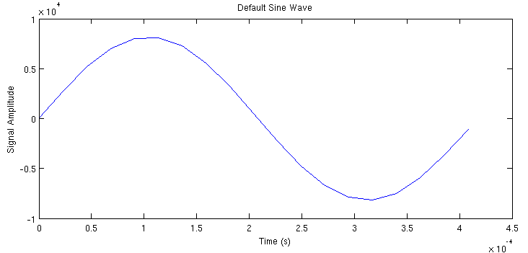

Usage

To run the program with default files and default output:

./rtspc -s output.txt -i input.wav -o output.wav

Resources

[1] http://www.cplusplus.com/doc/tutorial/files/
[2] http://www.cplusplus.com/reference/cmath/sin/
[3] http://www.cprogramming.com/tutorial/cfileio.html
[4] http://www.codingunit.com/c-tutorial-binary-file-io
[5] https://gcc.gnu.org/onlinedocs/gcc/Type-Attributes.html
[6] http://c2.com/cgi/wiki?NonNullTerminatedString
[7] http://stackoverflow.com/questions/1921539/using-boolean-values-in-c
[8] https://www.thinkage.ca/english/gcos/expl/c/lib/atof.html
[9] http://blog.regehr.org/archives/1139
[10] http://www.cplusplus.com/reference/ctime/clock/
[11] http://www.tutorialspoint.com/c_standard_library/limits_h.htm

