Christopher Bero
CPE 381
Spring 2015

Project Phase 3 Report

Task

Create a program which can determine the dominant spectral component of a signal in a .wav file.

Proposed Solution

I intend to reimplement the main code structure developed in phase 1 of this project to open, read, and process wave files. During phase 2 of this project, I learned that the Fourier transform can be used as a capable tool for signal analysis. I will implement a similar algorithm as that used in the plot_fft matlab function with an FFT library.

The general algorithm of the program should be as follows:
- Read in samples and collect them as time domain signals.
- Compute the Fast Fourier Transform on the time signals and retrieve signals in frequency domain.
- Discard half of the frequency signal due to Nyquist sampling frequency.
- Account for the missing data by multiplying all i>0 data by 2.
- Take the absolute value of frequency signal since we're looking for magnitude.
- Set the x-axis of the frequency data to be
(index of current value) / (index of final value) * (sampling frequency)
- Iterate through the frequency data and determine the largest value.
- Display the associated frequency (x-axis) for the largest component.

Processing

Original file
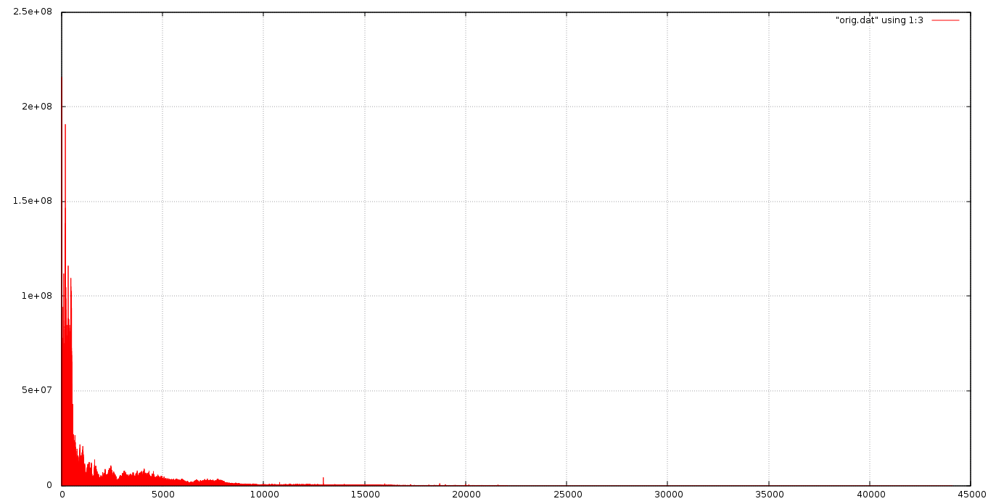
Summary File - CPE 381 - Christopher Bero
=========================================
Sampling Frequency: 44100Hz
Audio Time: 45.583810s
Program Execution Time: 243.796951s
Ran in: Not Real Time.
Dominant component: 21.520800Hz
Data file: orig.dat

Modified file
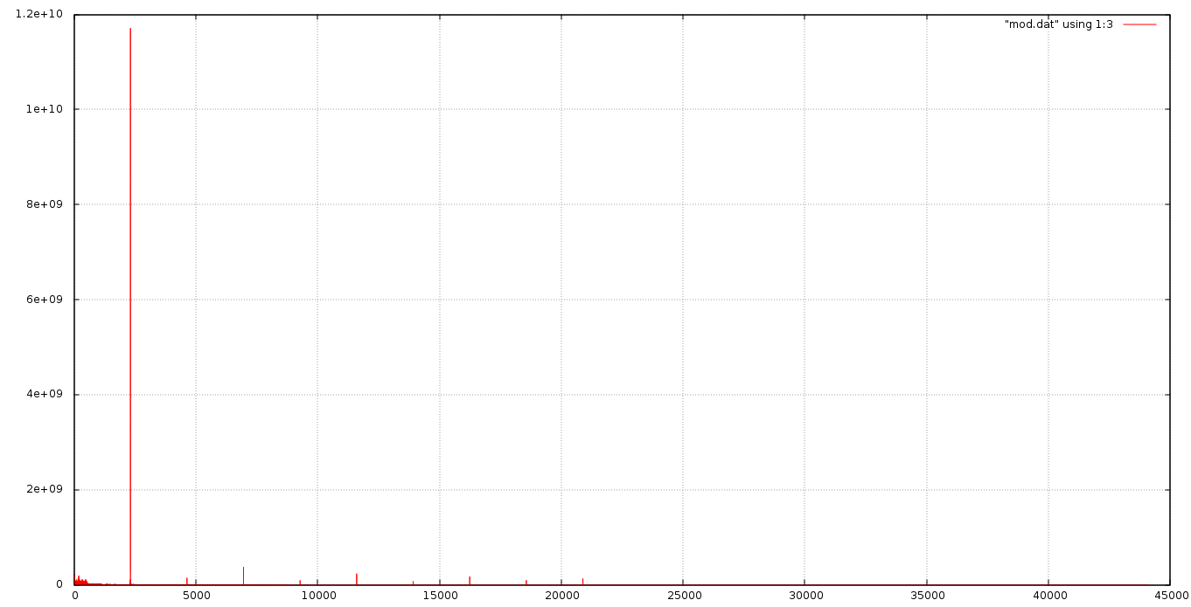
Summary File - CPE 381 - Christopher Bero
=========================================
Sampling Frequency: 44100Hz
Audio Time: 45.583810s
Program Execution Time: 244.393631s
Ran in: Not Real Time.
Dominant component: 2321.043457Hz
Data file: mod.dat

Filtered file
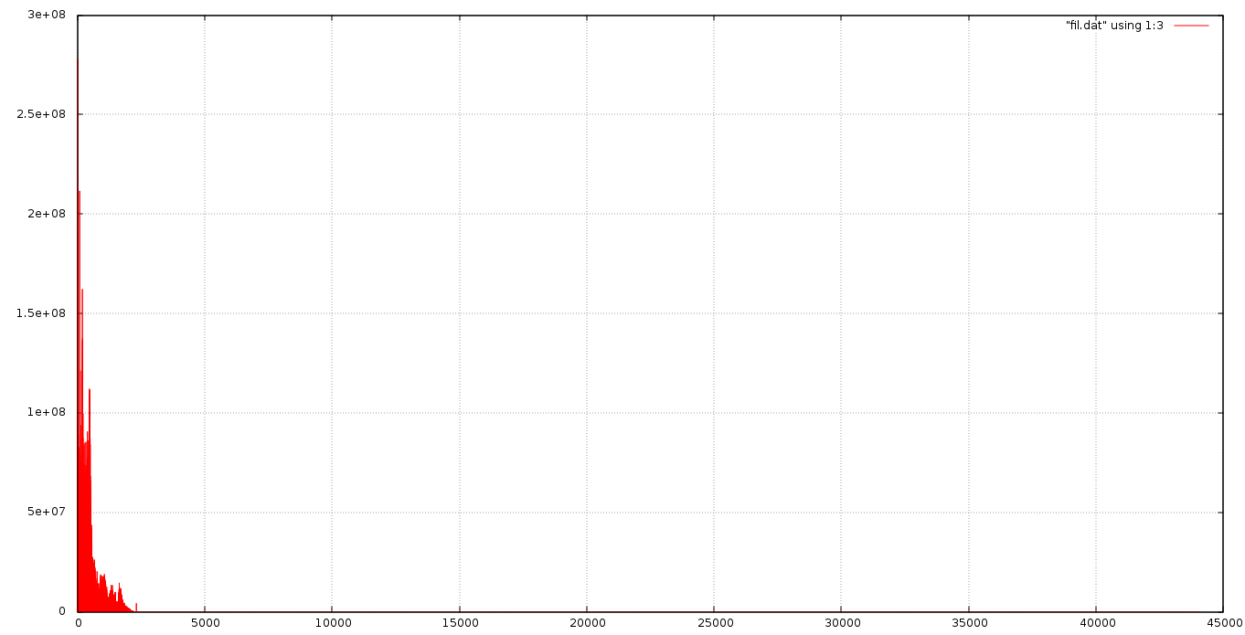
Summary File - CPE 381 - Christopher Bero
=========================================
Sampling Frequency: 44100Hz
Audio Time: 45.583810s
Program Execution Time: 406.865021s
Ran in: Not Real Time.
Dominant component: 21.520800Hz
Data file: fil.dat

Plotting

The program has the ability to write a data file which can be plotted with gnuplot. Use either 1:2 or 1:3 to plot each channel's magnitude spectra.

gnuplot> plot "test.dat" using 1:2 with lines

Default Usage

To run the program with defaults (FIR filtering):

./rtspc_fmag -s summary.txt -i mod.wav -o mod.dat

Compilation

This program should compile with the following gcc commands; for this phase of the project, I have only tested compiling with an IDE's assistance.

gcc -g -c main.c -o main.o
g++ -o rtspc_fmag kiss_fft.o kiss_fftr.o main.o

Real Time Processing

This program currently does not run in real-time with files I've tested from my computer. Perhaps a more efficient method of organizing the frequency and time data would improve the execution time.

Conclusion

I wish that I had allowed myself more time to work on this project, as it has been a fascinating event to see FFT leap a signal into the frequency domain. There are still some aspects with which I am confused, and I have no doubt that they are reflected in the program. For instance, I yet to successfully take the returned magnitude and reach the associated power of the signal; a task I originally intended to complete by means of
Power = (FFT * Conjugate(FFT)) / (size(FFT) * (size(signal)).

Resources

Phase 1
[1] http://www.cplusplus.com/doc/tutorial/files/
[2] http://www.cplusplus.com/reference/cmath/sin/
[3] http://www.cprogramming.com/tutorial/cfileio.html
[4] http://www.codingunit.com/c-tutorial-binary-file-io
[5] https://gcc.gnu.org/onlinedocs/gcc/Type-Attributes.html
[6] http://c2.com/cgi/wiki?NonNullTerminatedString
[7] http://stackoverflow.com/questions/1921539/using-boolean-values-in-c
[8] https://www.thinkage.ca/english/gcos/expl/c/lib/atof.html
[9] http://blog.regehr.org/archives/1139
[10] http://www.cplusplus.com/reference/ctime/clock/
[11] http://www.tutorialspoint.com/c_standard_library/limits_h.htm
[12] http://www.topherlee.com/software/pcm-tut-wavformat.html

Phase 2
[13] http://www.eas.uccs.edu/wickert/ece2610/lecture_notes/ece2610_chap8.pdf
[14] http://askubuntu.com/questions/340835/simple-example-of-gnuplot
[15] http://c.learncodethehardway.org/book/ex16.html
[16] http://www.tutorialspoint.com/cprogramming/c_passing_pointers_to_functions.htm
[17] http://www.codingunit.com/c-reference-stdlib-h-function-calloc
[18] http://www.cs.hmc.edu/~vrable/gnuplot/using-gnuplot.html

Phase 3
[19] http://www.lumerink.com/courses/ece697/docs/Papers/The%20Fundamentals%20of%20FFT-Based%20Signal%20Analysis%20and%20Measurements.pdf
[20] https://github.com/itdaniher/kissfft
[21] http://www.fftw.org/
[22] https://dadorran.wordpress.com/2014/02/20/plotting-frequency-spectrum-using-matlab/
[23] http://www.mathworks.com/help/signal/examples/practical-introduction-to-frequency-domain-analysis.html#zmw57dd0e3533
[24] http://www.iowahills.com/5FIRFiltersPage.html

