CH121 Exam III Fall 2009 Practice Exam

7.1 The Pauli Exclusion Principle

1. Which of the following sets of quantum numbers is allowed?
a) n = 2,  = 1, m = +1/2, m_{s} = -1/2
b) n = 3,  = 2, m = +1, m_{s} = +1
c) n = 4,  = 2, m = -2, m_{s} = -1/2
d) n = 4,  = 4, m = -1, m_{s} = +1/2
e) n = 5,  = 2, m = +2, m_{s} = -1

Answer: c

7.2 Atomic Subshell Energies and Electron Assignments

2. Which of the following statements is/are CORRECT for a carbon atom?
1. The effective nuclear charge felt by a 2s electron is greater than that felt by a 1s electron.
2. The effective nuclear charge felt by a 2p electron is less than that felt by a 2s electron.
3. The effective nuclear charges felt by 2s and 2p electrons are identical.
a) 1 only b) 2 only c) 3 only d) 1 and 3 e) 1, 2, and 3

Answer: b

3. Which of the following statements concerning ground state electron configurations is/are CORRECT?
1. For a hydrogen atom with one electron, the 2s and 2p orbitals have identical energies.
2. For a lithium atom with three electrons, the 2s and 2p orbitals have different energies.
3. The effective nuclear charge felt by an electron in a 2p orbital is greater for a carbon atom than for a boron atom.
a) 1 only b) 2 only c) 3 only d) 2 and 3 e) 1, 2, and 3

Answer: e

7.3 Electron Configurations of Atoms

4. Hund’s rule states that the most stable arrangement of electrons (for a ground state electron configuration)
a) has a filled valence shell of electrons.
b) has three electrons per orbital, each with identical spins.
c) has m values greater than or equal to +1.
d) has the maximum number of unpaired electrons, all with the same spin.
e) has two electrons per orbital, each with opposing spins.

Answer: d

5. Which element has the following ground state electron configuration?
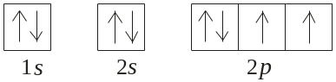
a) P b) S c) O d) N e) F

Answer: c

6. What is the correct orbital box diagram for the ground state electron configuration of Cr?
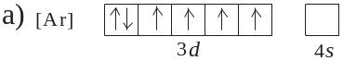
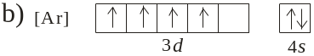
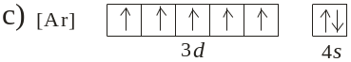
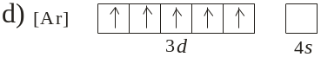
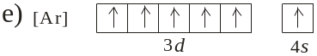

Answer: e

7.4 Electron Configurations of Ions

7. What 2+ ion has the following ground state electron configuration?
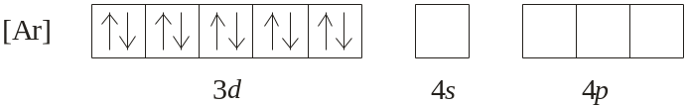
a) Ge²⁺ b) Ni²⁺ c) Zn²⁺ d) Cu²⁺ e) None

Answer: c

7.5 Atomic Properties and Periodic Trends

8. Which one of the following statements is INCORRECT?
a) Ionization energy is a positive value for all elements.
b) Ionization energy is the energy required to remove an electron from a gaseous atom.
c) For any element, the second ionization energy is larger than the first ionization energy.
d) Ionization energy increases across a periodic of the periodic table.
e) Ionization energy increases down a group of the periodic table.

Answer: e

8.1 Chemical Bond Formation

9. Which combination of atoms is most likely to produce a compound with covalent bonds?
a) Na and Cl b) Al and O c) S and Br d) Pb and F e) K and I

Answer: c

8.2 Covalent Bonding and Lewis Structures

10. Which of the following is a correct Lewis structure for nitrous acid, HNO₂?
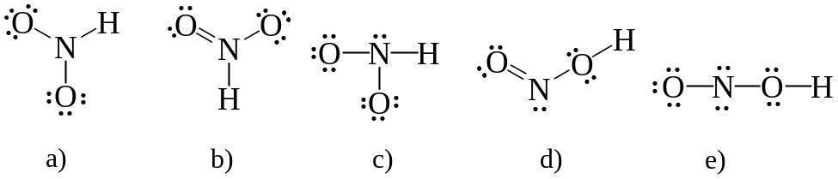

Answer: d
8.3 Atom Formal Charges in Covalent Molecules and Ions
11. One resonance structure for OCN⁻ ion is drawn below. What is the formal charge on each atom?
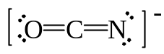a) O atom = 0, C atom = 0, and N atom = 0
b) O atom = 0, C atom = 0, and N atom = -1
c) O atom = -1, C atom = 0, and N atom = 0
d) O atom = -1, C atom = -1, and N atom = +1
e) O atom = +1, C atom = 0, and N atom = -2

Answer: b

8.4 Resonance

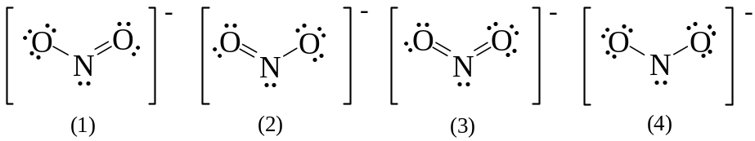12. Which of the following are resonance structures for nitrite ion, NO₂⁻?

a) 1 and 2 b) 2 and 4 c) 3 and 4 d) 1, 2, and 3 e) 2, 3, and 4
Answer: a

8.5 Exceptions to the Octet Rule

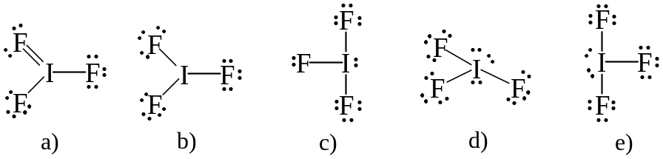13. What is the correct Lewis structure for IF₃?

Answer: e

8.6 Molecular Shapes

14. Use VSEPR theory to predict the molecular geometry of BrF₅.
a) tetrahedral
b) see-saw
c) trigonal-bipyramidal
d) square-pyramidal
e) octahedral

Answer: d

8.7 Bond Polarity and Electronegativity

15. Which of the following compounds has polar covalent bonds: NaBr, Br₂, HBr, and CBr₄?
a) NaBr only
b) Br₂ only
c) HBr only
d) Br₂ and HBr
e) HBr and CBr₄
Answer: e

16. Electronegativity is a measure of
a) the ability of a substance to conduct electricity.
b) the charge on a polyatomic cation.
c) the charge on an polyatomic anion.
d) the ability of an atom in a molecule to attract electrons to itself.
e) the oxidation number of an atom in a molecule or polyatomic anion.

Answer: d

8.8 Bond and Molecular Polarity

17. Which one of the following molecules is polar?
a) CCl₄ b) PF₅ c) SO₂ d) F₂ e) BH₃

Answer: c

18. Which one of the following molecules is polar?
a) CO₂ b) SF₄ c) XeF₂ d) XeF₄ e) SO₃

Answer: b

19. Three possible structures of C₂H₂Cl₂ are shown below. Which of these molecules are polar?
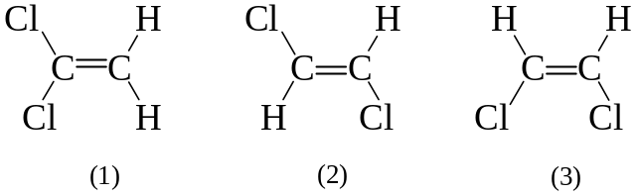
a) 1 only b) 2 only c) 3 only d) 1 and 3 e) 2 and 3

Answer: d
8.9 Bond Properties: Order, Length, Energy
20. Use the bond enthalpies tabulated below to estimate the enthalpy of formation of H₂O(g).
H₂(g) + ½ O₂(g) → H₂O(g)

Bond | Bond Enthalpy  (kJ/mol·rxn)
H-H | 436
O-H | 463
O-O | 146
O=O | 498

a) -417 kJ b) -241 kJ c) -168 kJ d) -8 kJ e) +8 kJ
Answer: b

9.1 Orbitals and Theories of Chemical Bonding

21. Which one of the statements concerning valence bond (VB) and molecular orbital (MO) bond theories is correct?
a) MO theory predicts that electrons are localized between pairs of atoms.
b) In VB theory, bonding electrons are delocalized over the molecule.
c) MO theory accurately describes bonding in O₂ and NO, VB theory does not.
d) VB theory can describe molecular bonding in excited states.
e) MO theory is used to accurately predict the colors of compounds.

Answer: c
9.2 Valence Bond Theory

22. What is the molecular geometry around a central atom that is sp³d² hybridized and has one lone pair of electrons?
a) tetrahedral
b) trigonal-bipyramidal
c) square-planar
d) square-pyramidal
e) see-saw

Answer: d
9.3 Molecular Orbital Theory

The following molecular orbital diagram may be used for problems 23 and 24. For oxygen and fluorine, the σ_{2p} orbital should be lower in energy than the π_{2p}. However, the diagram will still yield correct bond order and magnetic behavior for these molecules.

Energy |  | ________ |  |  | σ*_{2p}
 | ________ |  |  | ________ |  | π*_{2p}
 |  | ________ |  |  | σ_{2p}
 | ________ |  |  | ________ |  | π_{2p}
 |  | ________ |  |  | σ*_{2s}
 |  | ________ |  |  | σ_{2s}
 |  | ________ |  |  | σ*_{1s}
 |  | ________ |  |  | σ_{1s}

23. According to molecular orbital theory, which of the following species is least likely to exist?
a) Be₂ b) F₂²⁺ c) C₂²⁻ d) Li₂ e) B₂²⁻

Answer: a

24. What is the molecular orbital configuration of F₂?
a) [core electrons] (σ_{2s})² (σ*_{2s})² (π_{2p})⁴ (σ_{2p})² (σ*_{2p})²
b) [core electrons] (σ_{2s})² (σ*_{2s})² (π_{2p})² (σ_{2p})² (π*_{2p})²
c) [core electrons] (σ_{2s})² (σ*_{2s})² (π_{2p})⁴ (π*_{2p})⁴
d) [core electrons] (σ_{2s})² (σ*_{2s})² (π_{2p})⁴ (σ_{2p})² (π*_{2p})⁶
e) [core electrons] (σ_{2s})² (σ*_{2s})² (π_{2p})⁴ (σ_{2p})² (π*_{2p})⁴

Answer: e

25. The following valence molecular orbital energy level diagram is appropriate for which one of the listed species?
σ*_{2p}
π*_{2p}
σ_{2p} |  |  | 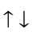
π_{2p}
σ*_{2s}
σ_{2s}

a) B₂²⁻ b) C₂²⁻ c) N₂²⁻ d) O₂²⁻ e) F₂²⁻

Answer: c

