Christopher Bero
13-2-2015
CPE 324

Lab Report 04

Scanning Keypad Interface

Introduction
Today's lab focuses again on furthering our understanding of Quartus's design techniques as we work on a project comprised of different types of components such as Verilog and Schematic representations for elements of our circuit. The structure for this circuit is supplied by a template, which we will then add to and complete in order to accomplish the end goal of reading input from a matrixed keypad. The keypad is designed to minimize the number of connections needed to address its full range of keys; thus, reading it requires some processing on our end. The interface to the keypad is similar to a multiplexed LED display of a previous project by this student, each column and row of keys are interconnected. The act of pressing a key connects the row and column lines for the key together, which creates a unique output on the eight data pins given a particular input.

Theory and Analysis
Our experiment hinges on the concept of multiplexing: to combine “multiple streams of information for transmission over a shared medium”.¹
In order to read from the keypad, the circuit will employ a pull-up resistor on the first four pins [3..0] of the keypad and wire them to circuit input. The last four pins [7..4] will be driven directly by our circuit. This configuration allows us to step through each of the [7..4] pins and then check the associated values on [3..0]. When a key is pressed, the pull-up resistor will allow one of the pins in [3..0] to be driven to ground as the corresponding [7..4] pin is lowered to logic 0. By knowing which output is low, and which input has been pulled low as well, we can determine the key that is being pressed. Our keypad matrix will follow a similar design as shown below:
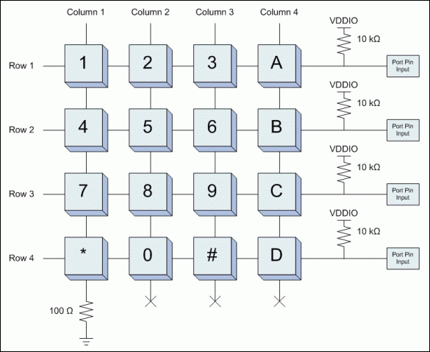Illustration 1: 16-Key Multiplexed Representation
We will also employ debouncing techniques to ensure an accurate representation of key presses in our circuit. The essential theory to our implementation is that a delay will be instigated between first recognizing a change in input and accepting a final keypress as input. This delay allows the circuit to ignore noise generated upon a keypress.

Resources
[1] http://comsci.liu.edu/~jrodriguez/cs154fl08/Slides/Lecture5.pdf
[Illustration 1]
http://www.maximintegrated.com/en/images/appnotes/3414/3414Fig03.gif

Procedure
Procedures were gathered and carried out directly from the lab manual, “Laboratory Assignment #4 – Scanning Keypad Interface”. Much of the lab was spent interpreting and applying the manuals directions to the supplied Quartus template files. Working from the provided top level schematic design provided, we first used a logic probe to manually follow the circuits supposed path of operation. This aided us in overcoming a number of ambiguous declarations in the lab manual with which we were unacquainted, such as the role of a clock driving our [7..4] output pins and what logic level they should reside at. We then reviewed the supplied project code, and as instructed by the manual attempted to run the project with the keypad wired as shown.
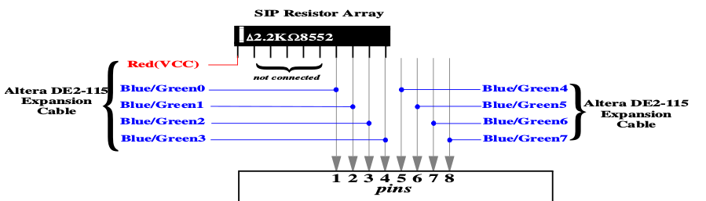Illustration 2: Keypad Wiring Diagram

Without a complete understanding of how the template code was generated, this initial test proved to be nonconstructive and only led us to question the integrity of the keypad being employed; the output given appeared highly unrepresentative of the project's flow or function. After it was decided to move forward, the key_scan module was completed by wiring the clock signal into a binary counter which supplied inputs to test our input and output lines sequentially. The first attempt at this module had line logic values reversed. The debounce module was then assembled with a series of J/K flip flops and logic gates in an attempt to propagate only a series of seven or more consecutive, uniform logic values. This approach was later abandoned in favor of a shift register which provides an immediate view of the seven latest logic values to be compared. The code_cnv module worked appropriately on the first attempt, which was to use an always statement and switch statement to map input lines to empirically determined output lines.

Results
No ostensible calculations were required in today's lab, and truth tables were supplied in the form of Illustration 2. The end operation of our circuit was as described by the lab manual, with consecutive digits being shifted along the DEC2-115's seven segment displays.

Conclusion and Discussion
As mentioned in the Procedure section, the lab had some aspects of fear, uncertainty, and doubt as described the the manual. Without a more complete understanding of the expected outcome, designing sub components became a much more laborious object than necessary. This lends to a better appreciation of sequential logic circuit design, in which more man power and less comprehensive understanding may be detrimental to a professional project. Nevertheless, post review of the circuit provided much insight to the utility and operation of scanning matrix keyboards, debouncing, and the implementation of multiplexing in schematic representations. It is our takeaway that this circuit could be used as a component of a larger project to gather keypad input for more serious or applicable purposes, though the debouncing module designed left the circuit with a “dead” feel to it: something to be reevaluated before implementation in future projects.

Questions
Questions were provided with the lab manual. In order to prevent a slew of complications in our lab report, they will be answered directly in this extraneous section.

1. Verilog HDL equivalent design. There was some confusion as to what a binary counter is if not what's provided.

2. clk_in – 50Mhz
scan_clk – 1.526Khz
debounce_clk – 24.414Khz

3. scan_en is the condition for a ternary operator which either allows scan_clk to be assigned from the register, or to be re-assigned its existing value for as long as scan_en is a logic high. debounce_clk is unaffected.

4. Debouncing allows the circuit to function with the presence of noise generated during a keypress. In Phase 1, the circuit interpreted each high level keypress as multiple connections and disconnections of the keyswitch. The operation of our debounce module is described in the report.

5. We students are not aware of the factors at play when choosing the frequencies of a general purpose clock, thus only a general conjecture from the lab is available. It seems the number of operations would be a defining factor in determining clock speed, as similarly determined for implementation of algorithms in general computer software. For a larger number of operations, likely indicated by more keys on the board, we may have to increase the clock speed, but ensure that the debounce time is unaffected. Assuming “These values” refers to the clk_in speed of 50Mhz, we can only provide an answer of “no”; there must be a keyboard in existence for which a 50Mhz clock speed is inappropriate. More specifically, a single SPST momentary switch likely operates without complications on much slower clock speeds than the ones we are dealing with, in fact many microcontrollers used in keyboards run a core speed at less than 20Mhz.

6. The hex_seven_shift module operates by mapping raw binary values to registers which correspond with the LEDs in our seven segment displays. As the input changes, a new binary value is loaded into the top level register, and at the next shift signal, the seven segment registers each assume the adjacent displays' contents with the top most display reading from the top level register. The shift signal is active only after the debounce module has delayed our input, it instigates the transfer of register contents from one display to the adjacent, though the assignment breaks most coding conventions previously understood by us students, with a newly assigned register passing a now non-existent value to the next register.

7. The code_cnv module is described in our lab report. It is a combinational system.

