Christopher Bero
EH-102 Research Paper
Due 2014-7-29
Re-tweets for Health
For a moment I stare perplexed at my left arm. In front of me the sound of Nathan calling that he has gotten free of the crawl and is waiting can be heard. Behind me Daniel chuckles in amazement at our colleague's pace. During the following silence it takes a few moments to ponder the status of my arm and recognize a now crushing weight on my chest, then startling conclusion is gathered: I've been caught between two protruding sections of rock in the Blue Crawl. A section of the cave about four hours back from the entrance and widely regarded as the most difficult area for cavers, the Blue Crawl makes for the basis of any experienced caver's nightmares. I am in a one hundred foot long horizontal tunnel which is so small that my hardhat must be taken off and pushed sideways in front of me. Just to reach the crawl, we had to scale a ledge with a drop waiting below. Once inside, the ledge allows for no backing up; the Blue Crawl is a one way ticket, and being able to physically fit becomes mandatory. I have apparently just failed that bit, only a few feet into the crawl my left elbow has slipped and dropped my torso about six inches, totally wedging it between the sides of the tunnel. Frozen like a grotesque ballerina, I lie trapped on my side with hands raised in front of my head and toes pointed backwards to keep my boots from becoming stuck. There is no room to move my hands backwards and push myself through, nothing to grab hold of in front of me and pull. As claustrophobia encroaches I squirm and arch to no avail. After becoming exhausted more sophisticated measures are called for, such as swearing while crying in desperation. The stinging sensation of how absolutely backwards and wrong I find such a scenario to be is incredible. A sense of hopelessness washes over me and burns hot behind my nose as I consider just how asinine the situation is: to be caught in a section of cave that I really have no business visiting in the first place. (More information? Play with re-writes that either contain more or are more succinct) An eternity passes, and fifteen minutes later, with Daniel's help in finding a usable foothold to kick from, I'm free and begin slowly working the remaining ninety feet to the section's end.
It is only hours later and back above ground that I am able to step back and consider my thoughts and emotions while seized by the cave; I find that they are not unique or new in most aspects. As I can only assume many other adolescence go through, at times I've felt lost and abandoned while wading through the choices and paths available in life. More specifically I can relate the aforementioned feelings to those I experience when I consider growing up with technology, so called social media, and how lost myself and others are when confronted with the two. (Look for a better way to merge the caving accident, feeling lost while growing up, and feeling lost over the new situations technology poses while growing up) My generation is writing itself into what once could only be an over generalized science fiction plot: a society of individually intelligent persons who collectively fail to understand the mechanics of the devices upon which they depend daily. Only a small percentage of the entire populous actually holds a strong comprehension of wireless communications which enable everything from cellphones to vehicular anti-theft tools. There are millions of examples to choose from which showcase the peril of our situation: from identity theft to the repression of entire countries by their own government. Just as we insist on driving gargantuan metal cages with wheels at speeds we are inherently unprepared to react to, so we insist on enriching ourselves with 'magical' devices which do our bidding and reshape how we interact without any concern with how or why they work. Even granting that the cultural view towards technology is a superstitious one, why have we settled for cheap entertainment over a powerful means of self improvement and resource for knowledge? How does our society really compare to previous eras where such influences weren't available, and can it be argued that our current path is one of self harm and destruction? (questions to be re-written as a thesis statement after finishing the paper)
The health aspects of heavy technology integration are becoming more profound with every passing day. To be pedantic, there are two general categories that may be generated from the introduction: the impact of our everyday use of or contact with technology, and the impact of technology on medical procedures and effectiveness. For the purposes of the investigation we shall be considering the former, that of everyday contact, as medical procedures and development falls outside the command of the author's experience. Technology integration has been going on for over a century, and rather than discuss the impact of a motorcar, we further classify the word 'technology' to specifically reference household electronics which have bloomed into everyday life in recent years. In the most straightforward and unconcealed form of such technology integration, sitting in front of a computer is well recognized as detrimental to physical health. Neck pain, back pain, shoulder and arm pain, carpel tunnel syndrome, poor circulation, eye strain, and headaches are documented and practices to reduce prevent such injuries have made their way into the general policies of large companies and institutions, such as that of the University of Pittsburgh (“Computer Operators'”). These injuries, which are sustained largely in a demographic which uses computers for a living, can be a nuisance and chronic dilemma of little doubt. They are most definitely not death though, and may appear to not further an inquisition to the association between death and modern gadgets. Perhaps injury can, however, count as a stage, type, or condition of death. Unlike a sprain received after stepping wrongly on a hike, the shoulder damage collected from constant contact with a computer is often much longer lived, even becoming chronic as the source of such pain is not removed in many cases (B. Green 3). In this way, an otherwise unmarred and capable body is entirely lowered in standard, presenting its associated character pain and limited ability. Similarly, there are people who have died while caving, yet their initial problem may be as simple as “I'm stuck.” (S. Green). To this juxtaposition we can relate the leveling off and downturn of overall healthiness for those experiencing these symptoms to be an initial “I'm stuck” phase of both concrete and psychological death. Something external has arrived to cause internal damage that may or may not be reversible or curable. An article by the University of Nebraska-Lincoln summarily concludes the gravity of computer use by identifying it as Cumulative Trauma Disorder, which indicates the persistent and unnatural qualities associated with our discussed repetitive strain injuries (Marxhausen).
Computers are but one aspect of life lived among circuits. Television systems developed rapidly after World War II, and cathode ray TV sets marched on living rooms under a banner depicting a united and interconnected world of intellectuals. Today TVs are so widespread, they are measured not in number of houses with television, but rather the number of televisions per house (Figure 2). A 2010 article entitled “Health Effects of Media on Children and Adolescents” lists a slew of situations and corresponding trends of important physiological and psychological shifts which indicate a slide in the wellbeing of developing children (Strasburger 1/3 down article). The studies correlate TV usage to attention-deficit disorder (ADD), speech development issues, poor academic performance, hypertension, sleep disorder, mood disorders, eating disorders, depression, and other psychological distress. These connections are troubling, in that they paint a picture very true to trends of heightened ADD diagnosis in the United States:
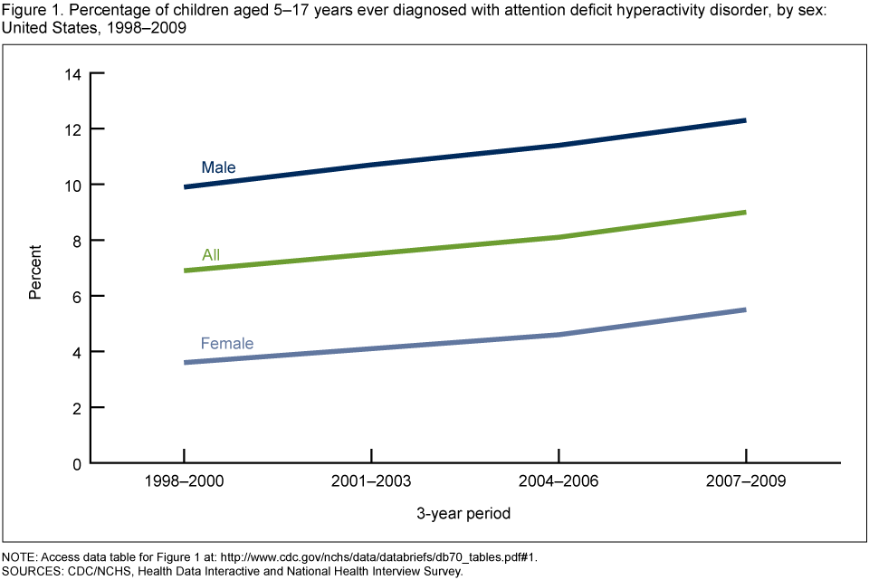
Figure 1:

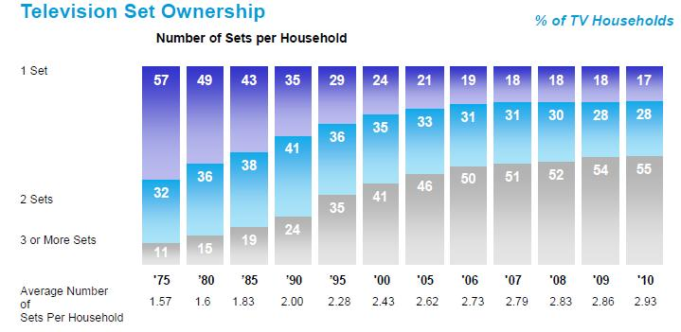
Figure 2:

Between the two graphics is is easy to see an external confirming correlation between ADD diagnosis and televisions per household.
To begin, we should seek some historical perspective. In Judith A. Swanson's book The Public and Private in Aristotle's Political Philosophy the writings of Aristotle, a Greek philosopher, are given interpretation in regards to common misconceptions. Through the book, Swanson argues that Aristotle's concept of privacy is prerequisite to society, and that it is also the provision for virtue and self improvement in a person's life (Swanson 12). Aristotle has just detailed that a person must be able to work internally to achieve self betterment. This contradicts many commercials for team building services, and even a public education system in which students are gathered and “instilled” with knowledge rather than being given just the tools to generate and gather for one's own. But upon closer look it may be apparent that team building exercises and public schools do serve the individual who is privately motivated to learn and accentuate lessons with a more fulfilled experience than another student who, not wrongly, simply participates in society. The private aspect and events of life are critical to development as a person, and in turn critical to the social environment in which he or she operates. This concept is further expounded in dizzying detail by our next writer, Joseph Tussman. In his book Government and the Mind, Tussman argues that contrary to a large faction of public belief, the government deserves complete involvement in the spirit and mind of its citizenry. The argument directly addresses our inherent belief that a government must be limited and bound in order to prevent it from developing tyrannical tendencies. Indeed, Tussman states, the government's best course of action to remain as righteous as possible is to ensure that each citizen is educated to a level capable of carrying the home country forward (Tussman 54). In a way, this is nothing new as government has been long established as the procurement of a standard education with the expressed goal of bettering its people. But the article drives to a deeper level of comprehension in attempting to show that common views of the 'big bad state' need to be combated by better involvement in the government, not be neutering the capabilities which allow society to remain cohesive and functional.
In light of recent events, however, Tussman's philosophy appears ephemeral and fragile. The government of the United States has been found conducting high scale surveillance on the entire planet by means of a secret court (“The NSA”). The knowledge that every time a person has used a phone, sent an email, or visited an HTTPS webpage in the past several years has had that data recorded and analyzed may rightfully drudge forth that characteristic feeling of loss and helplessness. Our case in point, that such an endeared and determinedly valuable aspect to life can be wrest from an entire population's grasp without their knowledge.

Outline remainder
- Address supersitious views of technology
- Laptops in HSV schools
- Public education and Aristotle's philosophy
- Facebook social experiments
- Material values brought by a culture shock of new things to own
- Lifestyle of debt
- Health affects of technology on a society as a whole

(Conclusion to be written after thesis)
Works Cited

Bromfield, Morton. “Dial 1984.” American Privacy Foundation, 1983. Print.
Swanson, Judith A. The Public and Private in Aristotle's Political Philosophy. Ithaca: Cornell UP, 1992. Print.
“The NSA Files.” The Guardian. The Guardian, n.d. Web.
Tussman, Joseph. Government and the Mind. Oxford UP, 1977. Print.
“Computer Operators' Risk Factors.” Workplace Health and Safety. University of Pittsburgh, Sept. 19th 2007. Web. 29th July 2014.
Green, Bart N. “A Literature Review of Neck Pain Associated with Computer Use: Public Health Implications.” J Can Chiropr Assoc. 52(3) (Aug 2008): 161-167. Web. 29Th July 2014.
Green, Stewart. “Utah Caver Dies After Becoming Stuck.” About. n.p., 28th Nov. 2009. Web. 29th July 2014.
Marxhausen, Paul. “Computer Related Repetitive Strain Injury.” unl. University of Nebraska-Lincoln, 2013. Web. 29Th July 2014.
Strasburger, Victor C. et al. “Health Effects of Median on Children and Adolescents.” Pediatrics Vol. 125 (1 April 2010): 756-767. Web. 29Th July 2014.

