Lab 01 Report
Christopher Bero
EE 316

Circuits Review

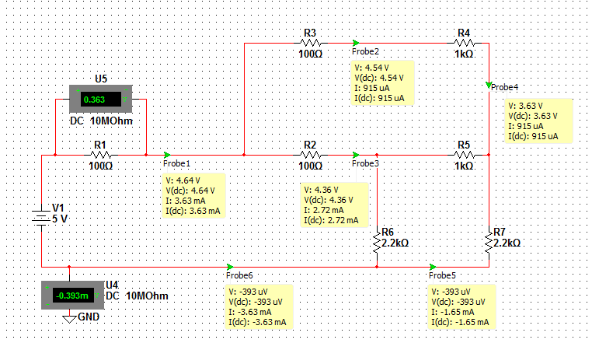Illustration 1: Circuit 1

Branch Voltages | Branch Currents | Node Voltages | Loop Currents
VR1 = 0.36V | IR1 = 3.63mA | V1 = 4.64V | I1 =3.63mA
VR2 = 0.27V | IR2 = 2.72mA | V2 = 4.54V | I2 =1.65mA
VR3 = 0.09V | IR3 = 0.92mA | V3 = 4.36V | I3 =0.92mA
VR4 = 0.92V | IR4 = 0.92mA | V4 = 3.63V
VR5 = 0.74V | IR5 = 735uA
VR6 = 7.60V | IR6 = 3.46mA
VR7 = 3.67V | IR7 = 1.65mA

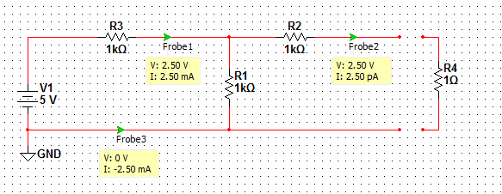Illustration 2: Circuit 2

RL (Ohms) | VL (V) | IL (mA)
10 | 0.454 | 45.4
30 | 1.155 | 38.5
70 | 2.058 | 29.4
100 | 2.541 | 25.3
150 | 3.021 | 20.2
200 | 3.331 | 16.7
300 | 3.747 | 12.4
500 | 4.164 | 8.3
1000 | 4.523 | 4.5

