Christopher Bero
CPE412
HW4

Matrix Multiplication with Pthreads

1.

Execution
> ./bin/mm_mult_serial_gnu 3
A matrix =
48.3962 65.3245 15.0385
72.383 25.8898 46.0265
15.4881 50.6507 6.74602

B matrix =
71.0055 12.2209 77.5441
61.5452 31.5127 46.8515
89.4849 70.0342 57.3195

C matrix =
8802.52 3703.21 7675.39
10851.7 4923.87 9464.07
4820.71 2257.87 3960.75

time=0 seconds

> ./bin/mm_mult_serial_gnu 3 4 5
A matrix =
48.3962 65.3245 15.0385 72.383
25.8898 46.0265 15.4881 50.6507
6.74602 71.0055 12.2209 77.5441

B matrix =
61.5452 31.5127 46.8515 89.4849 70.0342
57.3195 75.4144 83.5553 91.7832 7.74197
40.0845 11.1709 26.5416 83.9488 86.5328
51.0444 65.3442 85.2683 76.9977 49.0015

C matrix =
11020.5 11349.3 14296.8 17162.2 8743.33
7437.87 7769.66 9788.71 11741.4 5991.69
8933.24 10771 13185.4 14117.4 5879.46

time=0 seconds

2.

Execution
> ./bin/mm_mult_pthread_gnu 2 3 4 5
A matrix =
48.3962 65.3245 15.0385 72.383
25.8898 46.0265 15.4881 50.6507
6.74602 71.0055 12.2209 77.5441

B matrix =
61.5452 31.5127 46.8515 89.4849 70.0342
57.3195 75.4144 83.5553 91.7832 7.74197
40.0845 11.1709 26.5416 83.9488 86.5328
51.0444 65.3442 85.2683 76.9977 49.0015

C matrix =
11020.5 11349.3 14296.8 17162.2 8743.33
7437.87 7769.66 9788.71 11741.4 5991.69
8933.24 10771 13185.4 14117.4 5879.46

time=0.000199 seconds

> ./bin/mm_mult_pthread_gnu 4 3 4 5
A matrix =
48.3962 65.3245 15.0385 72.383
25.8898 46.0265 15.4881 50.6507
6.74602 71.0055 12.2209 77.5441

B matrix =
61.5452 31.5127 46.8515 89.4849 70.0342
57.3195 75.4144 83.5553 91.7832 7.74197
40.0845 11.1709 26.5416 83.9488 86.5328
51.0444 65.3442 85.2683 76.9977 49.0015

C matrix =
11020.5 11349.3 14296.8 17162.2 8743.33
7437.87 7769.66 9788.71 11741.4 5991.69
8933.24 10771 13185.4 14117.4 5879.46

time=0.00026 seconds

> ./bin/mm_mult_pthread_gnu 6 3 4 5
A matrix =
48.3962 65.3245 15.0385 72.383
25.8898 46.0265 15.4881 50.6507
6.74602 71.0055 12.2209 77.5441

B matrix =
61.5452 31.5127 46.8515 89.4849 70.0342
57.3195 75.4144 83.5553 91.7832 7.74197
40.0845 11.1709 26.5416 83.9488 86.5328
51.0444 65.3442 85.2683 76.9977 49.0015

C matrix =
11020.5 11349.3 14296.8 17162.2 8743.33
7437.87 7769.66 9788.71 11741.4 5991.69
8933.24 10771 13185.4 14117.4 5879.46

time=0.000222 seconds

> ./bin/mm_mult_pthread_gnu 8 3 4 5
A matrix =
48.3962 65.3245 15.0385 72.383
25.8898 46.0265 15.4881 50.6507
6.74602 71.0055 12.2209 77.5441

B matrix =
61.5452 31.5127 46.8515 89.4849 70.0342
57.3195 75.4144 83.5553 91.7832 7.74197
40.0845 11.1709 26.5416 83.9488 86.5328
51.0444 65.3442 85.2683 76.9977 49.0015

C matrix =
11020.5 11349.3 14296.8 17162.2 8743.33
7437.87 7769.66 9788.71 11741.4 5991.69
8933.24 10771 13185.4 14117.4 5879.46

time=0.000542 seconds

> ./bin/mm_mult_pthread_gnu 2 3
A matrix =
48.3962 65.3245 15.0385
72.383 25.8898 46.0265
15.4881 50.6507 6.74602

B matrix =
71.0055 12.2209 77.5441
61.5452 31.5127 46.8515
89.4849 70.0342 57.3195

C matrix =
8802.52 3703.21 7675.39
10851.7 4923.87 9464.07
4820.71 2257.87 3960.75

time=0.000207 seconds

> ./bin/mm_mult_pthread_gnu 4 3
A matrix =
48.3962 65.3245 15.0385
72.383 25.8898 46.0265
15.4881 50.6507 6.74602

B matrix =
71.0055 12.2209 77.5441
61.5452 31.5127 46.8515
89.4849 70.0342 57.3195

C matrix =
8802.52 3703.21 7675.39
10851.7 4923.87 9464.07
4820.71 2257.87 3960.75

time=0.000434 seconds

> ./bin/mm_mult_pthread_gnu 6 3
A matrix =
48.3962 65.3245 15.0385
72.383 25.8898 46.0265
15.4881 50.6507 6.74602

B matrix =
71.0055 12.2209 77.5441
61.5452 31.5127 46.8515
89.4849 70.0342 57.3195

C matrix =
8802.52 3703.21 7675.39
10851.7 4923.87 9464.07
4820.71 2257.87 3960.75

time=0.000363 seconds

> ./bin/mm_mult_pthread_gnu 8 3
A matrix =
48.3962 65.3245 15.0385
72.383 25.8898 46.0265
15.4881 50.6507 6.74602

B matrix =
71.0055 12.2209 77.5441
61.5452 31.5127 46.8515
89.4849 70.0342 57.3195

C matrix =
8802.52 3703.21 7675.39
10851.7 4923.87 9464.07
4820.71 2257.87 3960.75

time=0.000402 seconds

3.

Time Evaluation

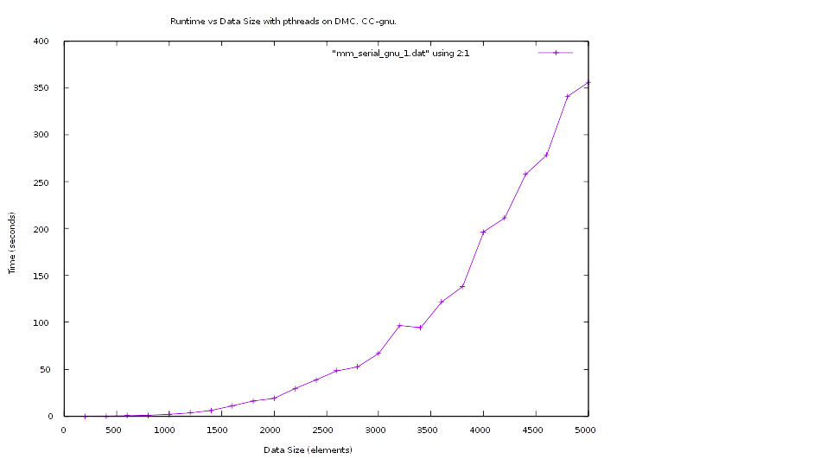
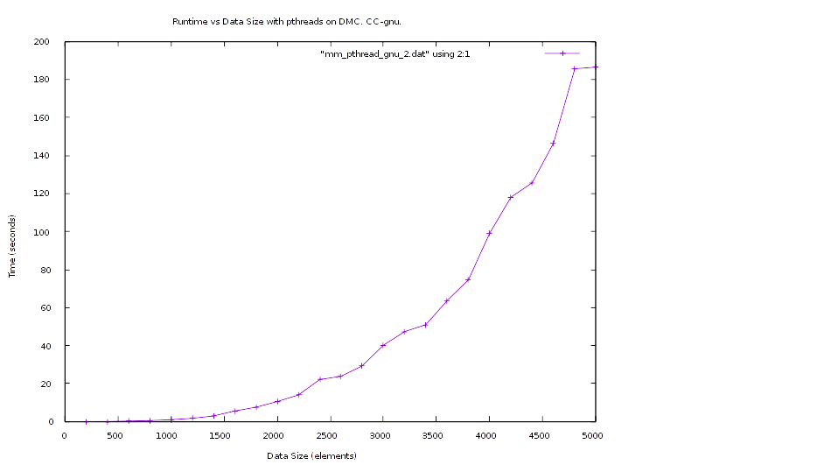

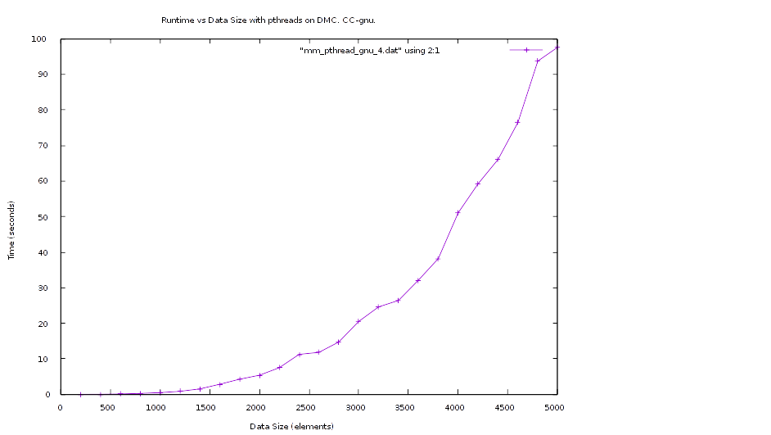
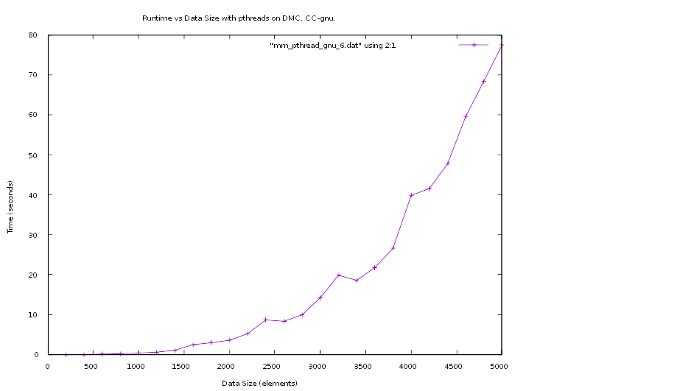

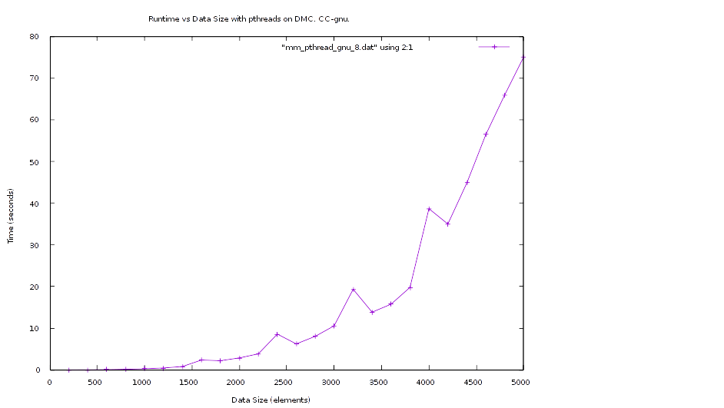
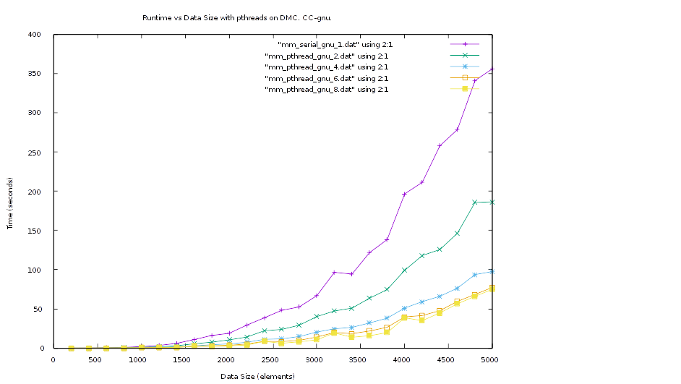
The algorithm appears to be O(N³).

Efficiency
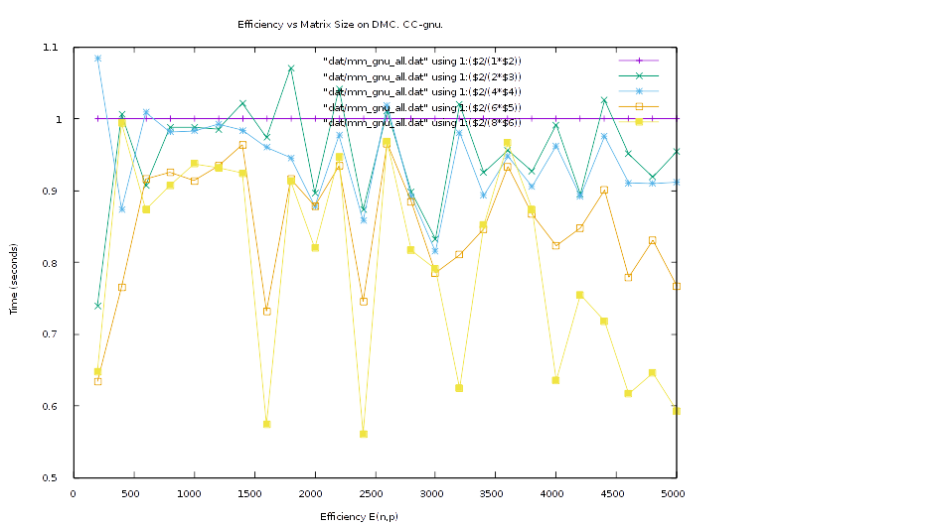
Speedup
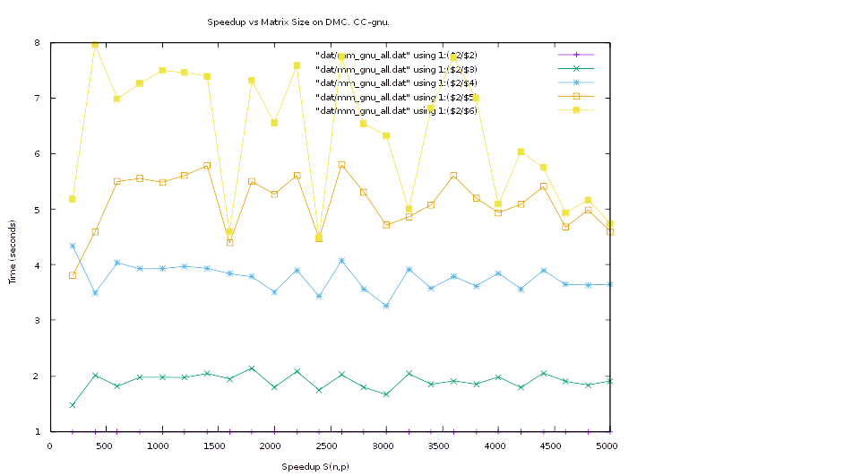

Makefile
all: mm_mult_serial_gnu mm_mult_pthread_gnu

mm_mult_serial_gnu:
g++ src/mm_mult_serial.cpp -o bin/mm_mult_serial_gnu -O3 -lm -Wall

mm_mult_pthread_gnu:
g++ src/mm_mult_pthread_gnu.cpp -o bin/mm_mult_pthread_gnu -O3 -lm -Wall -pthread

clean:
rm bin/*
rm src/*.o

mm_gnu_all.dat
#Size Thread 1 2 4 6 8
200 0.012415 0.008393 0.002861 0.003265 0.002396
400 0.097049 0.048226 0.027753 0.021124 0.012205
600 0.423630 0.233459 0.104991 0.077070 0.060638
800 0.965298 0.488444 0.245841 0.173843 0.133022
1000 1.932308 0.977752 0.491574 0.352367 0.257798
1200 3.349726 1.699582 0.843867 0.597637 0.449353
1400 6.002106 2.937586 1.524805 1.037911 0.811587
1600 10.79589 5.543588 2.811376 2.457509 2.35112
1800 16.084557 7.509092 4.251379 2.926122 2.200863
2000 18.819846 10.491979 5.358012 3.571051 2.870277
2200 29.169287 13.995196 7.466483 5.204190 3.850018
2400 38.563947 22.080063 11.236789 8.624153 8.588557
2600 48.137846 23.817796 11.813052 8.307243 6.218692
2800 52.539932 29.244758 14.724251 9.902529 8.043548
3000 66.834365 40.146301 20.500198 14.185645 10.567506
3200 96.523402 47.314063 24.603565 19.851688 19.327111
3400 94.324441 50.991014 26.40643 18.568165 13.843345
3600 121.67896 63.622781 32.098493 21.72647 15.745785
3800 138.27112 74.59853 38.175315 26.580889 19.777306
4000 196.56844 99.103223 51.067783 39.802383 38.659629
4200 211.23321 118.02812 59.219808 41.524966 34.980665
4400 257.74395 125.61351 66.042581 47.691784 44.853158
4600 278.49327 146.46752 76.441247 59.556957 56.441105
4800 341.00222 185.58191 93.717431 68.401868 65.985914
5000 356.00563 186.4496 97.621194 77.412276 75.057041

mm_mult_pthread_gnu.cpp

/******************************************************************/
/* Matrix Matrix Multiplication Program Example - pthread version */
/* September 2015 -- B. Earl Wells -- University of Alabama */
/* in Huntsville */
/* Modified base program - Chris Bero */
/******************************************************************/
/**
* Christopher Bero
* CPE 412 - HW4
* This program is a modification of mm_mult_serial.cpp
*/

using namespace std;
#include <iostream>
#include <iomanip>
#include <sstream>
#include <stdlib.h>
#include <stdio.h>
#include <string.h>
#include <sys/time.h>
#include <pthread.h>

#define DEBUG 0

#define MX_SZ 320
#define SEED 2397 /* random number seed */
#define MAX_VALUE 100.0 /* maximum size of array elements A, and B */

/* copied from mpbench */
#define TIMER_CLEAR (tv1.tv_sec = tv1.tv_usec = tv2.tv_sec = tv2.tv_usec = 0)
#define TIMER_START gettimeofday(&tv1, (struct timezone*)0)
#define TIMER_ELAPSED ((tv2.tv_usec-tv1.tv_usec)+((tv2.tv_sec-tv1.tv_sec)*1000000))
#define TIMER_STOP gettimeofday(&tv2, (struct timezone*)0)
struct timeval tv1,tv2;

typedef struct tdata
{
float * a;
float * b;
float * c;
int * dim_l;
int * dim_n;
int * dim_m;
int * tcount;
int tid;
} tdata;

/*
This declaration facilitates the creation of a two dimensional
dynamically allocated arrays (i.e. the lxm A array, the mxn B
array, and the lxn C array). It allows pointer arithmetic to
be applied to a single data stream that can be dynamically allocated.
To address the element at row x, and column y you would use the
following notation: A(x,y),B(x,y), or C(x,y), respectively.
Note that this differs from the normal C notation if A were a
two dimensional array of A[x][y] but is still very descriptive
of the data structure.
#define A(i,j) *(a+i*dim_m+j)
#define B(i,j) *(b+i*dim_n+j)
#define C(i,j) *(c+i*dim_n+j)
*/

#define A(i,j) *(data->a+i*(*data->dim_m)+j)
#define B(i,j) *(data->b+i**data->dim_n+j)
#define C(i,j) *(data->c+i**data->dim_n+j)

/*
Routine to retrieve the data size of the numbers array from the
command line or by prompting the user for the information
*/
void get_index_size(int argc,char *argv[],int * tcount,int *dim_l,int *dim_m,int *dim_n) {
if(argc!=3 && argc!=5) {
cout<<"usage: mm_mult_serial [thread count] [l_dimension] <m_dimension n_dimmension>"
<< endl;
exit(1);
}
else {
if (argc == 3) {
*tcount = atoi(argv[1]);
*dim_l = *dim_n = *dim_m = atoi(argv[2]);
}
else {
*tcount = atoi(argv[1]);
*dim_l = atoi(argv[2]);
*dim_m = atoi(argv[3]);
*dim_n = atoi(argv[4]);
}
}
if (*tcount<= 0 || *dim_l<=0 || *dim_n<=0 || *dim_m<=0) {
cout<<"Error: number of rows and/or columns must be greater than 0"
<< endl;
exit(1);
}
}

/*
Routine that fills the number matrix with Random Data with values
between 0 and MAX_VALUE
This simulates in some way what might happen if there was a
single sequential data acquisition source such as a single file
*/
void fill_matrix(float *array,int dim_m,int dim_n)
{
int i,j;
for(i=0;i<dim_m;i++) {
for (j=0;j<dim_n;j++) {
array[i*dim_n+j]=drand48()*MAX_VALUE;
}
}
}

/*
Routine that outputs the matrices to the screen
*/
void print_matrix(float *array,int dim_m,int dim_n)
{
int i,j;
for(i=0;i<dim_m;i++) {
for (j=0;j<dim_n;j++) {
cout << array[i*dim_n+j] << " ";
}
cout << endl;
}
}

void * twork (void * args)
{
float dot_prod;
int i, j, k;
int row_start, row_stop;
tdata * data = (tdata*)args;

// Not an elegant solution, but a fast one to implement
row_start = (*data->dim_l / *data->tcount) * data->tid;
row_stop = (*data->dim_l / *data->tcount) * (data->tid + 1);
if (data->tid == (*data->tcount-1))
{
row_stop = *data->dim_l;
}

//printf("\nWorking: %d, start: %d, stop: %d.", data->tid, row_start, row_stop);
//fflush(stdout);

for (i=row_start;i<row_stop;i++) {
for (j=0;j<*data->dim_n;j++) {
dot_prod = 0.0;
for (k=0;k<*data->dim_m;k++) {
dot_prod += A(i,k)*B(k,j);
}
C(i,j) = dot_prod;
}
}

return (NULL);
}

/*
MAIN ROUTINE: summation of a number list
*/
int main( int argc, char *argv[])
{
int dim_l,dim_n,dim_m;
int i;
float *a,*b,*c;
int tcount;
pthread_t * tids;
tdata * tdatas;

/*
get matrix sizes AND THREAD COUNT
*/
get_index_size(argc,argv,&tcount,&dim_l,&dim_m,&dim_n);

// dynamically allocate from heap the numbers in the memory space
// for the a,b, and c matrices
a = new (nothrow) float[dim_l*dim_m];
b = new (nothrow) float[dim_m*dim_n];
c = new (nothrow) float[dim_l*dim_n];
tids = new (nothrow) pthread_t[tcount];
tdatas = new (nothrow) tdata[tcount];
if(a==0 || b==0 || c==0 || tids==0) {
cout <<"ERROR: Insufficient Memory" << endl;
exit(1);
}

/*
initialize numbers matrix with random data
*/
srand48(SEED);
fill_matrix(a,dim_l,dim_m);
fill_matrix(b,dim_m,dim_n);

/*
output numbers matrix
*/
if (DEBUG)
{
cout << "A matrix =" << endl;
print_matrix(a,dim_l,dim_m);
cout << endl;

cout << "B matrix =" << endl;
print_matrix(b,dim_m,dim_n);
cout << endl;
}

/*
Start recording the execution time
*/
TIMER_CLEAR;
TIMER_START;

for (i=0; i<tcount; ++i)
{
tdatas[i].a = a;
tdatas[i].b = b;
tdatas[i].c = c;
tdatas[i].dim_l = &dim_l;
tdatas[i].dim_n = &dim_n;
tdatas[i].dim_m = &dim_m;
tdatas[i].tid = i;
tdatas[i].tcount = &tcount;
pthread_create(&tids[i], NULL, twork, &tdatas[i]);
}

for (i=0; i<tcount; ++i)
{
pthread_join(tids[i], NULL);
}

// multiply local part of matrix
/*
for (i=0;i<dim_l;i++) {
for (j=0;j<dim_n;j++) {
dot_prod = 0.0;
for (k=0;k<dim_m;k++) {
dot_prod += A(i,k)*B(k,j);
}
C(i,j) = dot_prod;
}
}
*/

/*
stop recording the execution time
*/
TIMER_STOP;

if (DEBUG)
{
cout << "C matrix =" << endl;
print_matrix(c,dim_l,dim_n);
cout << endl;
}
cout << "time=" << setprecision(8) << TIMER_ELAPSED/1000000.0
<< " seconds" << endl;

}

