Lab 09
Christopher Bero
EE384

Problem 1

Original Image
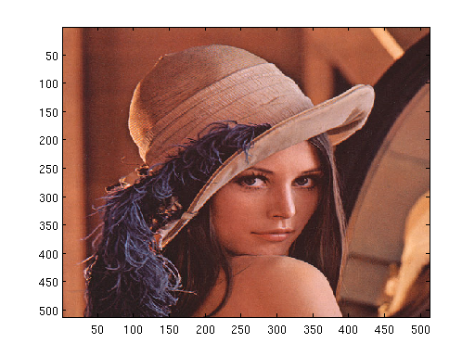
Grayscale Image
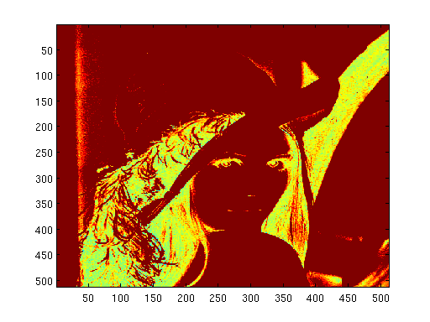
ee384_rgb2gray Image
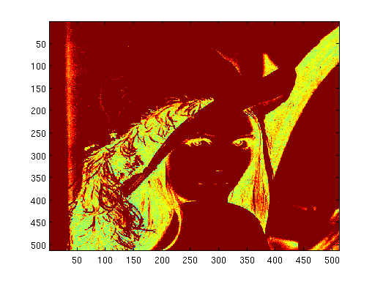
% Lab 09 - Problem 1
% EE384
% Christopher Bero

%P1.a
% Read and show lena.bmp
lena_a=imread('/home/berocs/Documents/uah/ee384/lab09/lena.bmp','bmp');
figure();
image(lena_a);

%P1.b
% Convert to greyscale with built-in function rgb2gray
lena_b=rgb2gray(lena);
figure();
image(lena_b);

% P1.c
% Write and use your own rgb2gray function
lena_c=ee384_rgb2gray(lena);
figure();
image(lena_c);

function [ bmp_gray ] = ee384_rgb2gray( bmp )
% ee384_rgb2gray - ee384 - Lab 09
% This function will stack R, G, and B mxn pages
% from an input bitmap. The color values are weighted
% 30% Red, 60% Green, 10% Blue

bmp_gray = (0.3 * bmp(:,:,1)) + (0.6 * bmp(:,:,2)) + (0.1 * bmp(:,:,3));

end

Problem 2

Original Lowcontrast
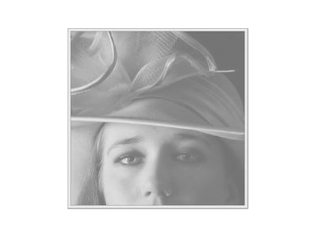
Original Histogram
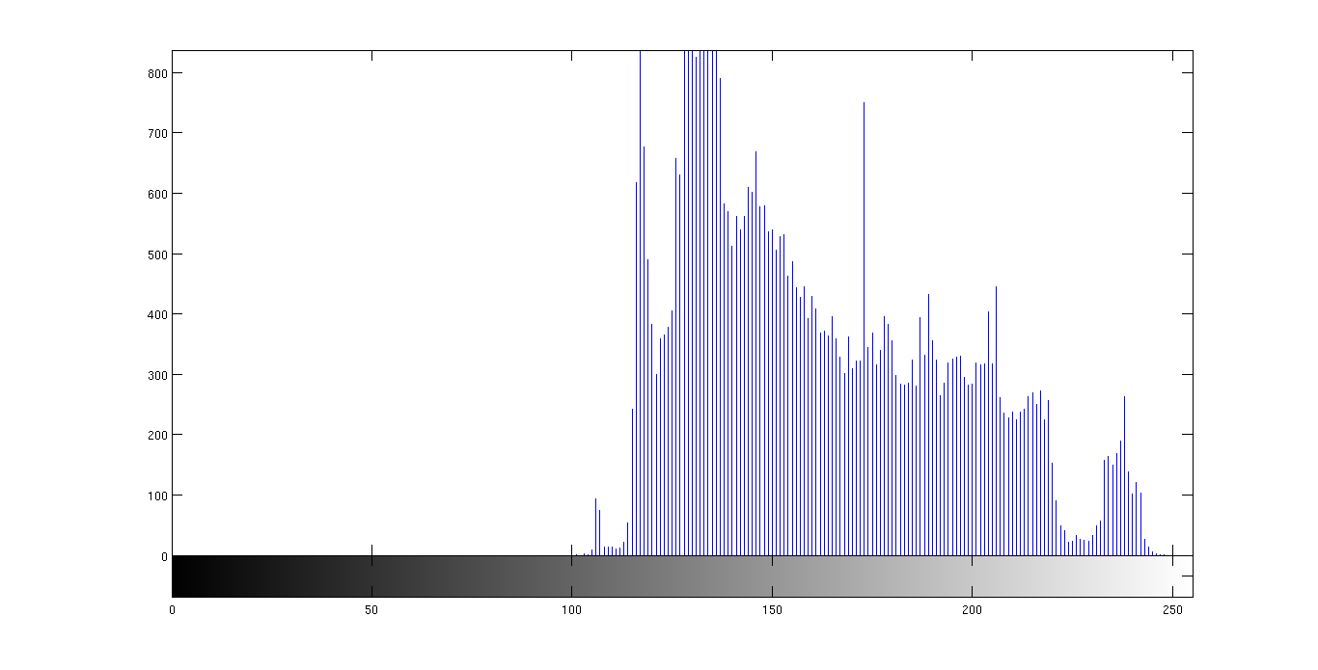

Modified Lowcontrast
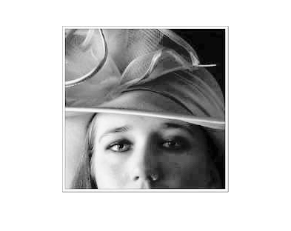
Modified Histogram
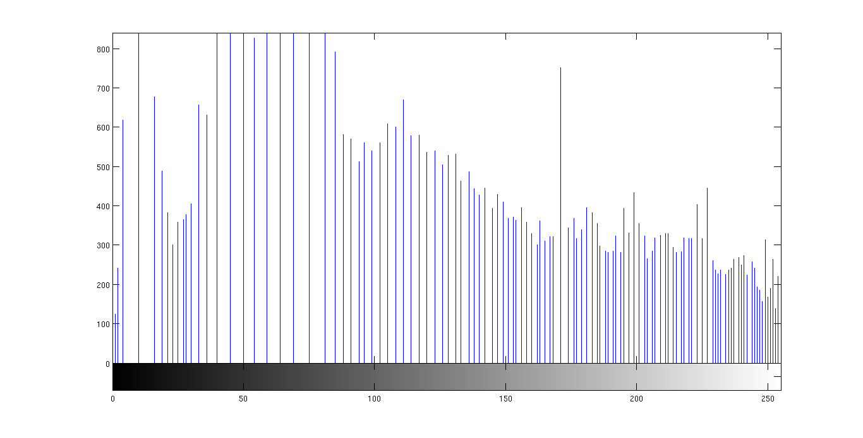
% Lab 09 - Problem 2
% EE384
% Christopher Bero

% P2.a
figa=figure();
lc_a=imread('/home/berocs/Documents/uah/ee384/lab09/lowcontrast.jpg');
imshow(lc_a);

% P2.b
figb=figure();
imhist(lc_a);

% P2.c
figc=figure();
lc_c=histeq(lc_a,256);
imshow(lc_c);
figc2=figure();
imhist(lc_c);

Problem 3

Noisy Image
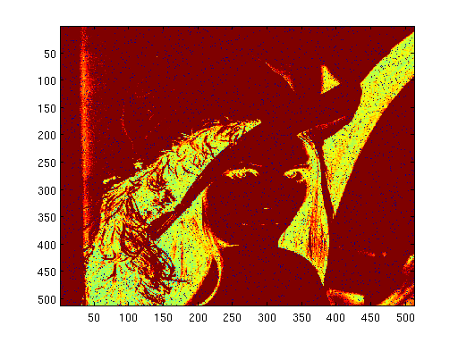
3x3 Averaged Image
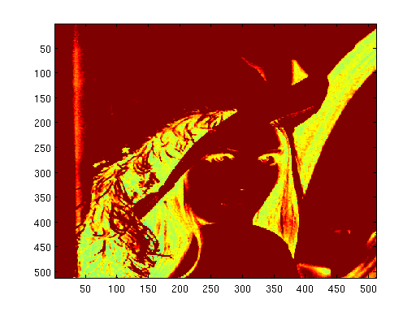

5x5 Averaged Image
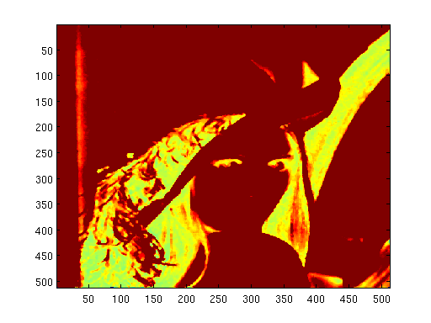
% Lab 09 - Problem 3
% EE384
% Christopher Bero

% P3.a
lena_a=imread('/home/berocs/Documents/uah/ee384/lab09/lena.bmp','bmp');
lena_a2=ee384_rgb2gray(lena_a);
lena_a3=imnoise(lena_a2, 'salt & pepper');
figure();
image(lena_a3);

% P3.b
lena_b=medfilt2(lena_a3);
figure();
image(lena_b);

% P3.c
lena_c=medfilt2(lena_a3, [5 5]);
figure();
image(lena_c);

We can see from the resulting images that the 3x3 filter does a good job at eliminating the noise by comparing it to the immediately neighboring pixels. The 5x5 filter also removes the noise, but degrades image quality noticeably by smoothing edges and textures.

