Christopher Bero
Journal 7
EH208

There were a few things that I immediately thought of while reading this adventure.

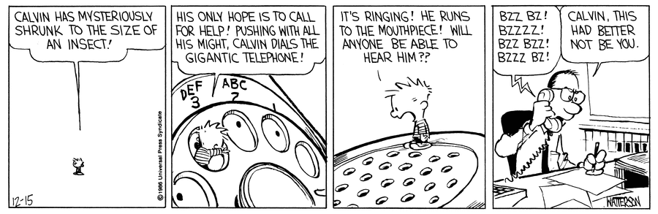
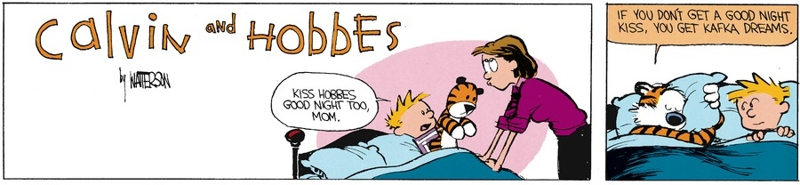
(journal on next page or back of sheet)
I'm not quite sure what to make of the beginning here, which may be intentional on the author's part. I want to say that Kafka is making an example of how quickly people can adapt to changes which are bizarre if given enough though, or the introduction is a way of stating “There's no sugarcoating this, I want to talk about bug-people.” But that doesn't feel quite accurate. I intend to ask in class if this is realism or modernism, because if I ignore the external cues from the book we're reading from, I can't really tell. And with that there's some waffling on what meaning is present. obviously there is a link to the prior works in which death is the final statement, but at the beginning of this tale – and in fact all the way up the the ending - Gregor is very much alive in his cockroach form.
If I stray a little further in than the journal prompt allows, the situation in which Gregor is trapped in his room heavily reminds me of a recent problem found largely in Japan. Hikikomori (ひきこもり) is when someone becomes so reclusive as to not leave a room or house, and it's becoming a massive problem in modern Japan where young people reject the immense social pressure to succeed and instead wall off their life. Families often support the afflicted, but from what I understand there's an aspect of their lifestyle or society that keeps parents from bothering or imploring their reclusive child to venture out. This similarity is very superficial though, as the situation that leads someone to Hikikomori, and I'm sure their experience of it, as well as the impetus which keeps them in the room must be different than that portrayed in The Metamorphosis.
Back to the opening. I'm going to settle on a final answer: Kafka is denouncing the way Gregor responds to discovering that he is an insect – worrying about work. It's too common even today. Get sick. Get in an accident. The first thing to worry about: will I be able to be at work tomorrow? Will I keep my job? Gregor has his humanity literally removed, and is still brought to a flustered frenzy of attempting to meet the demand of his occupation. It's satire similar to Gulliver's Travels in which things are absurdly wrong or unnatural, presented as fact, and bring you to question something that otherwise goes unnoticed.

