Lab 10 Report
Christopher Bero
EE 316

Amplification of a Signal Using JFETs

Simulation

The simulation portion of this assignment had us model a circuit from the following layout and test its output voltage against a variety of input frequencies. This shows us how the JFET will respond to a given bandwidth, or range of frequencies.

Circuit Model
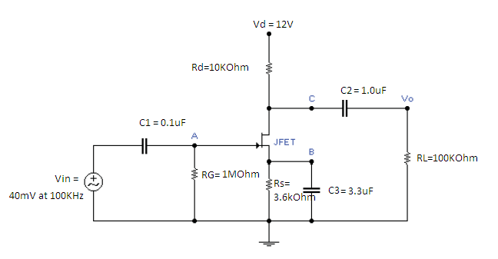

Simulation Circuit
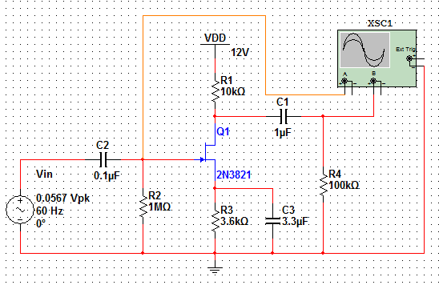
Circuit Responses

10Hz
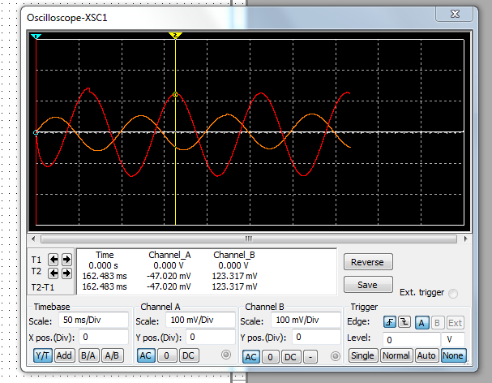
30Hz
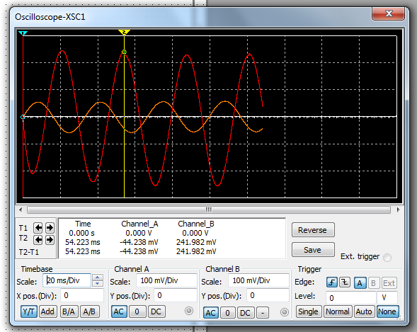

60Hz
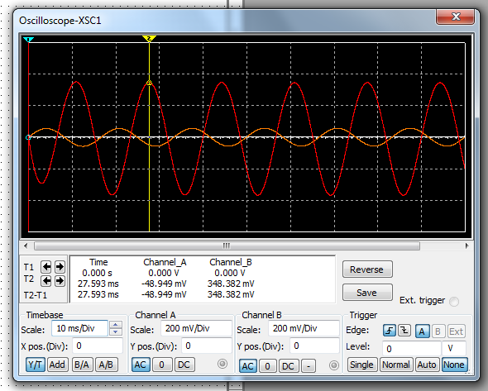
1.5KHz
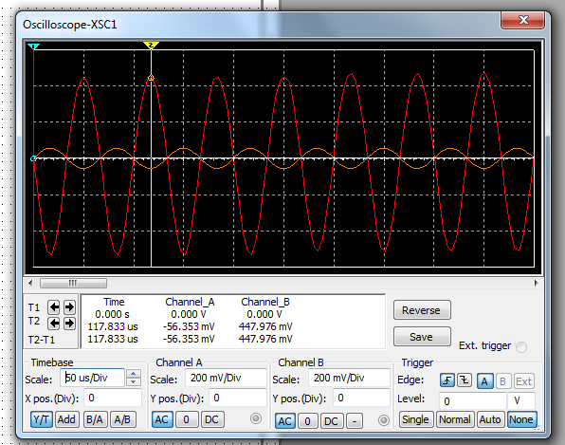

15KHz

Simulation Results

Frequency | Vout (Vpk) | Voltage Gain
10 | 0.123317 | 2.18
30 | 0.241982 | 4.27
60 | 0.348382 | 6.14
100 | 0.409094 | 7.22
200 | 0.451050 | 7.96
500 | 0.467524 | 8.25
1 KHz | 0.465341 | 8.21
2 kHz | 0.459702 | 8.11
5 KHz | 0.451954 | 7.97
10 KHz | 0.448771 | 7.91
15 KHz | 0.447976 | 7.9
20 KHz | 0.447574 | 7.89
50 KHz | 0.446900 | 7.88
75 KHz | 0.446820 | 7.88
100 KHz | 0.446822 | 7.88
150 KHz | 0.446905 | 7.88
200 KHz | 0.447018 | 7.88
500 KHz | 0.447529 | 7.89
750 KHz | 0.447528 | 7.89
1 MHz | 0.447117 | 7.89
1.5 MHz | 0.445025 | 7.85
2.0 MHz | 0.441252 | 7.78

Simulation Results

Hardware Results

Frequency | Vout (Vpk-pk) | Voltage Gain
10 | 0.191 | 1.68
30 | 0.334 | 2.95
60 | 0.490 | 4.32
100 | 0.595 | 5.25
200 | 0.680 | 6
500 | 0.710 | 6.26
1 KHz | 0.720 | 6.35
2 kHz | 0.720 | 6.35
5 KHz | 0.710 | 6.26
10 KHz | 0.700 | 6.17
15 KHz | 0.700 | 6.17
20 KHz | 0.690 | 6.08
50 KHz | 0.680 | 6
75 KHz | 0.680 | 6
100 KHz | 0.680 | 6
150 KHz | 0.680 | 6
200 KHz | 0.670 | 5.91
500 KHz | 0.800 | 7.05
750 KHz | 0.710 | 6.26
1 MHz | 0.650 | 5.73
1.5 MHz | 0.510 | 4.5
2.0 MHz | 0.410 | 3.62

Hardware Results

Conclusion

The JFET circuit used has a very clean gain mapping, where a large area of the frequency spectrum is plateaued. The gain graphs between simulation and hardware circuits were surprisingly agreeable, each showing the same characteristics that we expect. Compared to the MOSFET used in an earlier lab, the JFET has a much larger bandwidth and more leveled gain rather than the ramp plot we see from Lab 08.

