Final Project
Christopher Bero
EE384

DTMFE
Dual Tone Multiple Frequency – ASCII Extended

Project Description

This project is the groundwork for taking concepts introduced in EE381 and EE384 to further an extracurricular investigation. MODAC is the name of my pet project to integrate an embedded computer into the peripherals and CAN bus of an old Honda Civic. The system currently lacks remote access, and I'm unwilling to involve a cellular carrier. This DTMFE project is a proof of concept for implementing my own digital communications with the MODAC computer.

To fill space on this pace,
here's the solar charging circuit for MODAC
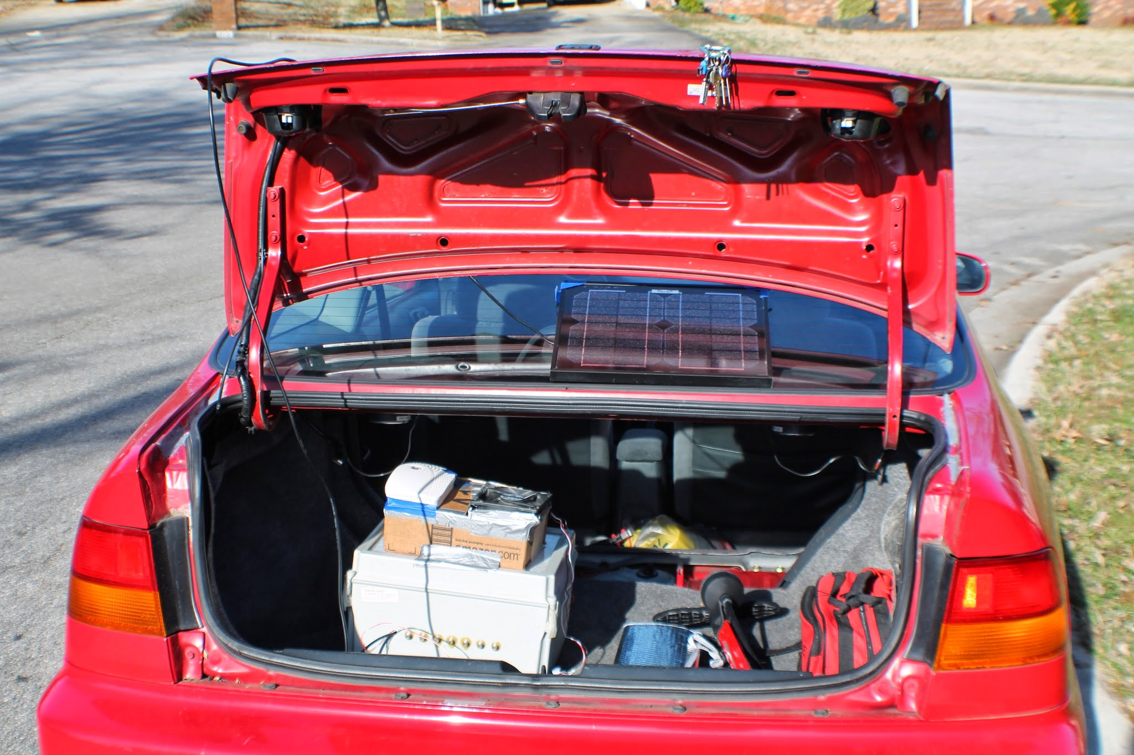

DTMFE Theory

DTMF is a well adopted tool for bridging traditional voice carriers and low speed character transmission. The standard, pioneered by AT&T during the 1950's, currently supports digits 0 through 9 and characters A, B, C, D (1). By increasing the number of frequencies available for generating a dual tone, this set should be able to cover most of the common characters found in serial connections.

To start out, we look at the original DTMF frequencies:

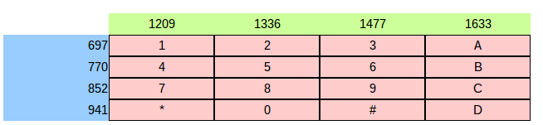

From the lonestar article on DTMF, we know that AT&T picked these odd looking frequencies specifically to decrease the probability that they will be mistaken for one another. The values minimize overlapping harmonics that will appear when the signal is analyzed in the frequency domain. I'm not very familiar with tools for designing such a grouping, so I found a correlation between the base values and extrapolated to fill the 12x12 extended ASCII table. Then the values were manually inspected and adjusted. This component of the system could use a lot more development to clean up the overlap between the row and column frequencies.

Multiplication between row and column:

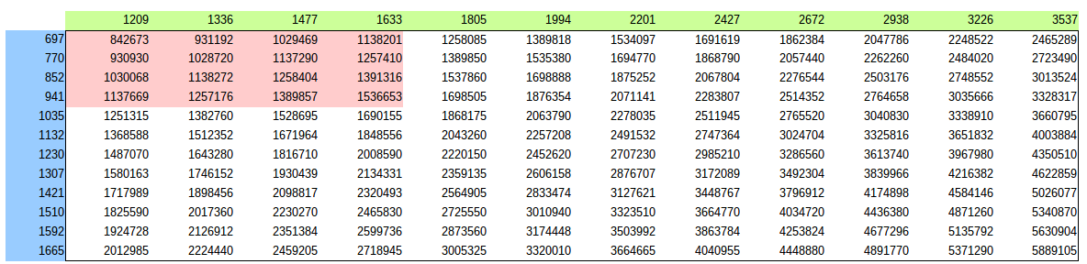

Addition between row and column:

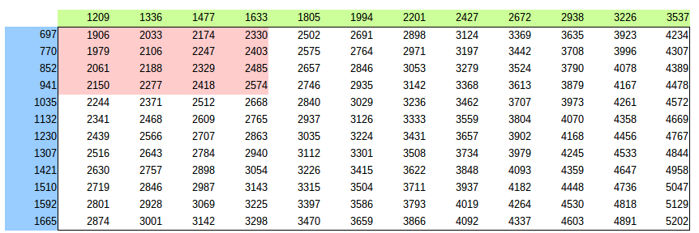
The final ASCII table:

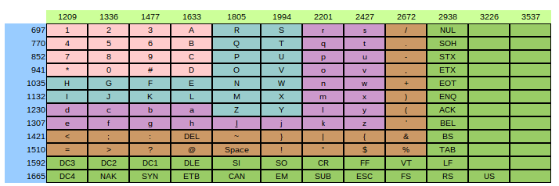
We're going to gloss over the Transmission side of the project, as it had more to do with embedded controllers and didn't require much signal processing theory.

The ATmega328 code has two libraries associated with it. One is a modified AMT1001 suite that will take analog data from the temperature and humidity sensors and deliver an integer to my process. The other is a tone generation tool which is attached to two PWM outputs and sends one of the chosen DTMFE waveforms to each pin (2).

The system follows this design:

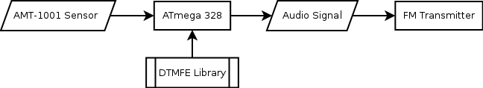

Now we have a standard for what the signal should look like, and a way to broadcast it as wideband FM. The signal has to be gathered and processed in Matlab. Gathering the signal requires a radio receiver and program such as rtl_sdr, the raw IQ data is written to a .dat file.

Reading .dat file
The .dat information is separated with alternating real and imaginary components. The values are 8 bit unsigned integers. Getting them read into Matlab is pretty simple, the elements are converted to doubles, and 127.5 is subtracted from each. Now Matlab has a complex signal.

Signal detection
Detection, or demodulation, is the process of taking our FM carrier signal and recovering the message stored in it. With AM, we know that the carrier can be used to retrieve the message directly. FM appears to be more complicated, but is resilient to the variations in amplitude present in radio.

FM demodulation (3):

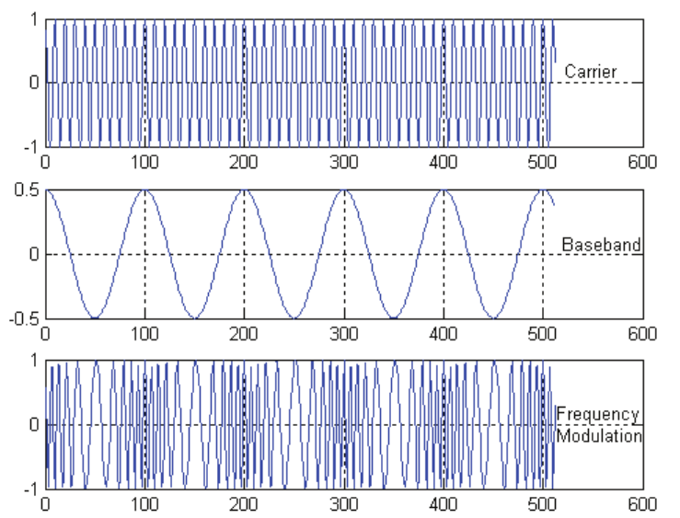http://www.acfr.usyd.edu.au/pdfs/training/sensorSystems/02%20Signal%20Processing%20and%20Modulation.pdf
This image helped in understanding how recovery of the message is possible. The modulated signal is convolved with an FIR differentiation filter. Matlab's conv function will multiply these two vectors together, which allows us to take the slope of the signal in the frequency domain. This slop then corresponds to the original message signal's amplitude, and can be used to reconstruct the message.
Once the audio has been recovered, a modified version of the course's dtmf_decode.m file is used to find the pair of frequencies and collect the ASCII characters. This file operates by taking small 0.05 second slices of the input signal and referencing them individually to control a state machine. The process lacks a lot of engineering and refinement, since it simply guesses at the ratio of noise found in silent portions to signal present during the tones. The governing state machine has two states to administer action on either silence or signal. When silence is detected, the system will discard the slices of signal until one has a cumulative power some factor higher than the others. Once a signal is detected the Matlab function will accumulate the small slices of signal until one has a lower cumulative power. The accumulated signal is then processed by a FFT to find its frequency spectrum. Here summation of the absolute value of the frequency representation is used as a rough stand in for an actual power calculation. Frequencies that land close to the DTMFE frequencies and have a local maximum are chosen and used in a lookup cell array to find the associated ASCII character.

The frequency spectrum of a section of silence compared with the frequency spectrum of a section of signal (two largest spikes are DTMFE tones)
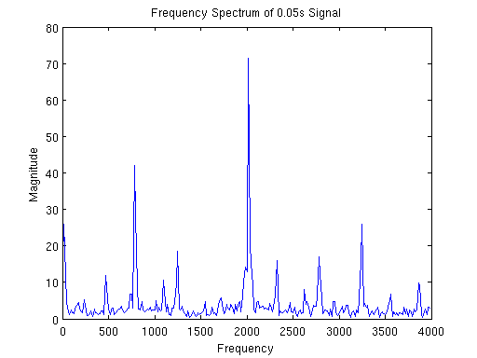
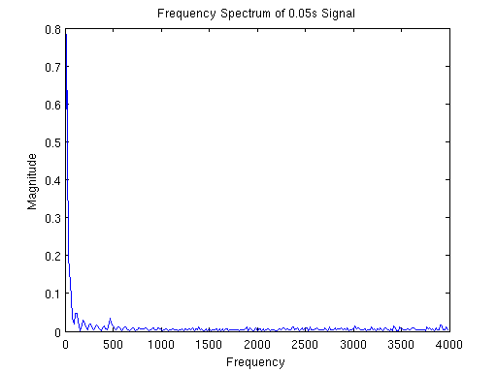
The differentiation filter response:
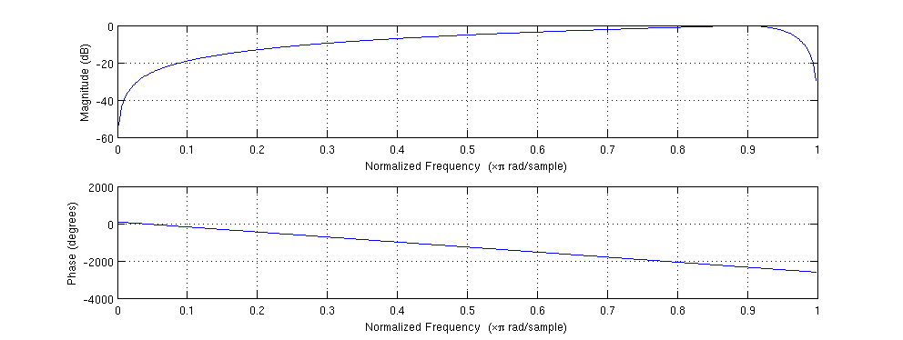
Implementation

Using the Matlab files is straightforward.

To capture IQ data, use the command:

rtl_sdr -f 103800000 -s 2048000 signal.dat

We're gathering a 2.048MHz bandwidth signal centered around the 103.8MHz broadcast. Its important that the signal we wish to decode is located at the center, the scripts do not currently support shifting to another section of the bandwidth before demodulating.

To process the file, use proc.m with the file's paths set accordingly. This should return a variable called “chars” which will contain the extracted characters.

Results

When there is no audible interference, the process will reliably return the correct characters. If there's audio, such as another radio station's broadcast leaking into our 103.8MHz target, as was the case during the presentation, then the interfering audio will cause the decoding function to incorrectly detect the change in states, which will cause character to either fail to detect or to be detected twice in a row.

I've saved the IQ data from class, and have processed a section of the raw signal's spectrum:
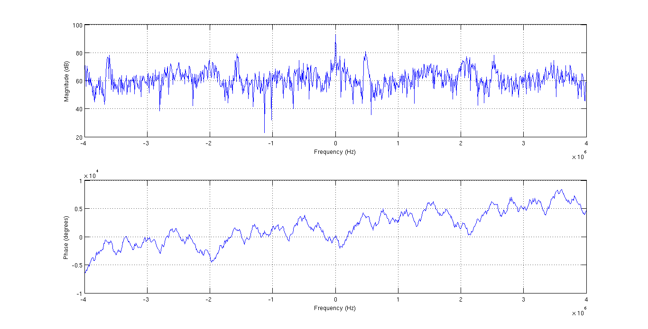
Our broadcast is centered at 0Hz on this plot, and we can see just half a megahertz to the right is 104.3MHz, a radio station in Huntsville. I believe with a better fitted filter, that voice could be eliminated from the signal sent for decoding.
Code

loadIQdat.m
function [ dat ] = loadIQdat( file )
% loadIQdat
% This function will parse a dat file output by rtl_sdr
% The .dat file is unsigned, so we have to center the signal.

% Open file handle
fid=fopen(file,'rb');

% Convert to double
dat=fread(fid,'uint8=>double');

% .dat is unsigned 0-255, center signal
dat=dat-127.5;

% Combine Real and Imaginary elements
dat=dat(1:2:end) + (1i*dat(2:2:end));

end

FM_IQ_Demod.m
function [y_FM_demodulated] = FM_IQ_Demod(y)
% FM_IQ_Demod
% This function demodualtes an FM signal. It is assumed that the FM signal
% is complex (i.e. an IQ signal) centered at DC and occupies less than 90%
% of total bandwidth.

% Design filter / differentiator
filter=firls(30,[0 .9],[0 1],'differentiator');

% Get the normalized signal?
diff=y./abs(y);

% Real portion of the signal
rd=real(diff);

% Imaginary portion of the signal.
id=imag(diff);

% Detected signal
y_FM_demodulated=(rd.*conv(id,filter,'same')-id.*conv(rd,filter,'same'))./(rd.^2+id.^2);

end
function [ chars ] = dtmfeDecode( tone, fs )
% dtmfeDecode - Extract ASCII from audio
% input - 1x? audio matrix, sampling frequency
% output - 1x? matrix of chars

% From previous dtmf homework:
% I plan to check 0.05 second chunks since the smallest
% audio (silence) is 0.1s. So we're employing Nyquist's Frequency
% to make sure that the silence is noticed. Then we'll parse the
% incoming signal by using silence as a cue to move on to the
% next button tone. In order to make the frequency detection more
% accurate, the tone slices of 0.05s will be stacked until silence
% is detected. Then the stacked tone is analyzed for frequencies.

% Specific to this file:
% Things left to do include:
% - Creating some graphical output of the signal during manipulation
% and the text recovered
% - Implementing a more robust detection for silence between tones.
% I don't understand the derivation of power for a signal very well,
% and believe there are better ways to calculate it.
% - Perform a rough size estimation before detecting characters, and then
% initialize 'chars' with a reasonable guess at the # of chars.
%

% Variables
rd=0.05; % Reference duration
cols=[1209 1336 1477 1633 1805 1994 2201 2427 2672 2938 3226 3537]; % Column frequencies
rows=[697 770 852 941 1035 1132 1230 1307 1421 1510 1592 1665]; % Row frequencies
len=length(tone); % Length of input
chars_index=1; % Index for list of keys
prev_sig=zeros(1,rd*fs); % Holds the audio for the precious rd*fs chunk
prev_power=sum(prev_sig); % Holds the cumulative power of the previous chunk
stacked_sig=zeros(1,len-1); % Stacked sig holds all previous chunks for a given tone
% States
% 1 - Consuming silence
% 2 - Stacking tone chunks
state=2;
chars_list={
'1' '2' '3' 'A' 'R' 'S' 'r' 's' '/' 'NUL' 'NA11' 'NA12';
'4' '5' '6' 'B' 'Q' 'T' 'q' 't' '.' 'SOH' 'NA10' 'NA13';
'7' '8' '9' 'C' 'P' 'U' 'p' 'u' '-' 'STX' 'NA9' 'NA14';
'*' '0' '#' 'D' 'O' 'V' 'o' 'v' ',' 'ETX' 'NA8' 'NA15';
'H' 'G' 'F' 'E' 'N' 'W' 'n' 'w' '+' 'EOT' 'NA7' 'NA16';
'I' 'J' 'K' 'L' 'M' 'X' 'm' 'x' ')' 'ENQ' 'NA6' 'NA17';
'd' 'c' 'b' 'a' 'Z' 'Y' 'l' 'y' '(' 'ACK' 'NA5' 'NA18';
'e' 'f' 'g' 'h' 'I' 'j' 'k' 'z' '''' 'BEL' 'NA4' 'NA19';
'<' ';' ':' 'DEL' '~' '}' '|' '{' '&' 'BS' 'NA3' 'NA20';
'=' '>' '?' '@' 'SPACE' '!' 'â€œ' '$' '%' 'TAB' 'NA2' 'NA21';
'DC3' 'DC2' 'DC1' 'DLE' 'SI' 'SO' 'CR' 'FF' 'VT' 'LF' 'NA1' 'NA22';
'DC4' 'NAK' 'SYN' 'ETB' 'CAN' 'EM' 'SUB' 'ESC' 'FS' 'RS' 'US' 'NA23';
}; % Go backwards from frequency index to key

for section = 0:1:uint64(floor( ( (len)/fs )/rd )-1)

% Extract 0.05s chunk of signal
this_sig=tone( ((section*fs)*rd)+1 : ((section+1)*fs)*rd );

% Get the power spectrum of this chunk
[p_vals,p_sig]=freqSpec_1s(this_sig,fs);

%figure();
plot(p_vals, abs(p_sig));
title('Frequency Spectrum of 0.05s Signal');
xlabel('Frequency');
ylabel('Magnitude');

% Get a rough overall magnitude for comparison
p_power=sum(abs(p_sig));

% State 1, listen for start of new tone
if state == 1

% Check for start of new tone
if p_power > (prev_power*1.1)
stacked_sig=zeros(1,len-1);
state=2;
end

% State 2, college new tone and find ASCII frequencies
elseif state == 2

% Stack signal slices
stacked_sig( ((section*fs)*rd)+1 : ((section+1)*fs)*rd ) = this_sig;

% Check for end of this tone
if p_power < (prev_power/1.1)
state=1;

% Get the rough power spectrum
[stacked_vals,stacked_p]=powerSpec(stacked_sig,fs);
[peak_power, peak_I]=max(stacked_p);

col_index = 1;
row_index = 1;
col_range_min = 1;
row_range_min = 1;

for iterator = 1:12

% Create subranges to match the frequencies we're looking for
range=10;
max_col_range=find(stacked_vals>(cols(iterator)-range) & stacked_vals<(cols(iterator)+range));
max_row_range=find(stacked_vals>(rows(iterator)-range) & stacked_vals<(rows(iterator)+range));

% Get the index of maximum value
[C_col,I_col]=max(stacked_p(max_col_range));
[C_row,I_row]=max(stacked_p(max_row_range));

% Safety net to ensure only suitably large tones are
% recognized
if C_col > (peak_power/3) && C_col > stacked_p(col_index)
col_index = I_col;
col_range_min = min(max_col_range);
end

if C_row > (peak_power/3) && C_row > stacked_p(row_index)
row_index = I_row;
row_range_min = min(max_row_range);
end

end

% Find the corresponding frequency
col_button_freq=floor(stacked_vals(col_index+col_range_min-1));
row_button_freq=floor(stacked_vals(row_index+row_range_min-1));

% Get the chars_list index
col_index=find(cols>(col_button_freq-10) & cols<(col_button_freq+10));
row_index=find(rows>(row_button_freq-10) & rows<(row_button_freq+10));

% Safety net, only stored detected chars
if isempty(col_index)
continue;
elseif isempty(row_index)
continue;
end

% Find the key value and append to list
chars(chars_index)=chars_list(row_index,col_index);
chars_index=chars_index+1;
end % End of frequency gathering
end % End of state model
prev_power=p_power;
end

if isempty(chars)
chars(1:5)={'E' 'r' 'r' 'o' 'r'};
end

end

powerSpec.m
function [ p_vals, p_sig ] = powerSpec( signal, sfs )

t_len=length(signal); % number of samples
nfft=2^ceil(log2(t_len)); % number of FFT bins

p_vals=sfs*(0:nfft/2-1)/nfft; % Frequency range (positive only)
y1_f=(fft(signal,nfft)); % Two sided, zero centered FFT
Py1=y1_f.*conj(y1_f)/(nfft*t_len);
p_sig=Py1(1:nfft/2);

end

proc.m
% Process an IQ .dat file

% Input IQ data:
% Fs - 2048000, 2.048 MHz
% Center freq - 130800000, 130.800 MHz
%
% Sample:
% 15 seconds
% 30720000 complex samples
%
% DTMF
% 8kHz audio

% Get the data
raw_iq=loadIQdat('/home/berocs/Documents/uah/ee384/final/data/signal.dat');

% Setup some convenience variables
iq_fs=2048000;
iq_size=size(raw_iq);
iq_seconds=(iq_size(1)/iq_fs);

% Filter other radio stations
decim=decimate(raw_iq,16,'fir');

% Get demodulated signal
demod=FM_IQ_Demod(decim);

% Lower sampling rate to 8KHz
demod_8k=decimate(demod,16,'fir');

% Write the audio
wavwrite(demod_8k, 8000, '/home/berocs/Documents/uah/ee384/final/data/signal.wav');

% Get audio signal
[tone,fs]=wavread('/home/berocs/Documents/uah/ee384/final/data/signal.wav');

% Parse with dtmfeDecode
keys=dtmfeDecode(tone,fs);

Resources

[1] http://nemesis.lonestar.org/reference/telecom/signaling/dtmf.html

[2] https://code.google.com/p/rogue-code/wiki/ToneLibraryDocumentation

[3] http://www.acfr.usyd.edu.au/pdfs/training/sensorSystems/02%20Signal%20Processing%20and%20Modulation.pdf

[4] http://www.aaronscher.com/wireless_com_SDR/RTL_SDR_AM_spectrum_demod.html

