Christopher Bero
CPE412
HW3

Matrix Multiplication & Compiler Comparison

Part 1

Compilation
> make mm_mult_serial_gnu
g++ src/mm_mult_serial.cpp -o bin/mm_mult_serial_gcc -O3 -lm

Execution
> ./bin/mm_mult_serial_gnu 4 5 6
A matrix =
48.3962 65.3245 15.0385 72.383 25.8898
46.0265 15.4881 50.6507 6.74602 71.0055
12.2209 77.5441 61.5452 31.5127 46.8515
89.4849 70.0342 57.3195 75.4144 83.5553

B matrix =
91.7832 7.74197 40.0845 11.1709 26.5416 83.9488
86.5328 51.0444 65.3442 85.2683 76.9977 49.0015
46.6826 12.2581 99.9706 40.1026 58.6347 47.2069
4.06732 37.0919 22.9082 82.6622 29.6587 65.2636
73.2939 86.2391 90.9079 98.2768 94.8432 77.6579

C matrix =
12988.7 8811.01 11723.7 15241.5 11798.4 14708.2
13160.9 8141.46 14530.1 11401.9 12318.5 12968.3
14267 10016.5 16690.7 16426 15281.9 13426.1
23380.1 14973.3 23217 23715.5 21289.8 25060.3

time=0 seconds

Part 2

Compilation
> make mm_mult_mpi_gnu
export OMPI_CXX=g++
mpic++ src/mm_mult_MPI.cpp -o bin/mm_mult_MPI_gnu -lm -O3

Execution
> mpirun -np 2 ./bin/mm_mult_MPI_gnu 4 5 6
A matrix =
48.3962 65.3245 15.0385 72.383 25.8898
46.0265 15.4881 50.6507 6.74602 71.0055
12.2209 77.5441 61.5452 31.5127 46.8515
89.4849 70.0342 57.3195 75.4144 83.5553

B matrix =
91.7832 7.74197 40.0845 11.1709 26.5416 83.9488
86.5328 51.0444 65.3442 85.2683 76.9977 49.0015
46.6826 12.2581 99.9706 40.1026 58.6347 47.2069
4.06732 37.0919 22.9082 82.6622 29.6587 65.2636
73.2939 86.2391 90.9079 98.2768 94.8432 77.6579

C matrix =
12988.7 8811.01 11723.7 15241.5 11798.4 14708.2
13160.9 8141.46 14530.1 11401.9 12318.5 12968.3
14267 10016.5 16690.7 16426 15281.9 13426.1
23380.1 14973.3 23217 23715.5 21289.8 25060.3

time=9.6e-05 seconds

> mpirun -np 4 ./bin/mm_mult_MPI_gnu 4 5 6
A matrix =
48.3962 65.3245 15.0385 72.383 25.8898
46.0265 15.4881 50.6507 6.74602 71.0055
12.2209 77.5441 61.5452 31.5127 46.8515
89.4849 70.0342 57.3195 75.4144 83.5553

B matrix =
91.7832 7.74197 40.0845 11.1709 26.5416 83.9488
86.5328 51.0444 65.3442 85.2683 76.9977 49.0015
46.6826 12.2581 99.9706 40.1026 58.6347 47.2069
4.06732 37.0919 22.9082 82.6622 29.6587 65.2636
73.2939 86.2391 90.9079 98.2768 94.8432 77.6579

C matrix =
12988.7 8811.01 11723.7 15241.5 11798.4 14708.2
13160.9 8141.46 14530.1 11401.9 12318.5 12968.3
14267 10016.5 16690.7 16426 15281.9 13426.1
23380.1 14973.3 23217 23715.5 21289.8 25060.3

time=0.000117 seconds

> mpirun -np 6 ./bin/mm_mult_MPI_gnu 4 5 6
A matrix =
48.3962 65.3245 15.0385 72.383 25.8898
46.0265 15.4881 50.6507 6.74602 71.0055
12.2209 77.5441 61.5452 31.5127 46.8515
89.4849 70.0342 57.3195 75.4144 83.5553

B matrix =
91.7832 7.74197 40.0845 11.1709 26.5416 83.9488
86.5328 51.0444 65.3442 85.2683 76.9977 49.0015
46.6826 12.2581 99.9706 40.1026 58.6347 47.2069
4.06732 37.0919 22.9082 82.6622 29.6587 65.2636
73.2939 86.2391 90.9079 98.2768 94.8432 77.6579

C matrix =
12988.7 8811.01 11723.7 15241.5 11798.4 14708.2
13160.9 8141.46 14530.1 11401.9 12318.5 12968.3
14267 10016.5 16690.7 16426 15281.9 13426.1
23380.1 14973.3 23217 23715.5 21289.8 25060.3

time=0.000628 seconds

> mpirun -np 8 ./bin/mm_mult_MPI_gnu 4 5 6
A matrix =
48.3962 65.3245 15.0385 72.383 25.8898
46.0265 15.4881 50.6507 6.74602 71.0055
12.2209 77.5441 61.5452 31.5127 46.8515
89.4849 70.0342 57.3195 75.4144 83.5553

B matrix =
91.7832 7.74197 40.0845 11.1709 26.5416 83.9488
86.5328 51.0444 65.3442 85.2683 76.9977 49.0015
46.6826 12.2581 99.9706 40.1026 58.6347 47.2069
4.06732 37.0919 22.9082 82.6622 29.6587 65.2636
73.2939 86.2391 90.9079 98.2768 94.8432 77.6579

C matrix =
12988.7 8811.01 11723.7 15241.5 11798.4 14708.2
13160.9 8141.46 14530.1 11401.9 12318.5 12968.3
14267 10016.5 16690.7 16426 15281.9 13426.1
23380.1 14973.3 23217 23715.5 21289.8 25060.3

time=0.00117 seconds

Part 3

a.
The algorithm and plot follows O(n²)
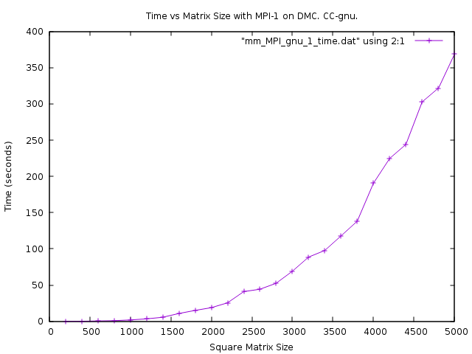
b.
The algorithm and plot follows O(n²)
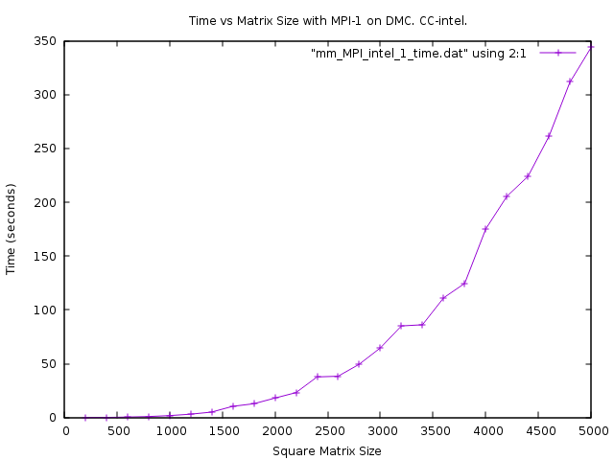

c.
The MPI instances had more erratic runtime as the number of cores and matrix size increased. They follow O(n²)

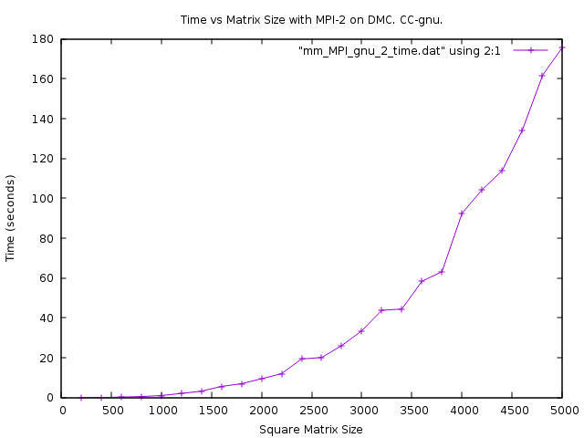
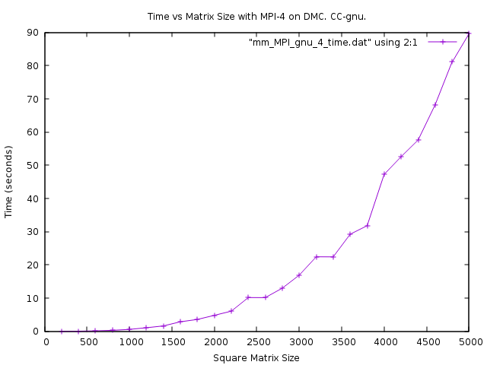
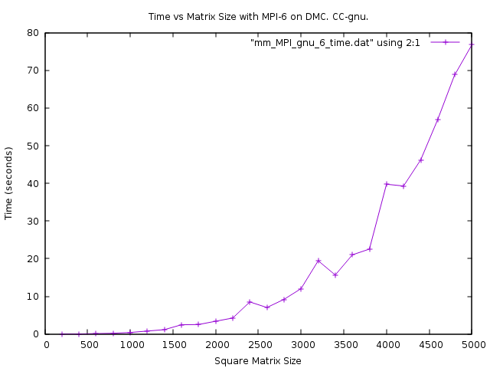
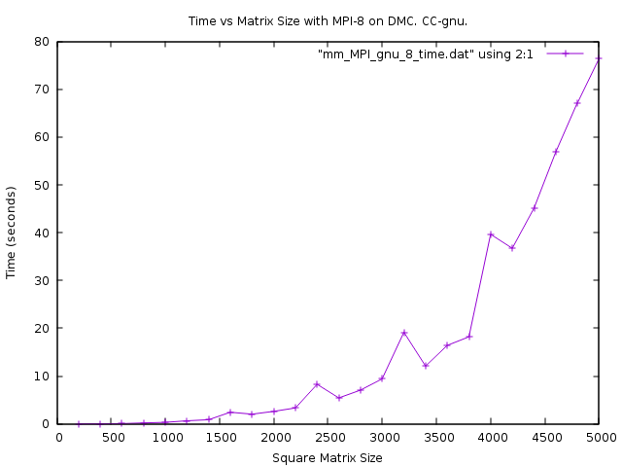

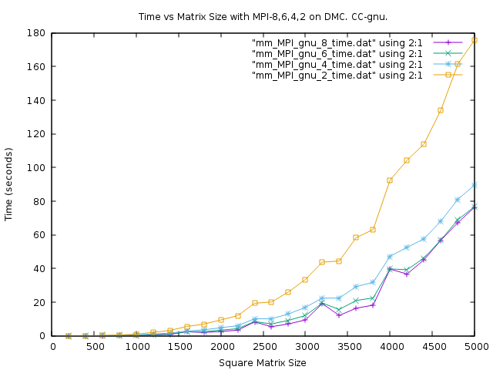
d.
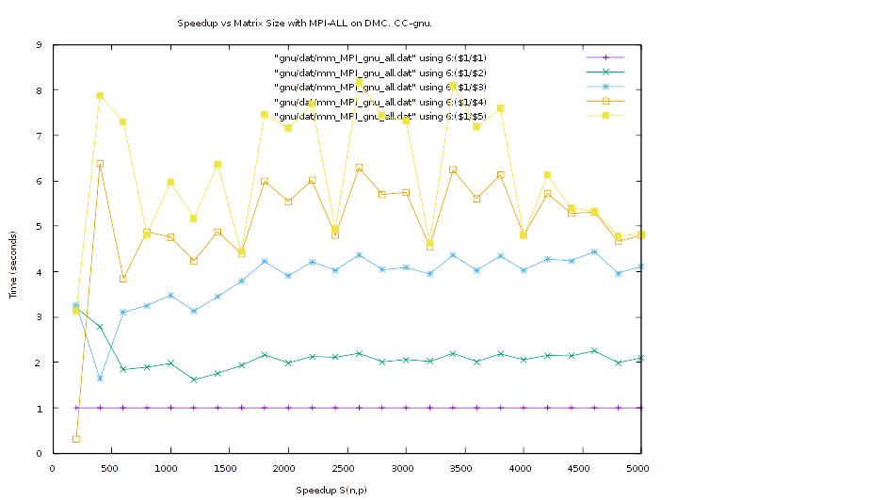
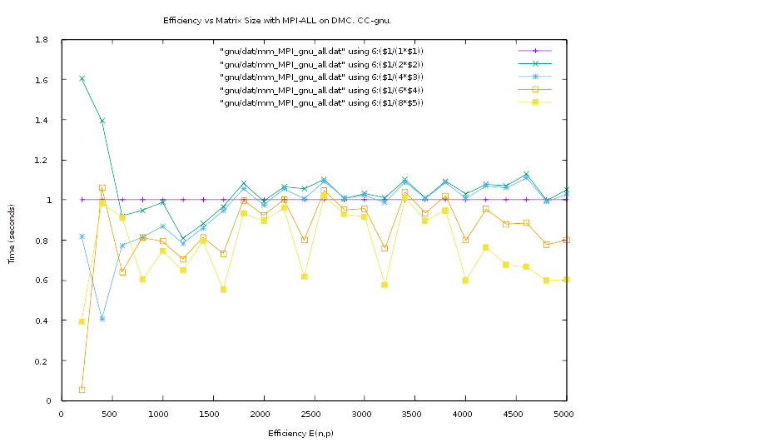

e.
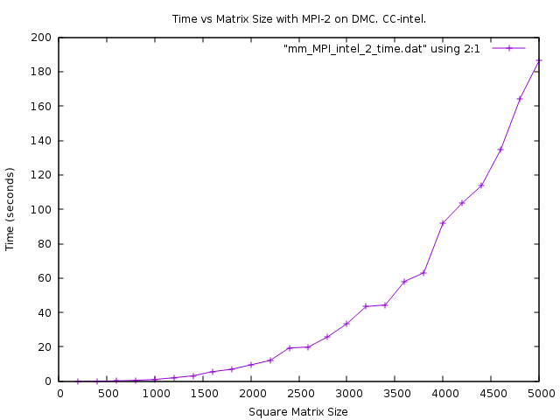
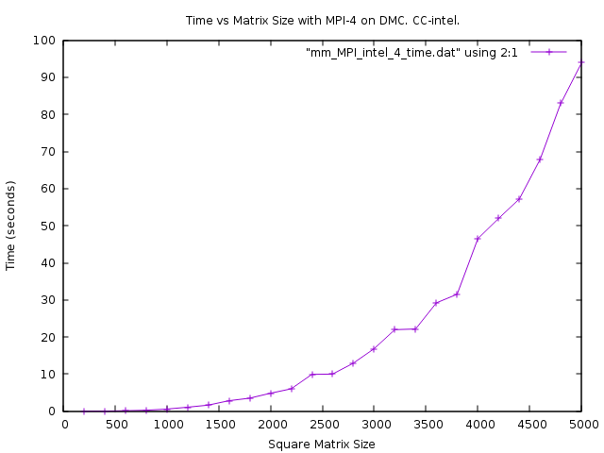
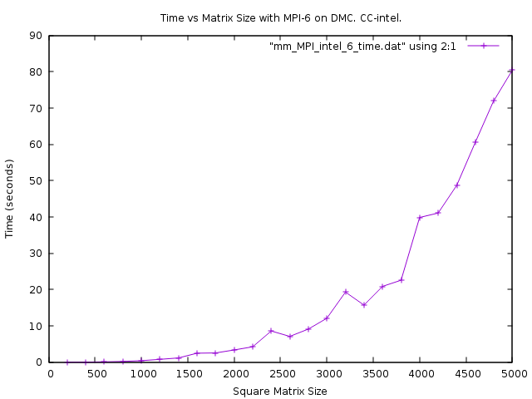
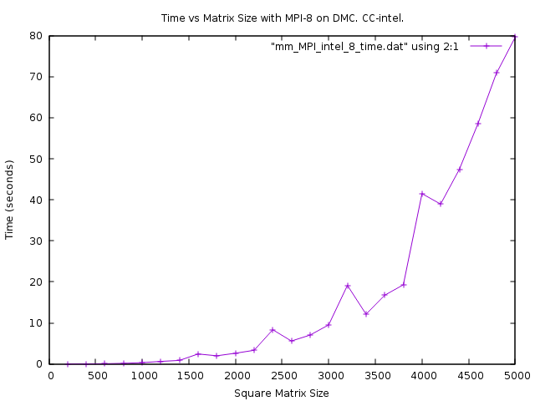
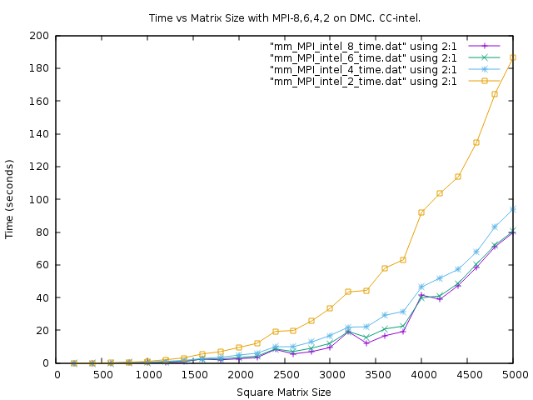
f.
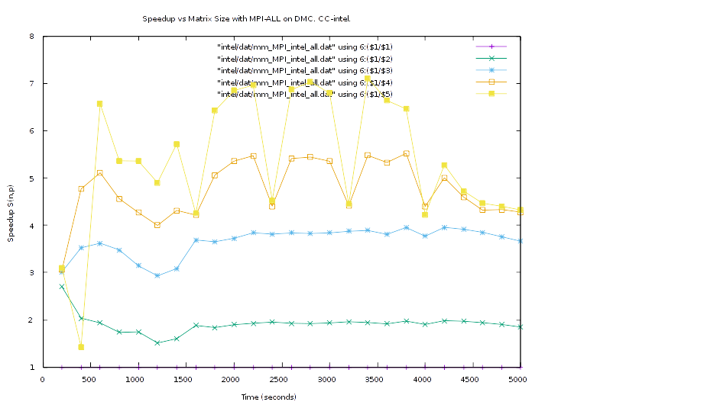
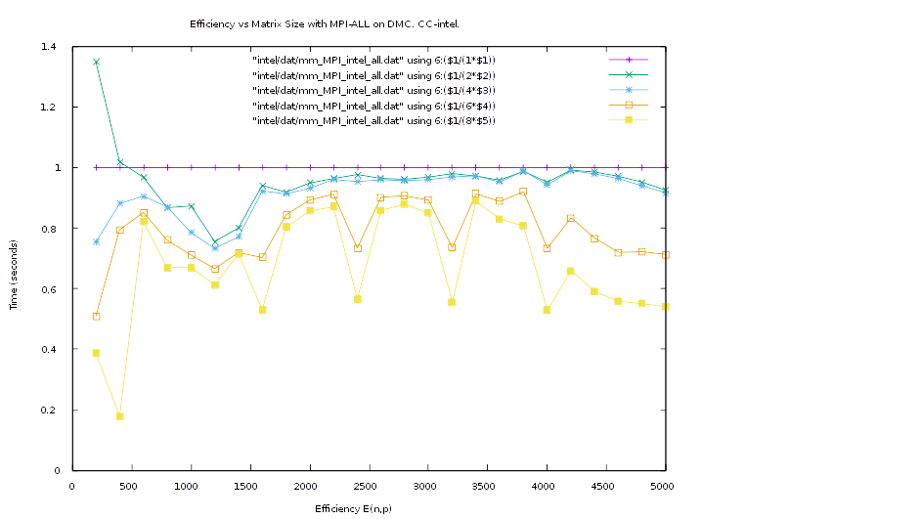
g.
The programs ran with very similar time characteristics. We expected the Intel compiled process to run faster due to better optimizations in the compiler. Other sources of discrepancies in runtime can be attributed to OS overhead, as these are single tests and not averages.
Source of mm_mult_MPI.cpp

Also available (along with supplemental scripts) at:
https://github.com/ctag/uah/blob/master/cpe412/hw3/src/mm_mult_MPI.cpp

/******************************************************************/
/* Matrix Matrix Multiplication Program Example -- MPI version */
/* September 2015 -- B. Earl Wells -- University of Alabama */
/* in Huntsville */
/******************************************************************/
/**
* Christopher Bero
* CPE 412 - HW3
* This program is a modification of mm_mult_serial.cpp
*/

using namespace std;
#include <iostream>
#include <iomanip>
#include <sstream>
#include <stdlib.h>
#include <string.h>
#include <sys/time.h>

/**
* headers for an MPI program
*/
#include <mpi.h>
#include <stdio.h>
#include <stdlib.h>
#include <unistd.h>
#include <math.h>

#define DEBUG false /* whether to output matrices or not */
#define MX_SZ 320
#define SEED 2397 /* random number seed */
#define MAX_VALUE 100.0 /* maximum size of array elements A, and B */

/* copied from mpbench */
#define TIMER_CLEAR (tv1.tv_sec = tv1.tv_usec = tv2.tv_sec = tv2.tv_usec = 0)
#define TIMER_START gettimeofday(&tv1, (struct timezone*)0)
#define TIMER_ELAPSED ((tv2.tv_usec-tv1.tv_usec)+((tv2.tv_sec-tv1.tv_sec)*1000000))
#define TIMER_STOP gettimeofday(&tv2, (struct timezone*)0)
struct timeval tv1,tv2;

typedef struct matrix_dimensions
{
/**
* Corresponding:
* [l,m] * [m,n] = [l,n]
*/
unsigned int l, m, n;
} matrix_dimensions;

/**
* Generic function which does the same as the definition statements
*/
float * cartesian (float * matrix, int row_sz, int row, int col)
{
return( (matrix + (row * row_sz) + col) );
}

/*
Routine to retrieve the data size of the numbers array from the
command line or by prompting the user for the information
*/
void get_index_size(int argc, char *argv[], unsigned int *dim_l, unsigned int *dim_m, unsigned int *dim_n)
{
if(argc!=2 && argc!=4)
{
cout<<"usage: mm_mult_serial [l_dimension] <m_dimension n_dimmension>"
<< endl;
exit(1);
}
else
{
if (argc == 2)
{
*dim_l = *dim_n = *dim_m = atoi(argv[1]);
}
else
{
*dim_l = atoi(argv[1]);
*dim_m = atoi(argv[2]);
*dim_n = atoi(argv[3]);
}
}
if (*dim_l<=0 || *dim_n<=0 || *dim_m<=0)
{
cout<<"Error: number of rows and/or columns must be greater than 0"
<< endl;
exit(1);
}
}

/*
Routine that fills the number matrix with Random Data with values
between 0 and MAX_VALUE
This simulates in some way what might happen if there was a
single sequential data acquisition source such as a single file
*/
void fill_matrix(float *array,int dim_m,int dim_n)
{
int i,j;
for(i=0; i<dim_m; i++)
{
for (j=0; j<dim_n; j++)
{
array[i*dim_n+j]=drand48()*MAX_VALUE;
}
}
}

/*
Routine that outputs the matrices to the screen
*/
void print_matrix(float *array,int dim_m,int dim_n)
{
int i,j;
for(i=0; i<dim_m; i++)
{
for (j=0; j<dim_n; j++)
{
cout << array[i*dim_n+j] << " ";
}
cout << endl;
}
}

/*
MAIN ROUTINE: summation of a number list
*/
int main( int argc, char *argv[])
{
// Matrix variables
float *a,*b,*c; /* matrix (0,0) address */
float * local_a; /* chunk of a to operate on */
float dot_prod; /* dot product result */
matrix_dimensions dim; /* matrix dimensions */
long unsigned int i,k; /* indexes */
long unsigned int mStart, mEnd; /* index of beginning and ending elements for subproblem */
long unsigned int aCount, bCount, cCount; /* Number of elements in matrix */

// MPI variables
int nmtsks, rank; /* default MPI variables */
unsigned int groupSize; /* Number of elements to process */

/**
* MPI initialization
*/
MPI_Init(&argc,&argv); /* initalize MPI environment */
MPI_Comm_size(MPI_COMM_WORLD,&nmtsks); /* find total number of tasks */
MPI_Comm_rank(MPI_COMM_WORLD,&rank); /* get task identity number */

/**
* Process 0 sets up the operands
*/
if (rank == 0)
{
/*
get matrix sizes
*/
get_index_size(argc,argv,&dim.l,&dim.m,&dim.n);

aCount = (dim.l * dim.m);
bCount = (dim.m * dim.n);
cCount = (dim.l * dim.n);

// dynamically allocate from heap the numbers in the memory space
// for the a,b, and c matrices
a = new (nothrow) float[dim.l*dim.m];
b = new (nothrow) float[dim.m*dim.n];
if(a==0 || b==0)
{
cout <<"ERROR: Insufficient Memory" << endl << flush;
exit(1);
}

/*
initialize numbers matrix with random data
*/
srand48(SEED);
fill_matrix(a,dim.l,dim.m);
fill_matrix(b,dim.m,dim.n);

/*
output numbers matrix
*/
if (DEBUG)
{
cout << "A matrix =" << endl;
print_matrix(a,dim.l,dim.m);
cout << endl;

cout << "B matrix =" << endl;
print_matrix(b,dim.m,dim.n);
cout << endl;
}

// Start recording the execution time
TIMER_CLEAR;
TIMER_START;
}

/**
* Disseminate matrix dimensions and operands
*/
MPI_Bcast(&dim, (sizeof(dim)/sizeof(unsigned int)), MPI_UNSIGNED, 0, MPI_COMM_WORLD);
if (rank != 0)
{
aCount = (dim.l * dim.m);
bCount = (dim.m * dim.n);
cCount = (dim.l * dim.n);
b = new (nothrow) float[bCount];
if(b==0)
{
cout <<"ERROR: Insufficient Memory" << endl << flush;
exit(1);
}
}
MPI_Bcast(b, bCount, MPI_FLOAT, 0, MPI_COMM_WORLD); /* Every process gets a full copy of b */

/**
* Calculate subproblem indexes
*/
groupSize = (cCount / nmtsks);
mStart = (groupSize * rank);
mEnd = (mStart + groupSize) - 1;

/**
* If we're the last proc,
* extend the group to any missed elements
*/
if (rank == (nmtsks-1))
{
mEnd = (cCount-1);
groupSize = (mEnd+1) - mStart;
}

/**
* Send only rows of matrix a that are needed
* A 5000x5000 matrix is 25000000 elements
* which with float is 100,000,000 bytes.
* I'm suddenly a little memory conscious.
*
* Need two arrays for scatterv:
* - Starting element in matrix a to send
* - Length of segment from matrix a to send
*/
int vSizes[nmtsks]; /* Size of segment */
int vDisps[nmtsks]; /* Offset of segment from 0 */
int elemStart, elemEnd;
unsigned int rootPartialA = (aCount / nmtsks); /* is the same for rank 0->(n-2) */
unsigned int lastPartialA = (aCount - (rootPartialA * (nmtsks-1)));
for (i=0; i<nmtsks; ++i)
{
elemStart = ((i*rootPartialA))/dim.m*dim.m;
if (i == (nmtsks-1))
{
elemEnd = ((((i*rootPartialA)-1)+rootPartialA)/dim.m)*dim.m + (dim.m-1);
} else {
elemEnd = ((((i*rootPartialA)-1)+lastPartialA)/dim.m)*dim.m + (dim.m-1);
}
vSizes[i] = (elemEnd - elemStart) + 1;
vDisps[i] = (elemStart);
}

local_a = new (nothrow) float[vSizes[rank]];
if(local_a==0)
{
cout <<"ERROR: Insufficient Memory" << endl << flush;
exit(1);
}

MPI_Scatterv(a, vSizes, vDisps, MPI_FLOAT, local_a, vSizes[rank], MPI_FLOAT, 0, MPI_COMM_WORLD);

/**
* Create resulting matrix
* Trying to save a little bit of memory on matrix C.
*/
if (rank == 0)
{
c = new (nothrow) float[dim.l*dim.n];
}
else
{
c = new (nothrow) float[groupSize];
}
if (c == 0)
{
cout <<"ERROR: Insufficient Memory" << endl << flush;
exit(1);
}

// multiply local part of matrix
int cIndex = 0;
for (i=0; i < groupSize; ++i)
{
long unsigned int elem = (mStart + i);
int a_row = (elem/dim.n);
int a_row_local= a_row - (vDisps[rank]/dim.m);
int b_col = (elem % dim.n);

dot_prod = 0.0;
for (k=0; k<dim.m; k++)
{
dot_prod += *cartesian(local_a, dim.m, a_row_local, k) * *cartesian(b, dim.n, k, b_col); // A(a_row,k)*B(k,b_col);
}
c[cIndex] = dot_prod;
cIndex++;
}

MPI_Status status;
if (rank == 0)
{
for (int mpitask = 1; mpitask < (nmtsks-1); ++mpitask)
{
MPI_Recv(&c[groupSize*mpitask], groupSize, MPI_FLOAT, mpitask, 123, MPI_COMM_WORLD, &status);
}
MPI_Recv(&c[groupSize*(nmtsks-1)], groupSize+(cCount % nmtsks), MPI_FLOAT, nmtsks-1, 123, MPI_COMM_WORLD, &status);
} else {
MPI_Send(c, groupSize, MPI_FLOAT, 0, 123, MPI_COMM_WORLD);
}

/**
* Proc 0 outputs results
*/
MPI_Barrier(MPI_COMM_WORLD);
if (rank == 0)
{
/*
stop recording the execution time
*/
TIMER_STOP;

if (DEBUG)
{
cout << "C matrix =" << endl;
print_matrix(c,dim.l,dim.n);
}
cout << endl;
cout << "time=" << setprecision(8) << TIMER_ELAPSED/1000000.0
<< " seconds" << endl;
}

MPI_Finalize();

return(0);
}

makefile
all: mm_mult_serial_gnu mm_mult_serial_intel mm_mult_mpi_gnu mm_mult_mpi_intel

mm_mult_serial_gnu:
g++ src/mm_mult_serial.cpp -o bin/mm_mult_serial_gnu -O3 -lm

mm_mult_serial_intel:
icc src/mm_mult_serial.cpp -o bin/mm_mult_serial_intel -O3 -lm

mm_mult_mpi_gnu:
export OMPI_CXX=g++
mpic++ src/mm_mult_MPI.cpp -o bin/mm_mult_MPI_gnu -lm -O3

mm_mult_mpi_intel:
export OMPI_CXX=icc
mpic++ src/mm_mult_MPI.cpp -o bin/mm_mult_MPI_intel -lm -O3

clean:
rm bin/*

