Supplementary

PopLDdecay: a fast and effective tool for linkage disequilibrium decay analysis based on variant call format files

version 3.30
2018-06-29

Contents
Usage 3
Step1 3
Step2 4
Classical case 5
One population 5
Muti population 5
One population with multi-chr 5
Muti population with multi-chr 6
Evaluation 6
Accuracy 6
Efficiency 7
Cited 9

Usage
It is convenient for user to apply PopLDdecay to analysis the LD decay, Just provide the SNP data in VCF format and perform follow two steps, users can get the decay figure.

Step1: Calculate LD decay
Step2: Draw the Figure

In the Example part, you can see the simple and clear usage to follow. Here are the two steps instructions

Step1
In this step, User will use the core program named “PopLDdecay” , A Dist~R^2 statistics file about will be output, which will be as input file in the step2.

The parameter description as below:
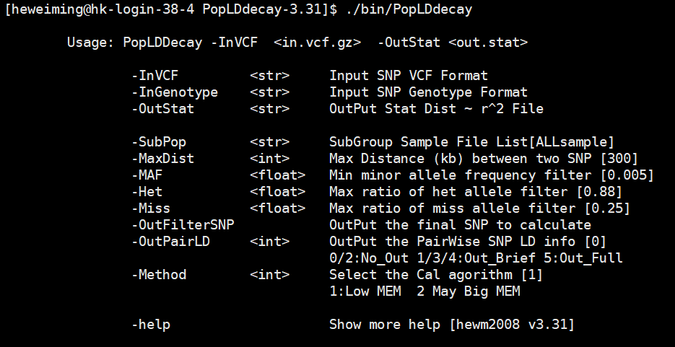
Fig1 parameter description of PopLDdecay
Note point:
- User with “./bin/PopLDdecay –h” command will see more help, see some Examples.
- Users can define the maximum distance with the command “-MaxDist”, default 300 kb.
- Users can also define their own filter criteria by using the command “-MAF –Het -Miss”.
- To see detail pairwise SNP calculation information, by using the command “-OutPairLD“
- To calculate the subgroup LD decay in VCF Files, put their names into List file, and add parameters with “–SubPop A.list”
- Program had two calculate algorithm , Method 1 is the optimal algorithm at most time.
- Parameters ‘-i’ is short for ‘–InVCF’ and ‘-o’ is short for ‘-OutStat’, ‘-s’ is short for ‘-SubPop’

A simple example
# 1) For gatk VCF file deal , run PopLDdecay direct
./bin/PopLDdecay -InVCF SNP.vcf.gz -OutStat Lddecay.stat.gz
# 2) For plink [.ped .map], chang plink 2 genotype first 2) run PopLDdecay
perl bin/mis/plink2genotype.pl -inPED in.ped -inMAP in.map -outGenotype out.genotype ; ./bin/PopLDdecay -InGenotype out.genotype -OutStat LDdecay.stat.gz
# 3) To Calculate the subgroup GroupA LDdecay in VCF Files # put GroupA sample names into GroupA_sample.list file
./bin/PopLDdecay -InVCF -OutStat -SubPop GroupA_sample.list

Step2
In this step, the main task is to plot the result in figure, here we provide two Perl scripts ‘plot_OnePop.pl’ and ‘Plot_MutiPop.pl’ to apply to different situations. And step2 only takes a few minutes to finish, User can change the drawing parameters until satisfied.
- To plot one population LD decay, user can use this ‘plot_OnePop.pl’. One population with multiple chromosome calculation result also can be generated to one file and plot the Result out.
- To plot multiple populations in one figure, the scripts ‘Plot_MutiPop.pl’ is recommend to plot the result.

Parameters of two Perl scripts ‘plot_OnePop.pl’ and ‘Plot_MutiPop.pl’ are similar. Parameters description as below:
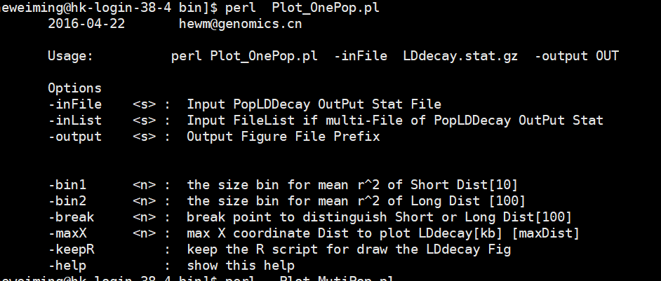
Fig 2: Parameters description of plot PERL script
Note point:
- User with “-maxX” can define theirs the max distance in the figure to plot
- The parameter ‘-break’ is the distance break point of “-bin1” and “-bin2”
- The distance smaller than the break point size will use the “-bin1”size to smooth lines
- The distance bigger than the break point size will use the “-bin2”size to smooth lines
- Users can keep the R script to modify the figure by their self with command “-keepR”

A simple example
# 2.1 For one Population
perl bin/Plot_OnePop.pl -inFile LDdecay.stat.gz -output Fig
# 2.2 For one Population muti chr # List Format [chrResultPathWay]
perl bin/Plot_OnePop.pl -inList Chr.ResultPath.List -output Fig
# 2.3 For muti Population # List Format :[Pop.ResultPath PopID]
perl bin/Plot_MutiPop.pl -inList Pop.ResultPath.list -output Fig

Classical case
Here, we provide four classic cases to demonstrate the application of this software, four situation will be show how to follow to get the LD decay figure out.

One population
This situation (one population with all chromosomes together) is encountered by most users, and this situation is the simplest to carry out.
./bin/PopLDdecay -InVCF ALLchr.vcf.gz -OutStat LDDecay.stat.gz
perl bin/Plot_OnePop.pl -inFile LDDecay.stat.gz -output Out.Prefix
Note:
This will generate the two finale figures named “Out.Prefix.png” and “Out.Prefix.pdf”

Muti population
This is common situation in the LD decay analysis. For example, if there are 50 samples (wild1, wild2, wild3…wild25, cul1, cul2, cul3…cul25) in the VCF file,
To compare the LD decay of these two groups (wild vs cultivation), first of all, put their sample names into own file list for each group, column or row is ok.

./bin/PopLDdecay -InVCF In.vcf.gz -OutStat wild.stat.gz -SubPop wildName.list
./bin/PopLDdecay -InVCF In.vcf.gz -OutStat cul.stat.gz -SubPop culName.list
# created manually muti.list by yourself
perl bin/Plot_MutiPop.pl -inList muti.list -output OutputPrefix
Note:
- The <wildName.list> can list as follow(column or row is ok):
wild1
wild2
…
Wild25
- The format of <muti.list> had two columns , the file path of population result and the population flag, such as:
/ifshk7/BC_PS/Lddecay/wild.stat.gz wild
/ifshk7/BC_PS/Lddecay/cul.stat.gz cultivation

One population with multi-chr
One population with multiple chromosome VCF files. For example, if there are 3 chromosomes VCF files (Chr1, Chr2 and Chr3) as the input.

./bin/PopLDdecay -InVCF Chr1.vcf.gz -OutStat Chr1.stat.gz
./bin/PopLDdecay -InVCF Chr2.vcf.gz -OutStat Chr2.stat.gz
./bin/PopLDdecay -InVCF Chr3.vcf.gz -OutStat Chr3.stat.gz
ls `pwd`/Chr*.stat.gz > chr.list
perl bin/Plot_OnePop.pl -inList chr.list -output OutputPrefix
Note:
- It can run in parallel when calculating the chromosomes’ statistics files.
- The files list only store the file path, which is diff with the multi-population list
- It will generate the file ‘OutputPrefix.bin’ is the summary statistics file of all chromosomes, and same format with the chromosomes’ statistics files.
- the <chr.list> format can be generated by as above command ‘ls Chr*.stat.gz > chr.list’ .

Multi population with multi-chr
Multi population with multiple chromosome VCF files. For example, if there are 2 chromosomes VCF files (Chr1, Chr2) as the input.
./bin/PopLDdecay -InVCF Chr1.vcf.gz -OutStat W.Chr1.stat.gz -SubPop wildName.list
./bin/PopLDdecay -InVCF Chr2.vcf.gz -OutStat W.Chr2.stat.gz -SubPop wildName.list
./bin/PopLDdecay -InVCF Chr1.vcf.gz -OutStat C.Chr1.stat.gz -SubPop culName.list
./bin/PopLDdecay -InVCF Chr2.vcf.gz -OutStat C.Chr2.stat.gz -SubPop culName.list
ls `pwd`/W.Chr*.stat.gz > W.chr.list
perl bin/Plot_OnePop.pl -inList W.chr.list -output Wild.cat
ls `pwd`/C.Chr*.stat.gz > C.chr.list
perl bin/Plot_OnePop.pl -inList C.chr.list -output Cul.cat
perl bin/Plot_MutiPop.pl -inList muti.list -output OutputPrefix
Note:
- The format of <muti.list> had two columns , the file path of population result and the population flag, such as:
/ifshk7/BC_PS/Lddecay/Wild.cat.bin wild
/ifshk7/BC_PS/Lddecay/Cul.cat.bin cultivation

Evaluation
To test the accuracy and the efficiency of PopLDdecay, we used data of this web site(ftp://ftp.1000genomes.ebi.ac.uk/vol1/ftp/release/20130502) to test follow software, only with two based site in chr22 (minimal chromosome SNP database) (2504 sample with 1,055,401 SNP numbers)to test these software. And all the shell and Perl script can be found in attachment.

Accuracy
In order to test and evaluate the accuracy of the results, we apply PopLDdecay and Haploview to calculate LD by using the same SNP dataset with the same thresholds parameter.

Haploview shell:
./iTools Formtools VCF2Genotype -InPut chr22.vcf -OutPut Haploview.genoytpe.gz -NoRef
perl genotype2pedigree.pl Haploview.genoytpe.gz Haploview.ped Haploview.info
java -jar ../Haploview.4.2.jar -n -pedfile Haploview.ped -info Haploview.info -log Hap.log -maxdistance 500 -minMAF 0.005 -hwcutoff 0.00 -dprime -memory 20960
perl PlotLDdecay.pl Hap.ped.LD LDdecay.svg

PopLDdecay shell:
./PopLDdecay -InVCF chr22.vcf -MaxDist 500 -OutStat Pop -MAF 0.005 -OutPairLD 5

we find the results of LD measure r² , D` and distance is exactly the same, as well as the number of pairwise comparisons. Therefore, we can get the conclusion that the results of PopLDdecay is accurate. Here is the top 10 line of two software results.
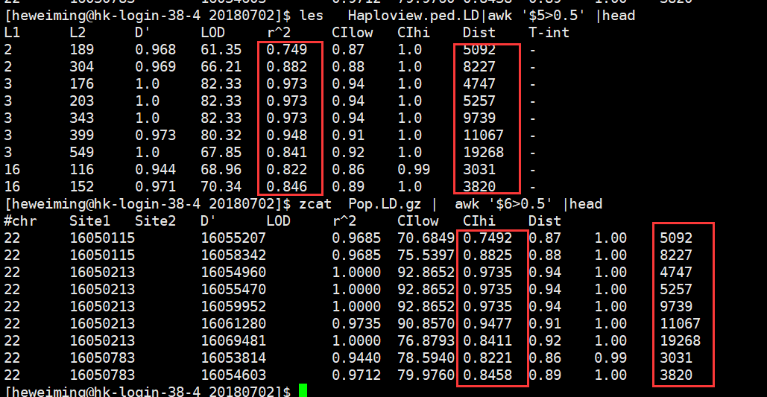
Fig 3: comparison Result of Accuracy
Here we also give out the Figure of LD Decay by Haploview and PopLDdecay, the two software lines are overlapping.
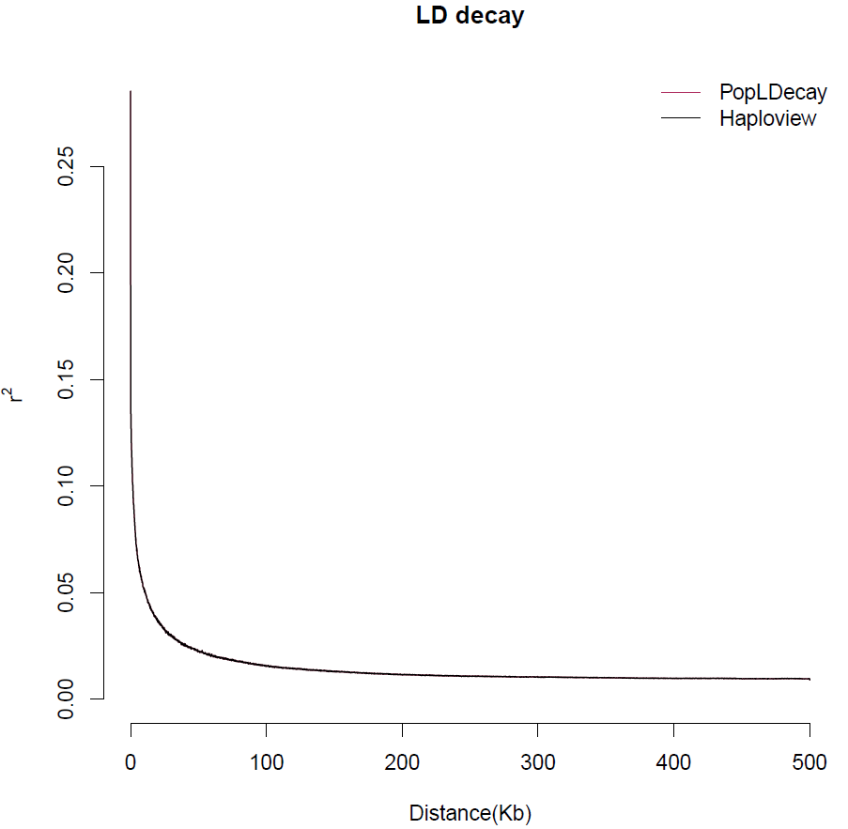
Fig 4: LD Decay of Haploview and PopLDdecay result

Efficiency
To compare the efficiency of this software, The Haploview and PLINK were taken to make a compare. Here are the shell script of running comparison.

Plinks 1.07 shell
../plink2.0 --vcf chr22.vcf --out chr22
../plink_v1.07 --bfile chr22 --noweb --ld-window-r2 0 --r2 --ld-window 99999 --ld-window-kb 300 --maf 0.005 --out P1.7
Perl StatLD2Decay.pl P1.7.ld P1.7.ld.stat

Plinks 1.9 shell
../plink2.0 --vcf chr22.vcf --out chr22
../plink2.0 --bfile chr22 --noweb --ld-window-r2 0 --r2 --ld-window 99999 --ld-window-kb 300 --maf 0.005 - -out P2.0 --threads 1
Perl StatLD2Decay.pl P2.0.ld P2.0.ld.stat

PopLDdecay shell:
./PopLDdecay -InVCF chr22.vcf -MaxDist 300 -OutStat Pop -MAF 0.005

Haploview shell:
../iTools Formtools VCF2Genotype -InPut chr22.vcf -OutPut Haploview.genoytpe.gz -NoRef
perl ../genotype2pedigree.pl Haploview.genoytpe.gz Haploview.ped Haploview.info
time java -jar -Xmx98g -jar ../Haploview.4.2.jar -n -pedfile Haploview.ped -info Haploview.info -log Hap.log -maxdistance 300 -minMAF 0.005 -hwcutoff 0.00 -dprime -memory 102400 #must set 100G ,Haploview can run complete

The comparison result were show at the table1. Form the table.,we can see
- The calculation time of PopLDdceay is much little, it is acceptable, although no the shortest one.
- The average memory of PopLDdceay also takes much little, it is acceptable.
- Since there is no intermediate file generation, the PopLDdceay output file takes up only little space.

Table 1. Computational resources statistics for chr22 LD decay

version | Average memory | Core calculation CPUs | Predicted Format conver & Statistics Time CPU | result size
Plink 1.07 | 1.4G | 680min | 5min+45min | 54G
Plink 2.0 | 18.81G | 25min | 5min+45min | 54G
Haploview 4.2 | 95.76G | 3904min | 5min+45min | 54G
PopLDdcay 3.30 | 1.5G | 200min | 0min | 4.1M

Here we also give out the Figure of LD Decay by Haploview, PLINK and PopLDdecay, the trend of four software lines is consistent.
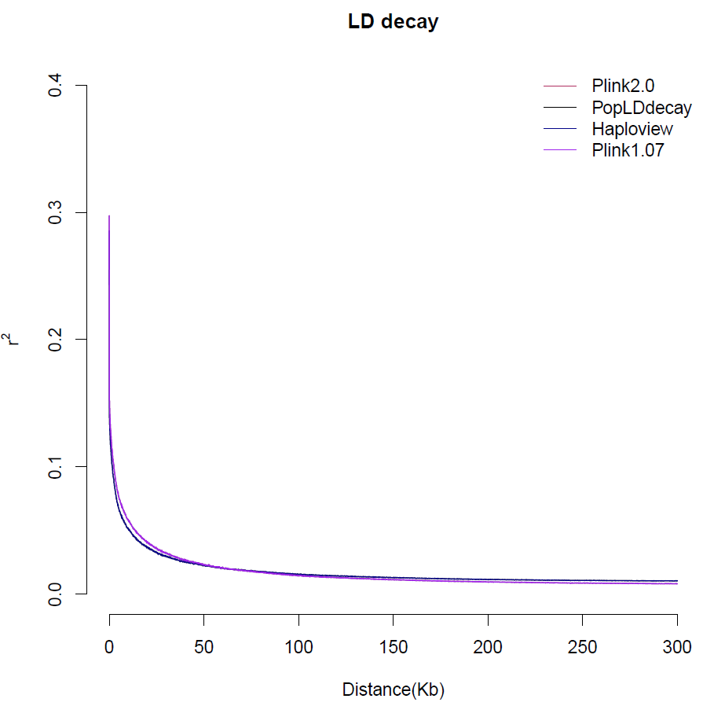
Fig 5: LD Decay of comparison software

Cited
It is noteworthy that PopLDdecay has been cited 9times form 2017-2018 according to google scholar. At least 7 times(update 2018-06-30) as follow(Chen, et al., 2017; Cui, et al., 2017; Li, et al., 2018; Liu, et al., 2016; Wu, et al., 2018; Zhang, et al., 2017)

Chen, W., et al. Genetic Diversity, Population Structure, and Linkage Disequilibrium of a Core Collection of Ziziphus jujuba Assessed with Genome-wide SNPs Developed by Genotyping-by-sequencing and SSR Markers. Front Plant Sci 2017;8:575.
Cui, C., et al. Genetic Diversity, Population Structure, and Linkage Disequilibrium of an Association-Mapping Panel Revealed by Genome-Wide SNP Markers in Sesame. Front Plant Sci 2017;8:1189.
Li, C., et al. The genetic architecture of amylose biosynthesis in maize kernel. Plant Biotechnol J 2018;16(2):688-695.
Liu, H., et al. Gene duplication confers enhanced expression of 27-kDa gamma-zein for endosperm modification in quality protein maize. Proc Natl Acad Sci U S A 2016;113(18):4964-4969.
Wu, Y., et al. Population genomic data reveal genes related to important traits of quail. Gigascience 2018;7(5).
Zhang, L., et al. RNA sequencing provides insights into the evolution of lettuce and the regulation of flavonoid biosynthesis. Nat Commun 2017;8(1):2264.

