**Description:**

1. 2 pipelines created for Capstone project.
   1. **Capstone Infra** – Create Kubernetes cluster
   2. **Capstone** – Rolling Deployment
2. Run pipeline “Capstone Infra” to create the Kubernetes cluster:

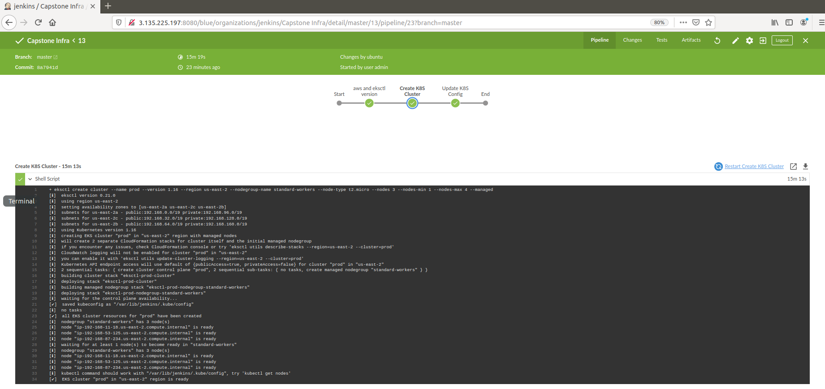

1. Application version 12 and LoadBalancer was created manually:

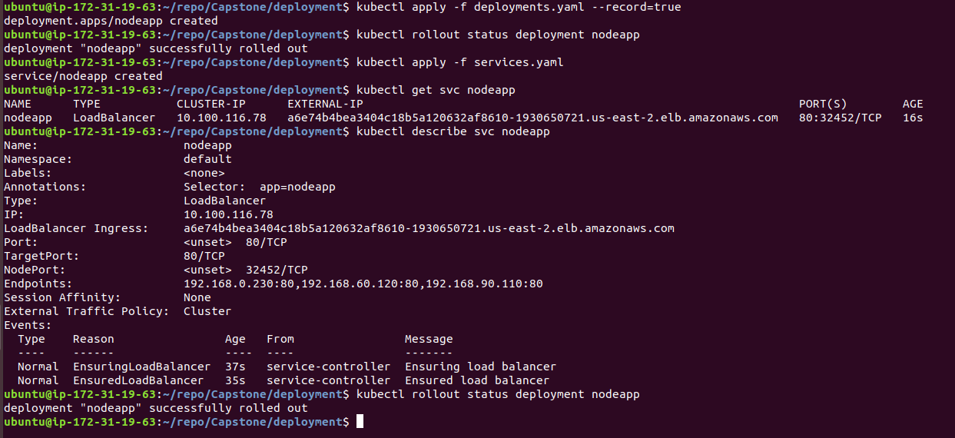

1. Version 12 of application:

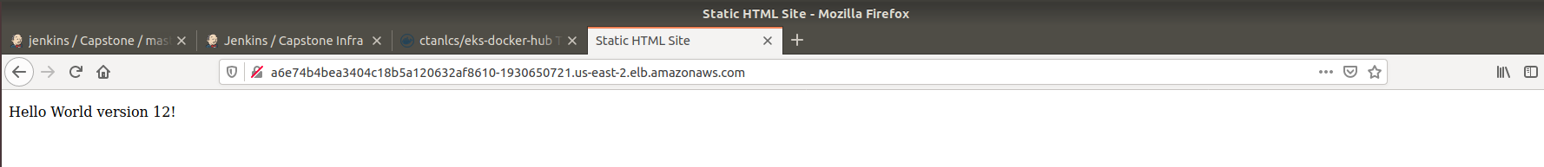

1. Update version 12 to version 13 (by changing the number in index.html and updating the tag in deployments.yaml). Running the Jenkins pipeline “Capstone”:
   1. Linting html is successful:

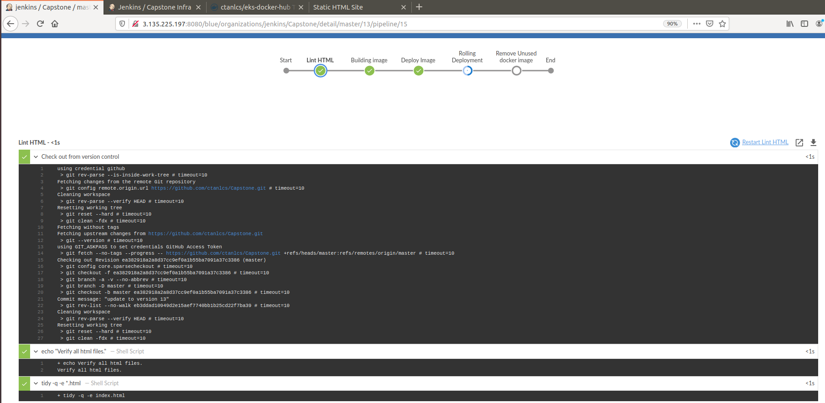

* 1. Building Image:

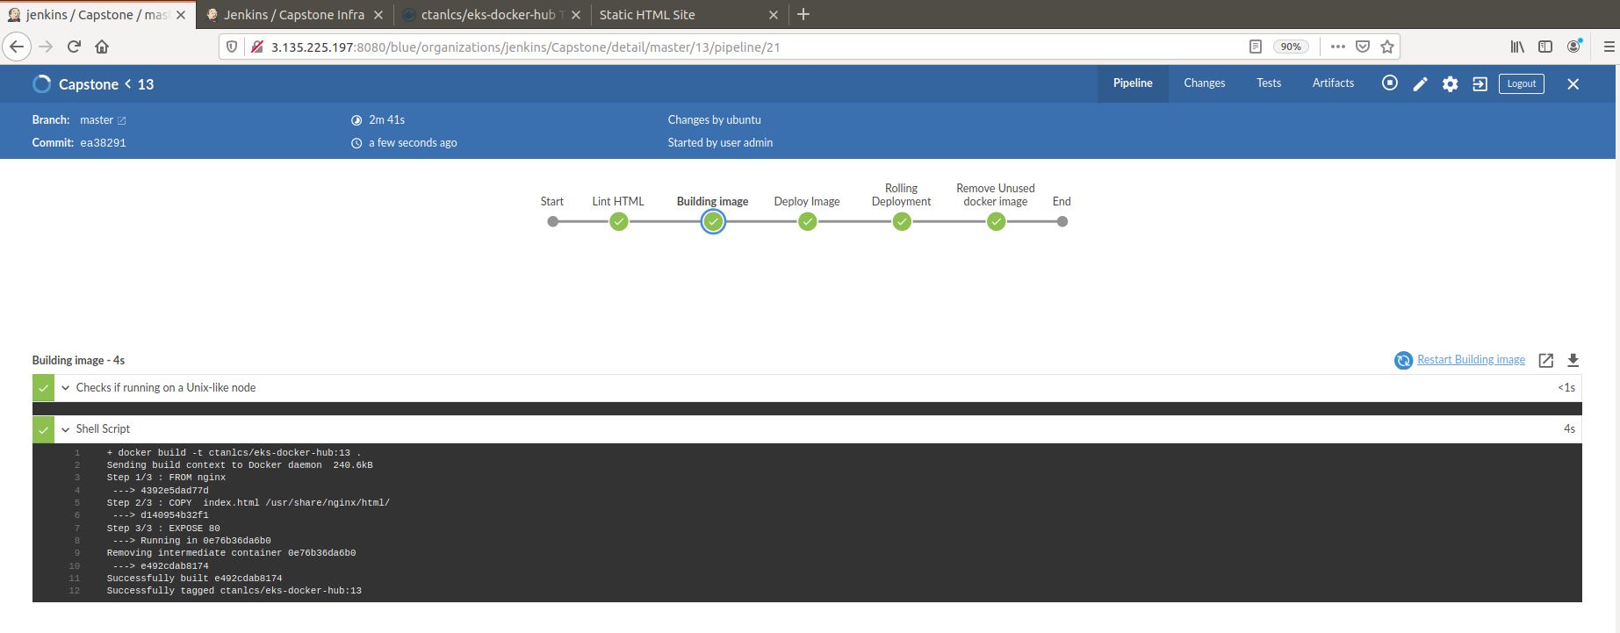

* 1. Deploy Image (version 13) to Docker Hub

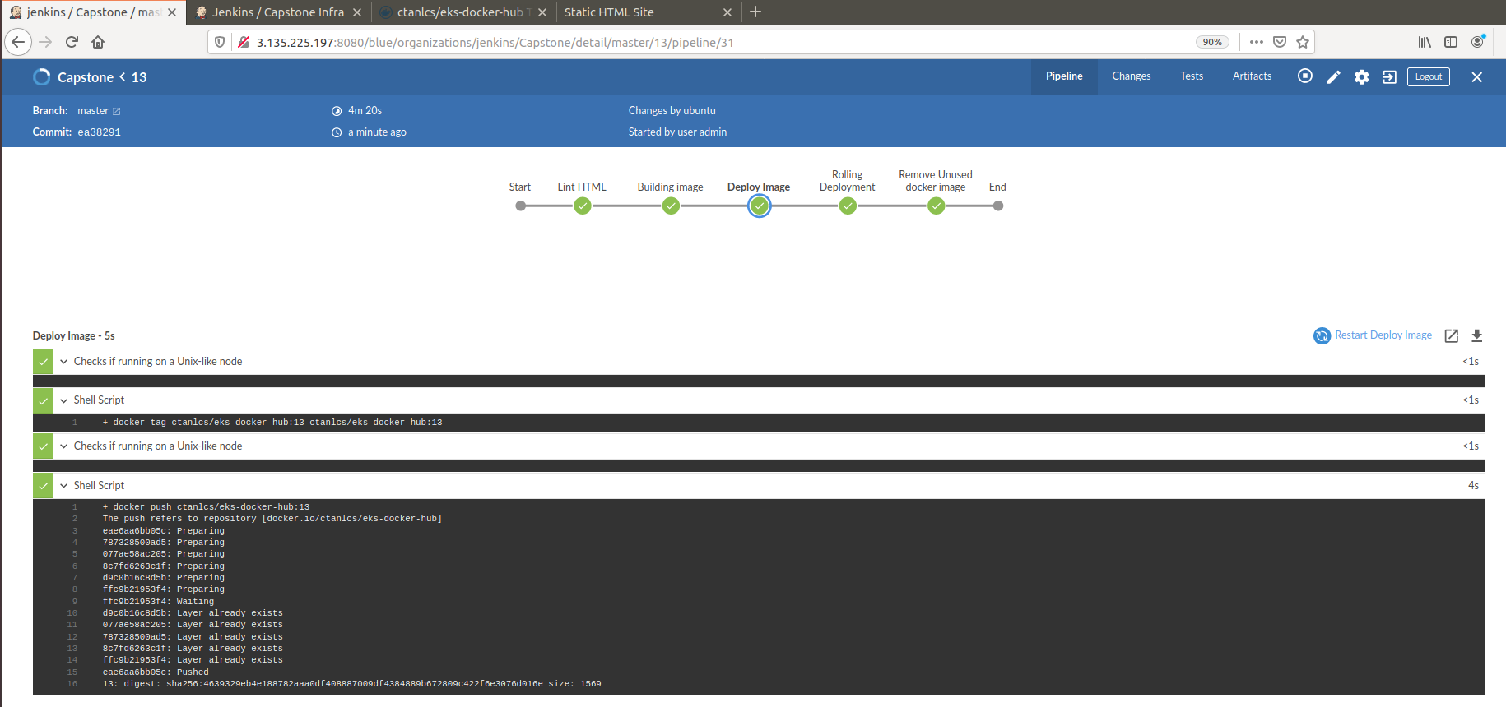

* 1. Rolling Deployment of version 13:

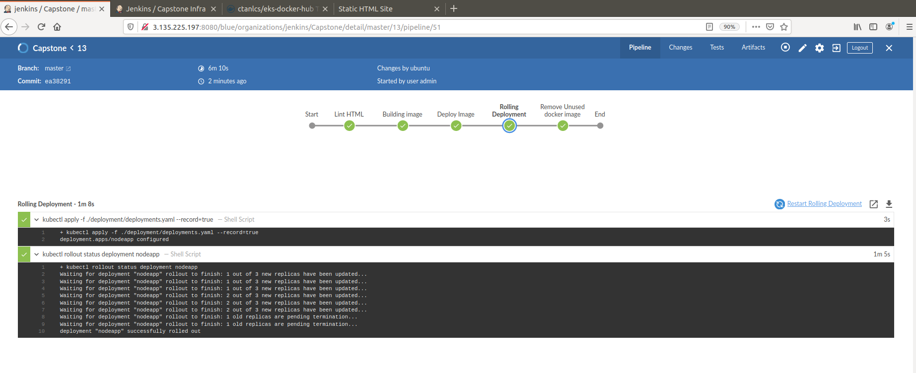

* 1. Refreshing website again shows updated version 13:

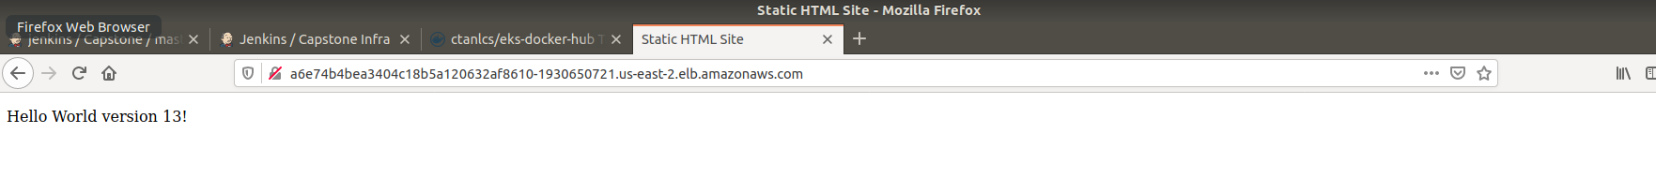

1. GitHub: <https://github.com/ctanlcs/Capstone/>