HTML Exercises W3SCHOOL

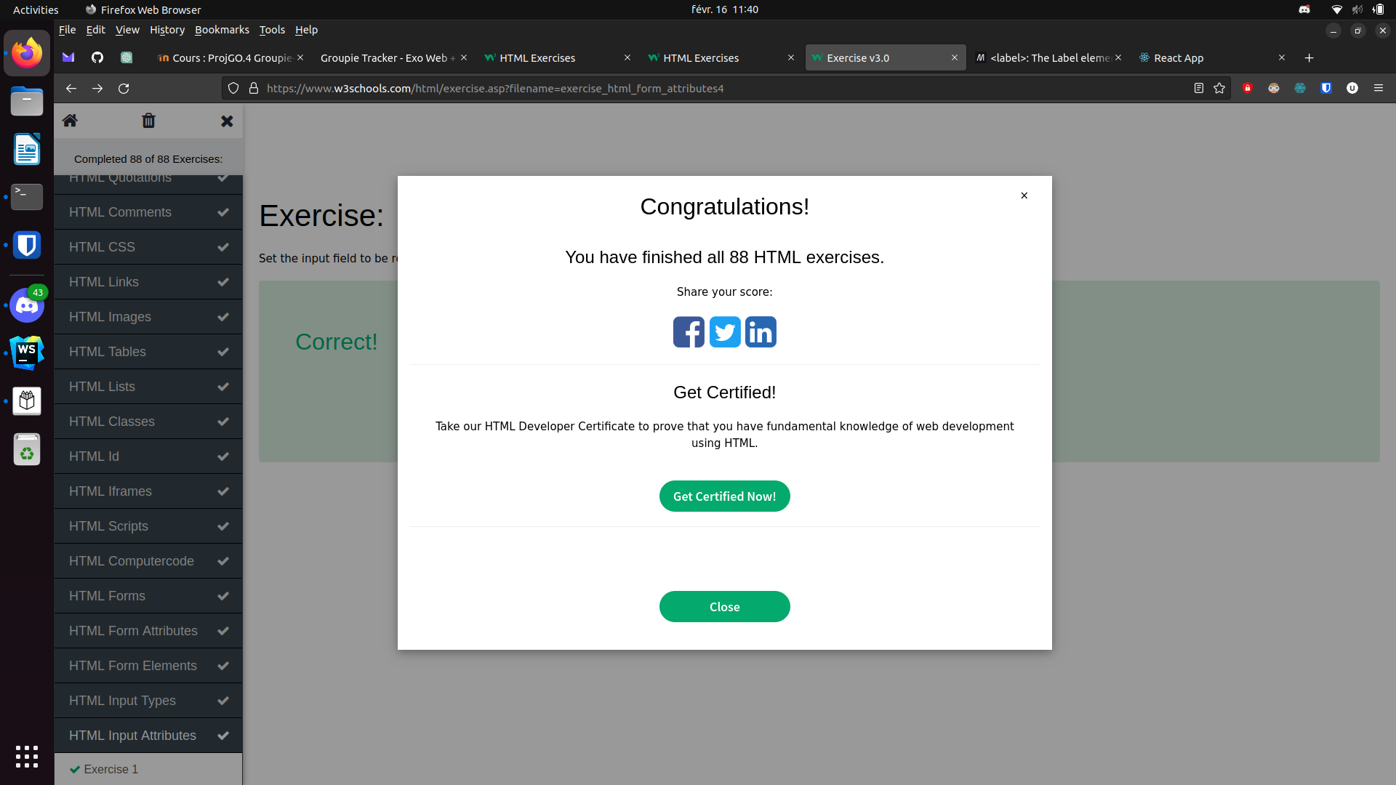

CSS Exercises W3SCHOOL



