Opinion: Trust in diesel running on empty
All participants at Berlin’s "Diesel Summit" agreed that a ban on diesel is to be avoided. Reclaiming trust, however, would be an important step, says DW's Dagmar Engel.
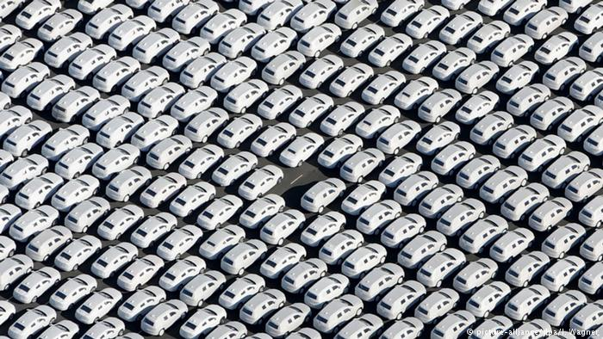
The result of this diesel summit is exactly what was to be expected: successes for all. For the time being, auto manufacturers have managed to avoid highly expensive hardware conversions. The leaders of German states that are home to car manufacturers have secured jobs in their respective constituencies. Cities are getting money to upgrade their buses and make traffic flows more intelligent, thus reducing the burden on the health of their citizens. And national politicians plan major reviews for 2018, thus giving them a break ahead of the elections in seven weeks' time. The possibility of banning diesel from German roads is off the table, and with it, Germany's diesel industry breathes a sigh of relief.
Industrial policy for Germany …
However, the fundamental problem is not cleared up. The issue lies not so much in the polluted air, which is still better than before (Personal note: I drive a ten-year-old German diesel car with emissions standard Euro 4. Besides, I used to smoke, a lot, even in closed rooms, for 25 years).
The fundamental problem lies in an industrial policy that is supposed to protect various interests at the same time: the automobile industry, which is essential for the grandiose foreign trade balance of Germany. The interests of the 800,000 people employed by car manufacturers. All those who earn their living from the retailers, service providers, and other stops along the way. And the political interests that seek to preserve the locations, the prosperity, the voters, and whatever factions are responsible for major party donations. The strengthening of European emissions standards in Brussels has been slowed down and possible references to fraud and cartel agreements have been deliberately overlooked. All in the service of these interests.

DW's Dagmar Engel
... is industrial policy against Germany
And yet things just keep rolling along, just like the diesel engine: Invented in 1893, refined for over a hundred years and now evidently reaching its limit. With it, the German auto industry and rich profits it reaps, because it ignores the fact that the world is changing - away from the internal combustion engine, away from the "Made in Germany" money machine. "It is probably the case that in the past, the state lacked a distance from the automotive industry," the German environment minister conceded last weekend.
Indeed, they stood so close together that any clear view of the future was obscured. What we are currently experiencing is a lesson in the consequences of a nationally-oriented industrial policy. "Germany first" worked wonders, financially speaking, but for a limited time. It tempted us to continue doing so. But what has fallen by the wayside is the German car of the future - and trust. Trust in the auto industry, in politics, and the sustainability of both.

