**NASA looks to Japanese art for radiation design inspiration**

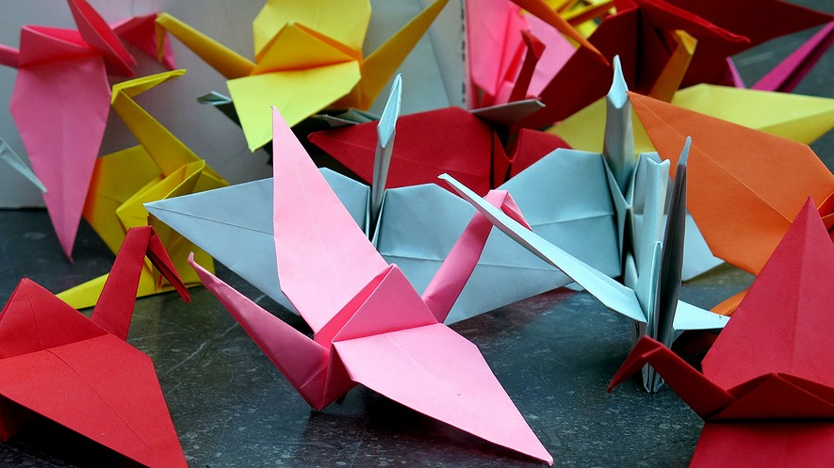

If you know your crane from your bishop's miter, NASA needs you. The space agency is launching a challenge to crowdsource origami-inspired ideas for a foldable radiation shield. The expandable cover will be used to protect spacecraft and astronauts on voyages to deep space.

The challenge opens for entries on July 26. Innovative designs can be submitted to NASA online through the website Freelancer.

Matt Barrie, CEO of Freelancer, believes there are lots of people with expertise in origami. He thinks they might be able to help NASA "find a very efficient way to pack a radiation shield."

Radiation Shields Crucial Part Of Spacecraft

Space engineer Helen O'Brien said that radiation shields are a crucial part of both manned and unmanned spacecraft. The shields are typically made of aluminum.

“Solar radiation can be very damaging to both people and electronics,” she said. It can cause cancer, as well as triggering faults in circuits.

But, O'Brien noted, mass means money when it comes to space missions, so large shields can be costly. Bulky items also take up space that could be used for instruments - or people.

"NASA want something that is sufficiently packed," said Barrie. The ideal radiation shield would be one that takes up very little room on a spacecraft but can expand to provide a lot of protection.

Other Design Projects

In addition to the radiation shield challenge, NASA has also announced two other projects. One is asking for help designing a short video. It will explain how NASA keeps track of objects inside the International Space Station (ISS). The other project is to create a badge, known as a mission patch, for the space agency's 3-D printer and recycling project.

The challenges are the latest in a series of conundrums posed to the public by NASA and Freelancer. Previous challenges included designing an astronaut smartwatch app and designing an arm for an ISS robot.

It is not the first time space engineers have turned to the Japanese art for inspiration. Earlier this year NASA announced it had joined forces with researchers at Brigham Young University to create an origami-inspired folding radiator. The device will control the rate of heat loss by changing its shape.

Robert J. Lang is an origami artist and a former NASA scientist. He said that he was not surprised that the space agency was looking to the Japanese art for inspiration.

"Origami Is A Natural Fit"

"Origami is a natural fit to many problems involving deployability in space," he said.

Mark Bolitho is an origami designer and an organizer of an international meeting on origami in science, which will be held next year. He said that applications of origami extend beyond space.

"There have been many advances in the application of folding in science," Bolitho said. One of the most famous examples is the car airbag, an inflatable cushion that folds up to fit inside the vehicle. Another is the heart stent, a small tube placed inside blood vessels to keep them from closing.

O'Brien, too, welcomed the use of origami in space engineering. She said the folding art can help scientists design more efficient structures. "There is no reason why that kind of [approach] cannot be used to provide innovative and low mass shielding for space missions."