A Relational Model: 3 Levels of Relationships

1 Tim. 1:5 “But the goal of our instruction is love from a pure heart and a good conscience and a sincere faith.”
1 Cor. 13:2 “If I speak with the tongues of men and of angels, but do not have love, I have become a noisy gong or a clanging cymbal. And if I have the gift of prophecy, and know all mysteries and all knowledge; and if I have all faith, so as to remove mountains, but do not have love, I am nothing.”

Basic Qualities of Love (from 1 Cor. 13): Gracious, Emotional, Disciplining, Sacrificial. The Relational Model below is a convenient way to talk about applying these basic qualities to relationships. Along the side are AREAS OF INVESTMENT, and along the top are LEVELS OF INVESTMENT. The basic point of this model is to show how relationships require investment.

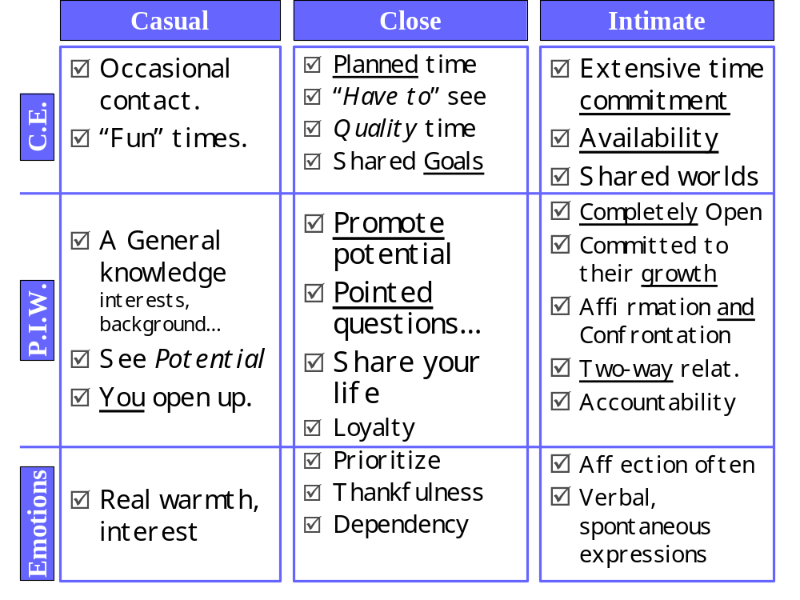How to apply this model: #1) Identify problem areas; #2) Appropriate God’s Power in these areas; #3) Deepen a relationship by bringing it into the next level,

