LTC 2011 Fall

# Introduction

## Labeling People:

### Mishandling:



### Correct usage:

1. Recognize blends, exceptions
2. Tendencies, *not sins*.
3. Appreciating God-given differences.Balanced Maturity (See *1 Cor. 11:1)
4. Resisting sinful *tendencies*.

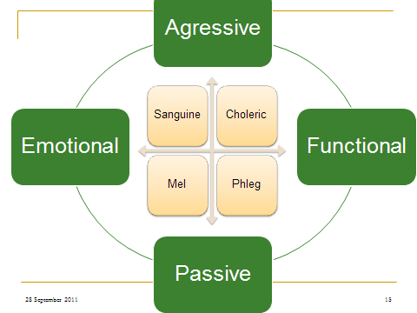 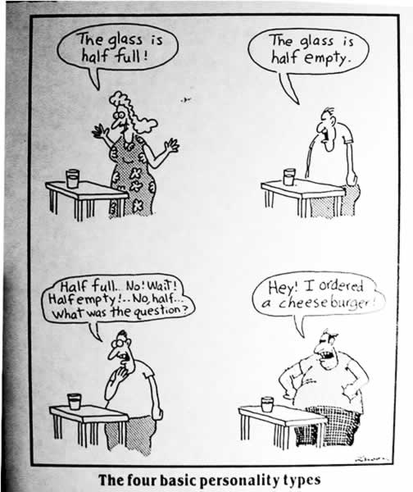

## Axis:

1. Team-building:
2. Team clashes:
3. Recognizing *crucial* weaknesses:
4. Recognizing *crucial* strengths:

# Application

## Sanguines

### Weaknesses

1. Weak willed:
2. Unstable
3. Undisciplined, unfocused
4. Undependable
5. Egocentric
6. Exaggerates
7. Fearful
8. Emotionalism preferred over depth of investment.

#### Counter-Balances:

1. Routine commitment:
2. Get accountable in relationships, duties
3. Self-examination, reflection:
4. Learning to qualify, not act.
5. Finish old business before new

### Sanguine positives:

1. Action-Oriented
2. Charismatic & warm.
3. Optimistic
4. Flexible

#### Supporting a Sanguine

1. Don't take the steam out of them
2. Give them opportunities to initiate.

## Phlegmatic

### NEGATIVES:

1. Stingy
2. Fearful
3. Indecisive
4. Spectator
5. Unmotivated
6. Selfish

#### Counter-Balances:

1. Convict of sin
2. Surround with active temperaments
3. Define principless
4. Practicing direct confrontation
5. Practice real, personal investment
6. Confess sins
7. Accountability and vulnerability

### Positives:

1. Reliable & sensible.
2. Patient & loyal.
3. Stress-reducers, dry humor

#### Promoting a Phlegmatic:

1. Objectivity
2. Initial follow up
3. Administrators
4. Balancers

## CHOLERICS:

### Weaknesses:

1. Angry, cruel, sarcastic
2. Domineering
3. Inconsiderate
4. Impervious
5. Self-Willed
6. Unemotional
7. Crafty

#### Counter-Balances:

1. The Art of apology
2. Practice emotional/nurturing concern
3. Structure time for inner walk
4. Teach genuine obedience

### Strengths:

1. Great Strategists
2. Practical Accomplishments –

#### Promoting a Choleric:

1. Give plenty of encouragement
2. Follow, if possible.

## MELENCHOLICS:

### Weaknesses:

1. Self-centered
2. Moody
3. Negative
4. Theoretical, impractical
5. Anti-Social
6. Critical
7. Vengeful
8. Rigid

#### Counter-Balances:

1. Resist brooding
2. Cultivate thankfulness
3. Connect abstract to practical steps

### Strengths

None.

#### Promoting a Mel

1. Give them a gun to shoot themselves in the head.
2. Give them crayons and a coloring book.