uTest

eBay Automation Framework

By: Christian Taveras

ABOUT:

uTest is a Web Based Application that is designed to create an automated chaining system for hardware benchmarking and application level testing. uTest accepts subprocess commands, sends them to a queue, executes them, and summarizes log file paths and pass/fail results.

INSTRUCTIONS:

1. Select “Add Test” while on the uTest home page.

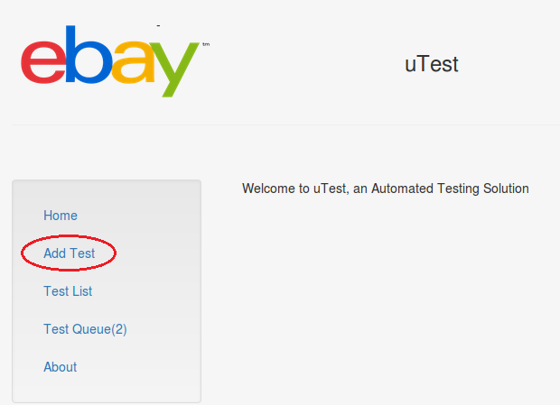

1. Complete form. NOTE: “Test” specifies a name. “Command” should be completed exactly as it’d be executed on a command line. “Runs” specifies the amount of times the test should be repeated if any.

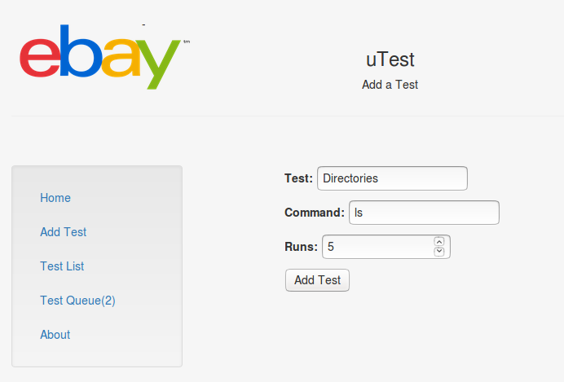

*This test is named “Directories.” The subprocess command would be executed as “ls” on a command line. This test will repeat 5 time.*

1. Browse “Test List”

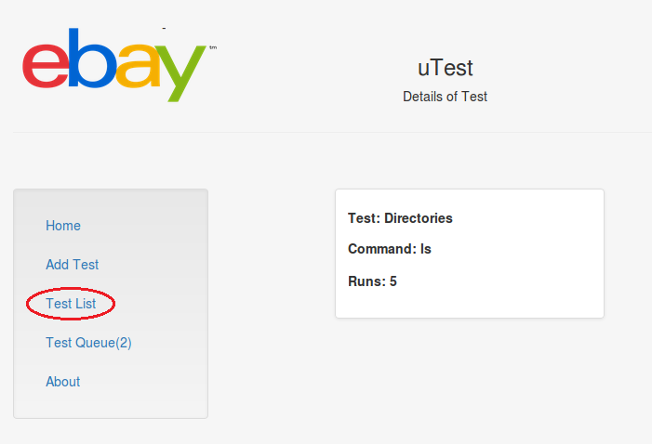

*The Test List displays all tests that have been added in the past.*

1. Here you can edit each test that has been added, remove a test, or get more details on each test. Select “Add” to add the given test to your Test Queue.

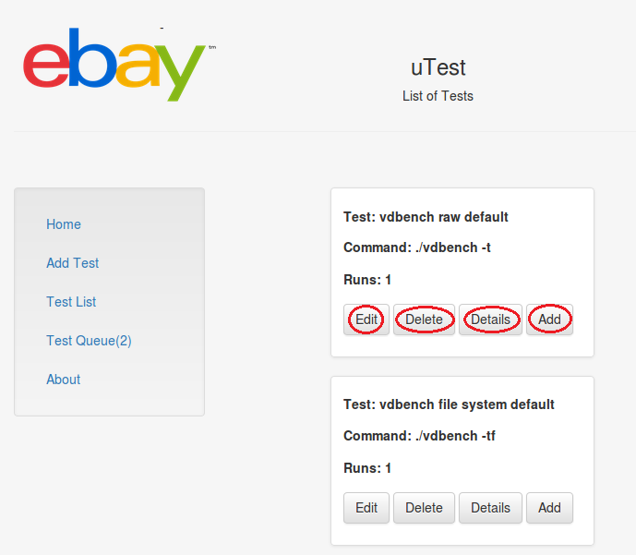

1. View “Test Queue”

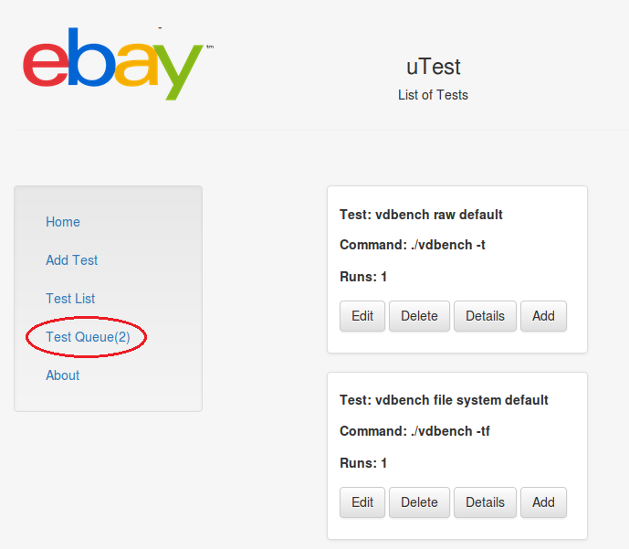

1. Add a “Typology File” and Start Queue

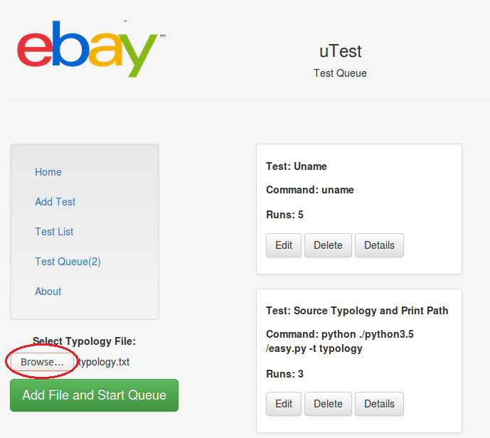

*Please see Typology for more info on what this file is and what it should include.*

1. Check Results

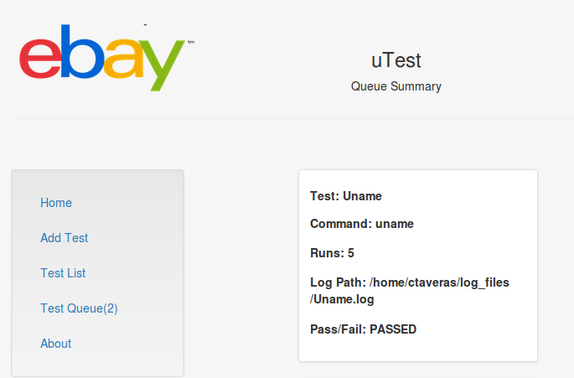

*The Summary page appears as soon as the Test Queue is complete. The Log Path specifies the path where the output has been stored on the server. Pass/Fail specifies whether or not the test returned a successful exit code.*