**Part 1:**

For this section I started out by sorting all the users closest to me by similarities in our age, occupation, and gender. Later I sorted the ratings and chose the top and bottom 3 of three users closest to me. My substitute was user 599 being that I love the movie Picture Perfect and One Night Stand.

*used substitution_you.py

*used correlation.py

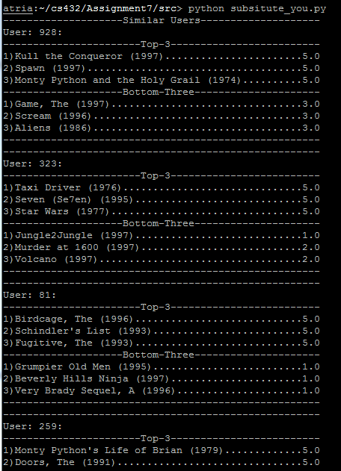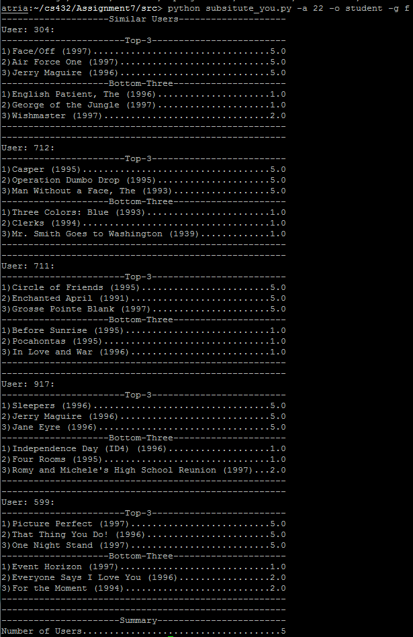

**User 304:**

**User 712:**

Top 3:

1) Casper (1995)...................................5.0

2) Operation Dumbo Drop (1995).....................5.0

3) Man Without a Face, The (1993)..................5.0

Bottom 3:

1) Three Colors: Blue (1993).......................1.0

2) Clerks (1994)...................................1.0

3) Mr. Smith Goes to Washington (1939).............1.0

Top 3:

1) Face/Off (1997).................................5.0

2) Air Force One (1997)............................5.0

3) Jerry Maguire (1996)............................5.0

Bottom 3:

1) Game, The (1997)................................3.0

2) Scream (1996)...................................3.0

3) Aliens (1986)...................................3.0

**User 599:**

Top 3:

1) Picture Perfect (1997)..........................5.0

2) That Thing You Do! (1996).......................5.0

3) One Night Stand (1997)..........................5.0

Bottom 3:

1) Event Horizon (1997)............................1.0

2) Everyone Says I Love You (1996).................2.0

3) For the Moment (1994)...........................2.0

* **I mostly identify with user 599, except I haven’t watched “That Thing You Do!” so I cannot judge on whether I like it or not.**

**Part 2:**

In this step I ran correlation.py and received the most correlated and least correlated users according to my substitute. I received five +1’s and five -1’s indicating that there was similarities in the movies for the most correlated and no similarity for the least correlated.

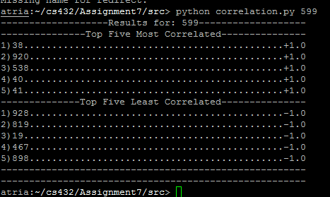

**--------------Top Five Least Correlated---------------**

**1)928.............................................-1.0**

**2)819.............................................-1.0**

**3)19..............................................-1.0**

**4)467.............................................-1.0**

**5)898.............................................-1.0**

**---------------Top Five Most Correlated---------------**

**1)38..............................................+1.0**

**2)920.............................................+1.0**

**3)538.............................................+1.0**

**4)40..............................................+1.0**

**5)41..............................................+1.0**

**Part 3:**

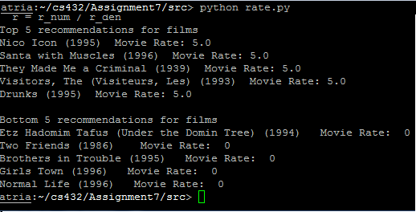

**Part 4:**

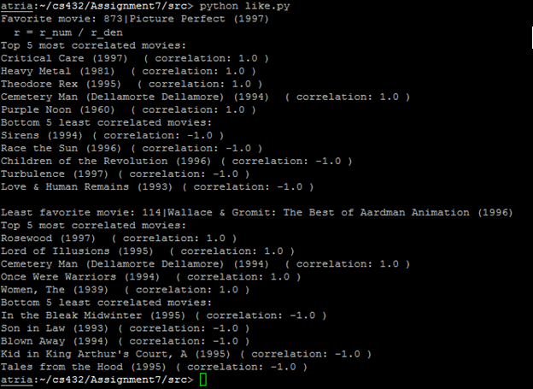

I picked movie 873; Picture perfect as my favorite movie, and Wallace & Gomit: The Best of Aardman Animation as my least favorite, In order to get the proper results I ran like.py and got these results:

* **For this section some of the results were right and the others I couldn’t comment on being that I haven’t watched those specific movies; the movies which I like were Cemetery Man and Critical care. For the Bottom least correlated, the data came out wrong being that I do enjoy the movies Siren, Turbulence, and Children of the Revolution.**