1. **Command: curl --data "q=GOOgfdgdfgdfgdf"** [**http://search.vt.edu/search/pages.html**](http://search.vt.edu/search/pages.html)

<!DOCTYPE html>

<html lang="en">

<head>

<meta http-equiv="Content-Type" content="text/html; charset=utf-8" />

<meta http-equiv="X-UA-Compatible" content="IE=edge" />

<meta name="viewport" content="width=device-width, initial-scale=1.0" />

<title>Virginia Tech | Search - Web</title>

<link rel="shortcut icon" type="image/x-icon" href="//www.assets.cms.vt.edu/images/favicon.ico" />

<link rel="stylesheet" href="/search/assets/css/base.css" type="text/css" media="screen" />

<link rel="stylesheet" href="/search/assets/css/enhanced.css" type="text/css" media="screen" />

<script type="text/javascript"

src="//www.assets.cms.vt.edu/jquery/archives/jquery-1.10.latest.min.js"></script>

<script type="text/javascript" src="/search/assets/js/search_utils.js"></script>

<script type="text/javascript" src="/search/assets/js/search_pages.js"></script>

</head>

<body>

<div class="vt_skip">

<h2><a id="vt-skipto-menu">Skip Menu</a></h2>

<ul>

<li><a href="#vt-skipto-search">Skip to Search</a></li>

<li><a href="#vt-skipto-results">Skip to Results</a></li>

</ul>

</div>

<div id="container">

<div id="header_container">

<!-- BEGIN HEADER -->

<div id="header">

<div id="vt_logo">

<a id="vt_home_btn" title="Virginia Tech" href="http://www.vt.edu"></a>

</div>

<div id="vt_utilities">

<ul id="vt_toplinks">

<li><a href="http://www.vtnews.vt.edu">News</a></li>

<li><a href="http://www.calendar.vt.edu">Calendar</a></li>

<li><a href="http://www.givingto.vt.edu">Giving</a></li>

<li><a href="http://www.lib.vt.edu">Libraries</a></li>

<li><a href="http://maps.vt.edu">Maps &amp;

Locations</a></li>

<li><a href="http://www.vt.edu/az_index/index.html">A to Z Index</a></li>

</ul>

<ul id="vt_student_tools">

<li><a

href="https://banweb.banner.vt.edu/ssb/prod/twbkwbis.P_WWWLogin">Hokie

Spa</a></li>

<li><a href="https://scholar.vt.edu/portal">Scholar</a></li>

<li><a href="https://my.vt.edu/">My VT</a></li>

</ul>

<ul id="vt_we_remember">

<li><a href="http://www.weremember.vt.edu">We Remember</a></li>

</ul>

</div>

</div>

<!-- END HEADER -->

</div>

<div id="content_container">

<div id="content">

<div class="vt_skip">

<a href="#vt-skipto-menu">Return to Skip Menu</a>

<h2><a id="vt-skipto-search">Search</a></h2>

</div>

<div id="vt_search_block">

<form action="#" onSubmit="return executeQuery()" method="get" name="vt_search_form" id="vt_header_search_form">

<input type="text" maxlength="50" placeholder="Search pages and people" name="q"

value="GOOgfdgdfgdfgdf" id="vt_search_box" autocomplete="off"/>

<button id="vt_go_button">

<span class="vt_skip">Search</span>

</button>

</form>

</div>

<div id="navigation">

<ul>

<li class="current"><a href="#">VT Web</a></li>

<li>

<a href="people.html;jsessionid=61D360B45D7E55EE815F3B4BDEFA6D43.mt-prod-3?q=GOOgfdgdfgdfgdf" id="vt-people-nav">People</a>

</li>

</ul>

</div>

<div class="vt_skip">

<a href="#vt-skipto-menu">Return to Skip Menu</a>

<h2><a id="vt-skipto-results">Results</a></h2>

</div>

<div id="results">

<div id="vt_gcse_script">

<noscript>

<div class="noscript">

It looks like you have JavaScript turned off. See search results

<a href="http://www.google.com?cx=012042020361247179657:wmrvw9b99ug&cof=FORID:11&ie=UTF-8&q=GOOgfdgdfgdfgdf">here</a>.

</div>

</noscript>

<div id="vt_gcse_results" class="gcse-searchresults-only" data-resultsetsize="7" data-gname="vt_gcse_results">

</div>

</div>

</div>

<div id="rb_content">

<h2>Mobile Search</h2>

<p>

Want to find something while you are on the go? You can now use VT

search with your <a href="/search/m">mobile</a> device.

</p>

<h2>Search Tips</h2>

<ul>

<li>

<p>

<strong>athletics sports</strong>: Finds all documents that

contain both words, "athletics" as well as "sports"

</p>

</li>

<li>

<p>

<strong>"HokieBird"</strong>: Finds all documents that contains

the exact phrase "HokieBird"

</p>

</li>

<li>

<p>

<strong>physics -quantum</strong>: Finds all documents that

contain the word "physics" but excludes ones containing the word

"quantum"

</p>

</li>

<li>

<p>

<strong>sports OR athletics</strong>: Finds all documents that

contain at least one of the two words. The "OR" needs to be

upper-case.

</p>

</li>

</ul>

</div>

</div>

</div>

<div id="footer_container">

<!-- BEGIN FOOTER -->

<div id="footer">

<ul>

<li><a href="http://www.bookstore.vt.edu">Bookstore</a></li>

<li><a href="http://www.jobs.vt.edu/">Jobs at Virginia Tech</a></li>

<li><a href="http://www.vt.edu/contacts/">Contact Us</a></li>

<li><a href="http://www.vt.edu/about/equal-opportunity.html">Equal

Opportunity</a></li>

</ul>

<ul>

<li><a

href="http://www.vt.edu/diversity/principles-of-community.html">Principles

of Community</a></li>

<li><a href="http://www.vt.edu/about/privacy.html">Privacy

Statement</a></li>

<li><a href="http://www.vt.edu/about/acceptable-use.html">Acceptable

Use Policy</a></li>

<li><a href="http://www.vt.edu/about/accessibility.html">Accessibility</a>

</li>

</ul>

<p>&copy; 2016 Virginia Polytechnic Institute and State University. <span id="version-number">VT Search: 2.4.3</span></p>

</div>

<!-- END FOOTER -->

</div>

</div>

<script type="text/javascript">

var gaJsHost = (("https:" == document.location.protocol) ? "https://ssl." : "http://www.");

document.write(unescape("%3Cscript src='" + gaJsHost + "google-analytics.com/ga.js' type='text/javascript'%3E%3C/script%3E"));

</script>

<script type="text/javascript">

var pageTracker = _gat._getTracker("UA-5217491-2");

pageTracker._trackPageview();

</script>

</body>

</html>

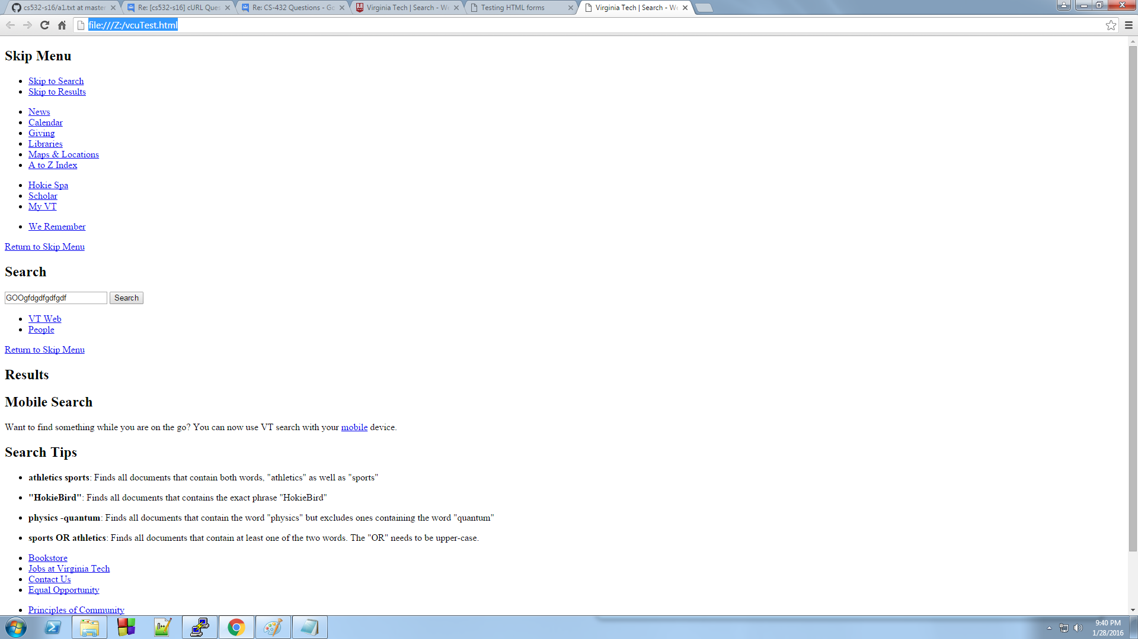

3.