**Part 1:**

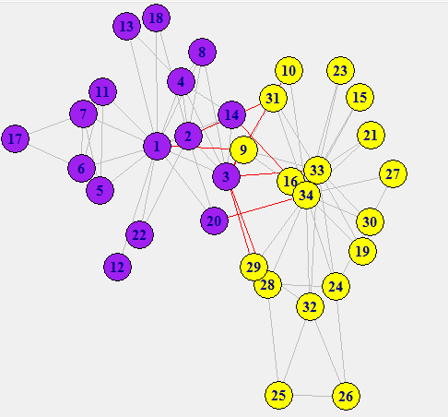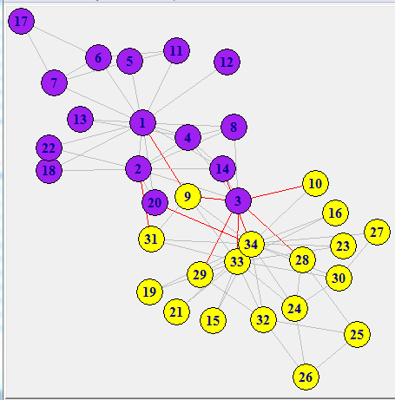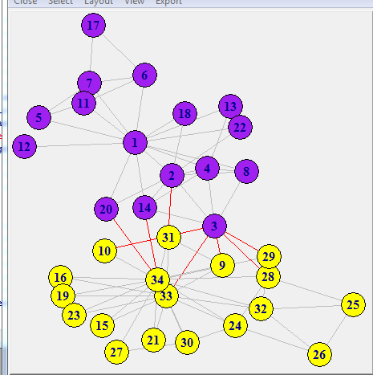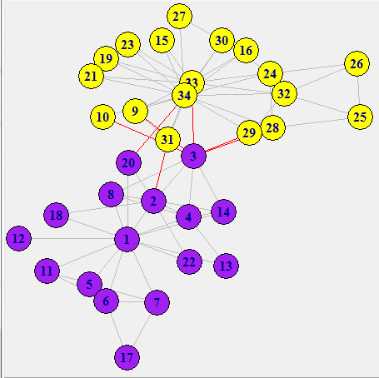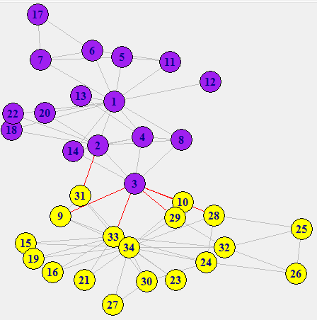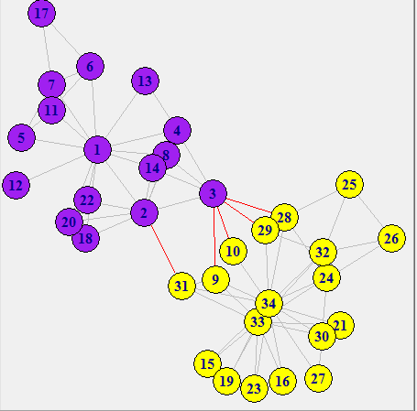

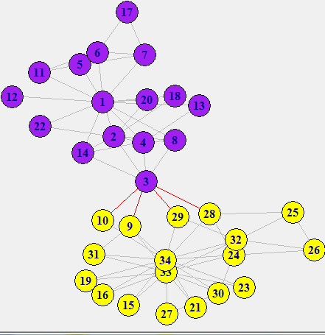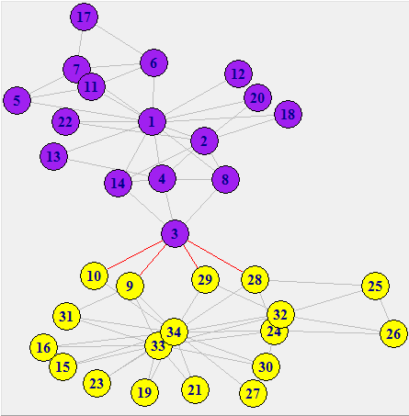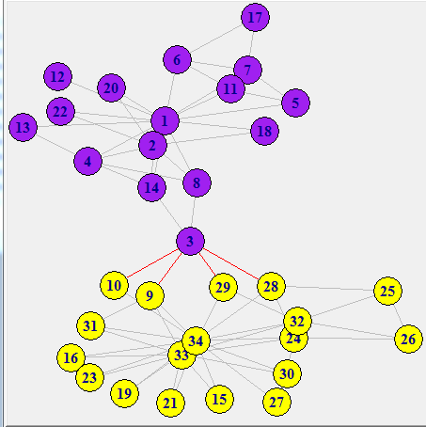

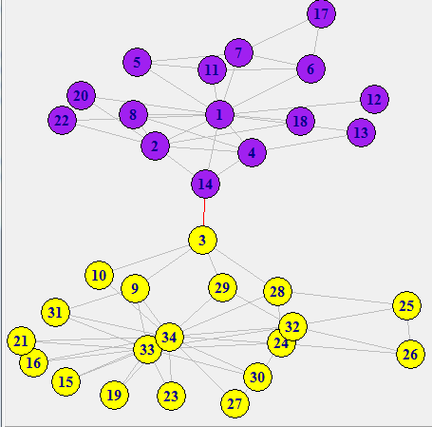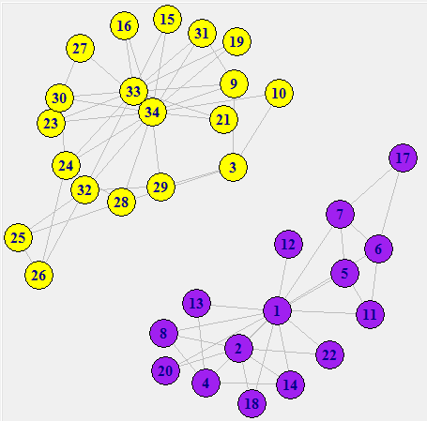

[1] "Edges will be deleted in the following order : "

[1] "1 -> 32 -- Betweenness = 71.3928571428571"

[1] "1 -> 3 -- Betweenness = 66.8951770451771"

[1] "1 -> 9 -- Betweenness = 77.3173992673993"

[1] "14 -> 34 -- Betweenness = 82.0029059176118"

[1] "20 -> 34 -- Betweenness = 123.232917082917"

[1] "3 -> 33 -- Betweenness = 100.205555555556"

[1] "2 -> 31 -- Betweenness = 143.626984126984"

[1] "2 -> 3 -- Betweenness = 109.25"

[1] "3 -> 4 -- Betweenness = 107.666666666667"

[1] "3 -> 8 -- Betweenness = 142.75"

[1] "3 -> 14 -- Betweenness = 285"

**Part 2:**

A) Split into 3

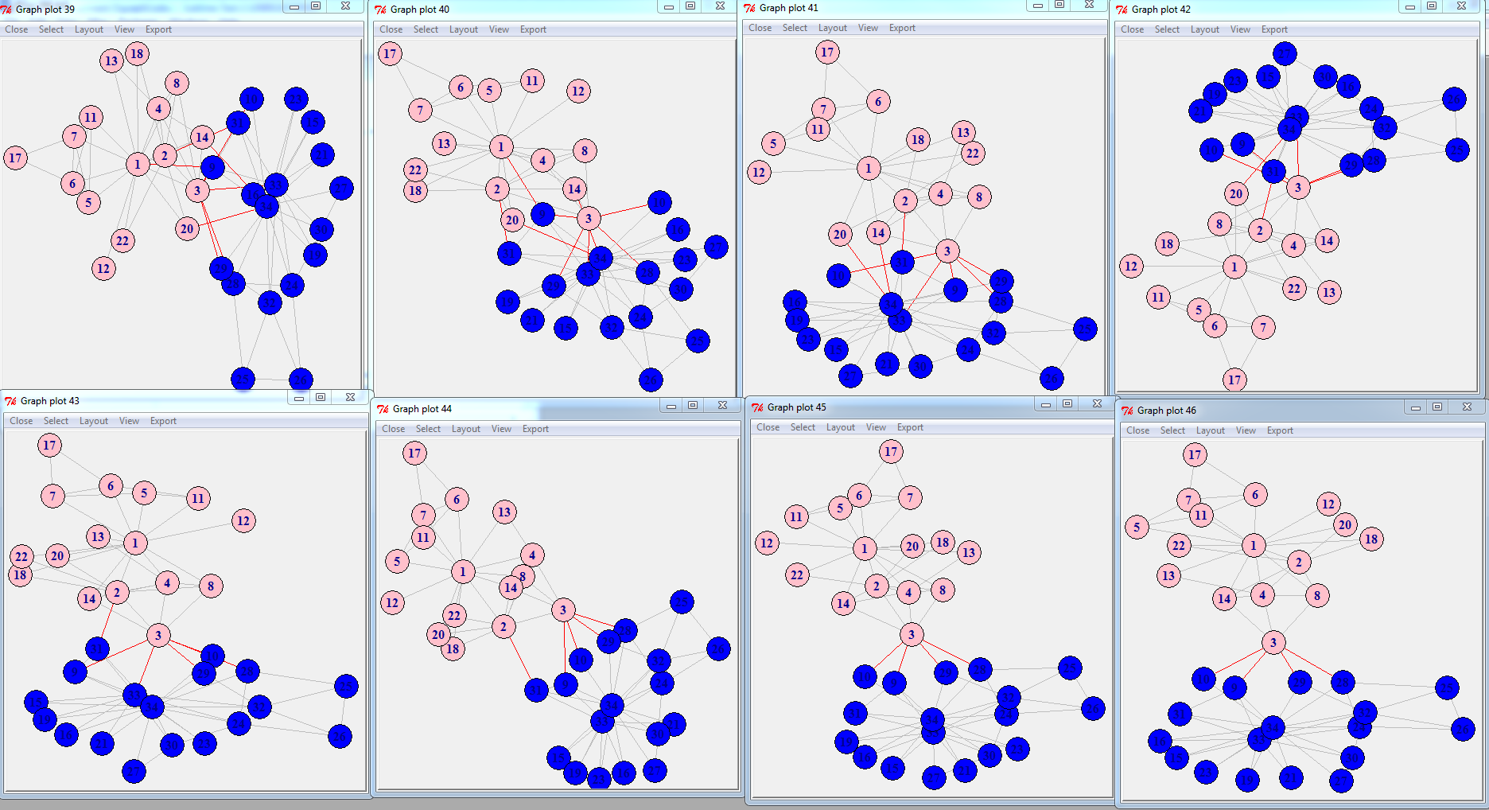

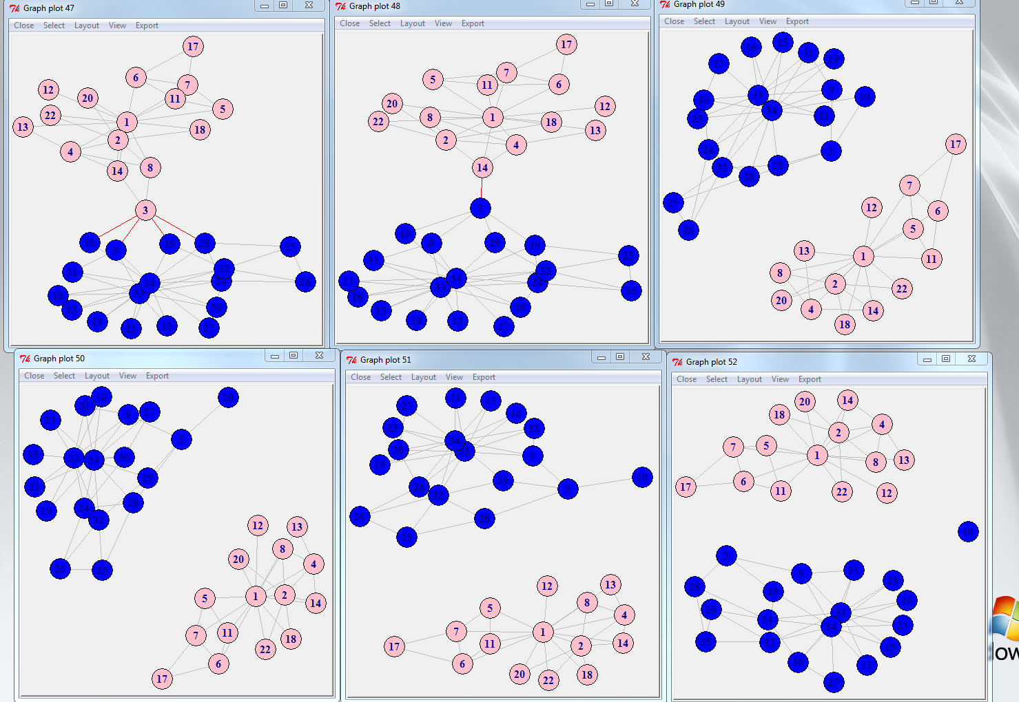

[1] "Edges will be deleted in the following order : "

[1] "1 -> 32 -- Betweenness = 71.3928571428571"

[1] "1 -> 3 -- Betweenness = 66.8951770451771"

[1] "1 -> 9 -- Betweenness = 77.3173992673993"

[1] "14 -> 34 -- Betweenness = 82.0029059176118"

[1] "20 -> 34 -- Betweenness = 123.232917082917"

[1] "3 -> 33 -- Betweenness = 100.205555555556"

[1] "2 -> 31 -- Betweenness = 143.626984126984"

[1] "2 -> 3 -- Betweenness = 109.25"

[1] "3 -> 4 -- Betweenness = 107.666666666667"

[1] "3 -> 8 -- Betweenness = 142.75"

[1] "3 -> 14 -- Betweenness = 285"

[1] "10 -> 34 -- Betweenness = 16.8333333333333"

[1] "28 -> 34 -- Betweenness = 18.1833333333333"

[1] "3 -> 10 -- Betweenness = 18"

B) Split into 4

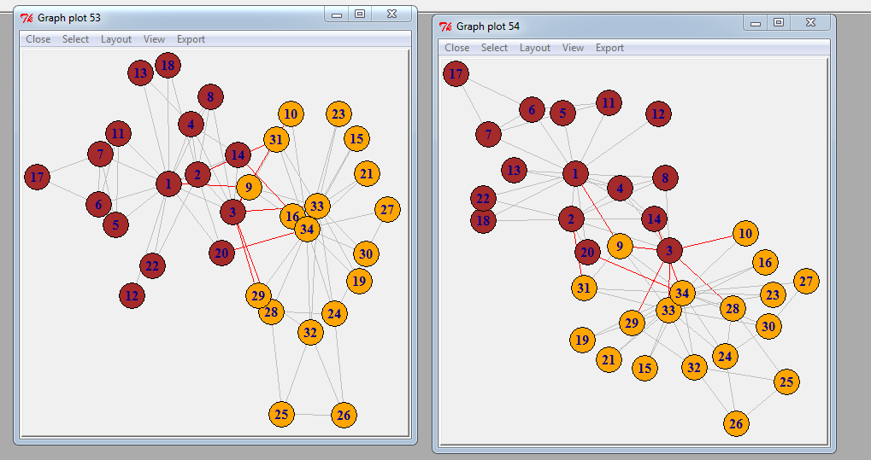

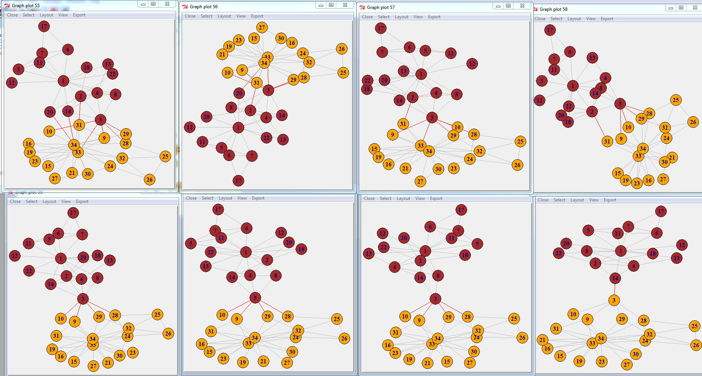

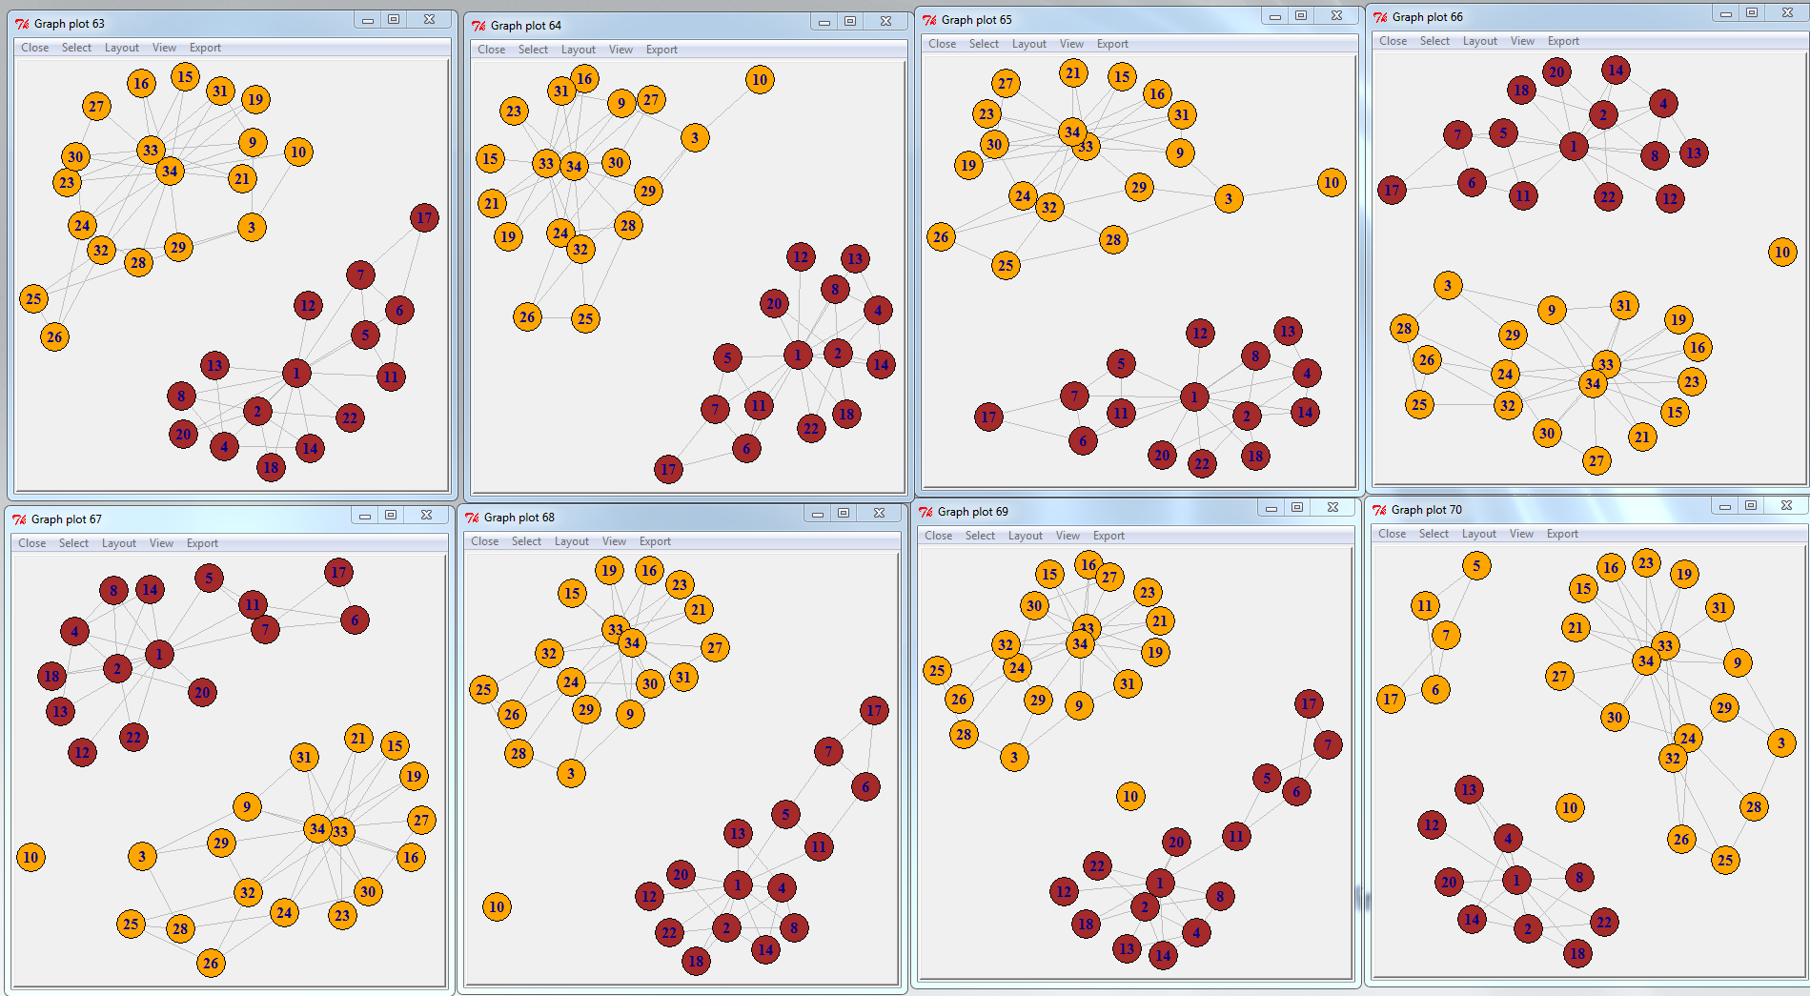

[1] "Edges will be deleted in the following order : "

[1] "1 -> 32 -- Betweenness = 71.3928571428571"

[1] "1 -> 3 -- Betweenness = 66.8951770451771"

[1] "1 -> 9 -- Betweenness = 77.3173992673993"

[1] "14 -> 34 -- Betweenness = 82.0029059176118"

[1] "20 -> 34 -- Betweenness = 123.232917082917"

[1] "3 -> 33 -- Betweenness = 100.205555555556"

[1] "2 -> 31 -- Betweenness = 143.626984126984"

[1] "2 -> 3 -- Betweenness = 109.25"

[1] "3 -> 4 -- Betweenness = 107.666666666667"

[1] "3 -> 8 -- Betweenness = 142.75"

[1] "3 -> 14 -- Betweenness = 285"

[1] "10 -> 34 -- Betweenness = 16.8333333333333"

[1] "28 -> 34 -- Betweenness = 18.1833333333333"

[1] "3 -> 10 -- Betweenness = 18"

C) Split into 5

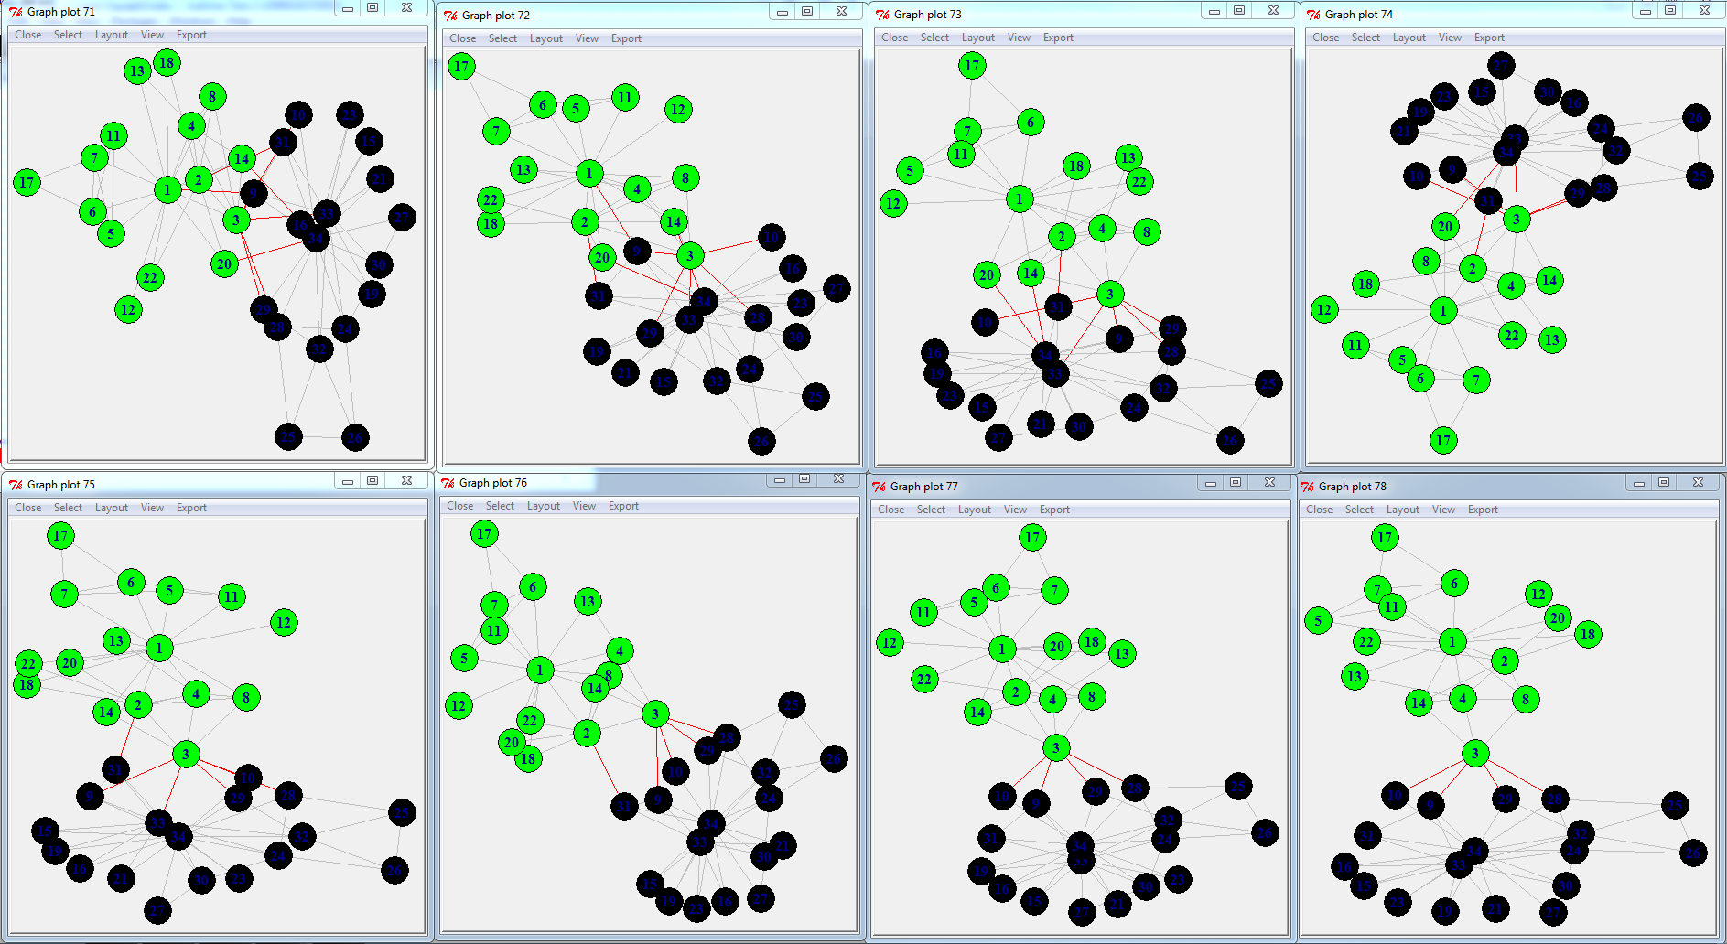

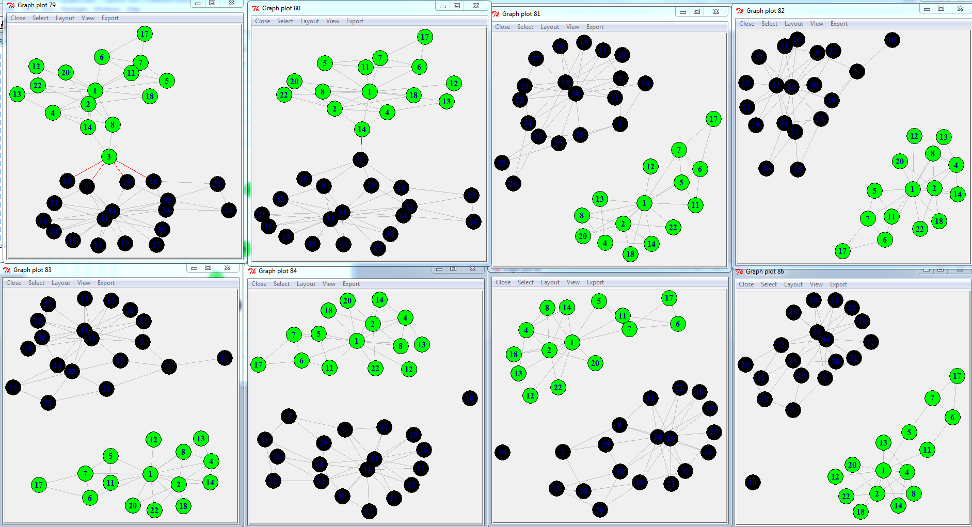

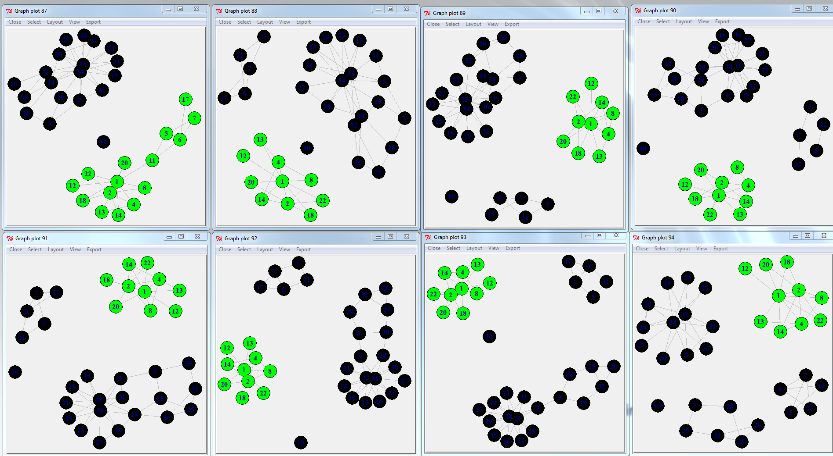

[1] "Edges will be deleted in the following order : "

[1] "1 -> 32 -- Betweenness = 71.3928571428571"

[1] "1 -> 3 -- Betweenness = 66.8951770451771"

[1] "1 -> 9 -- Betweenness = 77.3173992673993"

[1] "14 -> 34 -- Betweenness = 82.0029059176118"

[1] "20 -> 34 -- Betweenness = 123.232917082917"

[1] "3 -> 33 -- Betweenness = 100.205555555556"

[1] "2 -> 31 -- Betweenness = 143.626984126984"

[1] "2 -> 3 -- Betweenness = 109.25"

[1] "3 -> 4 -- Betweenness = 107.666666666667"

[1] "3 -> 8 -- Betweenness = 142.75"

[1] "3 -> 14 -- Betweenness = 285"

[1] "10 -> 34 -- Betweenness = 16.8333333333333"

[1] "28 -> 34 -- Betweenness = 18.1833333333333"

[1] "3 -> 10 -- Betweenness = 18"

[1] "1 -> 6 -- Betweenness = 15.3333333333333"

[1] "1 -> 7 -- Betweenness = 25.3333333333333"

[1] "1 -> 5 -- Betweenness = 25"

[1] "1 -> 11 -- Betweenness = 50"

[1] "32 -> 34 -- Betweenness = 14.5"

[1] "32 -> 33 -- Betweenness = 22.3690476190476"

[1] "29 -> 34 -- Betweenness = 25.6166666666667"

[1] "24 -> 26 -- Betweenness = 29.65"

[1] "24 -> 28 -- Betweenness = 40.6666666666667"

[1] "3 -> 9 -- Betweenness = 72"

Analysis:

In order to acquire these graphs, I used a code from one of the sources you provided on our email list; [https://github.com/maturban/cs595-f13/tree/master/assignment9/latex](https://www.google.com/url?q=https%3A%2F%2Fgithub.com%2Fmaturban%2Fcs595-f13%2Ftree%2Fmaster%2Fassignment9%2Flatex&sa=D&sntz=1&usg=AFQjCNGqTewCKpQgeRslqTuhg8KJsz1QHw) , which allowed me to understand the process of the fission more in depth. For the extra credit portion, After running the code in R, I received the results; later on I altered the code a bit to be able to have the cluster’s split into groups of 3, 4, 5 sets.

Political information through the club acts with the political strategy of the factions to pull apart networks. In most things conflict tend to arise, to be able to keep them in order; we must bind them by similar rules, this way contestants will know how they contest. With the karate club, the conflicting clubs made the order of things unclear to everyone. Because of this the club members grew to know less about what was going on as they shifted to different groups.

In conclusion, with fission in the groups; each link is gradually separated from each other. Node 10 was conflicted with node 34 and 1, and decided to isolate itself. This is an example of the mutual people in conflicting groups who are bias in neither side; being very similar to the Karate Club graph.