
Credits are the source and Debits are the destination.
Assets = Liabilities + Equity Note: Equity can be stock holders or owner’s equity.
Every account lives inside the Accounting Equation.
Double entry accounting keeps the Accounting Equation balanced.

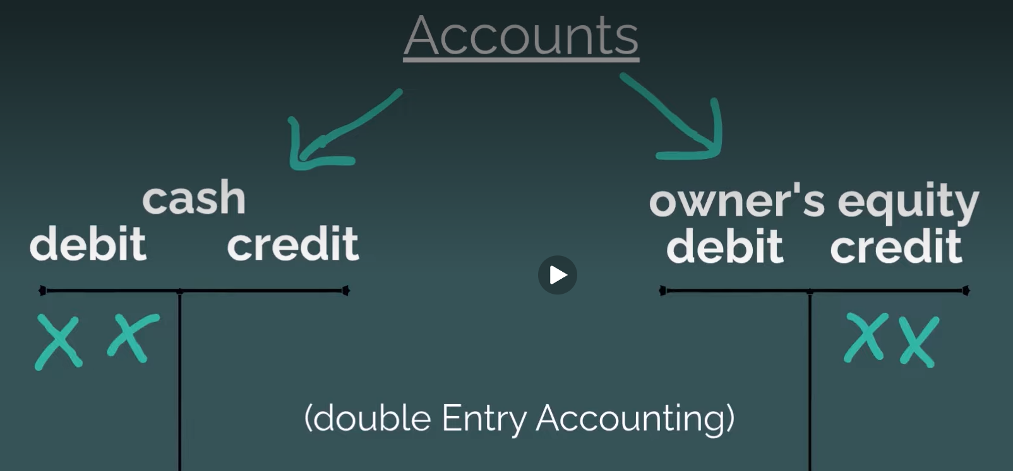

Debits and Credits increase or decrease an account balance. Whether we credit or debit an account depends on the type of account we are affecting. Which of the 6 Account Categories is the affected account in? OR Which side of the Account Equation is the account on?

Journal entries recorded on the left-hand side of an account using a T-account format. The rules of double-entry accounting require that debit entries be used to record increases in asset, expense and dividend accounts, and decreases in liability, capital contribution, retained earnings and revenue accounts. As a result, "debiting" an account may refer to an increase or decrease depending on the kind of account that is "debited." Most introductory accounting students inaccurately assume that debit always refers to some decrease. This is clearly not the case in double-entry accounting.









