About this project:

* Contains a Python flask api that exposes the below endpoint:
  + The area names by the area codes
  + The different types of data available to be queried
  + With a given area code and a column, returns the day to day changes from the baseline
* Tech stack
  + Python Flask
  + Docker containers
  + Docker Compose
  + Postgres database, SQLAlchemy
  + Bash
* Directory Structure
  + Mainly split into three:
    - One for Api
    - One for nginx
    - One for database

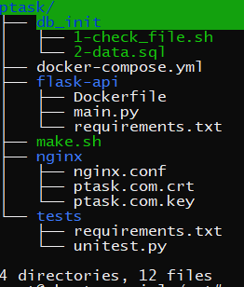

* Ptask/ – Contains the entire solution (pTask stands for PollenTask)
  + db_init/
    - 1-check_file.sh
      * To check if the csv file is ready to copy to database
    - 2-data.sql
      * Create postgres table
      * Copy the csv file content to postgres database table
  + flask-api/
    - Dockerfile
      * To create the container api
    - main.py
      * Api logic
    - Requirements.txt
      * Contains all the modules to be installed on the api container
  + nginx/
    - nginx.conf
      * Configuration to run the api endpoint using nginx with caching and ssl certs
    - Ptask.com.crt and key are the self-signed SSL certificate and its key
      * Command used:
      * openssl req -newkey rsa:2048 -nodes -keyout nginx/ptask.com.key -x509 -days 365 -out nginx/ptask.com.crt
  + tests/
    - Contains unittest implementation
  + docker-compose.yml
    - Used by docker-compose to build the application.
  + Make.sh
    - To build the application
    - Run ./make up – To build and ./make.sh down – To destroy
* Pre-requisites
  + Install docker and docker compose
* Result:
  + After running ./make.sh up, you should see the below containers up and running:
    - nginx
    - api
    - psdb
  + You might see an init container in stopped, its used a sidecar to fetch the csv file. Hence its exits after downloading the file
  + If ran successfully, below endpoint will be exposed:
    - curl -kv https://localhost:443/api/v1/healthcheck
    - curl -kv https://localhost:443/api/v1/activities
    - curl -kv https://localhost:443/api/v1/activities/area_by_code/E09000033
    - curl -kv https://localhost:443/api/v1/activities/pointers
    - curl -kv https://localhost:443/api/v1/activities/pointers/E09000033/area_name/Westminster