RNAscope-McKO-old-probe

CT Berezin

11/23/2021

library(tidyverse)

## -- Attaching packages --------------------------------------- tidyverse 1.3.1 --

## v ggplot2 3.3.5 v purrr 0.3.4  
## v tibble 3.1.6 v dplyr 1.0.7  
## v tidyr 1.1.4 v stringr 1.4.0  
## v readr 2.1.0 v forcats 0.5.1

## -- Conflicts ------------------------------------------ tidyverse_conflicts() --  
## x dplyr::filter() masks stats::filter()  
## x dplyr::lag() masks stats::lag()

library(MESS)  
library(ggpubr)  
library(ggthemes)

#creating the dataframe  
genotype <- c("WT", "WT", "WT", "WT", "WT",  
 "McKO", "McKO", "McKO", "McKO", "McKO", "McKO")  
mouse <- c("17", "pup1-1", "pup1-2", "31", "90",  
 "98", "pup1", "pup2", "pup4", "pup3", "pup2-2")  
positive <- c(16, 42, 63, 3, 58,  
 9, 46, 6, 19, 17, 19)  
total <- c(17, 42, 68, 3, 67,  
 15, 107, 7, 33, 21, 22)  
  
data <- tibble(genotype, mouse, positive, total)  
  
data <- mutate(data,  
 percent = positive/total*100)

#checking normality, variance, etc.  
shapiro.test(data$percent)

##   
## Shapiro-Wilk normality test  
##   
## data: data$percent  
## W = 0.86701, p-value = 0.07094

morlm <- lm(percent ~ genotype, data)  
  
resid <- rstandard(morlm)  
yhat <- morlm$fitted.values  
ggplot(data, aes(yhat, resid)) +  
 geom_point()

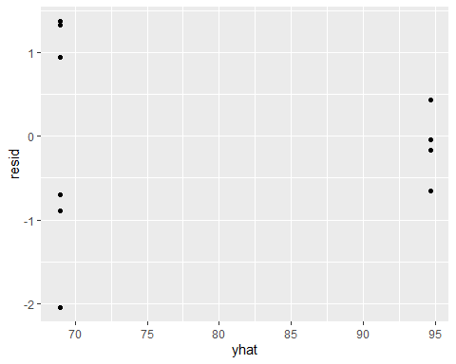

car::leveneTest(percent ~ genotype, data)

## Warning in leveneTest.default(y = y, group = group, ...): group coerced to  
## factor.

## Levene's Test for Homogeneity of Variance (center = median)  
## Df F value Pr(>F)   
## group 1 12.791 0.005964 **  
## 9   
## ---  
## Signif. codes: 0 '***' 0.001 '**' 0.01 '*' 0.05 '.' 0.1 ' ' 1

#null hyp = variances are equal, fails  
qqnorm(resid)  
abline(0,1, lty=2)

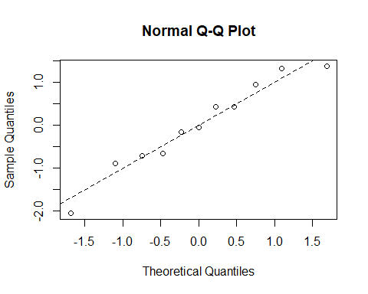

#Welch's t-test OK with non-homogenous variance  
data %>% group_by(genotype) %>% summarise(sd=sd(percent))

## # A tibble: 2 x 2  
## genotype sd  
## <chr> <dbl>  
## 1 McKO 18.0   
## 2 WT 5.63

t.test(percent ~ genotype, data)

##   
## Welch Two Sample t-test  
##   
## data: percent by genotype  
## t = -3.3203, df = 6.1434, p-value = 0.01545  
## alternative hypothesis: true difference in means between group McKO and group WT is not equal to 0  
## 95 percent confidence interval:  
## -44.591011 -6.876165  
## sample estimates:  
## mean in group McKO mean in group WT   
## 68.93279 94.66637

power_t_test(n=5, delta=94.66637-68.93279,  
 sd=5.63, ratio=1.2,  
 sd.ratio=17.953801/5.631853,  
 type="two.sample", alternative="one.sided")

##   
## Two-sample t test power calculation with unequal sample sizes and unequal variances   
##   
## n = 5, 6  
## delta = 25.73358  
## sd = 5.63000, 17.94789  
## sig.level = 0.05  
## power = 0.9004025  
## alternative = one.sided  
##   
## NOTE: n is vector of number in each group

stat.test <- compare_means(percent ~ genotype, data, method = "t.test")

plot <- ggplot(data, aes(genotype, percent)) +  
 geom_point(alpha=0.75) +  
 stat_summary(fun = 'mean', geom="bar", aes(alpha=0.5)) +  
 stat_summary(fun.data = mean_se, geom = "errorbar", width=.1, alpha=0.5) +  
 theme_few() +  
 theme(legend.position = "none") +  
 labs(y="% ipRGCs with MOR mRNA",  
 title = "RNAscope labeling of MOR mRNA") +  
 geom_bracket(  
 aes(xmin = "WT", xmax = "McKO", label = signif(p, 2)),  
 data = stat.test, y.position = 110) +  
 scale_y_continuous(expand = expansion(mult = c(0, 0.1)))  
plot

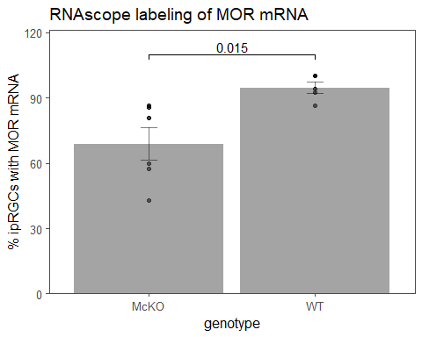

ggsave("../figures/RNAscope_McKO_old_probe.png",  
 plot=plot, height=3, width=3)