# SYSC 4005 Lab 2

## Question 1

### C:\Users\Cameron\School\SYSC 4005\Lab 2\OccupancyHistogram.png

1. The experimentally calculated probability that a packet is in the system more than 0.3 time units is 0.22139.

|  |  |  |  |
| --- | --- | --- | --- |
| Time (t) | Event List Contents | Server Status | Server Utilization to t |
| 500 | PRINT @ 500.0  ARRIVAL @ 500.037033852  DEPARTURE @ 500.063485401  PRINT @ 5000.0  PRINT @ 10000.0 | Busy | 0.5208851663824023 |
| 5000 | PRINT @ 5000.0  ARRIVAL @ 5000.02152642  DEPARTURE @ 5000.0704723  PRINT @ 10000.0 | Busy | 0.49223818668463126 |
| 10000 | PRINT @ 10000.0  ARRIVAL @ 10000.04830244 | Not Busy | 0.49693653805317684 |

The final utilization of the server is 0.4978522824190534

## Question 2

1. Server 1 Occupancy Histogram (queue + server)  
   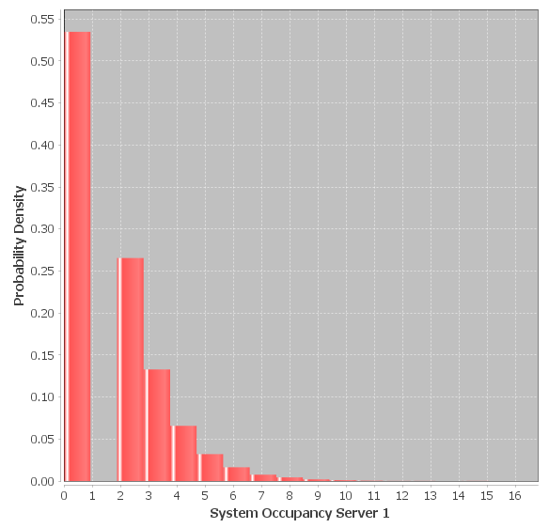

Server 2 Occupancy Histogram (queue + server)  
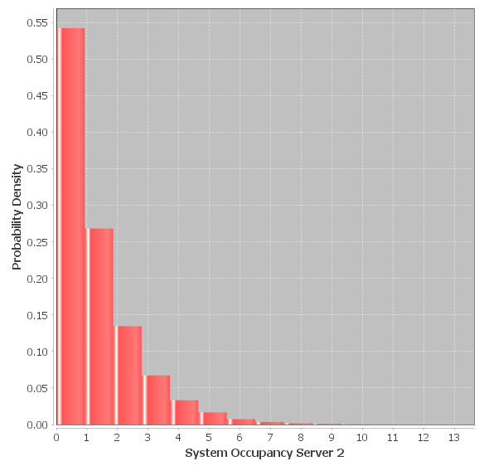

1. The experimentally calculated probability that a packet is in the system more than 0.2 time units is 0.7333.
2. Event List Contents

|  |  |
| --- | --- |
| Time (t) | Event List Contents |
| 500 | PRINT @ 500.0  ARRIVAL @ 500.03703385299946  DEPARTURE @ 500.06348540199946  PRINT @ 5000.0  PRINT @ 10000.0 |
| 5000 | PRINT @ 5000.0  ARRIVAL @ 5000.021526427508  DEPARTURE @ 5000.070472383508  PRINT @ 10000.0 |
| 10000 | PRINT @ 10000.0  ARRIVAL @ 10000.048302445286 |

|  |  |  |  |  |
| --- | --- | --- | --- | --- |
| Time | Server 1 Utilization | Server 1 Status | Server 2  Utilization | Server 2  Status |
| 500 | 0.5208851663824023 | Busy | 0.5158725033514003 | Not Busy |
| 5000 | 0.49223818668463126 | Busy | 0.4949304958213329 | Not Busy |
| 10000 | 0.49693653805317684 | Not Busy | 0.49913755906074514 | Not Busy |

Final server 1 utilization was: 0.4978483481769662.

Final server 2 utilization was: 0.49840631221897924.