Group Project 1 - Devices for Sharing
Christopher Caulfield, Mary Rose Weber
Game - Rock, Paper, Scissors

Problem:

We wanted to create a way to play the traditional game of rock, paper, scissors but to prevent there being communication issues between the players. Some think you say: “Rock, paper, scissors” then display your selection, while others do “Rock, paper, scissors, shoot!”. Allowing for the server to monitor the game - it allows the participants to enjoy the game stress free.

Design Process:

Functional Overview
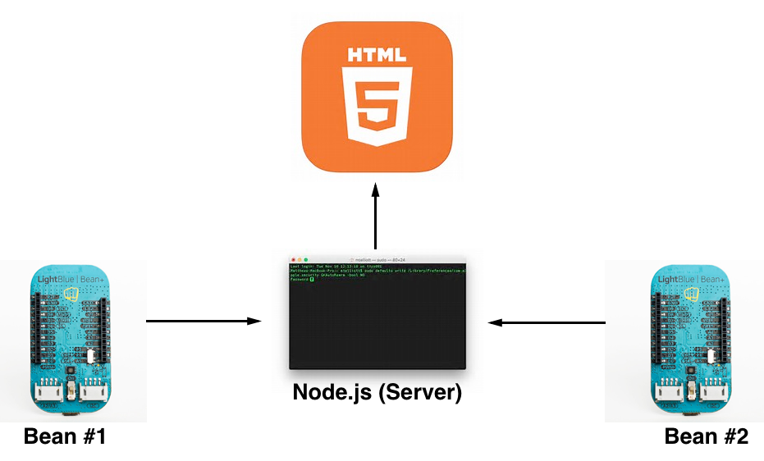

Setup:

Bill of materials:

Hardware:
- LightBlue Bean
- Grove Expander Board
- Grove Button
- Grove Touch Sensor
- Grove Magnetic Switch
- Three Grove cables
Each player need to have these materials.

Software/Files:
- Arduino
- Terminal
- Node.js
- JavaScript (Server.js & Main.js)
- HTML file

No other hardware or products were used other than what was provided from class.

