**Secret of Billionaire**

**Goal**:

Recently, the people who has invested in stock experienced a huge stock fall leading thousands of people losing money in stock market. So, many investors desire finding out a way to predict the stock price of next second.

So, I have three goals in the project:

1. **To simulate a basic brownian motion of particles suspended in a medium.**
2. **Using brownian motion to predict the stock price**.
3. **Compare results with Monte Carlo simulation.**

**Methods**:

**Brownian motion simulation**

As we’ve already known that brownian motion is a random motion of particles suspended in a medium. While brownian method usually was seen as a scientific simulation method for years, it could sometimes be used in stock market as well. With the properties of brownian motion that 1) expectation value of brownian motion and the random process of stock price are independent, 2) brownian motion only considers positive value like stock market and 3) the calculation of brownian motion is simpler than other complicated method.

**Monte Carlo simulation**

Monte carlo simulation is a widely used simulation method in many fields, including stock market. Generally, Monte Carlo method is a simulation based on random number. Simply put, a Monte Carlo simulation runs an enormous amount of trials with different random numbers generated from an underlying distribution for the uncertain variables. So, I expect to use this way to predict the stock price, too.

Challenges:

1. Background knowledge of brownian motion simulation and Monte Carlo simulation.
2. There must be possibly stochastic in real-world stock market, but brownian motion simulation ignores it. So, there will be error between them. I hope to adjust to model of brownian motion to get a better result.
3. In brownian and Monte Carlo simulation, we all assume that the distribution is normal. This is not compatible to stock market in real world.

Expect conclusion:

Based on the goals of this project mentioned in part I, I show some expect simulation conclusion here.

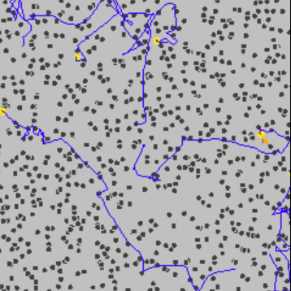

Figure 1. To simulate a basic brownian motion of particles suspended in a medium.

(Yellow: particle; gray polygon: fluctuation of environment; blue line: particle path)

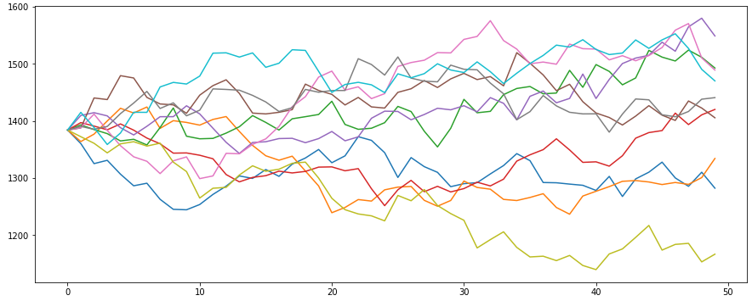

Figure 2. Expectation of simulation result by brownian and Monte Carlo method.

As figures showed above, I expect to get the particle movement of brownian motion first. Under this simulation model, I expect getting the prediction of stock price according to the model and Monte Carlo simulation. The results between these two methods should be different because of the difference of basic idea between them.

Reference:

[1] <https://en.wikipedia.org/wiki/Brownian_motion>

[2] <https://en.wikipedia.org/wiki/Monte_Carlo_method>

[3] <https://seekingalpha.com/article/289470-brownian-motion-of-the-stock-market?gclid=CjwKCAjwtKmaBhBMEiwAyINuwKEL0EtYry9ijzQtinUNtqpxL_Zwgd4kHkCv-G1ThY7b9oSe6iBQlRoCvbUQAvD_BwE&internal_promotion=true&utm_campaign=17125379236&utm_medium=cpc&utm_source=google&utm_term=135003782046%5Edsa-1485125202378%5E%5E595907318290%5E%5E%5Es>