Cameron Cuff

**COP 4600 - Homework 5**

Total time spent: 3 hours (approx.)

**Step 1**

This step was fairly straight forward, and I didn’t run into any problems. It took a few minutes to figure out how the code worked and how it was structured but besides that, no issues. Below is a screenshot showing successful completion of the program.

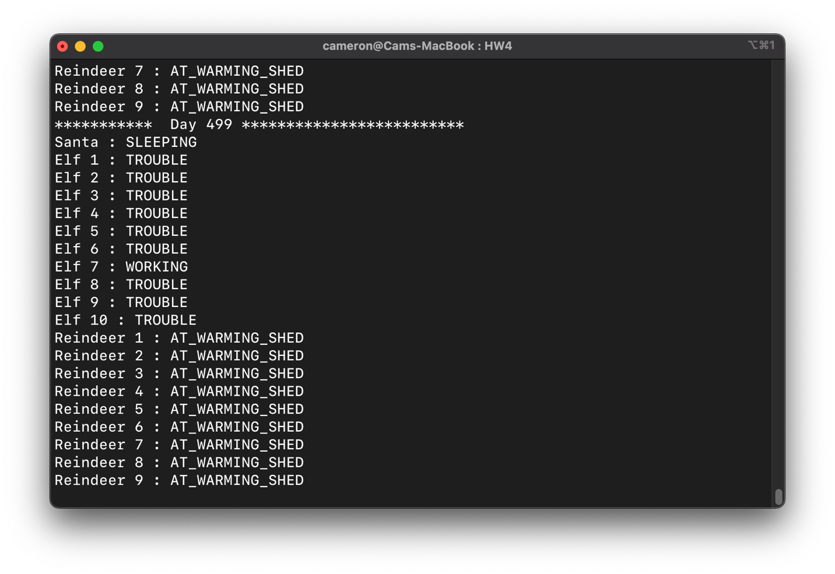

**Step 2**

This step was fairly straight-forward as well. The only major change I had to make was in the TROUBLE case of the switch statement in the Elf class. My idea was to add any elf with a TROUBLE state to an array list in the Santa class. Once an elf gets added to Santa’s list of elves in trouble, that elf’s state gets set to AT_SANTAS_DOOR and Santa wakes up to fix that elf’s problem. I’ve included a screenshot below that shows the execution of step 2 below. As soon as an elf has a problem, Santa fixes it.

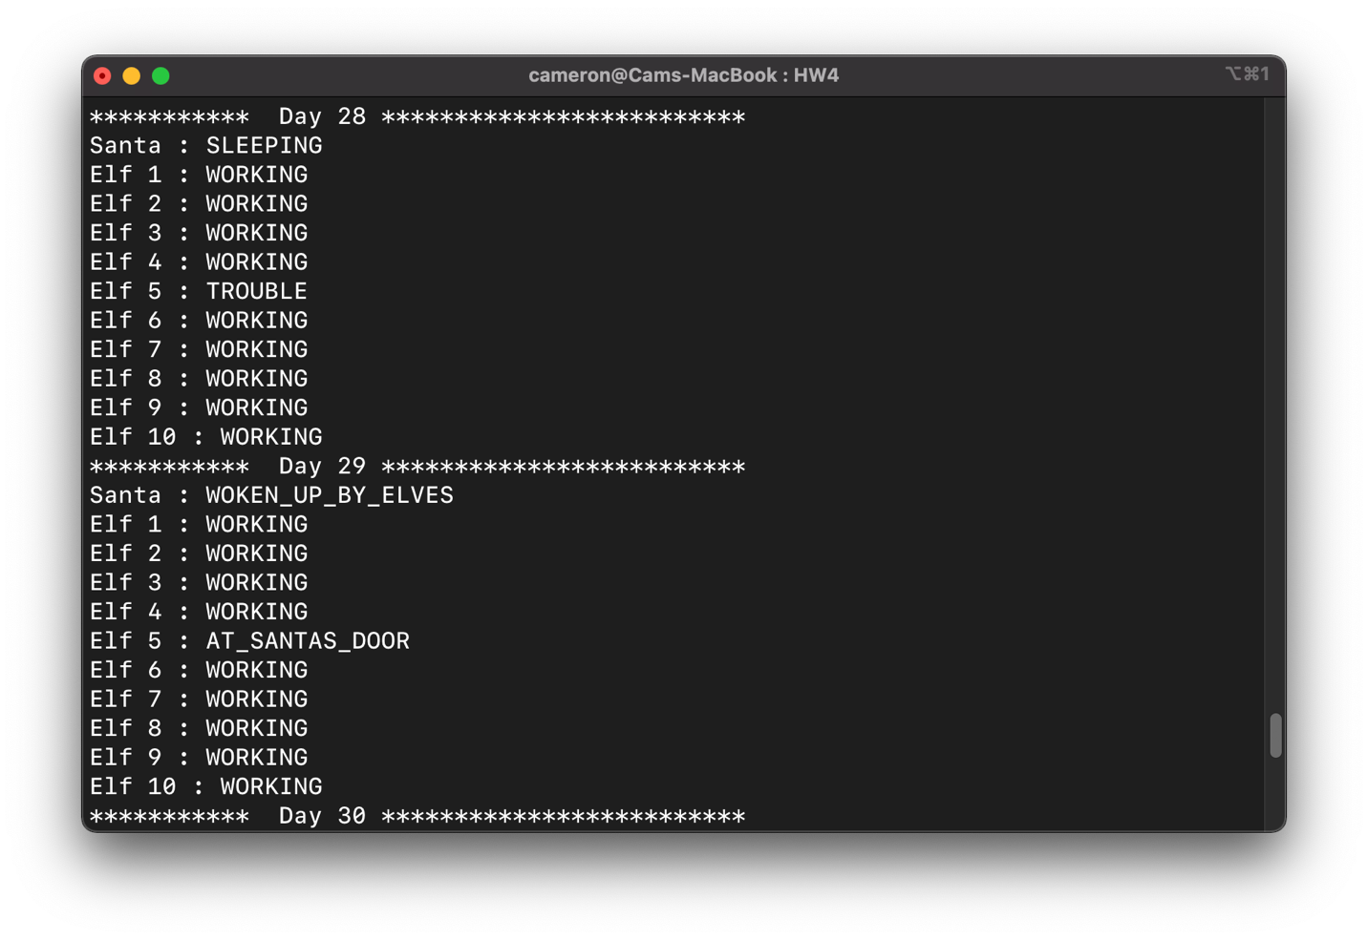

**Step 3**

This part was a little trickier than the last 2 steps. For this step, I had to loop through an array list to check if there were 3 elves that were in trouble. The problem was that I ran into NullPointerExceptions in the Santa class and ConcurrentModificationExceptions in the Elf class. The screenshot below shows Santa going into the WOKEN_UP_BY_ELVES state after 3 elves are in trouble.

**Step 4**

This step was by far the most difficult because I didn’t have experience using the Semaphore class in Java. However, after using it for a bit, it turned out to be simpler than I expected. When an elf is in trouble, it acquires the semaphore. Once the semaphore has run out of available permits, santa wakes up to solves the elves problems. Because the output of the step is exactly the same as step 3, I’ve attached a screenshot of the main semaphore code in the Elf class instead.

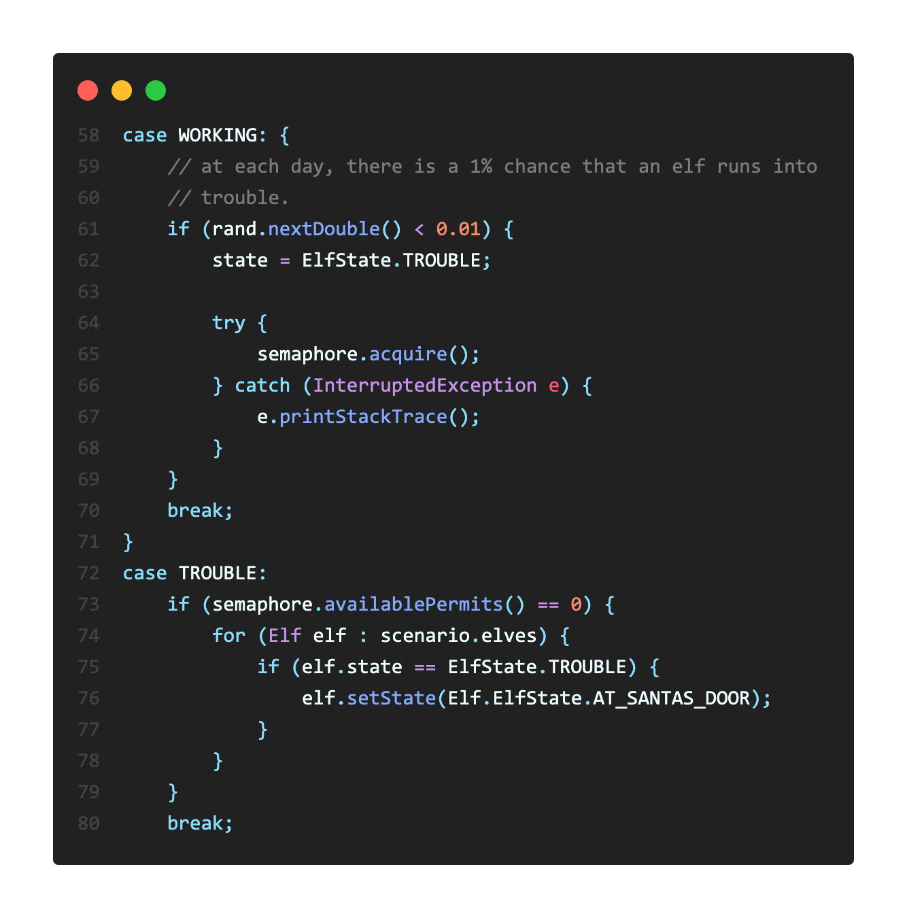

**Step 5**

This was the final step for the assignment. Although I has to use semaphores again, it became much easier because I had to use it for step 4. For this step, I checked if all reindeer have the AT_WARMING_SHED state in the switch statement. If they do, I know that the last reindeer needs to wake up Santa and acquire a semaphore. When Santa wakes up, he re-starts the reindeer threads (which were previously stopped at day 370) and sets all the reindeer’s states to AT_THE_SLEIGH. After that’s completed, the semaphore acquired by the last reindeer is released by Santa and Santa’s state is set to READ_FOR_CHRISTMAS. Below is a screenshot of the reindeer going from AT_WARMING_SHED to AT_THE_SLEIGH.

