**Domain Name and Web Host Assignment**

CIM 141-Creating a Web Page Using HTML

**Instructor:** Florence Lee, [flee@ivc.edu](mailto:flee@ivc.edu)

|  |
| --- |
| Student Name:Calvin Huynh |
| ID No.:679951 |

**Instructions:**

* To complete this assignments you need to read/review the **URL_DN&WH reading notes_su2016.pdf**  posted on BB. Use the provided file.
* Open the **URL_DN&WH_assignment_su2016.docx,** posted on **Blackboard, s**ave it as **yourname_URL_DN&WH_assignment_su2016.docx**
* **Type your name and your ID Number on the provided area on the top of the page.**
* Type your answers on providing areas under each question. Remember to save after you finish the assignment.

**Answer the questions below:**

1. Go to one of the following web hosting providers:

<https://www.networksolutions.com/>

<http://www.godaddy.com>

<https://register.hostgator.com/>

Enter your first name and last name or the domain name of your choice in the domain name search field on the web hosting site, click the search button to see the result.

Answer the following questions:

1. What domain name did you use? (2 points)

**Answer:**

calvin huynh

1. Was the domain name you were searching available? (2 points)

**Answer:**

yes

1. List three other available domain suffixes. (3 points)

**Answer:**

calvinhuynh.net

calvinhuynh.org

calvinhuynh.xyz

1. Take a screen capture of the search result and attached it here in the answer below. (4 points)  
   See how to capture a screen shot at the end of the document. And check out the example at the bottom of the document.

**Answer:**

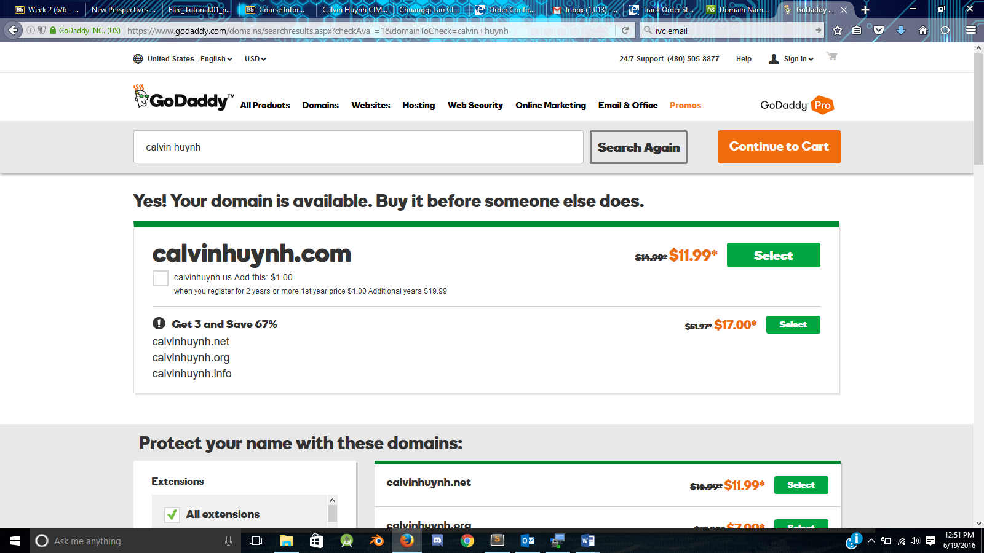

1. Use Google search or another search engine to search “domain name tips.”

Use one of the search results to answer the question below:

1. List 5 tips for choosing a domain name and explain why on each tip. (4 points)

**Answer:**

1. Make it easy to type

2. Keep it short

3. Use keywords

4. Target your area

5. Avoid numbers and hyphens

1. From what website did you get the tips information? (3 points)

**Answer:** https://www.godaddy.com

1. What is the URL of the website where you found the tips information? (3 points)

**Answer:**

https://www.godaddy.com/garage/smallbusiness/launch/10-tips-for-choosing-the-perfect-domain-name/

1. After your webpage/website is published (i.e., after a webpage/website has been uploaded to a server)?
2. Do you need an internet connection to view it live (not local)? (2 points)

**Answer:** No

1. How would you view the website that you just published on the internet? (2 points)

**Answer:** If you have an internet connection, then open a browser and enter the domainname in the address bar

1. What is an internet protocol? (2 points)

**Answer:** a set of rules governing the format of data sent over the Internet or other network.

1. List three internet protocols. (3 points)

**Answer:** HTTP, HTTPS, FTP

**Screen captures instructions:**

**Windows users:**

1. Activate the window you want to capture by clicking it. Press Alt + PrtSc on the keyboard (this will copy the window image to a temporary clipboard).
2. Open a Word document and paste the image from the clipboard to the work document you just open. Save the Word file.

**Mac Users:**

1. Activate the window you want to capture by clicking it. Hold down Shift + Command + 4 on your keyboard, click and drag the mouse to select the window that you want to capture. A screen capture file will automatically be saved to your computer desktop. Usually the captured screen shot is named **Screen Shot *date time***.
2. Locate the screen capture file on the desktop, change the file name if you wish.
3. Open a Word document and paste the screen capture image from your computer desktop to the work document you just opened (by clicking and dragging the image file to the document). Save the Word file.

Watch this YouTube video if you need visual help: <https://www.youtube.com/watch?v=EoTpIYLBtKs>

**Example for problem NO.1:**

I use godaddy.com to search a domain name using my name: florencelee

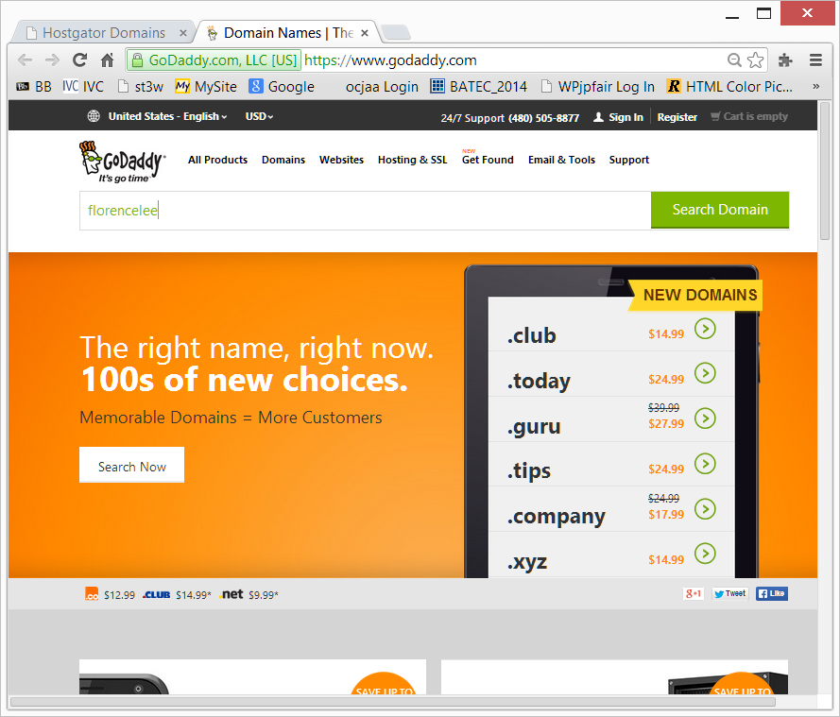

Search result:

