Quantifying AI data center flexibility as a resource adequacy asset
Chris Dunlap
Abstract
AI data centers are entering resource adequacy planning as inflexible firm load, a treatment that reflects operational convention rather than physical necessity and that is increasingly difficult to sustain at the scale of projected demand. We show that inference-dominant facilities possess meaningful demand-side flexibility through spatial compute migration that current models do not capture. We develop a ten-parameter multiplicative cascade for spatial migration feasibility and test it against four years of day-ahead electricity pricing data across five U.S. grid regions, finding that at least one cross-region destination is unstressed during 99% or more of observed stress hours from each of four source zones tested. A conditional Monte Carlo simulation conditioned on observed per-hour grid states yields commitment depths that decline from 47% for an individual 500 MW facility to 27% for a 10 GW fleet, as co-stressed operators compete for finite destination capacity. Individual operators can credibly commit flexibility well above existing demand response baselines, but fleet-level resource adequacy contributions require coordination mechanisms that do not yet exist in current market designs.
1. Introduction
In PJM Interconnection, the 2027/2028 capacity auction fell 6.6 GW short of the reliability requirement, the first such shortfall in the region's history, while large load adjustments, predominantly for data centers, total 33.7 GW by 2030 in PJM's 2026 Long-Term Load Forecast and account for effectively all net peak demand growth. Supply-side responses cannot keep pace: generation and storage projects face median completion timelines exceeding five years, with only 13% reaching commercial operation, and the underlying bottlenecks in permitting and equipment supply chains cannot be compressed by capital investment alone. Policy research has begun to argue that load flexibility should be the primary response. Norris and colleagues at Duke's Nicholas Institute estimated that the 22 largest U.S. balancing authorities could accommodate approximately 98 GW of new flexible load using existing system capacity, with an average annual curtailment rate of 0.5% and an average curtailment duration of approximately two hours.
Resource adequacy planning has responded to this growth by treating data center load as firm and inelastic at each facility, requiring corresponding procurement of generating capacity plus reserve margin for every additional megawatt and allocating those costs to retail customers through capacity charges. This treatment reflects how data center operators have historically operationalized their service-level contracts to guarantee uninterrupted compute reliant on maintaining locally firm power draw at every facility. The aggregation of these local firmness commitments across a rapidly growing fleet is what produces the system-level capacity requirement now exceeding what the interconnection queue can deliver.
Recent work has begun to challenge one technical premise of this convention. In a field demonstration on a 256-GPU cluster in a Phoenix hyperscale facility, Colangelo et al. showed that software-based workload orchestration — combining dynamic voltage-frequency scaling (DVFS), job pausing, and GPU resource reallocation — reduced cluster power consumption by approximately 25% during a peak stress event while maintaining service quality, and noted geographic workload shifting as a future direction for extending capability (ref. 5). We refer to this combined GPU-level flexibility mechanism as local- orchestration throughout, distinguishing it from the spatial migration mechanism developed below. The geographic mechanism itself has prior foundations: Zheng, Chien, and Suh showed that shifting data center load from fossil-heavy to renewable-rich regions can mitigate curtailment and reduce emissions (ref. 6), and Zhang et al. developed a market-clearing framework in which spatially flexible data center loads participate as ‘virtual links’ in electricity markets (ref. 7). These contributions establish that compute is geographically movable and that market mechanisms can in principle accommodate that movement.
Here we quantify whether spatial compute migration can provide committed, accreditable resource adequacy value during grid stress events, and identify the conditions under which it does. We make three contributions. First, we introduce a ten-parameter multiplicative cascade that decomposes the conditions required for cross-region workload migration into independently estimable parameters, grading each against the best available empirical evidence. Second, we present a stress decorrelation analysis using four years of day-ahead locational marginal pricing data across five U.S. grid regions, establishing that at least one unstressed migration destination is available during 99% or more of observed stress hours from all source zones tested. Third, we develop a conditional Monte Carlo simulation that relaxes the cascade's independence assumption, revealing that commitment depth is strongly scale-dependent, with destination contention becoming binding as fleet size grows. This finding has direct implications for both capacity planning and infrastructure investment.
2. Decomposing spatial migration feasibility
We decompose spatial migration feasibility into ten multiplicative parameters spanning source-side candidacy, destination-side capacity, and execution reliability conditions. Source-side parameters capture whether workloads are geographically movable and operationally available for migration. Destination-side parameters capture whether cross-region destinations have the capacity and capability to receive migrating workloads. Execution parameters capture whether the migration can complete within grid dispatch windows. The effective spatial fraction is the product of all ten parameters, combined with DVFS, job pausing, and GPU resource reallocation flexibility applied to the non-migrating portion of the inference-eligible load envelope following Colangelo et al. (ref. 5). The framework's primary function is decomposition rather than point estimation: it identifies the conditions that must hold for spatial migration to succeed and grades each against available empirical evidence (see Methods for parameter definitions and empirical grounding).
Three source-side parameters capture whether a facility's workloads are candidates for migration (S1, the inference-dominant share), whether regulatory data-locality constraints permit migration (S2), and whether active requests can drain within dispatch windows (S3). Five destination-side parameters capture whether cross-region facilities have the physical capacity (D1, observed per-hour from pricing data), GPU headroom (D2), hardware compatibility (D3), inference workload share (D4), and pre-staging readiness (D5) to absorb migrated load. Two execution parameters capture routing completion (E1) and bandwidth adequacy (E2). The product of all ten yields an effective spatial fraction of 0.038 at central values, corresponding to a commitment depth of 20.4% when combined with local software orchestration. Variance decomposition reveals that three destination-side parameters — D2, D4, and D5 — account for 85% of cascade output variance, concentrating model uncertainty in operationally actionable choices rather than physical constraints.
3. Cross-region stress decorrelation
Spatial compute migration requires that at least one destination grid region is operating under normal conditions when the source region is stressed. We test this condition empirically using 35,060 hours of day-ahead locational marginal pricing (DA LMP) data from January 2022 through December 2025, spanning five U.S. grid regions: PJM, ERCOT, CAISO, MISO, and NYISO. Within each region we identify destination pricing zones co-located with data center facilities using county-level data center capacity data from the U.S. Department of Energy / National Renewable Energy Laboratory Accelerating Speed to Power Data Viewer (ref. 8), which aggregates operational, under-construction, and announced data center capacity from multiple commercial and public sources. Stress hours are defined as hours in which the DA LMP exceeds the 99th percentile of the zone’s own four-year distribution, yielding the 200 highest-priced hours per zone (see Methods for threshold sensitivity).
Using the ComEd zone in Northern Illinois as the primary source region, we compute the fraction of source stress hours in which at least one cross-region destination zone exhibits a DA LMP below its stress threshold. Of the 200 observed ComEd stress hours, at least one cross-region destination was available in 198, corresponding to a dynamic availability of 99.0%. The two failure hours occurred during the January 2024 Arctic Blast. The decorrelation structure reflects the electrical topology of the North American transmission system. ERCOT operates as an electrically isolated interconnection with no synchronous ties to the Eastern grid. CAISO has temporal offset and weather patterns that are largely independent from the Midwest. Capacity-weighted stress overlap between ComEd and cross-interconnection destinations ranges from 3.7% (ERCOT, summer) to 14.0% (CAISO, annual), with CAISO exhibiting zero summer overlap across the four-year study period (Fig. 1). Same-interconnection destinations exhibit substantially higher overlap: MISO zones range from 43% to 66%, and NYISO zones from 29% to 41%, consistent with shared exposure to regional weather systems and partial electrical coupling.
We replicate the analysis from three additional source zones to test generalization beyond the ComEd perspective: PJM-DOM (Northern Virginia, approximately 9,400 MW of installed data center capacity), ERCOT-LZ-NORTH (Dallas-Fort Worth), and CAISO-NP15 (Silicon Valley). Dynamic availability is 99.5% from PJM-DOM (one failure hour, the same 2024 Arctic Blast event) and 100% from both ERCOT-LZ-NORTH and CAISO-NP15.
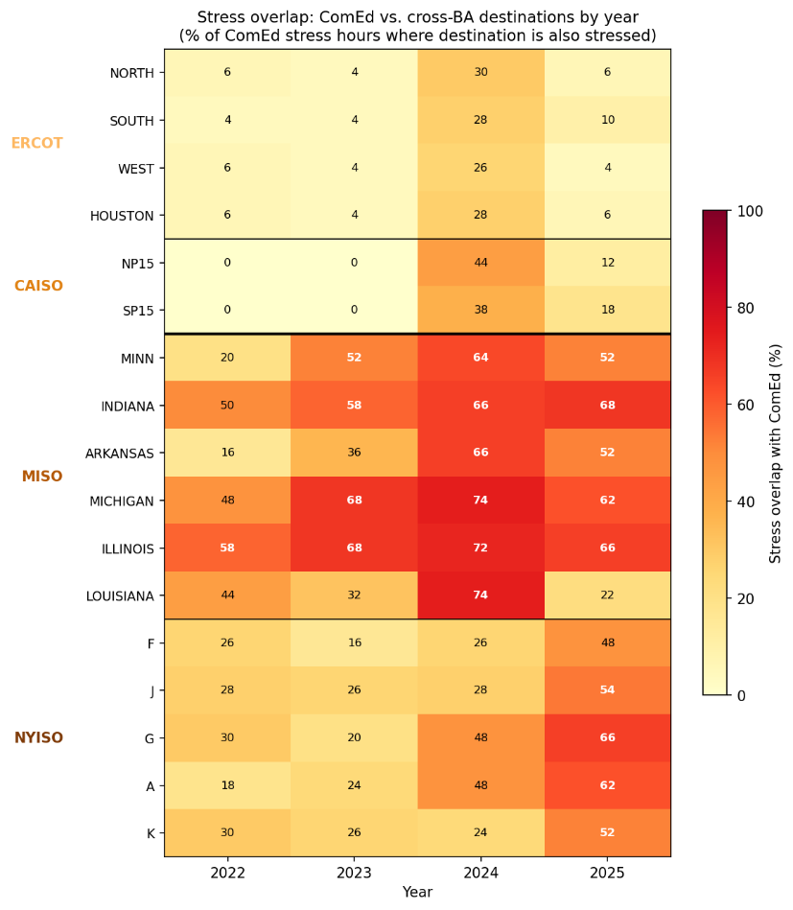
Fig. 1. Stress overlap between ComEd and 17 cross-BA destination zones by year, 2022–2025. Each cell shows the percentage of ComEd's 50 annual stress hours in which the destination zone was simultaneously stressed. Cross-interconnection destinations (ERCOT, CAISO) exhibit overlap below 30% in all years; same-interconnection destinations (MISO, NYISO) range from 16% to 74%, consistent with shared exposure to regional weather systems. The 2024 column reflects elevated co-stress during the January 2024 Arctic Blast. CAISO coverage begins November 2022; earlier periods are treated as available per Methods.

4. Workload characterization
The operational timing parameter (S3) captures whether active inference requests at a source facility can complete within the grid operator’s emergency dispatch window. We validate drain time using two independent production inference datasets totaling 49.4 million requests over a combined 128 days of observation (see Methods for dataset descriptions). P99 drain times range from 4.5 to 12.12 seconds across model configurations and datasets, approximately two orders of magnitude below PJM’s minimum dispatch window of 10 minutes (ref. 9), indicating that S3 = 0.90 is a conservative parameterization. The 10% excluded by S3 accommodates long-running or batched inference requests, multi-turn conversational sessions with persistent state, and potential future workload types with longer completion times.
5. Conditional Monte Carlo validation
We develop a conditional Monte Carlo simulation that conditions on observed per-hour grid states to capture how commitment depth depends on fleet size and destination contention during specific stress events.
For a representative 500 MW inference-dominant facility, the conditional Monte Carlo yields a mean commitment depth of 46.9%, approximately 27 percentage points above the cascade estimate of 20.4% (Fig. 2a). The distribution exhibits a sharp upper concentration near 48.3% with a left tail that stops well above the local-orchestration floor. The 5th percentile (VaR) is 30.7% and the conditional expected shortfall below the 5th percentile (CVaR) is 23.5%. Even in the worst 5% of outcomes, spatial migration contributes approximately 6 percentage points beyond the local-orchestration baseline. The cascade's conservatism at single-facility scale arises from a ratio effect: aggregate available headroom across unstressed destinations substantially exceeds the demand from a single migrating facility in the large majority of stress hours. Hardware compatibility and utilization constraints bind in 6.8% of draw-hour combinations, concentrated in the small number of stress hours where multiple destination zones are co-stressed with the source. The cascade's independence assumption is violated in these hours, but the violation is not damaging: the negative correlation between D1 and D2 bites only when aggregate headroom would have been sufficient regardless.
When the analysis is extended to simultaneous migration by geographically distributed facilities, commitment depth becomes scale-dependent. We first evaluate an empirical fleet defined by the geographic distribution of PJM data center capacity across load zones, with per-hour co-stress identified from the intra-PJM coincidence matrix described in Section 3. Only zones experiencing simultaneous stress contribute migrating load in each hour. The effective migrating fleet averages approximately 3,013 MW across stress hours, with substantial variation driven by whether the Dominion zone in Northern Virginia (9,431 MW of data center capacity) is co-stressed with ComEd, which occurs in 36% of stress hours. This empirical fleet yields a mean commitment depth of 28.9% (Fig. 2b). The conditional expected shortfall below the 5th percentile converges exactly to the local-orchestration floor of 17.5%. In the worst 5% of outcomes, spatial migration contributes no incremental flexibility beyond local power management. A reliability assessment grounded in worst-case performance such as PJM's Loss of Load Probability framework would therefore credit this fleet with no accreditable capacity from spatial migration. Fleet-level accreditation depends on the mean-versus-tail metric chosen by the capacity market operator, a methodological choice with direct consequences for the economic value quantified in Section 6.
We then evaluate commitment depth as a continuous function of fleet size using a parametric sweep from 0.5 to 20 GW. Commitment depth declines steadily as destination contention becomes binding: 46.4% at 1 GW, 42.5% at 3 GW, 35.8% at 5 GW, 26.9% at 10 GW, and 23.8% at 15 GW. At 10 GW, 100% of Monte Carlo combinations are destination-constrained, and the gap between the conditional Monte Carlo (26.9%) and the cascade estimate (20.4%) is 6.5 percentage points as destination contention absorbs the additional headroom that conditioning on observed states reveals. The 5th percentile converges toward the local-orchestration floor of 17.5% at fleet scales above 10 GW, indicating that spatial migration's incremental contribution diminishes as aggregate demand approaches destination pool capacity.
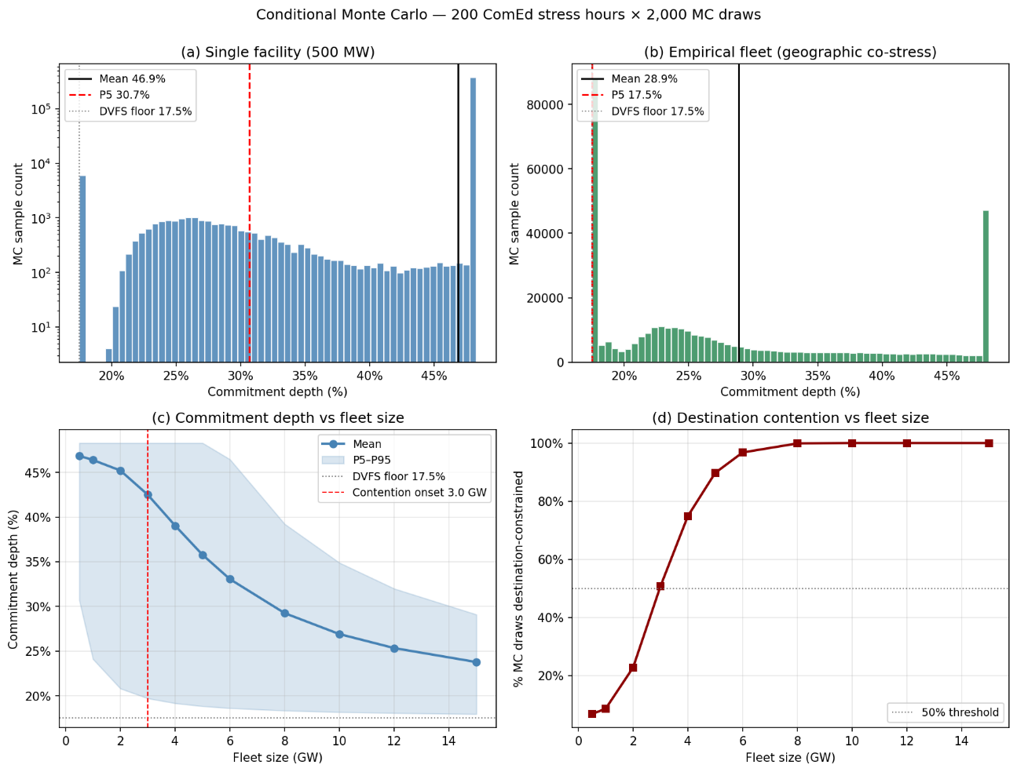
Fig. 2. Conditional Monte Carlo commitment depth results. (a) Single-facility (500 MW) commitment depth distribution across 400,000 draw-hour combinations; mean 46.9%, P5 30.7%; y-axis is log-scaled; the 48% mode contains ~75% of the mass. (b) Empirical fleet commitment depth distribution; mean 28.9%, P5 at local-orchestration floor (17.5%). (c) Per-GW fleet sweep: mean commitment depth (solid) with P5–P95 band, showing decline from 46.4% at 1 GW to 26.9% at 10 GW. (d) Percentage of draw-hour combinations that are destination-constrained, reaching 100% at 10 GW. Contention onset (>50% constrained) occurs at 3 GW.
The scale dependence of commitment depth has direct implications for how this flexibility should be quantified in capacity market design. A single operator evaluating participation faces a commitment depth distribution with meaningful spatial contribution even in the tail and can credibly bid at levels well above the DVFS-only floor. Fleet-level accreditation cannot be inferred from single-facility performance: destination contention reduces the aggregate contribution as fleet size grows, and beyond approximately 3 GW the majority of stress hours become destination-constrained. Capacity market operators evaluating DR class ratings for data center flexibility must therefore set accreditation at the fleet level rather than extrapolating from facility-scale studies.
6. System-level implications
The commitment depths estimated by the conditional Monte Carlo translate directly to resource adequacy contributions within existing capacity market frameworks. We evaluate system-level implications at two reference scales. Commitment depth values from Section 5 are fractions of inference-compute load; for translation to facility-metered quantities we apply PUE = 1.3, corresponding to approximately 770 MW of inference compute for a 1 GW nameplate facility and 7,692 MW for a 10 GW fleet. For an individual 1 GW inference-dominant facility, the conditional Monte Carlo yields a mean commitment depth of 46.4%, implying approximately 357 MW of curtailable load during system emergencies, or approximately 328 MW when derated to a 92% effective load carrying capability (ELCC) consistent with PJM’s treatment of demand response resources. For a 10 GW fleet, the mean commitment depth of 26.9% implies approximately 2,069 MW curtailable and 1,904 MW accredited.
These accredited capacity values use mean commitment depth, consistent with PJM's standard UCAP accreditation convention for demand response. An alternative approach using the 5th-percentile commitment depth would yield approximately 171 MW accredited at 1 GW and 1,288 MW at 10 GW. The gap between the mean and P5 accreditations (157 MW at 1 GW and 616 MW at 10 GW) quantifies the economic stakes of the methodological choice introduced in Section 5.
To estimate the economic value to the grid, we calculate avoided capacity costs using the capacity requirements identified in Energy + Environmental Economics' 2025 Resource Adequacy Study for Illinois and cost estimates from NREL's Annual Technology Baseline (ref. 17, 18). At E3's levelized CT cost of $180,000/MW-yr, the annualized avoided capacity cost is approximately $59 million for an individual 1 GW facility and approximately $343 million for a 10 GW fleet at the fleet commitment level. These figures represent the system planner's perspective: capacity procurement that spatial migration commitments would displace.
From the operator's perspective, a distinct and substantially larger incentive exists through interconnection acceleration. A flexible interconnection framework allows a facility to energize before network upgrades complete; the present value of avoided delay depends on foregone compute revenue during the waiting period. Using prevailing hyperscaler capital expenditure rates and a three-year acceleration window for a 1 GW facility, we estimate a central NPV of approximately $23 billion. This figure exceeds the annualized avoided capacity cost by roughly two orders of magnitude, indicating that operators' primary economic motivation under this framework derives from accelerated energization rather than capacity payments.
7. Discussion
Several limitations qualify these results. Most importantly, the three parameters that dominate model uncertainty: destination-side utilization headroom (D2, 44% of variance), inference workload share (D4, 28%), and pre-staging readiness (D5, 13%), are not directly observable in public data. For that reason, we do not interpret the model as providing a precise universal estimate of accreditable flexibility for AI data centers. The contribution of the cascade and conditional Monte Carlo is to show that, after the physical feasibility of cross-region migration and the operational feasibility of dispatch window compliance are established empirically (Sections 3 and 4), the remaining uncertainty is concentrated in a small set of destination-side operational choices. The framework therefore identifies where operator behavior, disclosure, or contractual commitments would have the highest impact on realized resource adequacy value, and bounds the consequences of those choices across a plausible parameter space.
The flexibility quantified here is a physical property of multi-region compute infrastructure: inference workloads can be geographically relocated during stress events regardless of what drove the underlying capacity shortfall. The relevant counterfactual is not a grid without data centers but a grid with data centers treated as inflexible firm load — the current planning convention. Under that convention, every MW of data center load requires a corresponding MW of generation or storage procurement. If some fraction of that load is demonstrably flexible, failing to recognize it results in over-procurement of supply-side resources at ratepayer cost.
The nature of this concentrated uncertainty is decision-relevant rather than irreducible. D2 reflects how much GPU headroom operators choose to maintain at destination facilities. D4 tracks the allocation of compute between inference and training, a ratio shifting rapidly toward inference (refs. 10, 11, 11B). D5 captures whether operators invest in systematic model weight pre-staging across geographically diverse facilities. Each is an investment or operational decision, not a physical constraint. The gap between the physical potential for spatial migration and realized commitment depth is therefore governed by institutional choices such as including disclosure requirements, contractual commitments, and capacity market design, rather than by the physics of compute migration itself.
Each of the three dominant parameters corresponds to a concrete policy or investment lever. The sensitivity surface (Fig. 3a) shows that mean commitment depth at 10 GW ranges from 21.6% to 34.1% across the plausible ranges of D2 and D5. The tornado chart (Fig. 3b) confirms that D2, D4, and D5 together account for the full sensitivity range, while source-side parameters (S2, S3, D1) show near-zero sensitivity at fleet scale because the fleet is entirely destination-constrained. Source-side policies such as data locality waivers and regulatory flexibility would increase individual facility commitment depth but have negligible effect at fleet scale, where destination-side investment is the binding constraint. Of the three destination-side parameters, pre-staging readiness (D5) is the most directly actionable: it requires no change in hardware or workload composition, only operational investment in model weight distribution across geographically diverse facilities.
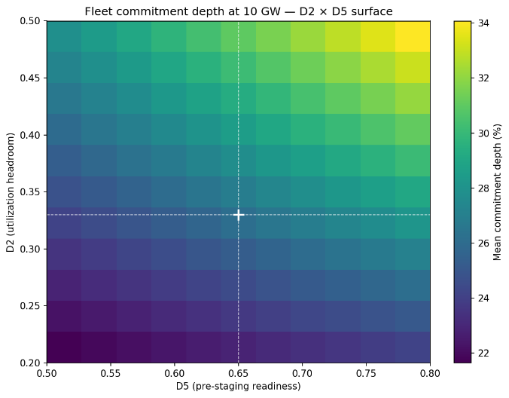  Fig. 3a. Two-dimensional sensitivity surface: mean fleet commitment depth at 10 GW across the D2 (utilization headroom) × D5 (pre-staging readiness) parameter space, with D3 and D4 held at central values. Crosshairs mark central values (D2 = 0.33, D5 = 0.65). Depth ranges from 21.6% to 34.1%. | 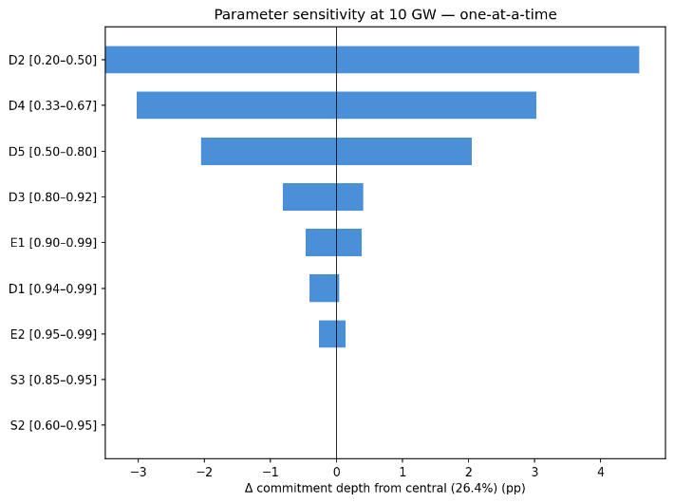  Fig. 3b. Tornado chart: one-at-a-time parameter sensitivity at 10 GW fleet scale. D2, D4, and D5 together account for the full sensitivity range. Source-side parameters (S2, S3) show zero sensitivity at fleet scale because the fleet is entirely destination-constrained.

The scale dependence identified in Section 5 implies that accreditation frameworks should distinguish between individual facility commitments and fleet-level resource contributions. Aggregation of spatial migration commitments across multiple operators, analogous to demand response aggregation in existing capacity markets, could allocate destination headroom more efficiently than uncoordinated facility-level decisions. Zhang et al.'s virtual link framework provides a formal basis for incorporating spatially flexible loads into market clearing (ref. 7), though its application to reliability-committed resources under the destination contention conditions identified here remains unexplored. The development of such mechanisms is a precondition for fleet-level spatial migration to achieve commitment depths substantially above the local-orchestration baseline in tail scenarios. The conditional Monte Carlo developed here provides a tool for quantifying the value that coordination would unlock.
The system-level calculations apply PJM's 92% ELCC for demand response, but the conditional Monte Carlo tail profile, specifically the fleet CVaR of 17.5% at the 5th percentile, indicates that a full sequential Monte Carlo reliability determination would likely yield a different accreditation value. The workload validation draws from two production datasets totaling 49.4 million requests across 128 days of observation; while the consistency of drain time results across both datasets provides partial cross-validation, generalization to other providers, model architectures, and deployment configurations remains an open empirical question.
The framework proposed here reallocates reliability risk. Under current practice, the grid operator bears the full obligation to procure capacity to serve data center load at nameplate rating, and procurement costs are allocated to retail ratepayers. Under this framework, the data center operator assumes responsibility for managing a portion of its own power availability during system emergencies. The cross-region decorrelation of grid stress demonstrated in Section 3 is a physical property of the North American transmission system, and major data center operators have already constructed the multi-region infrastructure that would activate it. What remains is institutional mechanism design: flexible interconnection frameworks for facilities in the interconnection queue and accredited demand response participation for operating facilities, mutually exclusive and sequenced by grid position. A detailed policy treatment of both mechanisms is developed in a companion article (C. Dunlap, Data Centers Can Help Solve the Grid Crisis They’re Creating, EPIC Working Paper, 2026, in preparation). Direct empirical measurement of the destination-side parameters that dominate framework uncertainty would sharpen quantitative predictions, but the institutional gap is the binding constraint on realized value.
Methods
Cascade parameter specifications.
Specifications for all ten cascade parameters are reported in Table M1. Three specifications and the commitment depth formula require additional explanation.
Table M1. Cascade parameter specifications.
Parameter | Symbol | Central | Distribution | Empirical basis | Key sources
Workload candidacy | S1 | 0.70 | Fixed | Inference-dominant facility share; inference as fastest-growing segment of data center compute | McKinsey (2026); see Technical Appendix Section 2
Data locality | S2 | 0.70 | Uniform[0.60, 0.95] | GDPR, PIPL, HIPAA residency constraints; ultra-low-latency SLOs; enterprise contractual restrictions | Radovanović et al., IEEE Trans. Power Syst. 38(2), 2023; SkyLB, arXiv:2505.24095 (2025); Bain (2025)
Operational timing | S3 | 0.90 | Uniform[0.85, 0.95] | P99 drain times 4.5–12.1 s versus 10-minute minimum dispatch window | This paper, Section 4
Cross-region availability | D1 | Observed | Per-hour from data | 200 ComEd stress hours × unstressed-destination capacities from day-ahead LMP across five RTOs | This paper, Section 3
Utilization headroom | D2 | 0.33 | Uniform[0.20, 0.50] | GPU-compute absorption capacity during stress hours; bound by LBNL AI-inference server operational-time modeling (40% annual-average assumption) and practitioner testimony that peak-to-off-peak capacity gap is operationally recognized headroom; D2 = 1 − utilization | Shehabi et al., LBNL (2024); Stojkovic et al., HPCA (2025); Uptime Institute Global Data Center Survey (2024)
Hardware compatibility | D3 | 0.88 | Fixed | CUDA backward compatibility; TensorRT-LLM architecture-specific engines; framework portability via vLLM | NVIDIA CUDA and TensorRT-LLM documentation; Red Hat (October 2025)
Inference workload share | D4 | 0.50 | Uniform[0.33, 0.67] | Industry inference share trajectory: ~33% (2023) → ~67% (2026) | Patterson et al., IEEE Computer (2022); Aljbour et al., EPRI (2024); Deloitte (2025); McKinsey (2025)
Pre-staging readiness | D5 | 0.65 | Uniform[0.50, 0.80] | Multi-region model deployment at hyperscale; cold-start latency constraints eliminated by pre-staging | NVIDIA Run:ai Model Streamer (2025); Llama 3 405B specification
Routing completion | E1 | 0.95 | Uniform[0.90, 0.99] | Load balancer SLAs ≥99.99%, conservatively derated for orchestration layer that does not yet exist as a production system | AWS ELB SLA; Azure Standard Load Balancer SLA; Govindan et al., ACM SIGCOMM (2016)
Bandwidth adequacy | E2 | 0.98 | Uniform[0.95, 1.00] | Hyperscaler wavelength purchases on a single North American carrier grew 133% from 18.2 Tb (2020) to 42.4 Tb (2024); inference request/response payloads trivial relative to pre-staged weights. | Jain et al., ACM SIGCOMM (2013); Data Center Knowledge (November 2025)  See 3.4

Observed versus drawn parameters. D1 (cross-region availability) is the only parameter that is observed per-hour rather than drawn parametrically. For each of the 200 ComEd stress hours, the conditional Monte Carlo uses the set of unstressed destination zones and their realized capacities directly from the day-ahead pricing data, rather than sampling from a distribution. This conditioning on observed grid states is the defining methodological feature of the conditional Monte Carlo relative to the baseline cascade.
  - D2 as GPU compute absorption, not facility load factor. D2 represents the fraction of destination facility GPU compute capacity available to absorb migrated inference workloads, not overall facility load factor. Cooling, networking, and storage overhead consume facility power but cannot absorb migrated inference workloads. The D2 range [0.20, 0.50] reflects headroom available during grid stress hours, bounded below by a commercial overprovisioning floor (redundancy, burst handling, business continuity) and above by LBNL's modeled 40% annual-average operational time for AI inference servers (Shehabi et al. 2024). The range width reflects the absence of published GPU-level utilization measurements at production AI inference facilities during stress hours — the single most valuable empirical contribution operators could make to tighten this estimate.
E1 conservative derating. Component-level load balancer SLAs imply availability exceeding 0.9999 across the major cloud providers. E1 is derated to 0.95 because the orchestration layer translating grid dispatch signals to compute routing does not yet exist as a production system; the value accounts for end-to-end reliability of software that has not been built and tested. As production orchestration systems are developed and operated, E1 would be expected to converge toward the SLA-implied values.
Commitment depth formula. Commitment depth is computed as Spatial + FLEX × (S1 − Spatial), applying software-orchestrated GPU flexibility only to the compute-amenable portion of facility load. The FLEX coefficient is set at 0.25, consistent with the aggregate power reduction sustained by Colangelo et al. on a 256-GPU cluster through combined DVFS, job pausing, and GPU resource reallocation (ref. 5). The restriction to the S1 envelope reflects the physical constraint that GPU-level flexibility techniques cannot reduce cooling, networking, or power conditioning load, and should not be applied to the full facility envelope. Commitment depth throughout is reported as a fraction of the facility's inference-compute envelope. Translations to facility-metered quantities in Section 6 apply a PUE factor of 1.3, representative of hyperscale inference-dominant facilities; at higher PUE values, facility-metered MW would scale inversely with the PUE assumption. The local-orchestration floor reported in Section 5 (17.5% for inference-dominant facilities) is FLEX × S1 = 0.25 × 0.70, representing the commitment depth achievable through software-orchestrated GPU flexibility alone — combining DVFS, job pausing, and GPU resource reallocation as demonstrated by Colangelo et al. — without any spatial migration..
Variance decomposition. The cascade Monte Carlo (N = 50,000) draws the nine stochastic parameters independently from their specified distributions, computes the multiplicative product, and applies the commitment depth formula. S1 is held fixed at 0.70 because it defines the analysis scope (inference-dominant facilities) rather than representing uncertainty within that scope. Variance attribution uses the η² correlation ratio, computed by digitizing each parameter into 20 quantile bins and measuring the between-bin variance of cascade output as a fraction of total variance. This yields the variance shares reported in Section 2 (D2: 44%, D4: 28%, D5: 13%, S2: 13%). These shares reflect the model's distributional assumptions, not empirical frequencies; their function is to identify which parameters most repay direct measurement.
Stress threshold definition. Stress hours are defined as the top 50 hours per year per zone (approximately the 99.4th percentile of each zone's four-year distribution), yielding 200 ComEd stress hours over the January 2022 through December 2025 observation period. Sensitivity analysis at alternative thresholds confirms the headline any-destination availability finding is stable: 99.0% at the baseline, varying by at most 1.25 percentage points at the top 25 and top 100 hours per year specifications. The capacity-weighted overlap declines monotonically with threshold tightness (23.9% at top 100/year, 21.6% at baseline, 15.2% at top 25/year), indicating that cross-region decorrelation strengthens at more extreme stress intensities (Extended Data Fig. 1).
Workload datasets. We analyzed 44.1 million production LLM inference requests across two Azure services (Coding and Conversation) drawn from the DynamoLLM trace release on the Azure Public Dataset repository, spanning seven days in May 2024. The underlying traces were characterized for energy-management purposes by Stojkovic et al. (ref. 12). We separately analyzed the BurstGPT dataset (arXiv v3 release), comprising 5.29 million requests from Azure OpenAI regional endpoints over 121 days of continuous observation (ref. 13). Both datasets represent production inference traffic. Drain times are computed as generated tokens divided by a central generation rate of 60 tokens per second, with sensitivity across 30–120 tokens/sec reported in Extended Data Fig. 2.
The two datasets differ in temporal structure: DynamoLLM shows strong diurnal variation (3.3× peak-to-trough for conversational workloads, 34.6× for coding workloads) while BurstGPT exhibits near-continuous 24-hour activity with minimal weekly periodicity. This divergence reflects differing user populations and does not affect the S3 parameterization, which depends on per-request drain time rather than aggregate traffic volume.
Conditional Monte Carlo simulation. D1 is observed per-hour from the empirical pricing data rather than drawn from a distribution. For each of the 200 ComEd stress hours, the simulation identifies the set of unstressed destination zones from DA LMP flags and uses their realized capacities directly. For each unstressed destination, available headroom is computed as destination capacity × D2 × D3 × D4 × D5. Migrating demand is allocated across destinations in proportion to available headroom; when aggregate demand exceeds aggregate headroom, destinations fill to their individual capacities and the unallocated demand contributes only the local-orchestration floor to commitment depth. This produces the scale-dependent contention effect analyzed in Section 5.
Three parameters are drawn independently per iteration from their specified uniform distributions: D2 (utilization headroom), D4 (inference workload share), and D5 (pre-staging readiness). These represent the residual absorption uncertainty the operator cannot observe at commitment time. Six parameters are held fixed at central values because, from an operator's perspective at commitment time, they are either scope-defining (S1 = 0.70), known in-house software properties (S3 = 0.90, D3 = 0.88), regulatory constraints (S2 = 0.70), or high-confidence infrastructure SLAs (E1 = 0.95, E2 = 0.98). This parameter scheme distinguishes the conditional Monte Carlo's question from the cascade Monte Carlo's question of which parameters drive scientific uncertainty in the framework itself.
The simulation uses 2,000 independent draws per stress hour, yielding 400,000 total samples.

Destination pool. The destination pool comprises 17 hourly-price zones across four grid regions: ERCOT (four load zones), CAISO (two zones), MISO (six zones keyed to MISO-published day-ahead hub LMPs: Minnesota, Indiana, Illinois, Michigan, Arkansas, and Louisiana), and NYISO (five zones), totaling 17.2 GW of operational data center capacity.
Two MISO load-resource zones with operational data center capacity are excluded because MISO does not publish dedicated day-ahead hub LMPs for these zones: Zone 2 (Wisconsin, 24 MW operational with ~7,600 MW announced buildout) and Zone 5 (Missouri, 411 MW operational). Sensitivity analysis using neighboring-hub LMP proxies for these zones is deferred to future work. MISO Illinois Hub is retained despite its geographic proximity to ComEd because MISO and PJM are independently dispatched; its mapped operational capacity (66 MW) is negligible relative to the destination pool. WECC non-ISO bilateral trading hubs (Mid-Columbia, Palo Verde) are also excluded because their published price data is daily-resolution, insufficient for hourly stress event detection.
These excluded hubs represent approximately 9,900 MW of current data center capacity. Their inclusion would increase destination headroom and shift fleet commitment depth upward; reported figures are therefore conservative with respect to the full destination pool.
Per-GW parametric sweep. The fleet-level analysis evaluates commitment depth as a continuous function of fleet size from 0.5 to 15 GW. At each fleet size, the migrating demand in each stress hour is fleet_MW × S1 × S2 × S3 (the source-side cascade product). This demand competes for the same per-hour destination headroom computed in the conditional MC. The same D2/D4/D5 draws are reused across all fleet sizes to isolate the scale effect from Monte Carlo variance. The sweep identifies the contention onset (the fleet size at which more than 50% of draw-hour combinations become destination-constrained) and produces the commitment depth curve reported in Section 5.
Sensitivity analysis. The two-dimensional sensitivity surface evaluates fleet commitment depth at 10 GW across a 10 × 10 grid of D2 and D5 values. D3 and D4 are held at central values. Source-side and execution parameters (S1, S2, S3, E1, E2) are held at their conditional MC central values, and D1 is observed per-hour from the empirical pricing data as in the base conditional MC. Each grid point computes deterministic hour-by-hour commitment depth under these fixed parameter choices.
The tornado chart quantifies one-at-a-time sensitivity at 10 GW fleet size across nine parameters, sweeping each from its lower to upper bound while holding all others at central values. S1 is excluded as a scope-defining parameter. D1 is swept parametrically across its range (0.945, 0.990, 0.995) rather than observed per-hour, which enables direct comparability of D1's uncertainty envelope against the other parameters. Source-side parameters (S2, S3) register zero sensitivity at fleet scale because destination contention binds in the majority of draws, making source-side multipliers irrelevant to the allocated migration volume.
System-level calculations. System-level calculations evaluate avoided capacity cost and interconnection acceleration value at two reference scales (1 GW facility and 10 GW fleet), using the commitment depths reported in Section 5. The 92% ELCC applied to committed MW follows PJM precedent for demand response resources (ref. 16). Avoided capacity cost is computed using the levelized CT cost of $180,000/MW-yr from the E3 2025 Resource Adequacy Study for Illinois (ref. 17). Full assumptions and scenario values for the interconnection acceleration NPV are reported in Extended Data Table 2.
Data and Code Availability
Day-ahead locational marginal pricing data are publicly available from the respective RTO market portals: PJM Data Miner 2 (https://dataminer2.pjm.com), ERCOT Market Information System (https://www.ercot.com/mp/data-products), CAISO OASIS (http://oasis.caiso.com), MISO Market Reports (https://www.misoenergy.org/markets-and-operations/real-time--market-data), and NYISO Custom Reports (https://www.nyiso.com/custom-reports). The Microsoft Azure LLM Inference Dataset 2024 (DynamoLLM traces) is publicly available at https://github.com/Azure/AzurePublicDataset under AzureLLMInferenceDataset2024. The BurstGPT dataset is publicly available at https://github.com/HPMLL/BurstGPT. Data center location data are from the U.S. Department of Energy / National Renewable Energy Laboratory Accelerating Speed to Power Data Viewer (https://maps.nrel.gov/speed-to-power), accessed via its public backend API. Analysis code and processed datasets are available at https://github.com/ctdunlap32/data-center-flexibility-resource-adequacy.
Acknowledgments
The author thanks Robert Rosner for advisory support. This research was supported by the Bartlett Fellowship at the Energy Policy Institute at Chicago (EPIC). The author used Anthropic's Claude for assistance with structural organization, literature search, computational code development, and prose drafting. All analytical design, empirical methodology, results, interpretation, and final editorial decisions are the author’s own.
References
[1] PJM Interconnection. 2025 Long-Term Load Forecast (2025).
[2] PJM Interconnection. 2027/2028 Base Residual Auction Report (2025).
[3] LBNL. Queued Up: Characteristics of Power Plants Seeking Transmission Interconnection (2024).
[4] Norris, T. H., Profeta, T., Patino-Echeverri, D., & Cowie-Haskell, A. Rethinking Load Growth: Assessing the Potential for Integration of Large Flexible Loads in US Power Systems. NI R 25-01, Nicholas Institute for Energy, Environment & Sustainability, Duke University (March 2025).
[5] Colangelo, P., Coskun, A. K., Megrue, J., Roberts, C., Sengupta, S., Sivaram, V., Tiao, E., Vijaykar, A., Williams, C., Wilson, D. C., Records, B., MacFarland, Z., Dreiling, D., Morey, N., Ratnayake, A., & Vairamohan, B. AI data centres as grid-interactive assets. Nature Energy 11, 254–261 (2026). https://doi.org/10.1038/s41560-025-01927-1.
[6] Zheng, J., Chien, A. A., and Suh, S. Mitigating curtailment and carbon emissions through load migration between data centers. Joule 4, 2208–2222 (2020).
[7] Zhang, W., Roald, L. A., Chien, A. A., Birge, J. R., and Zavala, V. M. Flexibility from networks of data centers: A market clearing formulation with virtual links. Electric Power Systems Research 189, 106723 (2020).
[8] U.S. Department of Energy / National Renewable Energy Laboratory. "Data Center Demand Capacity by County." Accelerating Speed to Power Data Viewer. maps.nrel.gov/speed-to-power (accessed December 2025)
[9] PJM Interconnection. PJM Manual 13: Emergency Operations. Rev. 97, effective November 20, 2025.
[10] Deloitte. Technology, Media and Telecommunications Predictions 2026 (November 2025).
[11] M Arora, C., Sorel, M., Sachdeva, P., Bhan, A., He, J., Shaw, N., Garg, R., & Ravishankar, S. The next big shifts in AI workloads and hyperscaler strategies. McKinsey & Company, Technology, Media & Telecommunications Practice (December 2025).
(11B) Patterson, D., Gonzalez, J., Hölzle, U., Le, Q., Liang, C., Munguia, L.-M., Rothchild, D., So, D. R., Texier, M., & Dean, J. The carbon footprint of machine learning training will plateau, then shrink. IEEE Computer 55(7), 18–28 (2022).

[12] Stojkovic, J., Zhang, C., Goiri, Í., Torrellas, J., & Choukse, E. DynamoLLM: Designing LLM Inference Clusters for Performance and Energy Efficiency. Proc. HPCA 2025, pp. 1348–1362.
[13] Wang, Y., Chen, Y., Li, Z., Kang, X., Zhao, Y., Ma, Z., Bao, H., Mei, X., Liu, Y., Chen, Y., Zhang, Q., Guo, M., Jin, W., Guo, M., & Cui, H. BurstGPT: A Real-World Workload Dataset to Optimize LLM Serving Systems. arXiv:2401.17644v3 (2024). Dataset: github.com/HPMLL/BurstGPT.
[14] Patel, P., Choukse, E., Zhang, C., Goiri, Í., Warrier, B., Mahalingam, N., & Bianchini, R. Characterizing Power Management Opportunities for LLMs in the Cloud. Proc. ASPLOS 2024..
[15] Cortez, E. et al. Resource Central: Understanding and predicting workloads for improved resource management in large cloud platforms. In Proceedings of SOSP (2017).
[16] PJM Interconnection. 2025 Effective Load Carrying Capability and Reserve Requirement Study (2025).
[17] E3 (Energy and Environmental Economics). 2025 Resource Adequacy Study for Illinois (2025).
[18] NREL. 2024 Annual Technology Baseline. atb.nrel.gov/electricity/2024.
[19] Zhang, W. and Zavala, V. M. Remunerating space–time, load-shifting flexibility from data centers in electricity markets. Applied Energy 326, 119930 (2022).
[20] Jain, S. et al. B4: Experience with a globally-deployed software defined WAN. In Proceedings of ACM SIGCOMM (2013).

Extended Data

Extended Data Fig. 1. Stress threshold sensitivity.
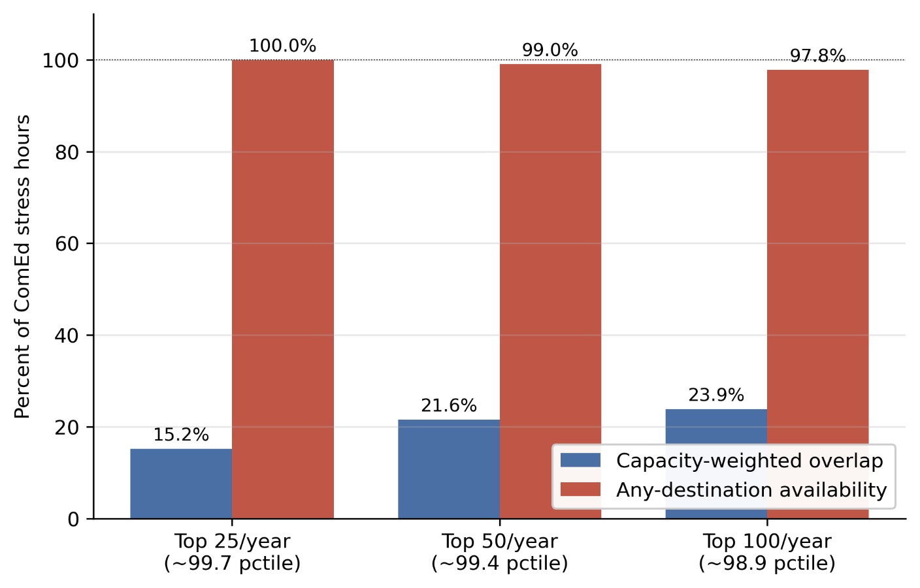
Capacity-weighted destination overlap and any-destination availability at three alternative stress-hour thresholds. Baseline: top 50 hours per year per zone (~99.43 percentile, 200 ComEd stress hours total). Alternatives: top 25 (~99.71st percentile) and top 100 (~98.86th percentile). Any-destination availability varies by at most 1.25 percentage points across thresholds; capacity-weighted overlap declines monotonically with threshold tightness

Extended Data Table 1. Multi-source generalizability.
Source Zone | Source RTO | Source IC | Stress Hours | N Cross RTO Dests | N Cross IC Dests | Dynamic Avail Cross RTO | Dynamic Avail Cross IC | All Stressed Hours | Cap Weighted Overlap | Summer Hours | Summer Avail | Winter Hours | Winter Avail
PJM_COMED | PJM | Eastern | 200 | 17 | 6 | 99 | 94 | 2 | 21.6 | 102 | 100 | 87 | 97.7
PJM_DOM | PJM | Eastern | 200 | 17 | 6 | 99.5 | 99 | 1 | 11.3 | 73 | 100 | 70 | 98.6
ERCOT_LZ_NORTH | ERCOT | ERCOT | 200 | 20 | 20 | 100 | 100 | 0 | 8.2 | 104 | 100 | 39 | 100
CAISO_NP15 | CAISO | Western | 200 | 22 | 22 | 100 | 100 | 0 | 7.8 | 39 | 100 | 137 | 100
Capacity-weighted destination overlap computed with alternative source zones (PJM-DOM, ERCOT-LZ-NORTH, CAISO-NP15, others). Headline decorrelation result holds across all tested source zones.
Extended Data Table 2. Interconnection acceleration NPV assumptions.
Parameter | Value | Description
GPU_PER_MW_GRID | 603 | GPUs per MW of grid capacity (derived: 10.2 kW / 8 GPUs Ã— 1.3 PUE)
GPU_RATE_HR | 2.2 | H100 spot rate, USD/hour (Jan 2026)
WACC | 0.1 | Weighted average cost of capital
ACCELERATION_YEARS_CENTRAL | 3 | Queue acceleration window, central case (years)
FACILITY_SIZE_MW | 1000 | Reference facility size (MW)
NPV_CONSERVATIVE_BILLIONS_USD | 16.1 | NPV of accelerated interconnection, conservative (2-year acceleration)
NPV_CENTRAL_BILLIONS_USD | 23.1 | NPV of accelerated interconnection, central (3-year acceleration)
NPV_OPTIMISTIC_BILLIONS_USD | 29.5 | NPV of accelerated interconnection, optimistic (4-year acceleration)
DOMINANCE_RATIO | 714.8 | Ratio of IX NPV to annual capacity revenue differential
Input parameters and central estimate for the interconnection acceleration NPV calculation reported in Section 6

PJM Interconnection, 2027/2028 Base Residual Auction Report (Valley Forge, PA: PJM Interconnection, December 17, 2025).
PJM Interconnection, 2026 Long-Term Load Forecast Report (Valley Forge, PA: PJM Interconnection, January 14, 2026), Tables B-9 and B-9b.
Lawrence Berkeley National Laboratory, Queued Up: 2025 Edition, Characteristics of Power Plants Seeking Transmission Interconnection As of the End of 2024. (Berkeley, CA: LBNL, 2025).
Norris, T. H., Profeta, T., Patino-Echeverri, D., & Cowie-Haskell, A. Rethinking Load Growth: Assessing the Potential for Integration of Large Flexible Loads in US Power Systems. NI R 25-01, Nicholas Institute for Energy, Environment & Sustainability, Duke University (March 2025).

